Wendover Canal Trust – October 2022 Work Party Report
The two-week October work party started on 7th October. The plan was to spend the first week completing the work at the Narrows and to prepare for laying Bentomat and the second week to lay Bentomat and continue the canal lining.
Wet weather during the second week hampered activities on site.
Health and Safety
There was a minor accident when the cover to the concrete mixer fell on a volunteer’s hand causing a laceration. First aid was administered. The mixer has been taken away for a service and then have a more secure strut fitted to the cover.
There was a near miss when a water container was being unloaded from the trailer. The water container slipped on the pallet bars and toppled over, nobody was injured. The action from this is to produce a set of diagrams showing correct methods of slinging loads and to send some volunteers on a slinging course.
Bridge 4.
The existing dilapidated fence was removed and new post and rail fencing completed to the towpath.
The expansion joint in the base was cleaned out and polysulphide sealant installed.
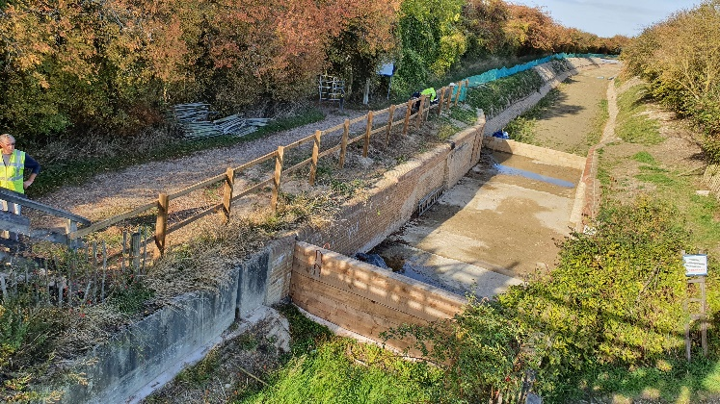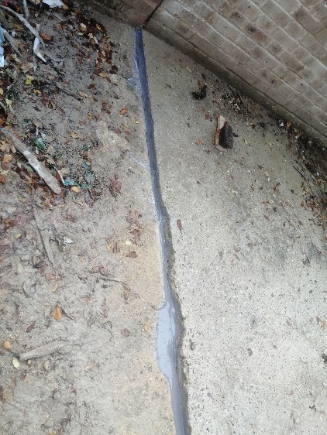

Tip Clearance
The stockpile of ash from the tip was disposed off site. 7 lorry loads of ash were taken away.

Canal Channel
Final canal bank profiling was carried out to the towpath and offside to allow 80m of Bentomat to be laid. The arising spoil was used as backfill on other parts of the site.
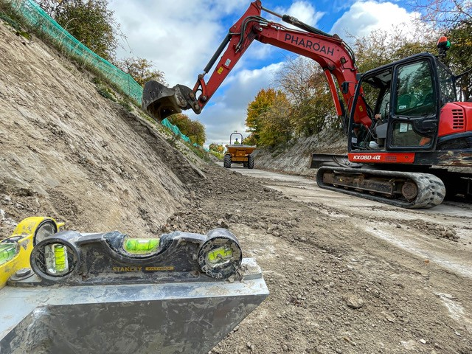
80m of Bentomat was laid to each side of the channel.
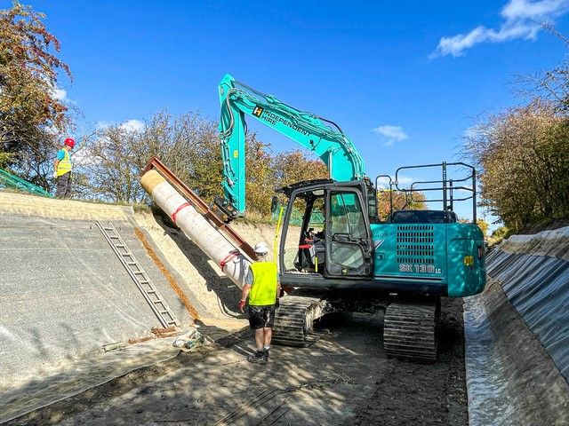
Concrete blockwork was started on both sides, but progress was hampered by the wet weather towards the end of the second week.
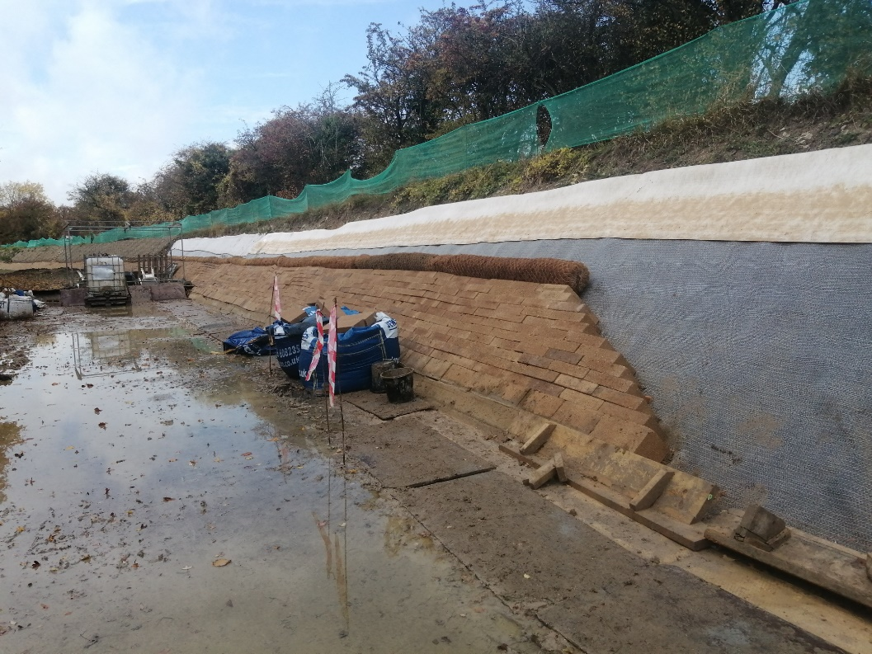

Narrows
The concrete corner coping stones were cast, completing the Narrows walls. Backfill was placed behind the walls to bring the ground back to towpath level.
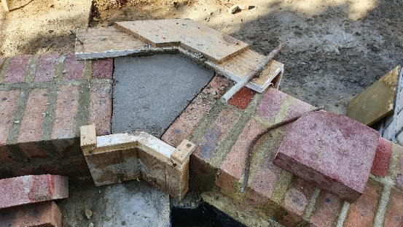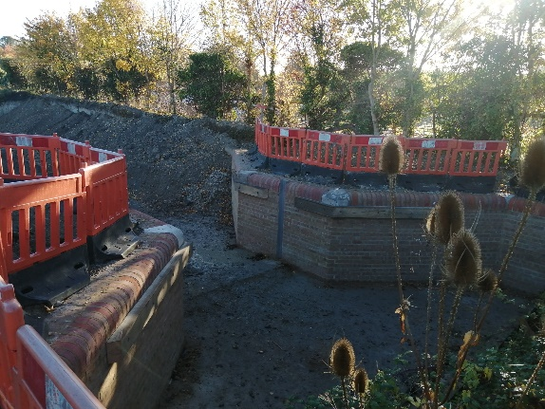

Work continued on from the Waterway Recovery Group BITM weekend and the towpath strengthening wall was completed. Once the blockwork mortar had cured backfilling both sides of the wall was undertaken.
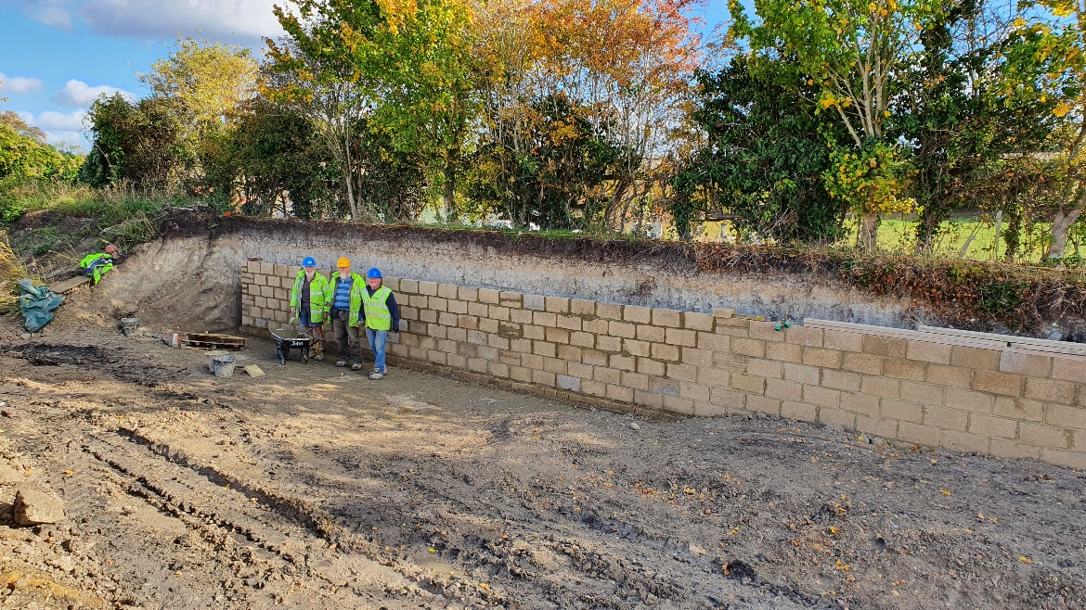
The timber fenders were installed to the Narrows walls and the tops of the stainless steel stop plank channels were cut to profile.
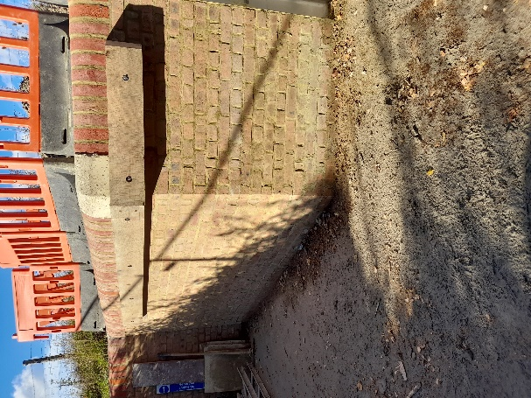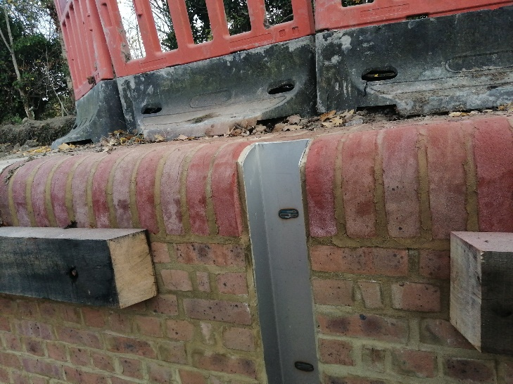

Tidy Friday was spent strimming and cutting the grass at the Whitehouses area, getting ready for sowing more wild flower seeds.
The area at Bridge 4a was partially cleared ready for planting the trees which will form the commemorative woodland in honour of Her Majesty Queen Elizabeth II.
Site Visit
On Thursday 13th October the site was visited by a party from Canal and River Trust. They were shown around the whole site and then went on to Wendover to look at the towpath that will be upgraded in the New Year.
Block Grab
A second-hand block grab that can be used on the 8 and 13 tonne excavators was purchased. Some surface rust needs to be cleared and the steel painted. The rubber grips have been removed for cleaning and refixing.
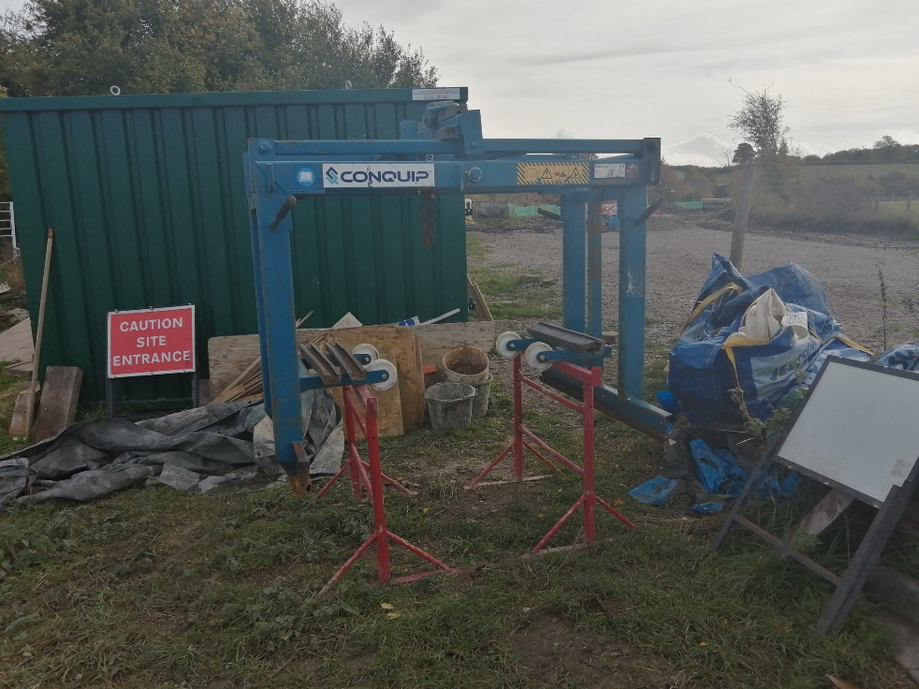
Noticeboard and community engagement
A notice board has been installed to the timber footbridge at Bridge 4. Conversations with towpath users led to comments from people who had read the notice placed on the board.
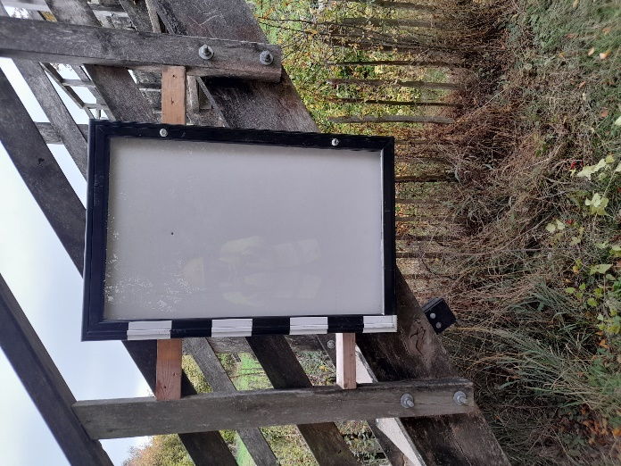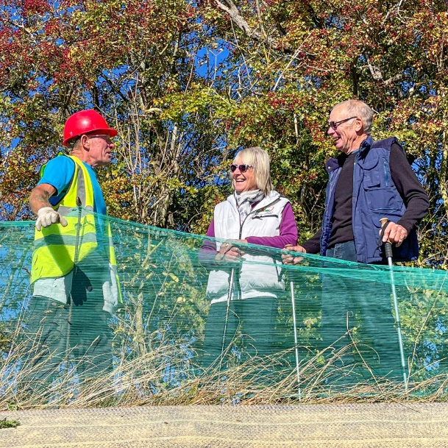

Outline plan for the November work party
The two-week November work party will start on 4th November. The work will continue with lining the canal banks to cover the Bentomat laid during the October work party.
The vertical expansion joints at Bridge 4 and the Narrows will be finished with poly sulphide sealant.
Permanent fencing will continue at bridge 4.
Depending on receiving the go-ahead from Canal and River Trust volunteers will investigate the sluice gate at Whitehouses and carry out a repair to stop the leak.

M Bradley, 24th October 2022. V1

