Wendover Canal Trust – September 2022 Work Party Report

The one-week September work party started on 2nd September. Work was carried out in 4 work areas, Bridge 4, canal channel, ash tip and Narrows. Work was hampered towards the end of the week by wet weather.
Health and Safety
There were no reported accidents or incidents.

Bridge 4.
The orange plastic fencing was taken down and moved to the storage area while there was still access for plant along the bed of the canal. The vegetation along the towpath was cut back and a new post and rail fence erected to replace the orange fencing. Measurements were taken to allow more fencing to be ordered to make the area look tidy and finished.
Joints to the offside brickwork foundations were inspected and cut back where there was obvious damage or weak areas.
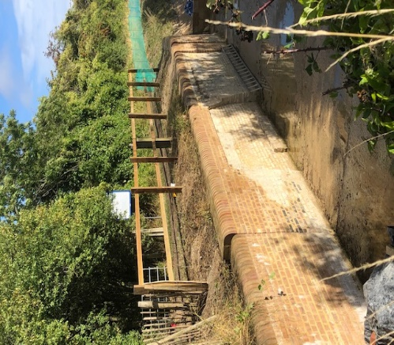 | 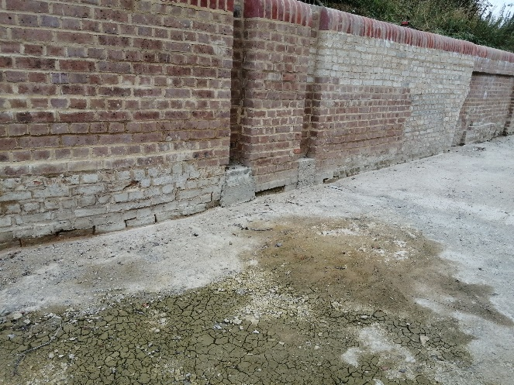

Canal Channel
Final profiling of the offside bank was carried out over the 40m ready to lay the Bentomat.
Solid concrete blocks and coil roll was placed over the Bentomat to complete the lower section of bank lining. The banks are ready for backfilling when the spoil has reached the right moisture content (if the spoil is too dry it slides down the Bentomat).
The next roll of Bentomat was joined at the bed and sides and rolled out over a 20m length.
Sleeping policeman (concrete upstands to protect the Bentomat joint and to provide support across the canal channel) were cast at 10m intervals and backfill placed on the Bentomat. The rolled-up end of Bentomat was protected with timber boards
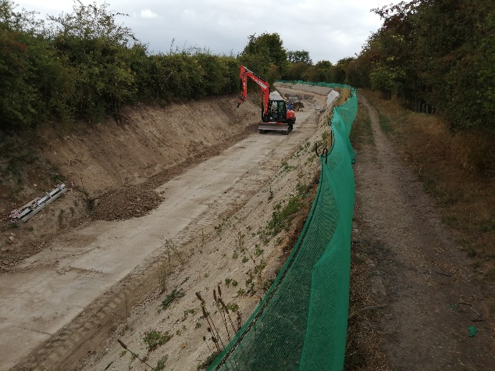 | 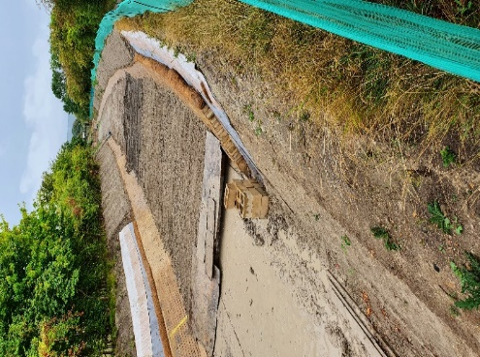
Tip Area.
More ash was excavated and stored at the end of the access track ready for disposal off site.
A trench was excavated on Keith’s side to expose the ash and top of the coal tar. The line was measured off the fence posts on Keith’s side. The trench was backfilled.
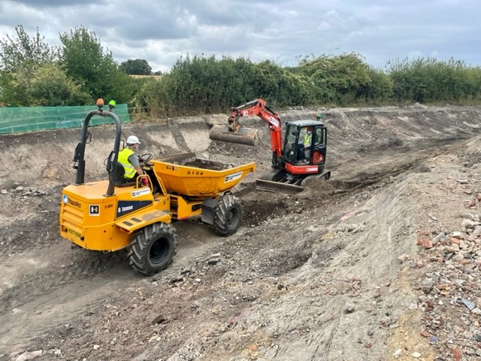 | 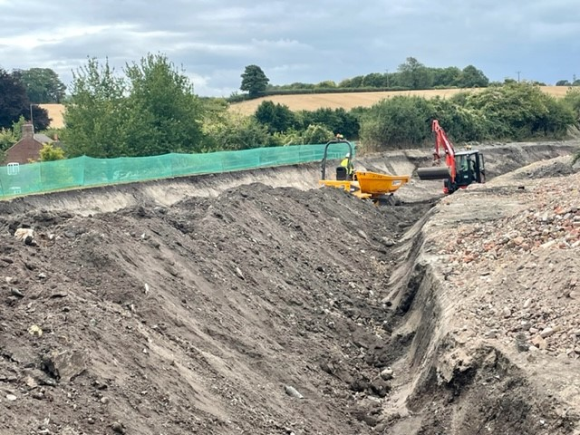

Bottle diggers have been on site making the tip unsafe. Heras fencing has been erected across the site at the end of Henry Grace’s land, but they are still getting in. in addition they have been throwing bottles onto Keith’s land and he is worried that broken glass could injure his livestock.
Will reported that a bottle diggers facebook page had advertised the work we are doing, encouraging bottle diggers to come to our site from far and wide.

Narrows
Progress has been made laying the coping to the top of the Narrows walls. Two concrete corner stones have been cast.
The excavation for 12m of the towpath strengthening wall has been carried out and a length of concrete blinding placed.
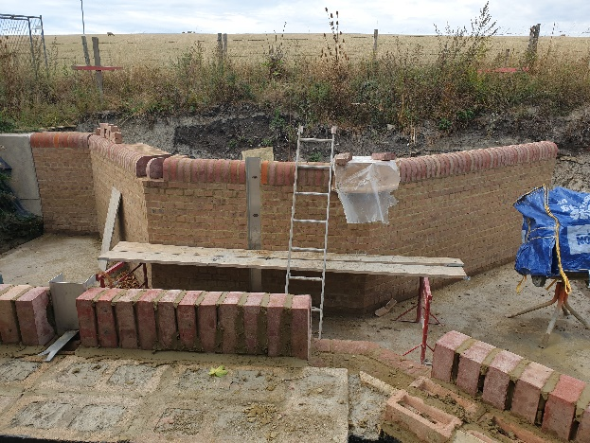 | 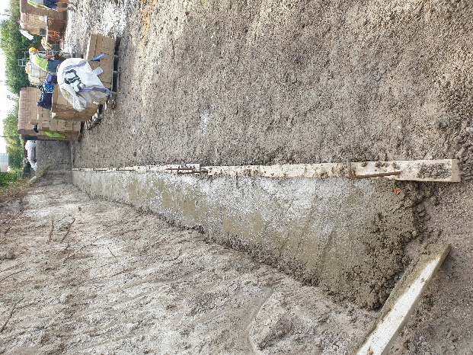

Solid concrete blocks and bulk materials were moved to the area of the Narrows to allow the Waterway recovery Group BITM to hold a work party on the weekend of 16-18 September.

Tidy Friday
Tidy Friday was spent strimming and cutting the grass at the Whitehouses area, giving the area it’s annual cut.
Mile markers
On Monday we were visited by John Henderson, a member and former volunteer who returned some mile markers that he had taken from site to restore.  CRT heritage adviser has been notified and he will give advice on their restoration. | 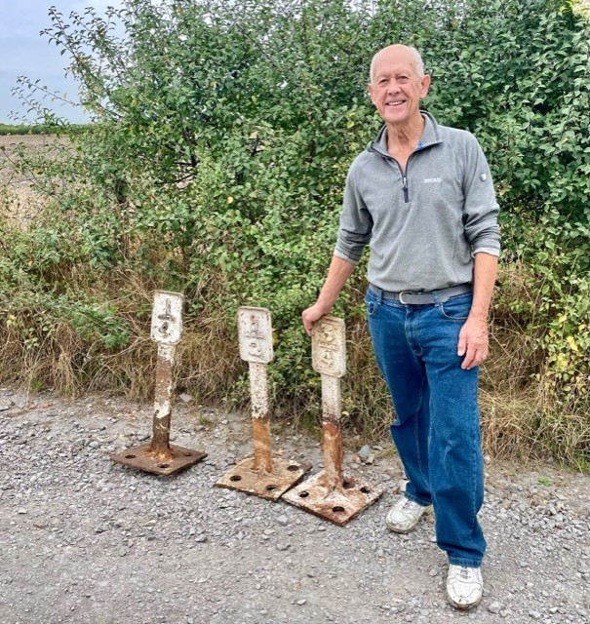

Outline Plan for September WRG BITM work party
Over the weekend of 16-18th September BITM will be on site to carry on with work at the Narrows, including building the towpath strengthening wall.
Another task would be repairing the eroded banks at the ends of the mooring walls near Drayton Beauchamp.

Outline plan for the October work party
The October work party starts on 7th October 2022, and we are hoping to have enough leaders and volunteers for it to run for 2 weeks.
CRT staff have been invited to look around the site and a provisional date has been set for 13th October.
The work will depend on how much work BITM get done. Work will continue on the four work areas from September. The work party may be two weeks depending on availability of team leaders and volunteers.

M Bradley, 12th September 2022. V3

