Wendover Canal Trust – July/August 2022 WRG Canal Camp Report
Waterway Recovery Group (WRG) held two weeks of ‘canal camps’ at Wendover between 23 July and 6 August 2022. Canal camps are working holidays where volunteers spend a week working on a canal restoration project. The volunteers come from all over the country and some come from abroad.
Health and Safety
There was one accident, a cut and bruised finger due to stubbing it on concrete. First aid was administered and the finger was bandaged.
The main issue for the work party was the weather, being hot and sunny for most days. Volunteers were encouraged to take regular breaks in the shade and to drink plenty.
Narrows.
The intention of the canal camp was to build the block and brick Narrows adjacent to the winding hole.
Prior to the camp WCT had moved materials to the site of the Narrows and in the area at the end of the tip where WRG intended setting up their rest area.
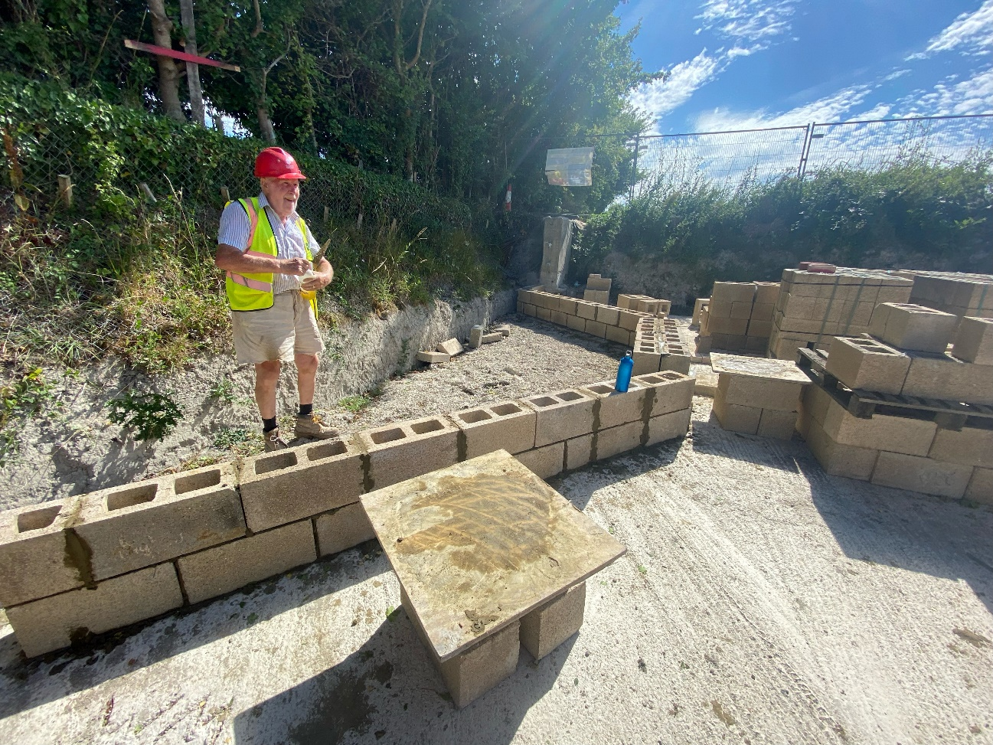
The first week of the camps focused on building the block walls to the Narrows. Previous WCT work parties had concreted the base slab including the ‘starter’ bars in the concrete for building into the hollows of the concrete blocks. Much of the first day was spent organising the working area and setting out and levelling the blockwalls.
During the remainder of the first week the block walls were built to height and the hollows filled with concrete. Included in the work was setting up the stainless steel stop plank channels which are built into the walls.
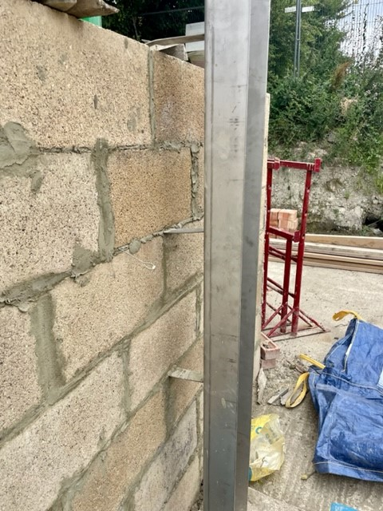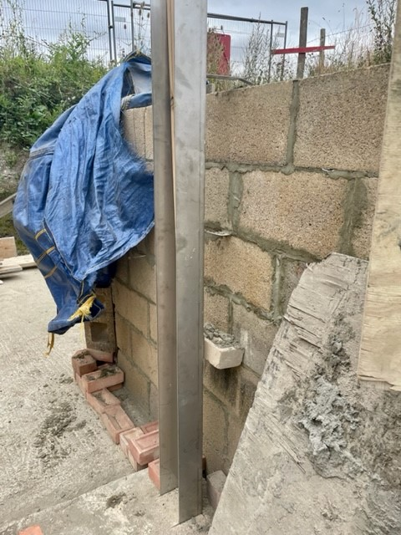
The back of the block walls were painted with a bituminous waterproofing paint and were partly backfilled with spoil excavated from the canal channel and the towpath strengthening wall. The backfill was compacted in layers.
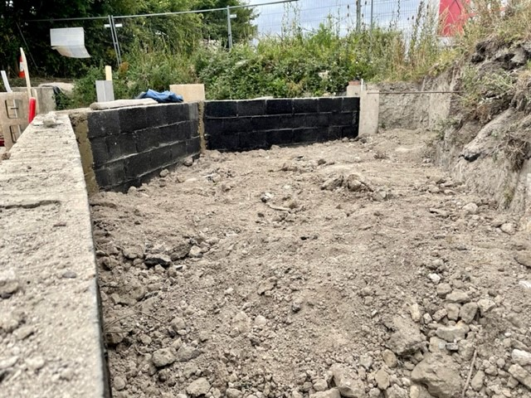
During the first week WRG filmed a promotion video. The video is intended to show volunteers at work and play. Once completed the video will be posted on the IWA website.
During the middle Saturday, change-over day for the two canal camps, WCT volunteers were on site to carry on with the backfill behind the block walls.
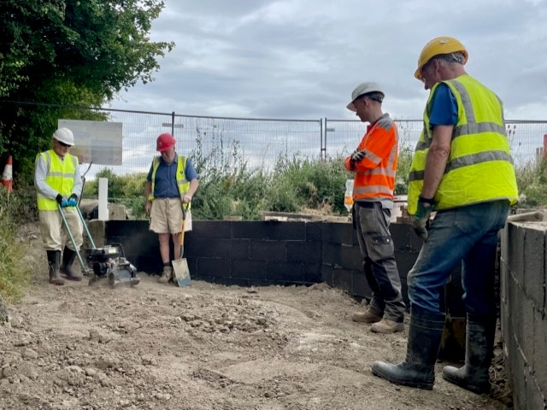
The start of the second week prepared to build the brickwork facing walls. Movement joints between the concrete walls of the winding hole and new blockwork of the narrows were sealed using a poly sulphide sealant. It was reported to be a very sticky job.
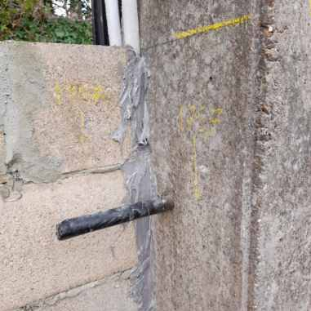
The brick courses were carefully laid out to ensure an adequate bond between courses to comply with the specification for the English Bond walls.
Great progress was made and the brickwork was built to the underside of the coping bricks, with some coping bricks laid.
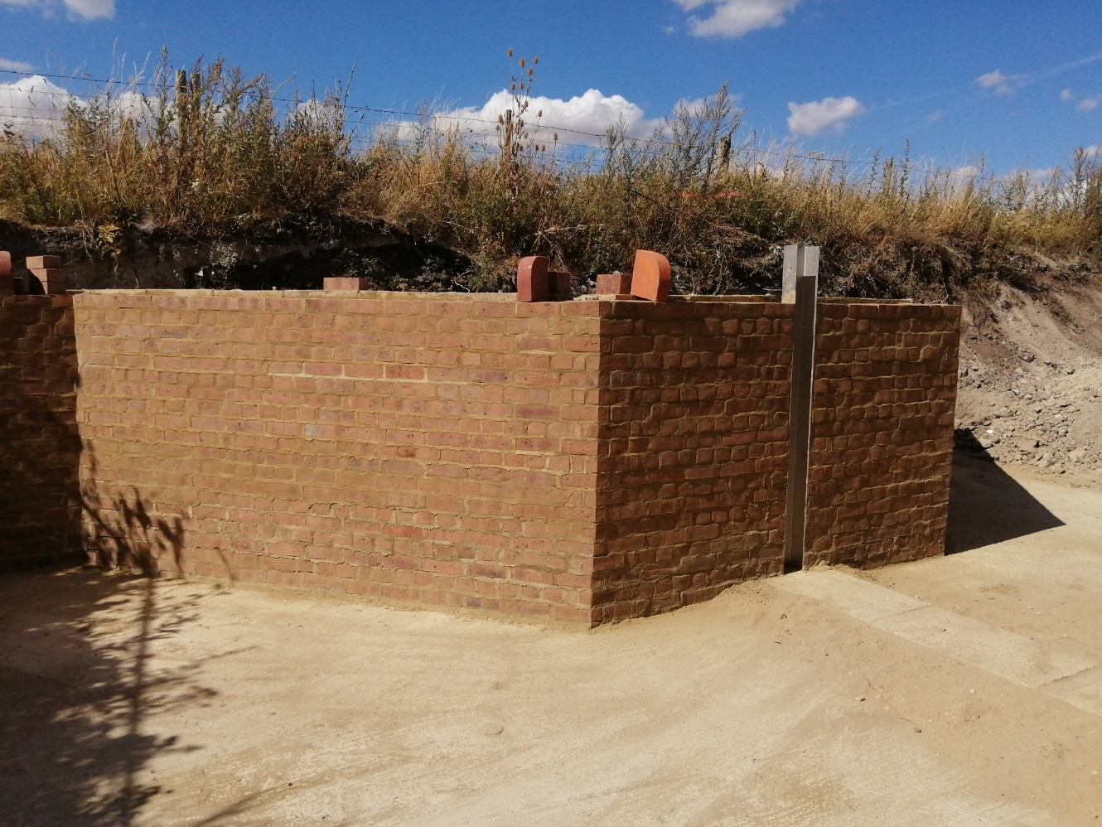

M Bradley

