Wendover Canal Trust – August 2022 Work Party Report
The two-week August work party started on 5th August with the first week prioritising preparation work for ash removal from the tip area in the second week. The WCT work party followed on directly after the two weeks of Waterway Recovery Group Canal Camps (see separate report).
Health and Safety
There were no reported accidents or incidents.
The main issue at the work party was the weather, being hot and sunny for most days. Volunteers were encouraged to take regular breaks in the shade and to drink plenty.
Bridge 4.
Surplus materials were moved from Bridge 4 and the shelter dismantled and moved to where the canal lining would be continuing.
At the end of the current lined section some of the spoil was moved and the end of the bed Bentomat was uncovered. There were two areas of damaged Bentomat which were repaired by patching-in squares of Bentomat cut from the end of a roll. The joints were sealed with Bentonite granules.
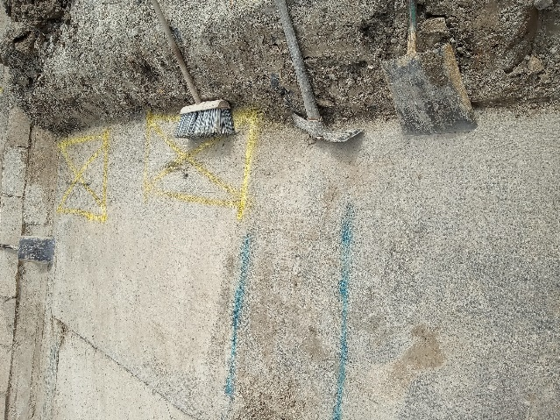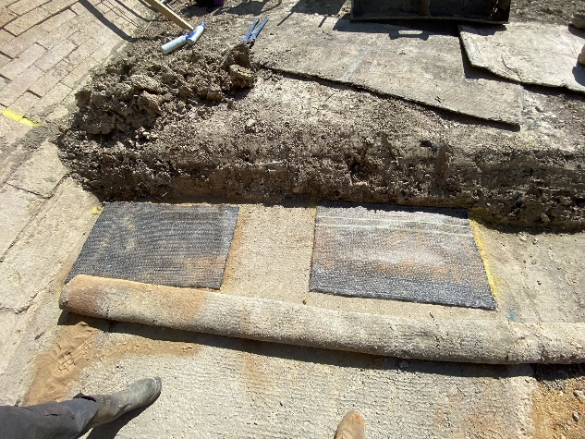
The next 40m roll of Bentomat was joined at the bed and sides and rolled out.
Sleeping policeman (concrete upstands to protect the Bentomat joint and to provide support across the canal channel) were cast at 10m intervals and backfill placed on the Bentomat. This work completed a further 40m of canal channel.
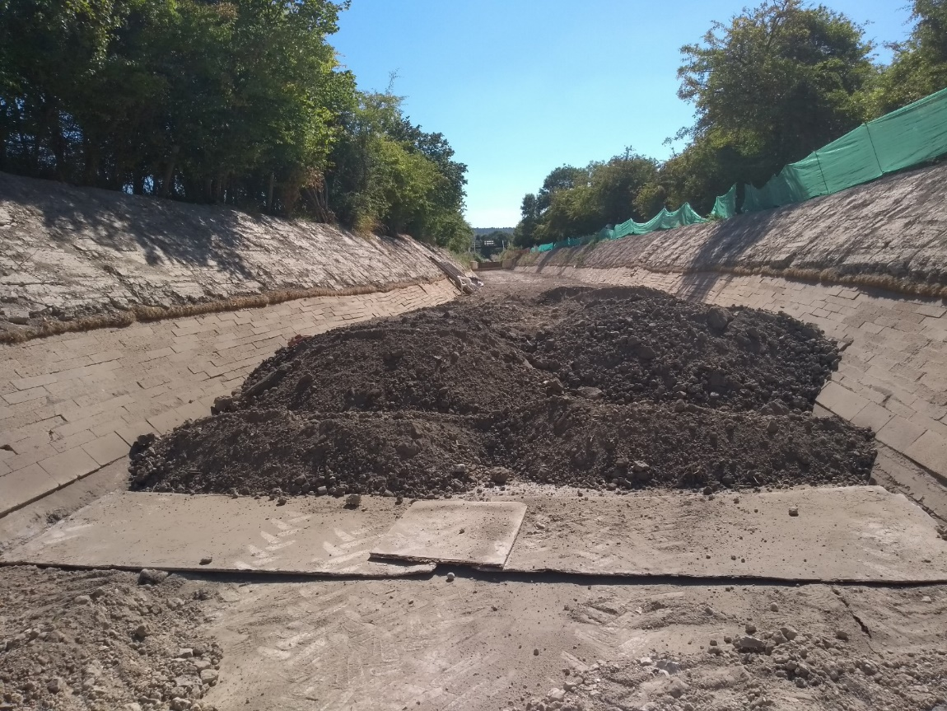
The end of the Bentomat was covered with protective boards and surplus spoil was heaped over the back ready for the next connection.
Tip Area.
The boundary fence at Henry Grace’s boundary was taken down and the materials stored. The stock fencing and barbed wire could possibly be reused.
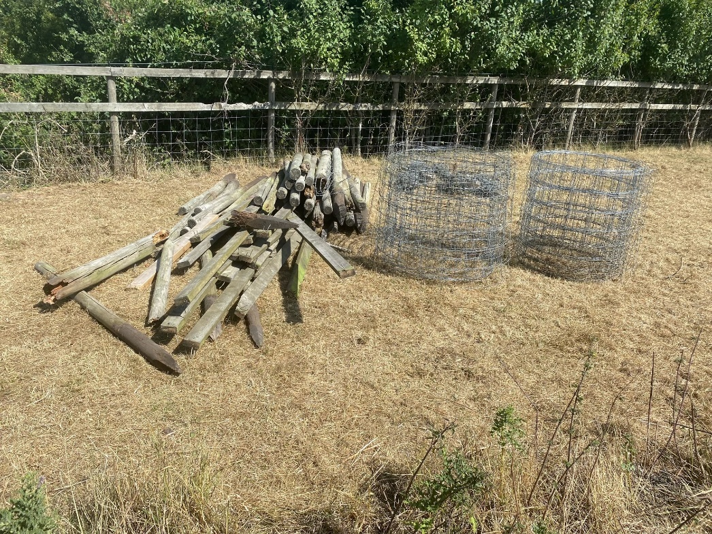
A survey of the fence lines to both sides of the canal channel was undertaken.
The surplus spoil over the ash was scraped up and used as backfill in the canal channel at Bridge 4.
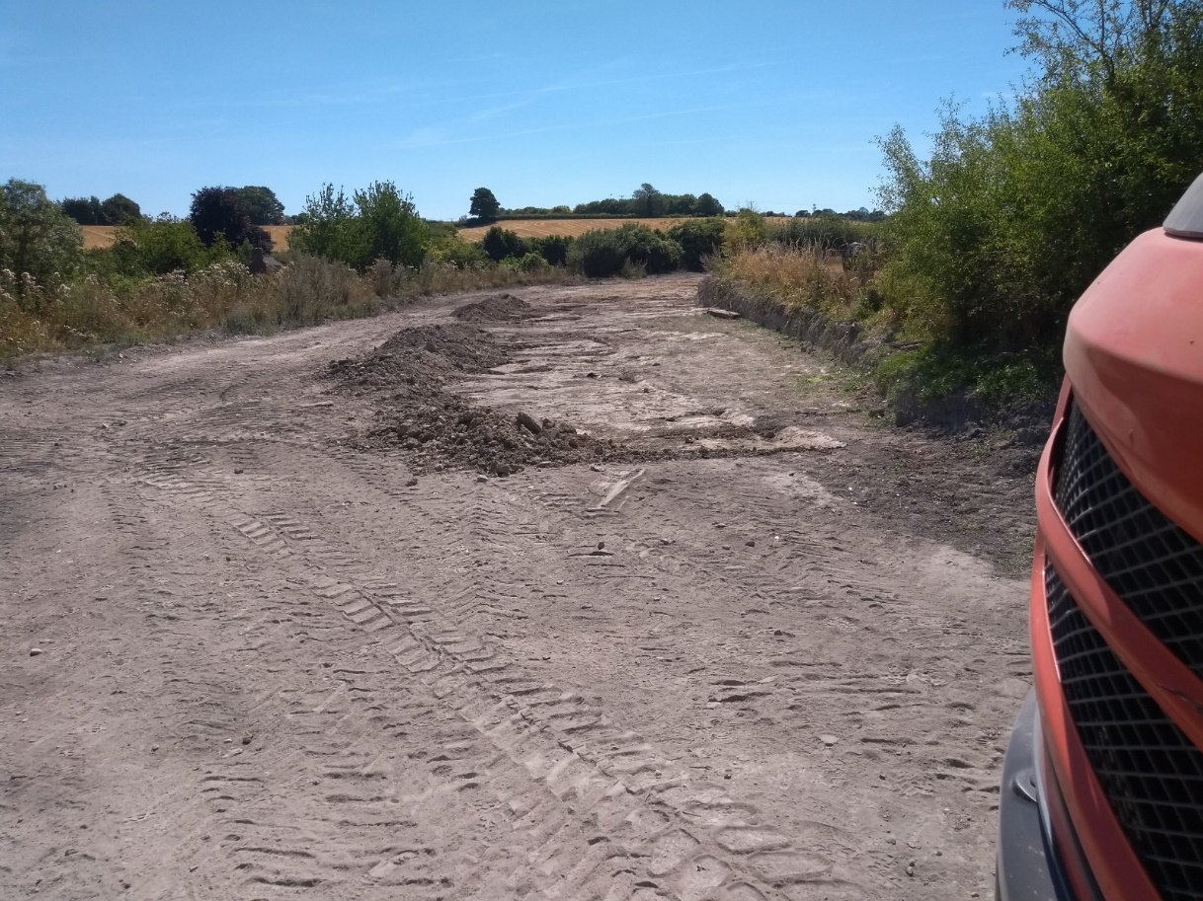
A hard-core access track was laid to allow the muck-away lorries to be loaded direct at the excavation face.
The 20T excavator was delivered to site and the low loader was able to drive onto the site so there was no disruption to the traffic on Little Tring Road.
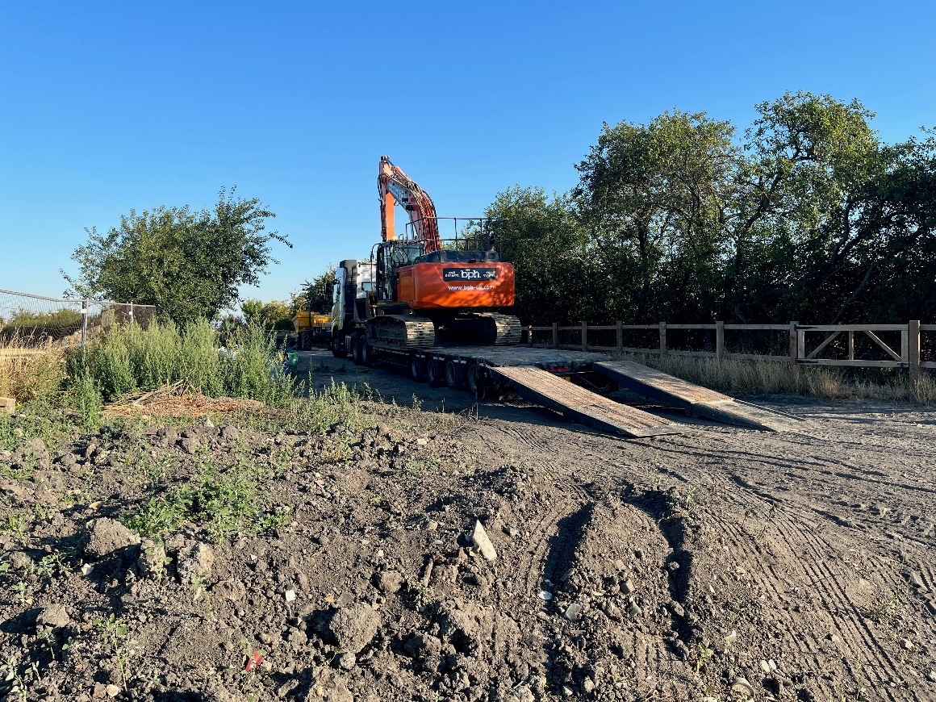
The second week of the work party concentrated on removing the ash from the tip area. There was an average of 5 volunteers each day due to the criteria of not having facial hair in order to effect a seal when wearing a face mask, a requirement of the control measures identified in the risk assessment.
The 20T excavator dug out the bulk of the ash, which was made much easier because it had a tilt rotator bucket which could be turned sideways or to any angle. The 5T excavator trimmed the sides down to the coal tar layer and moved ash to the 20T excavator.
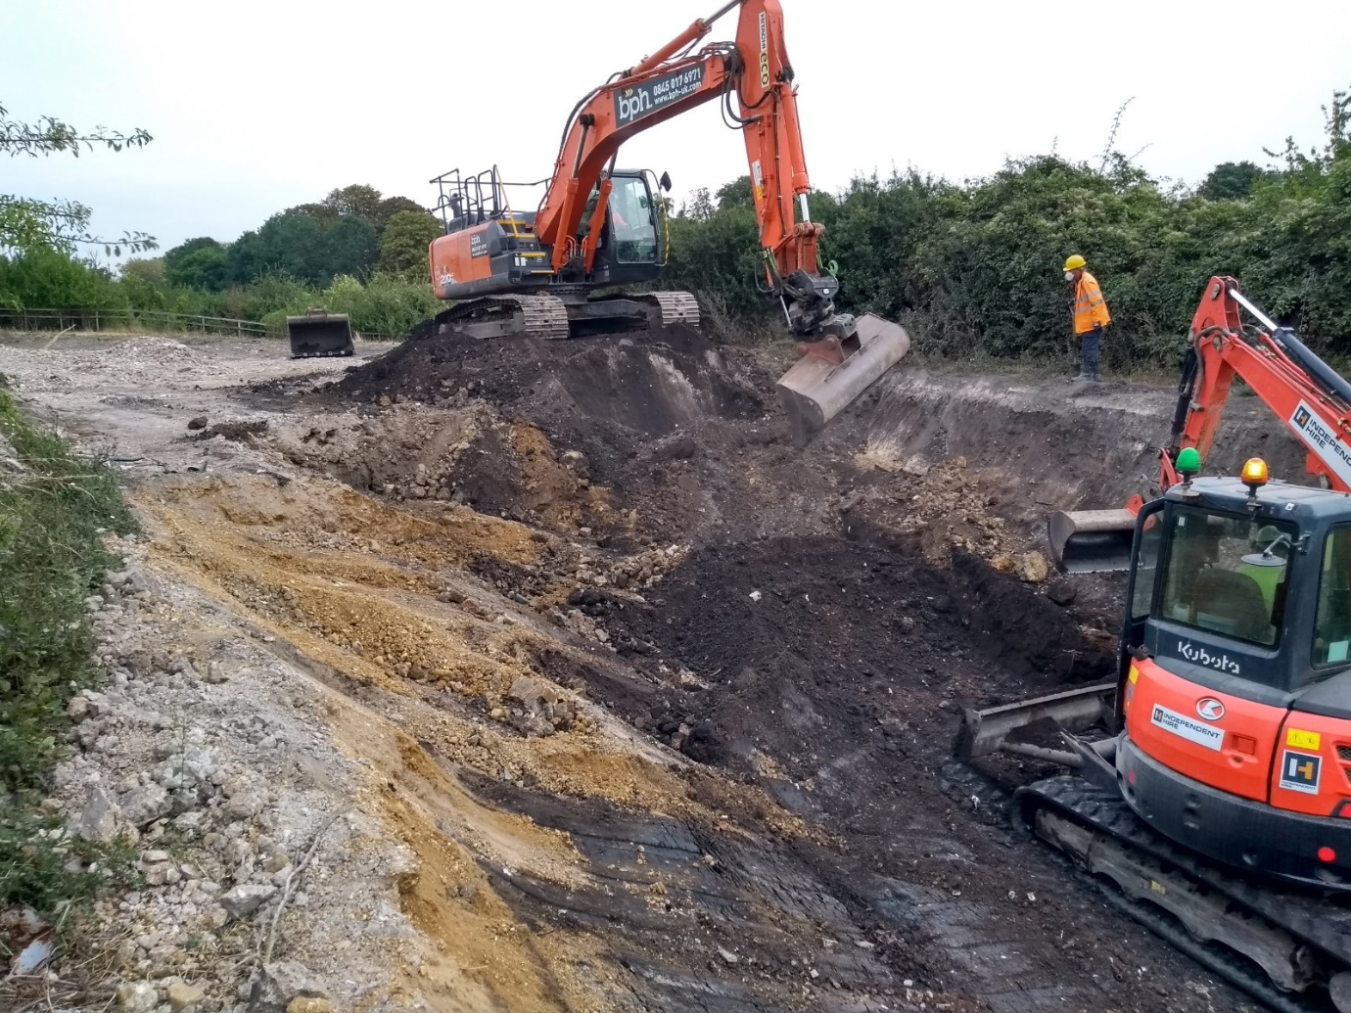
By the end of the week 70 lorry loads of ash had been removed, 1400 Tonnes of material. The coal tar has been exposed over the full length on the towpath side but only part way on the offside.
Discussions about boundaries of the canal cannot start until the full extent of the coal tar has been exposed and the channel surveyed.
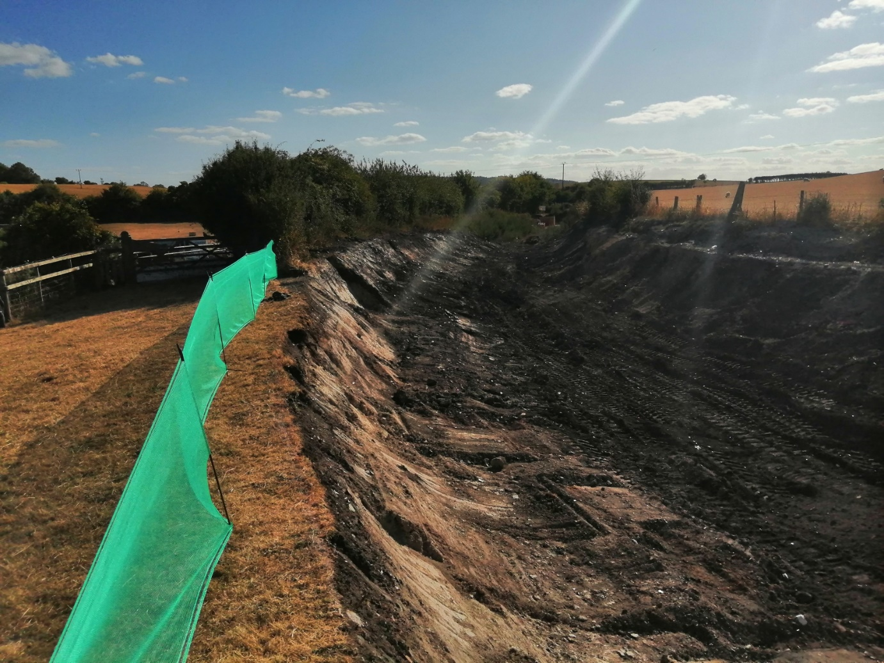
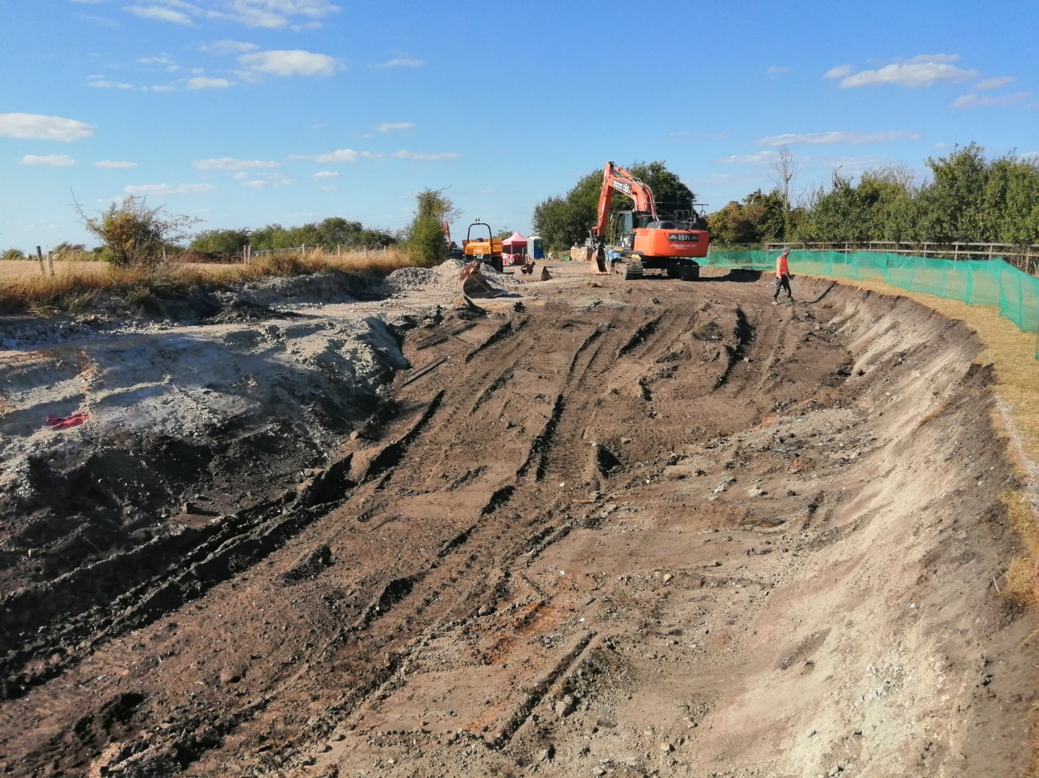
Well done to the team that spent the week excavating the tip.
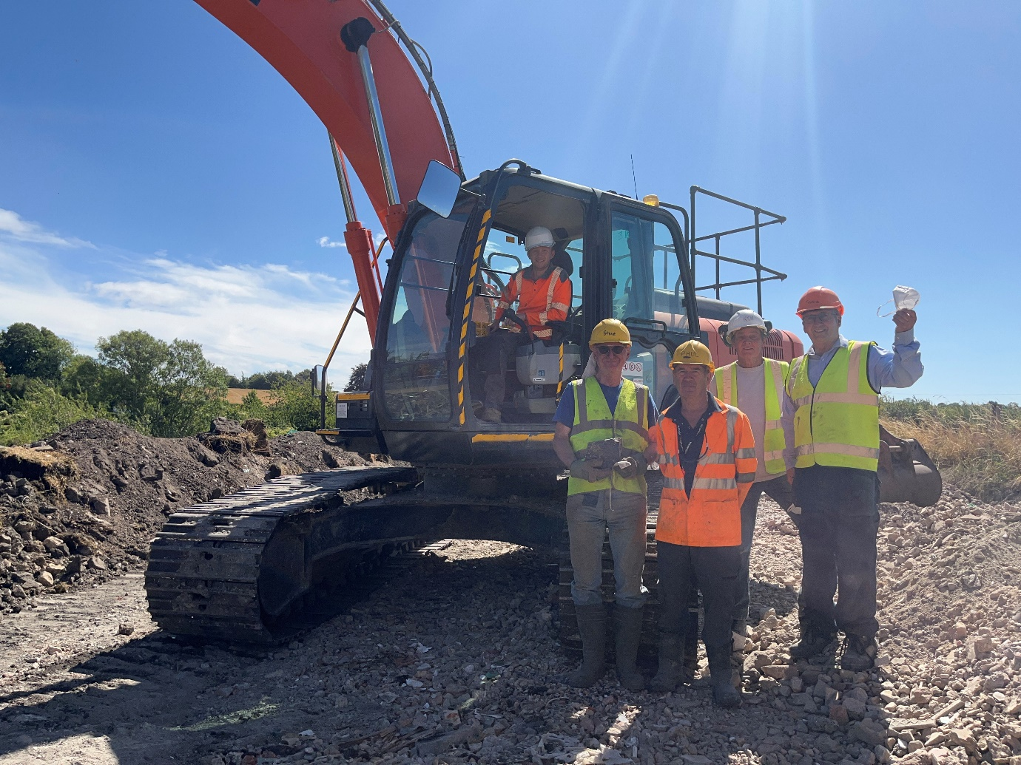
Tidy Friday was spent continuing strimming and cutting the grass on the path, around the benches and at Whitehouses. The new powered wheeled strimmer donated in memory of David Page was used. This will save strimming time by 75% and will reduce the risks of vibration, noise and manual handling from using hand-held strimmers.
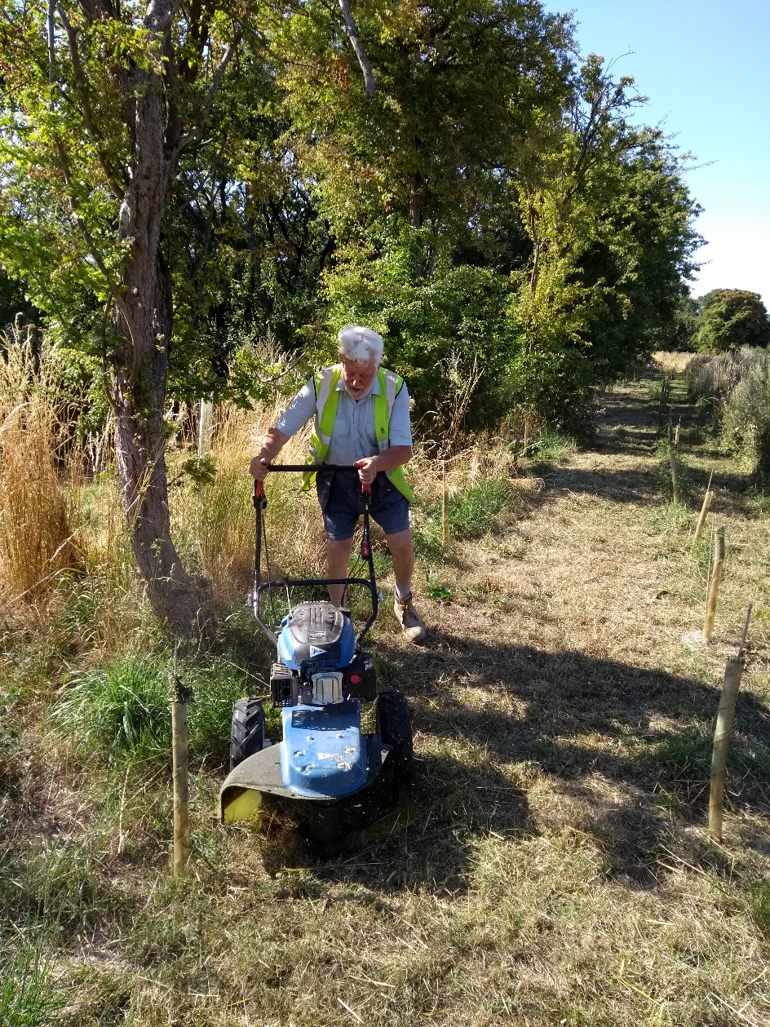
Outline Plan for September Work Party
The September work party will be one week starting on 2nd. Work at the Narrows will continue with the aim being to complete the structure. Depending on the supply of water the water loss investigation and filling the canal channel will continue. Further work to the canal lining at Bridge 4 will be done, but it is anticipated that backfill material will be too dry to place on the banks.

M Bradley, 19th – 24th August 2022

