Wendover Canal Trust – July 2022 Work Party Report
The July work party started on 1st July, but the leak investigation team carried out some trials on 30th June.
Health and Safety
There was one accident, a cut finger during block laying. First aid was administered and the cut covered with a plaster.
The main issue at the work party was the weather, being hot and sunny for most days. Volunteers were encouraged to take regular breaks in the shade and to drink plenty.
Water Leak.
The sluice gate at Whitehouses was closed and the section of canal at Whitehouses was rewatered. Water was observed passing the closed sluice gate. There were minor leaks through the block wall on Bridge 4 side of Whitehouses.
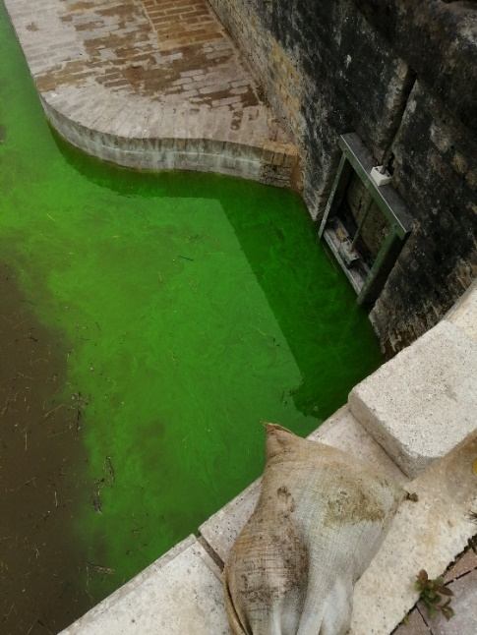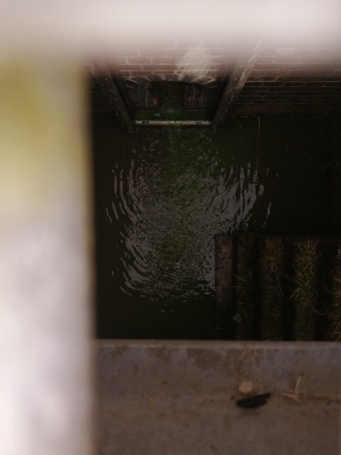
The block walls were sealed using a cement grout brushed onto the walls. Further observations showed that there is a seal on the back of the sluice gate requiring the gate to be accurately aligned in order to effect a seal.
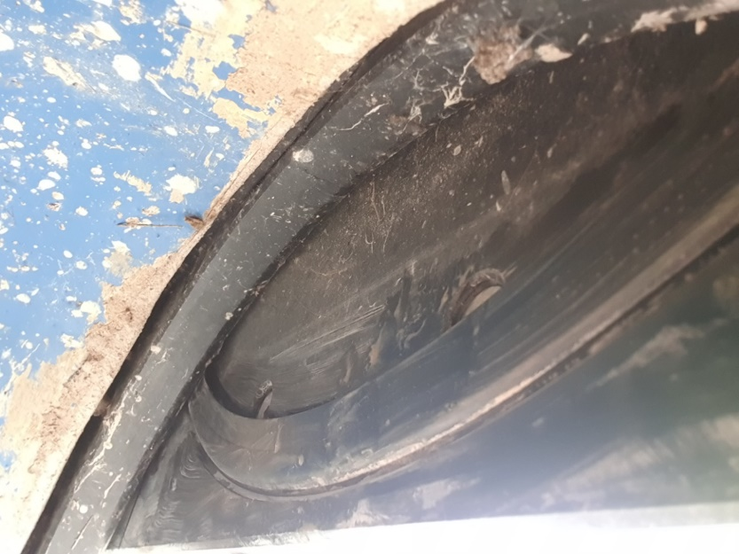
More trials will be undertaken.
Fence to separate the towpath from the work site.
The timber post and rail fence at the entrance of the site was completed. The intermediate posts were installed and the rails fitted.
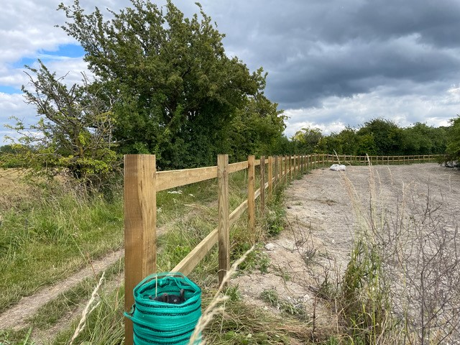
Canal channel the Little Tring side of Bridge 4.
The canal banks which had been profiled earlier in the year were trimmed for a distance of 40m in order to lay the next section of Bentomat. Bentomat was placed on both banks using the Bentomatic. And the lower edge protected with timber boards.
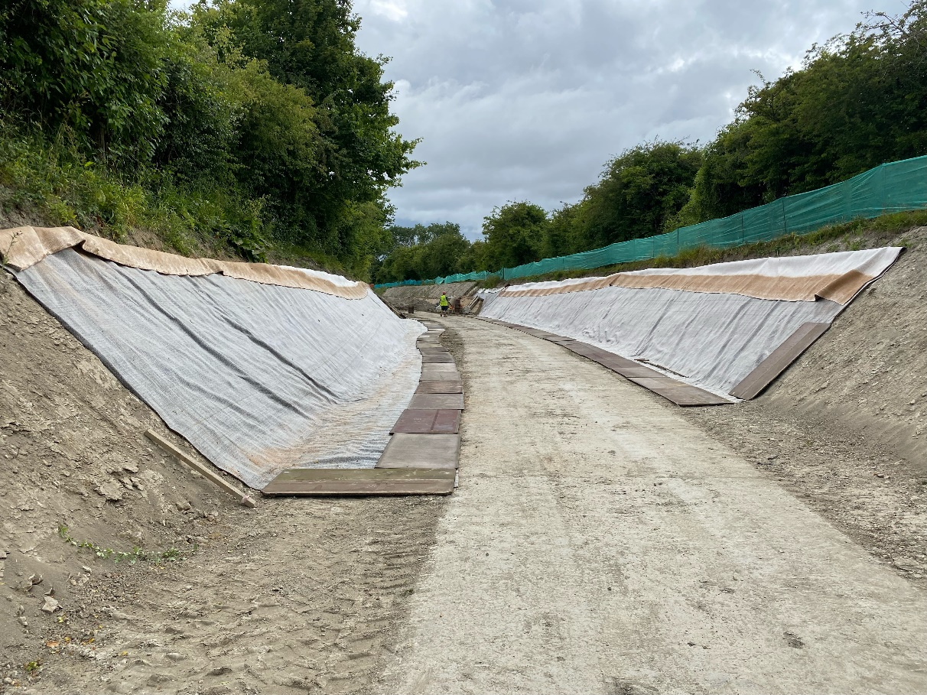
During the remainder of the work party the hollow block foundation was placed, solid blocks and coir rolls were installed and backfilling to the banks was commenced.
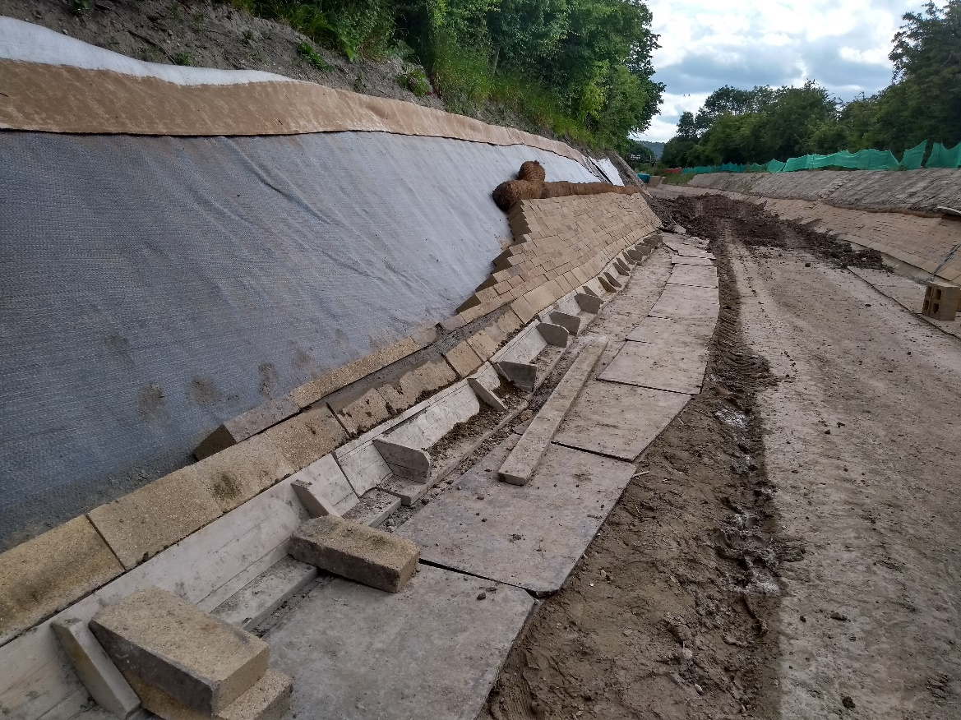
Some additional boards for protecting the Bentomat were purchased and collected from Bicester in the Cabstar pick-up.
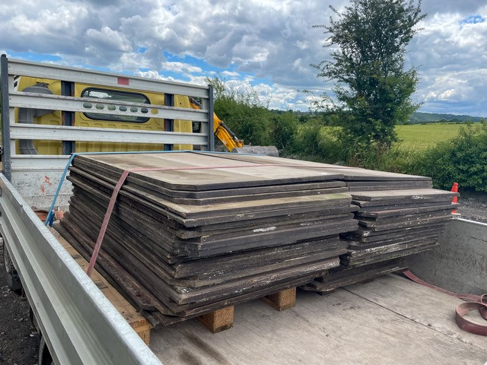

Tip Area
Trial holes were excavated in the tip area adjacent to Henry Grace’s fence to determine the position of the coal tar lining. It was found that the fence had been erected in the wrong position. Discussions with Henry Grace concluded that WCT would remove the fence, erect a temporary fence to allow ash removal from the tip and then erect a permanent fence on the new boundary line.
Tidy Friday was spent strimming and cutting the grass on the path, around the benches and at Whitehouses. The area looks much more inviting.
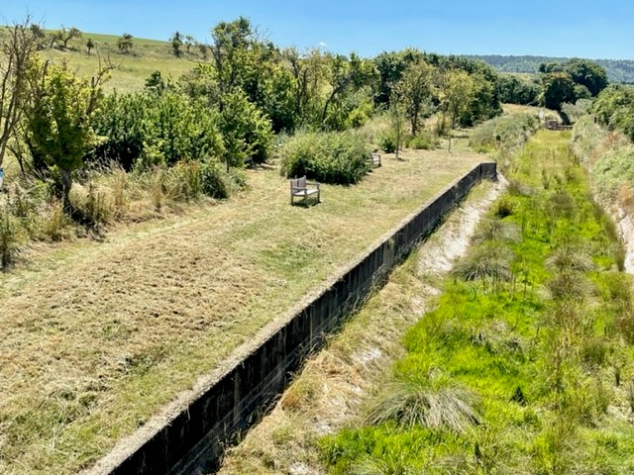
Narrows
Materials were moved from the store at the carpark along to the working area at the Narrows ready for the Waterway Recovery Group canal camp. The camp is due to start on 23rd July for two weeks. The plan for the canal camp is to complete the brick and block construction of the narrows and the towpath strengthening wall and to backfill the area around the Narrows and the canal channel adjacent to the structure.
Outline Plan for August Work Party
The August work party will be two weeks starting on 5th. The first week will continue with the canal channel lining adjacent to Bridge 4 and preparing for the ash removal. The second week will see the removal of the bulk of the ash from the tip area with a restricted number of volunteers.

