Wendover Canal Trust – June Work Party Report
In June the work party was delayed from the usual first Friday of the month to the second because of the Queen’s 70th Jubilee celebrations. Team leaders wanted to start earlier than the Friday so a non-machine day was set for the Thursday.
Health and Safety
No accidents were reported during the work party.
The main issue at the work party was the weather, being hot and sunny for most days. Volunteers were encouraged to take regular breaks in the shade and to drink plenty.
Memorial Bench.
A memorial bench for Ray and Margaret Flanigan was set in place at the winding hole. The base was hand dug and a concrete slab cast. The following day the bench was set in place. This entailed some making good of the concrete due to overnight vandalism.
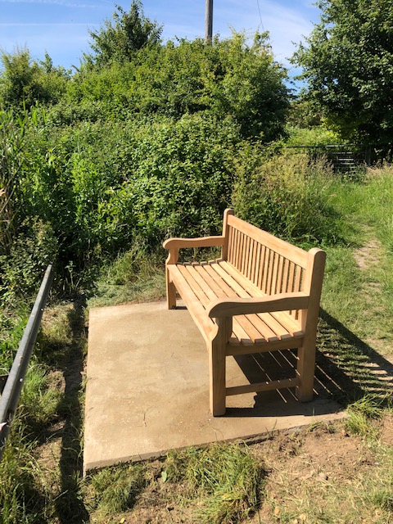
Fence to separate the towpath from the work site.
The timber post and rail fence at the entrance of the site needed to be extended because surplus contaminated spoil that had been stored between Little Tring and the winding hole has been moved into the canal channel. Some work had been carried out during the Kescrg weekend, but the rails were poorly aligned. The rails were reset and additional posts were set in place. Intermediate posts and the rails need to be completed, but the post holes could not be augered due to the presence of rocks making use of the auger unsafe.
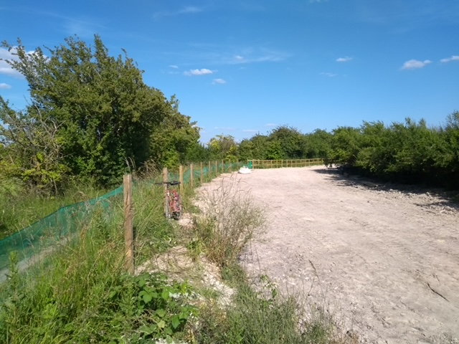
Canal channel the Little Tring side of Bridge 4.
The backfill to the banks and canal bed needed to be finished off (when laying Bentomat was stopped in January the spoil was too wet to trim to shape but is now dry enough to support the excavator). The bed material was levelled off and surplus backfill material moved to the Little Tring end.
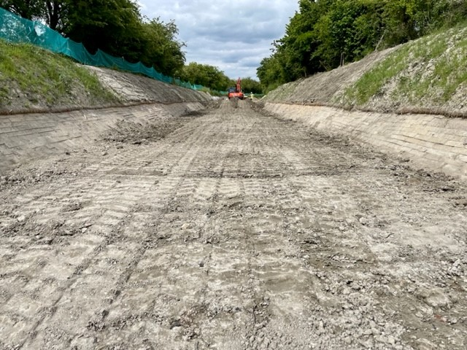
The solid concrete blocks to the offside had been poorly laid. The blocks were taken down as far as the hollow concrete blocks and the top surface made good to cover the ‘steps’ between blocks. The solid blocks were carefully placed and any voids between the blocks and Bentomat was filled with sand.
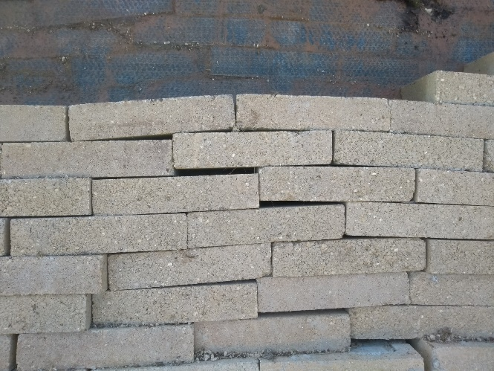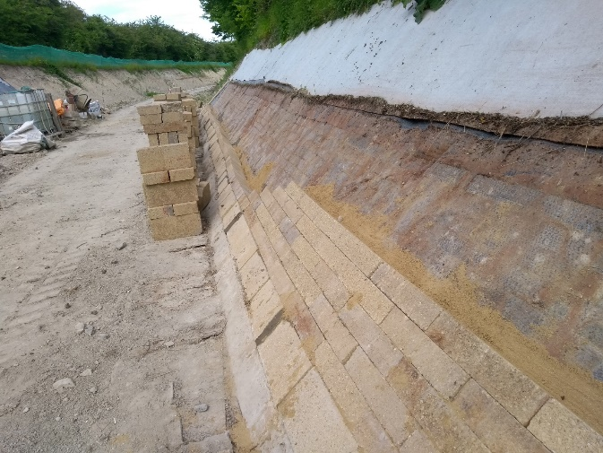
Before. Start of rebuild.
The towpath bank adjacent to Bridge 4 was scraped to improve the towpath level and the red and green fence realigned.
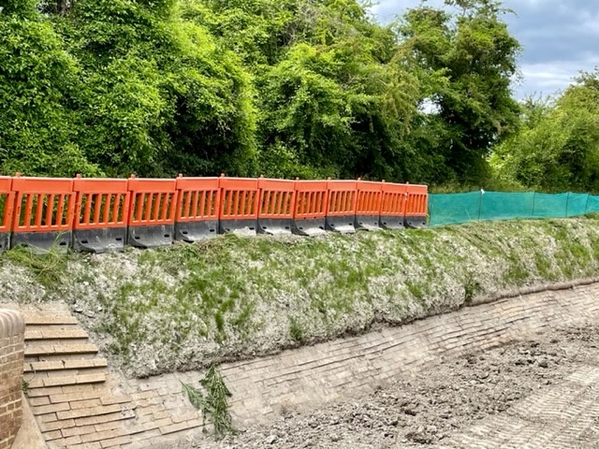
Bridge 4.
A low concrete wall was built to retain the canal bed backfill. In addition a temporary low bund wall was build across the canal channel to allow water testing of the walls to Bridge 4.
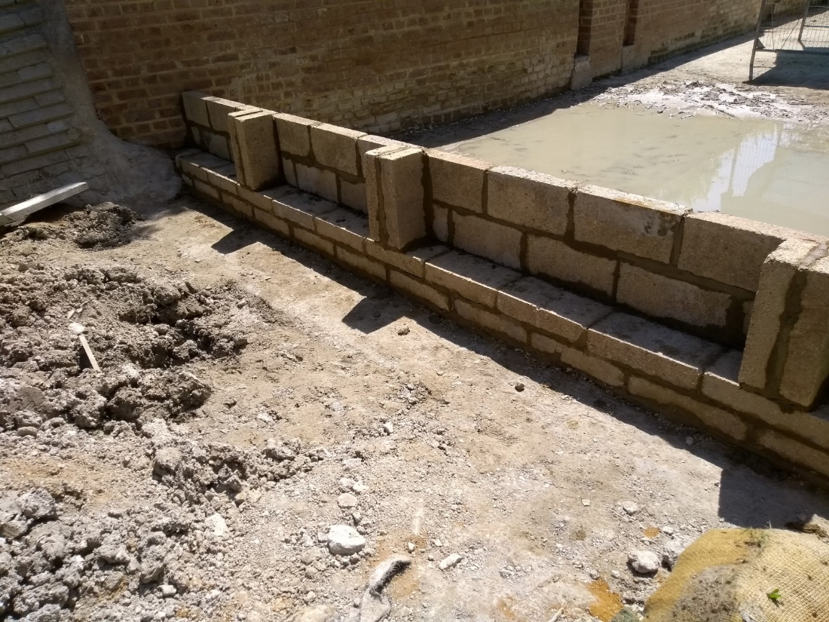
Whitehouses Sluice Structure.
During the last work party a crack was identified in the brick apron to the Whitehouses sluice structure. in consultation with the CRT heritage adviser it was agreed to break back the brickwork to part of the apron and to investigate any void under it. The void was backfilled with compacted concrete and the surface finished off with heritage brickwork. The CRT heritage adviser was sent photos of the finished work and complimented the bricklayers on a very good job.
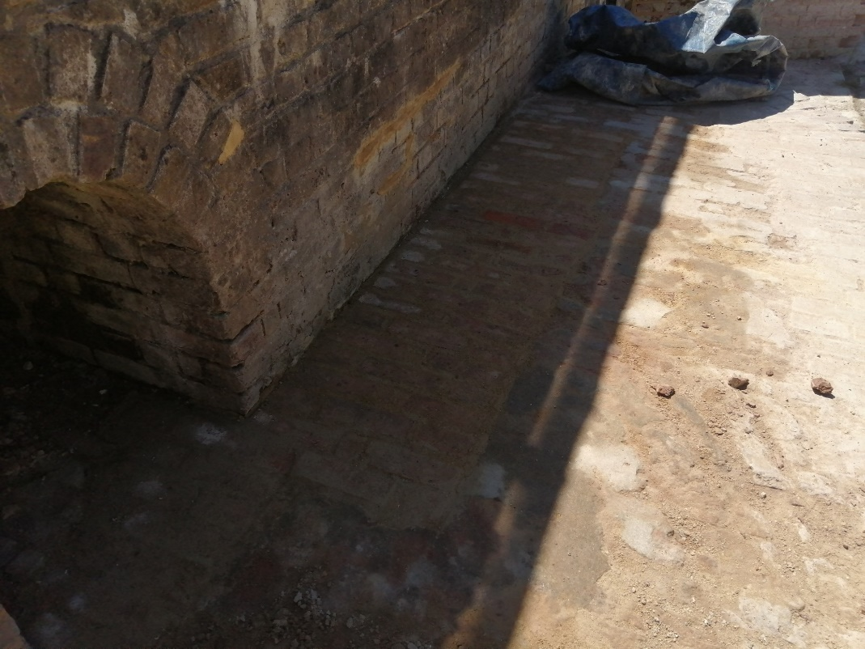

Bridge 4a.
In order to control the water flow back into the canal at the earth bund under Bridge 4a, a small temporary block weir structure was proposed. The earth bund was excavated and the structure build. During the work party CRT gave approval to refill the canal with water. Testing of the temporary bund walls at Whitehouses and ultimately the canal channel can recommence.
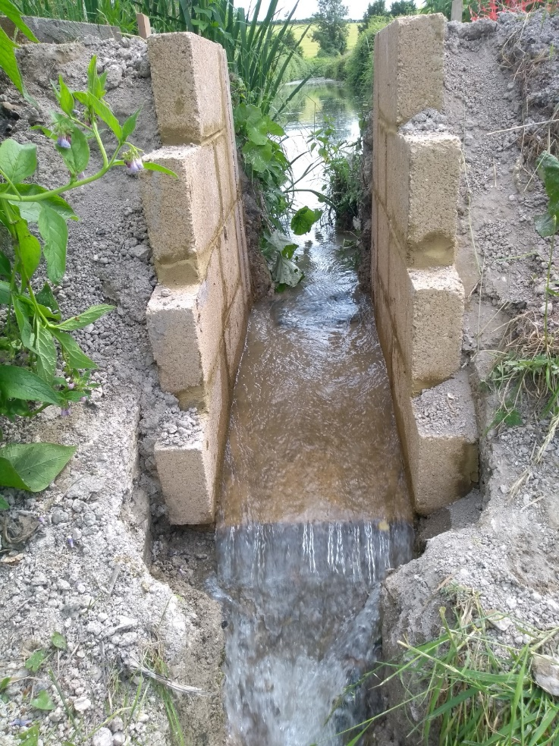
After the water was run for a couple of days it was apparent that there was a small leak around the first bund wall on the towpath side. Control of the leak will be discussed by the water loss team.
Tidy Friday was spent strimming and cutting the grass on the path, around the benches and at Whitehouses. The area looks much more inviting.
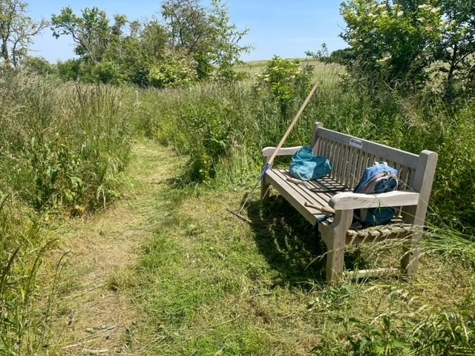
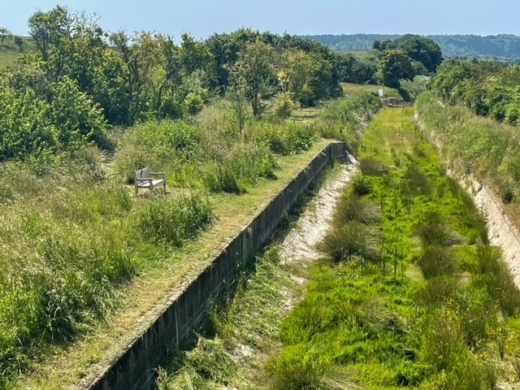
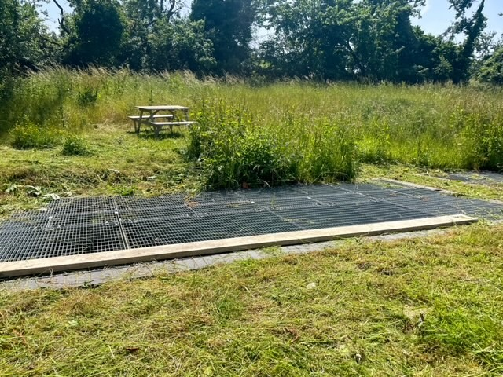
Outline Plan for July Work Party
The July work party will be one week starting Friday 1st, and likely activities are listed below;
Complete the timber post and rail fence.
Trim the prepared banks to the finished profile, lay Bentomat over the next 80m and the install hollow and solid concrete blocks in accordance with the revised working method. This is subject to Trust Council approval.
Seal the leak to the bund wall at Whitehouses and continue filling all three sections.
Start the block and brick laying at the Narrows. Start to strengthen the towpath bank near the narrows, with an internal concrete wall. This concrete wall will eventually be buried within the towpath bank.
The July work party will be supplemented with two weeks of Waterway Recovery Group canal camps. The building of the Narrows and strengthening towpath wall will be undertaken by WRG. The canal camps start on 23rd July.

