Operations Report May 2022
The weather was mostly good, even quite warm and sunny at times, except for the Wednesday when it poured all day. Fortunately conditions were dry enough before this rain, that they quickly improved the following day.
As well as one of our team leaders arriving by boat, we were glad to welcome Paul and Carole, who joined the work party for most of the week as part of their boating to London.
Narrows
Blockwork was laid as a permanent shutter to the required shape, which as can be seen below, is something like an hourglass when seen from above. It took a lot more effort than expected to tie together steel reinforcement, which unfortunately had to be completed in Wednesday’s rain. 5 loads of ready-mix concrete were delivered and placed, poured, spread, compacted and tamped on Thursday. Despite Wednesday’s rain it was possible for some of the ready-mix lorries to reverse through our site most of the way to the narrows.
To the casual observer, the resulting concrete foundation looks too wide to be a narrows, but by the time blockwork walls have been laid round the edges of the concrete, and then faced with brick, the narrows will be little wider than a 7 foot wide narrowboat.
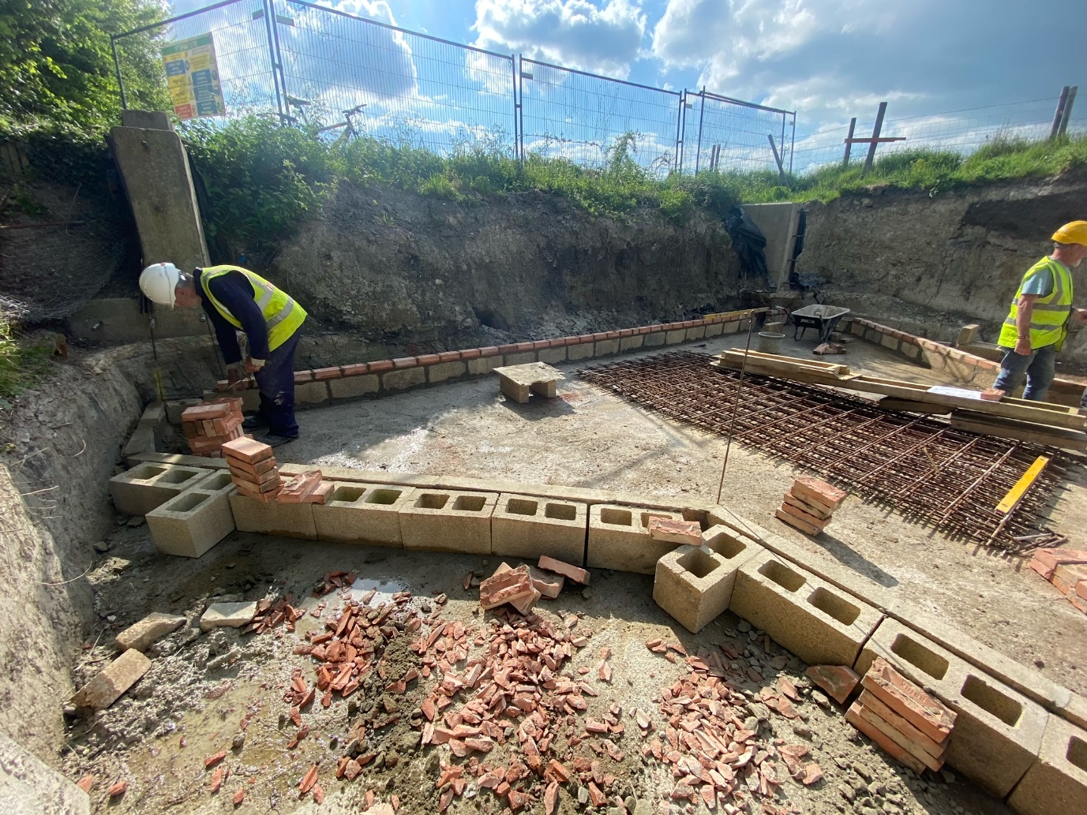
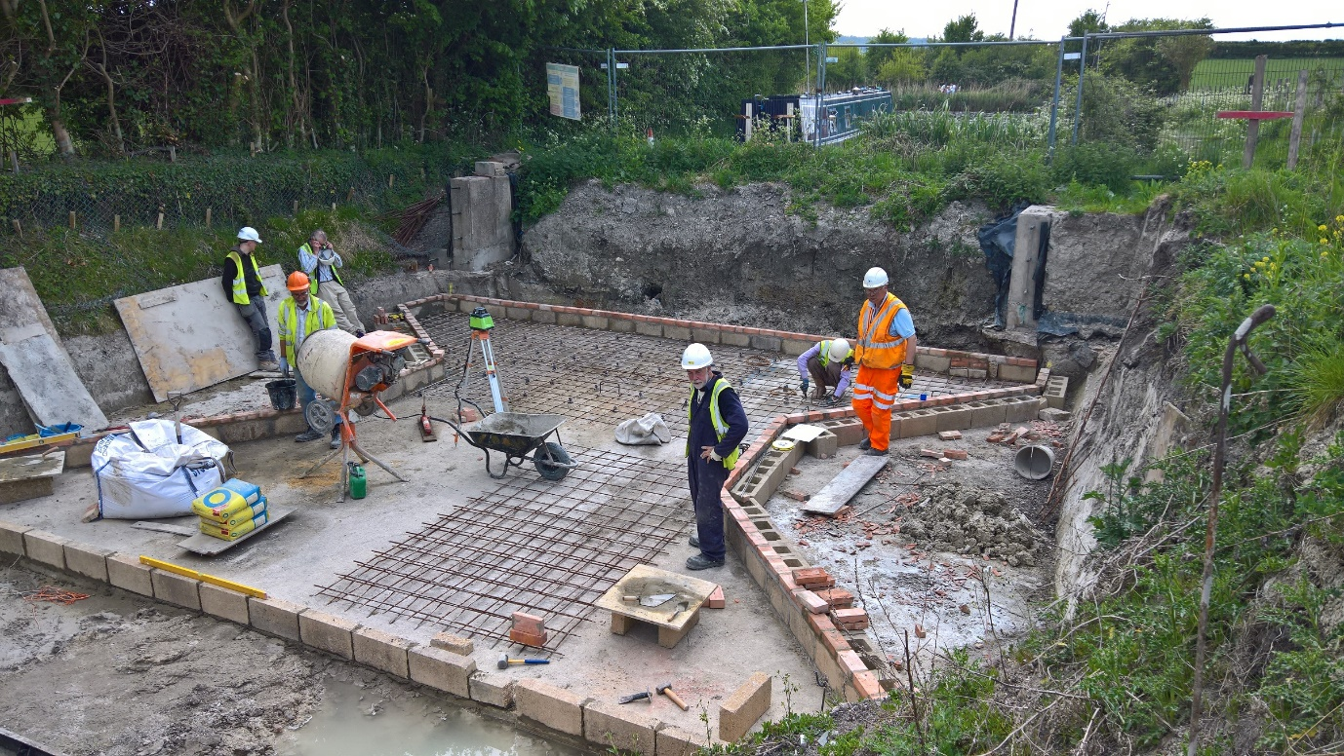

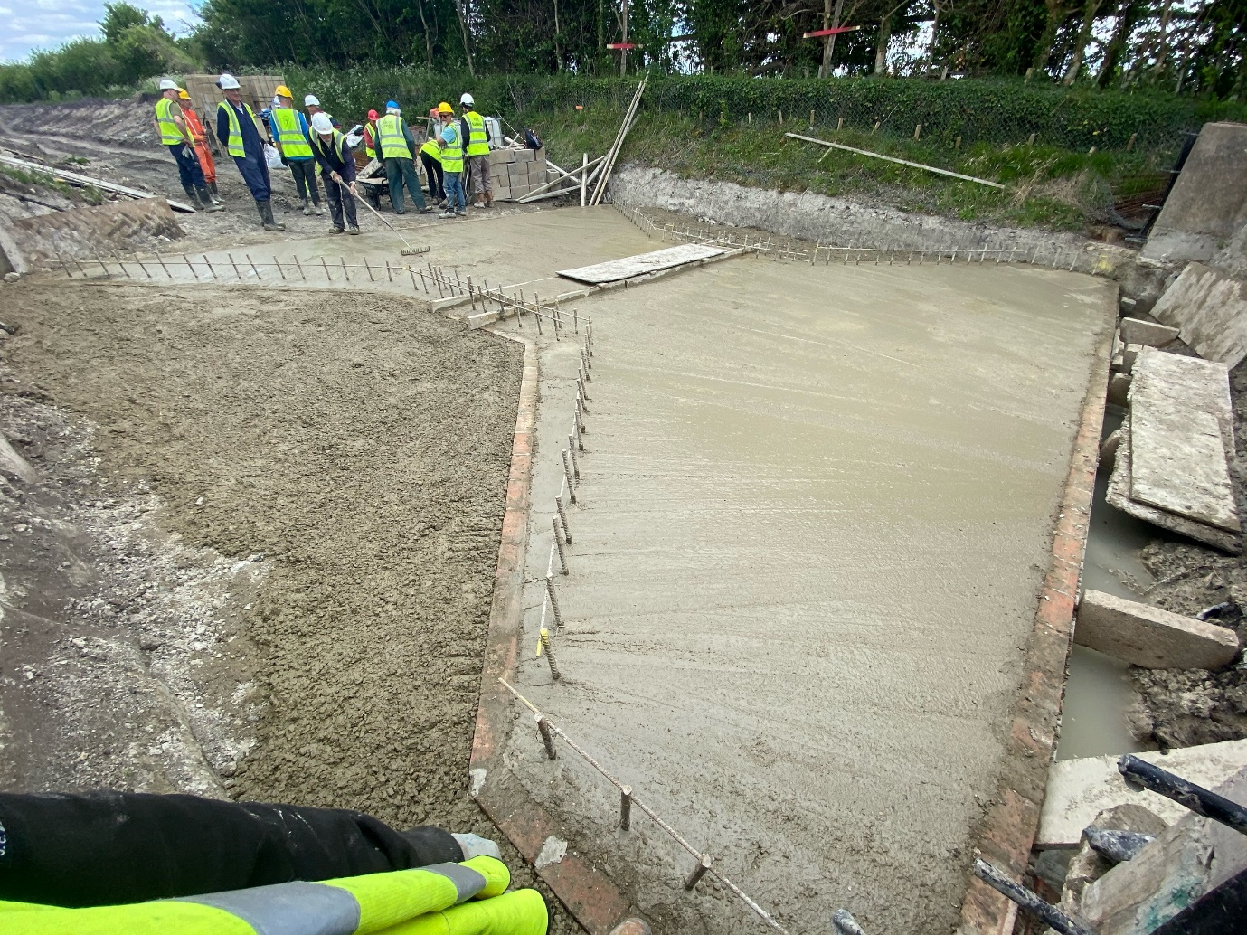

Spoil Relocation
In preparation for this summer’s major ash removal exercise, our mountain of clay contaminated with coal tar has been moved. Until now it was on top of the ash, between the car park and the winding hole/narrows. Now it has been temporarily placed just the other side of the car park and entrance, at the beginning of the section towards Bridge 4. It has temporarily filled in a short section of canal to towpath level. It is expected that this spoil will be gradually used up when we recommence lining the canal. For now, we have an additional storage area for materials.
We experimented with a remote-controlled hired roller to compact this spoil so that it can be driven over. However we were disappointed; it achieved little that we couldn’t have achieved as well or better by driving the large excavator back and forth over it.
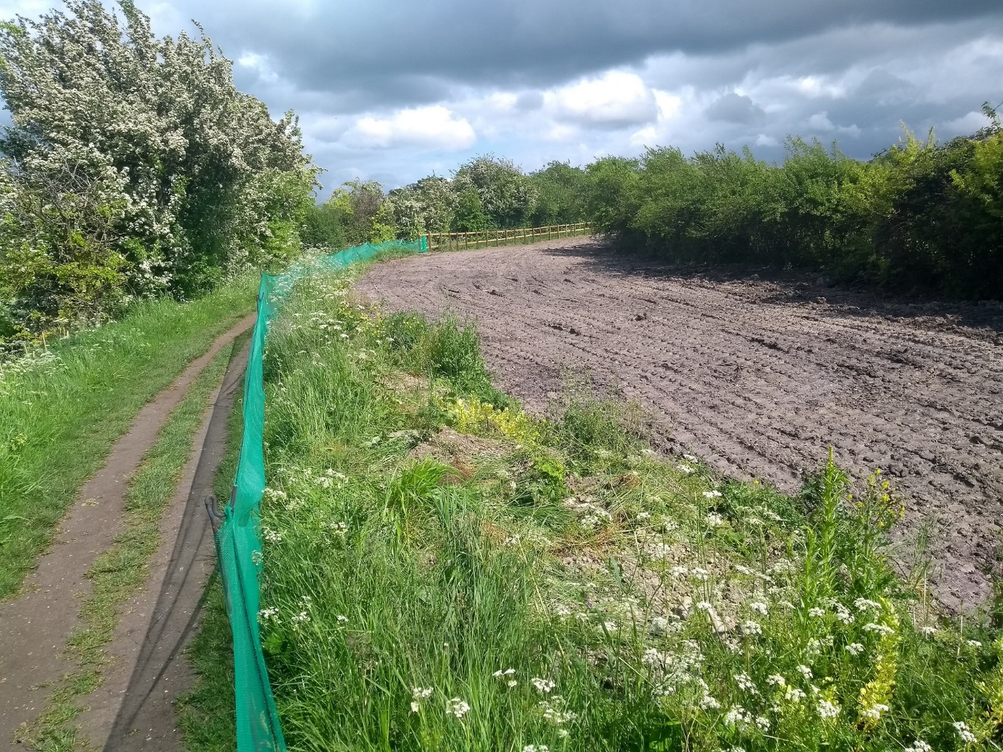

[ Continues…

Ash removal
Almost all the ash we stockpiled last month has gone to FCC’s tip at Calvert. This took 13 lorry-loads across 4 days. We look forward to a major operation in July and August, which we expect will clear most or all of the ash, EXCEPT that which lies under our volunteers’ car park and the entrance area where we store material for removal. These sections will be the last to be relined, and so will not be cleared of ash until we have completed all other relining.
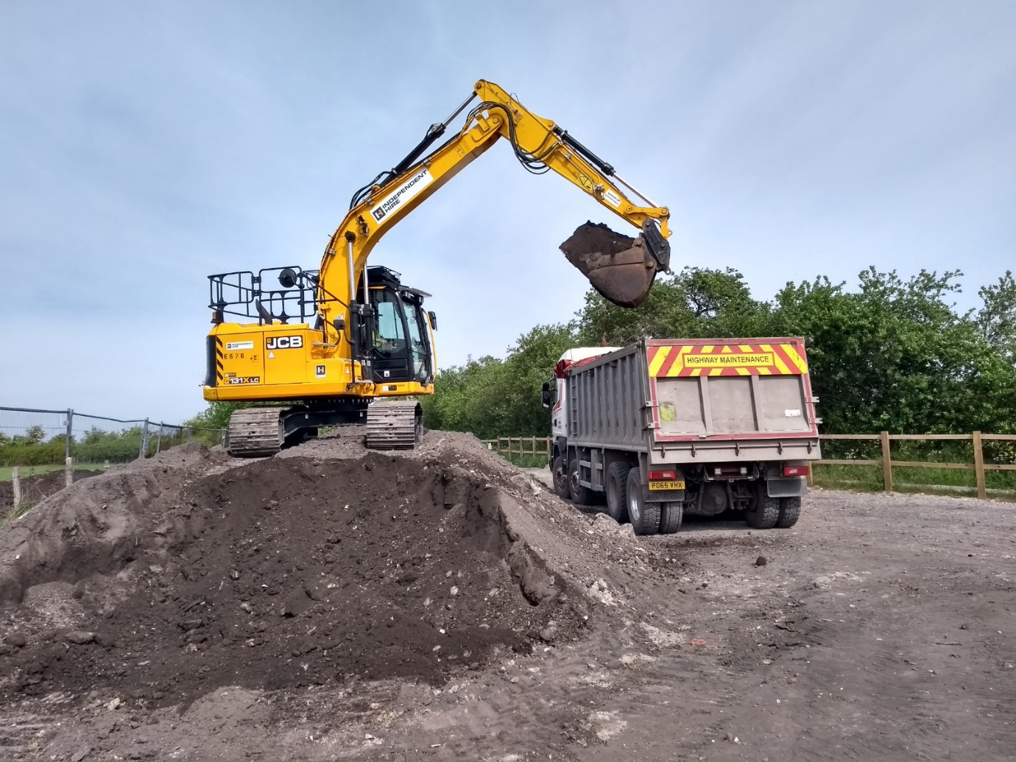

Unexplained water loss Bridge 4a to 4
This month’s work has concentrated on chipping out the brickwork crack we found last month at Whitehouses. While it is by no means clear whether this has anything to do with the water loss to date, it will certainly cause water loss in future unless we repair it. It was worse than we expected; having chipped out some old brickwork, the cracks led to voids which appear to have been dug by rabbits under the Whitehouses walls. Suitable repairs are being discussed with CRT.

[ Continues…

Tidy Friday
We had 7 volunteers. We spent the time at the rear of the winding hole clearing the vegetation, from around all the new trees that we have planted over the last 2 years. We have found that this last lot of trees have a much better survival rate than the previous year’s, around 95% compared with only 75% of the earlier ones. We think this is because until this last year they all came bare root, but now they come as plug plants. John Reynolds has already ordered more for later this year, we hope to continue with the hedge along the fence line between us and the farmer’s field. This will be a project for the tree planting over the next few years, unless anyone has a better idea.
Visit of Kescrg and London WRG
Members of two of the WRG travelling groups jointly visited us over the weekend at the end of our work party. They finished the spoil relocation, extended the towpath fence next to where the spoil now is, further excavated the crack at Whitehouses, and did some final brickwork at repairs at Bridge 4. Thank you!
Next Working Party
Our next working party will be a week late because of the Jubilee, starting on Friday June 10th and running for 7 days. We considered a 2-week work party, but this would have left only a single week’s gap before the July work party which will start Friday July 1st.
By Clive Johnson, Restoration volunteer and Chairman,
On behalf of all the Wendover Canal Trust team leaders and volunteers.

