Operations Report April 2022
Narrows
The weather was variable, with conditions being good enough on Sunday for 26 dumper loads of ash to be removed from the edges of the hole, and stored near the road access. But next day it was so wet that attempts to excavate the narrows had to be abandoned. (And Thursday was very windy).
By the end of Tuesday, we completed excavating the required profile to build a narrow section of canal next to the Little Tring winding hole. On Wednesday, 7 cubic metres of ready-mix concrete was spread across the floor of the excavation as a “blinding” layer. The pictures below show the excavation, and then volunteers laying the concrete.
Bottle diggers continue to disturb our excavation, so to deter them and increase site safety, we have erected a “Heras” steel fence at the top of the ramp down into the hole.
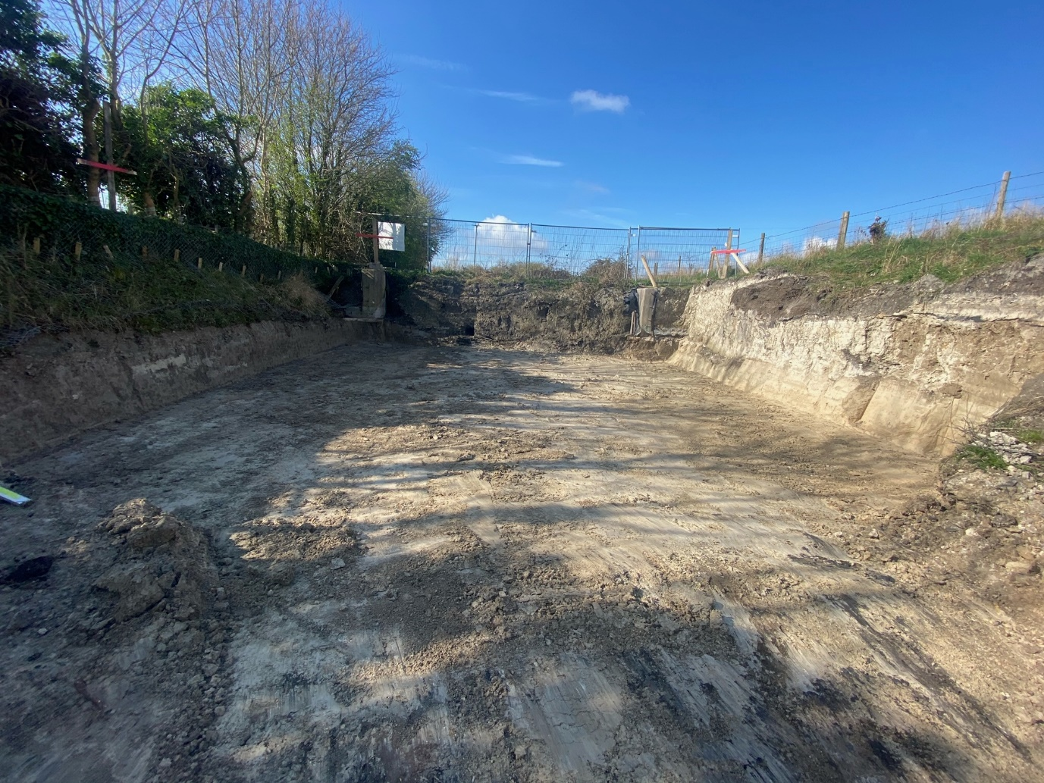
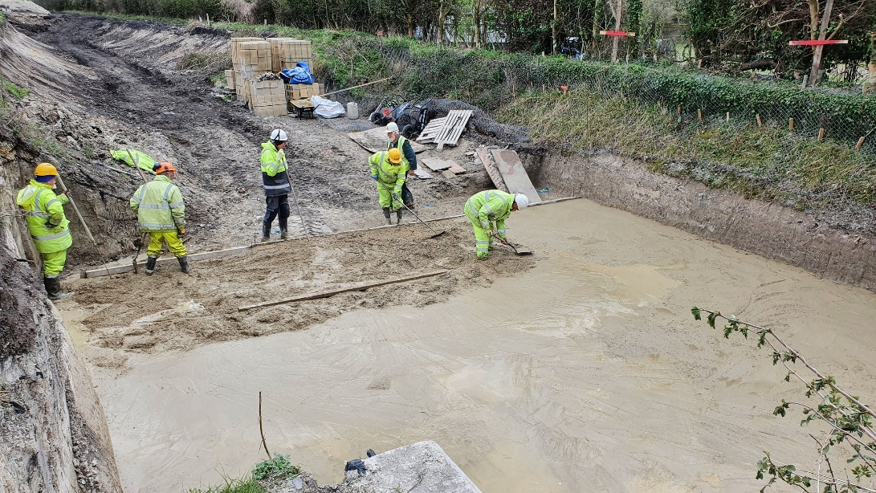
Unexplained water loss Bridge 4a to 4
Our ongoing work has not yet explained the water loss in this section, although there is now some as-yet-incomplete evidence that at least some of the loss is at Whitehouses. Our bunds illustrated last month needed further work because water was running round the ends, so we had to remove some concrete blocks from the side of the canal above each end and replace them with actual concrete. At the end of the work party, there were still some unexplained trickles of water, and work continues.
We found some minor pointing needed at Whitehouses, perhaps from the work done in 2008, and that was done on Tuesday. While tidying the site for this, we were surprised to find a large and long crack along the back of the low-level original brick apron in front of Whitehouses, across the lower front of the arches. It is not yet clear when the crack started, but it seems to have become larger. Initial thoughts were that while this may not explain our current water loss issue, it would certainly leak in future when the water reaches full height. Mikk is consulting CRT on the required repair.
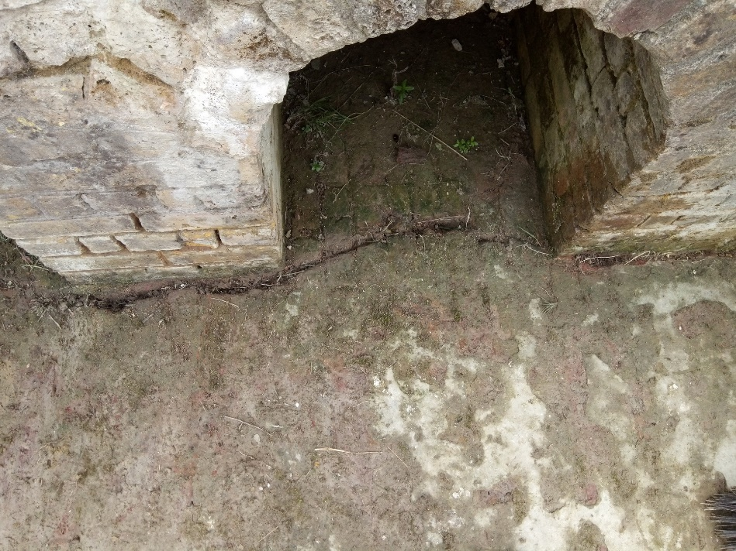
Next Working Party
Our next working party will be a week starting on Friday May 6th followed by a weekend KESCRG visit.
Tidy Friday
We had a good turn-out of 7 people, we planted another 6 trees grown by Steve Bonser, thanks Steve. We are trying to catch up on the work we should have done during lockdown, i.e. clearing around all the trees we have planted in the last 3 years and strimming the area along from Whitehouses back to Bridge 4.
We have managed to bring it back to some sort of order but that 18 months without maintenance really put us behind. Next month we will have to try and sort out the triangle behind the winding hole, we haven't been back in there since we planted the saplings nearly 2 years ago.
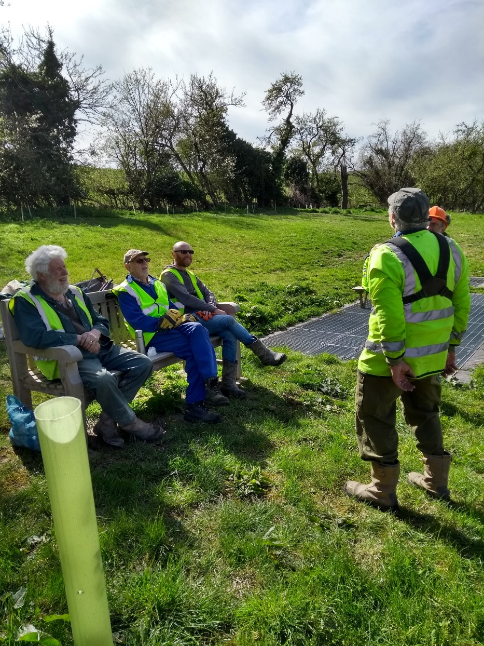
By Clive Johnson, Restoration volunteer and Chairman,
On behalf of all the Wendover Canal Trust team leaders and volunteers.

