Operations Report March 2022
Narrows
We have been excavating the required profile to build a narrow section of canal next to the Little Tring winding hole. A lot of rain on the first day made conditions difficult. By the end of the week ground conditions had improved so much that 23 dumper loads (about 4 lorry loads) were successfully removed.
Around the edges of this hole, we did a lot of manual digging to separate the last of the ash from the coal tar layer underneath – we have to do this so that the ash can be sent away uncontaminated with coal tar. This ash, and any clay we dig out which is not contaminated with coal tar, is stacked in separate piles near the road ready for removal, while anything with coal tar in it is added to the existing separate piles. Being this careful will save us a lot of money in spoil removal.
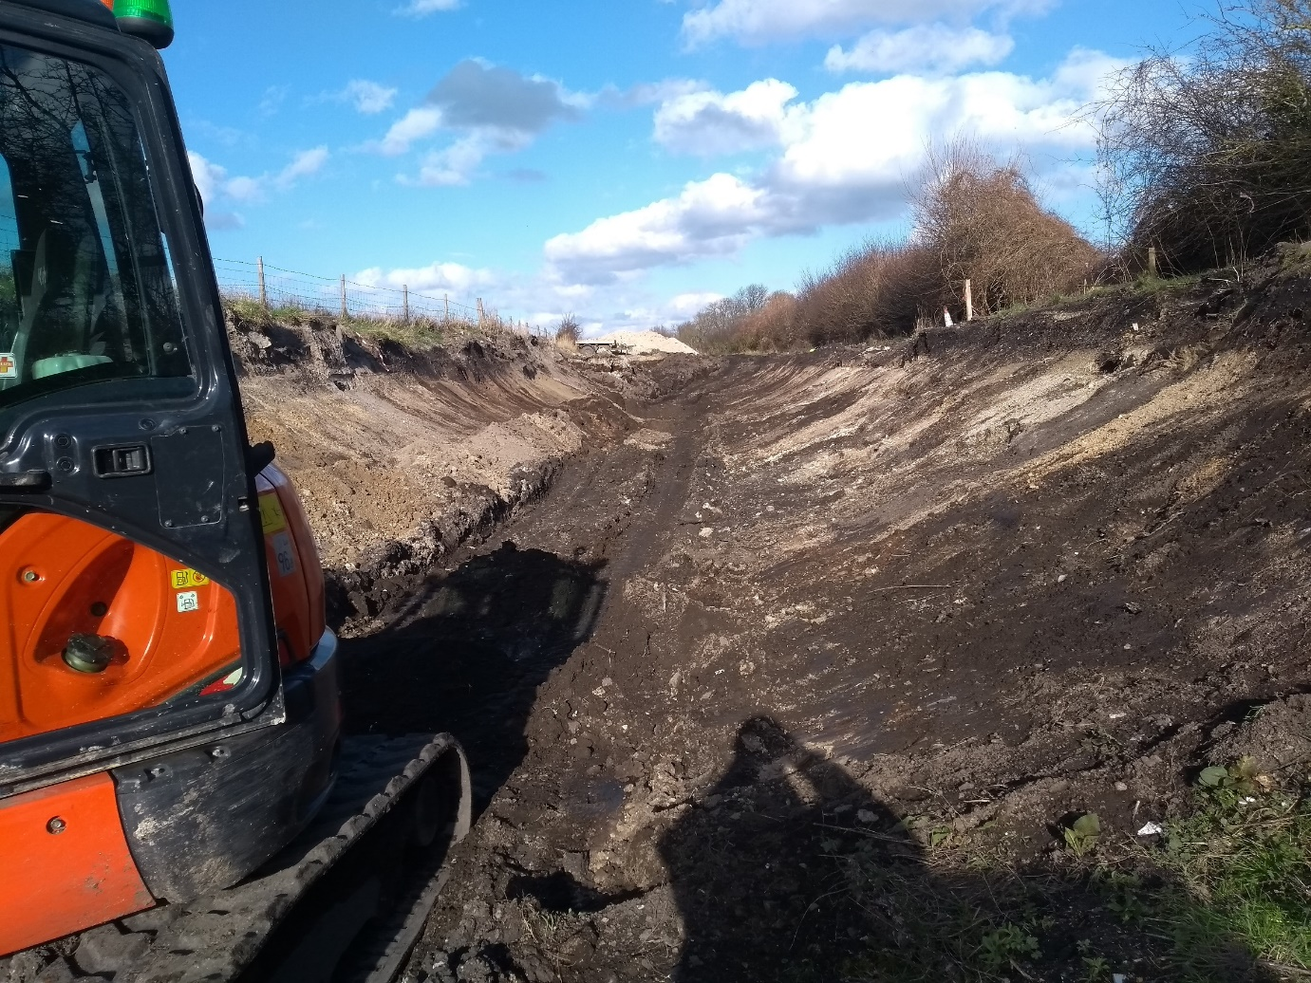

[ Continues…

Unexplained water loss Bridge 4a to 4
Our ongoing work has not yet explained the water loss in this section. We drained it down as far as possible ready for some work. We’d like to know whether one end is losing more water than the other, so this month in the bed of the canal in front of Whitehouses, we constructed temporary block walls either end of the concrete canal bottom (see picture below). We will now be able to put some water back into this section, and find out whether 4a to Whitehouses is losing more or less water than Whitehouses to 4, or even whether the loss is at Whitehouses itself.
Constructing these temporary block walls took much more effort than it sounds, because all materials including well over a hundred heavy concrete blocks, had to be transported along the towpath for the second half of their journey, using a trolley and wheelbarrows. Finally the blocks got a special treat, a slide down a scaffold plank from the towpath into the canal!
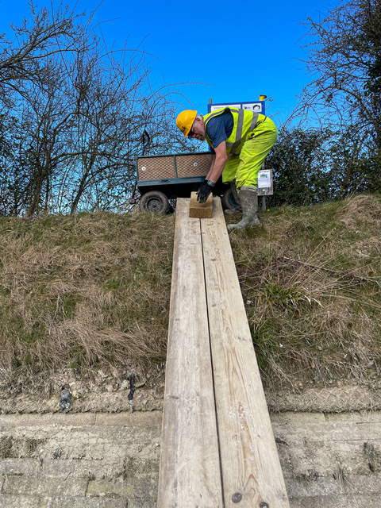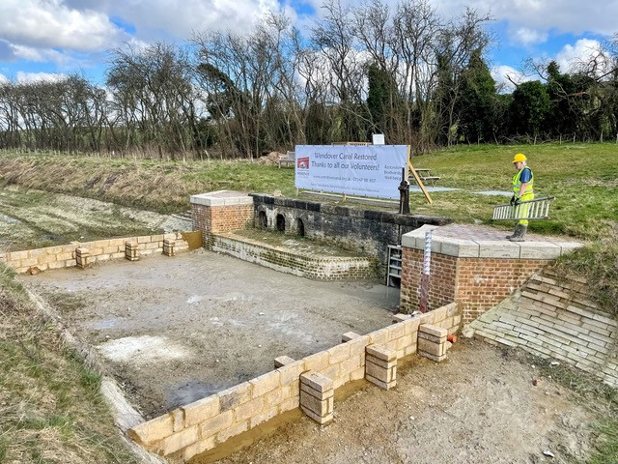
Housekeeping
As with any construction site there are always activities to undertake to keep the site tidy and safe. During the work party the storage and tool huts were tidied, shelves erected and vegetation cut back from our storage shed next to Tringford Pumping Station.
Volunteer Co-ordination
We have set up a new email address volunteer@wendovercanal.org.uk for all offers of help and requests. Our volunteer co-ordinator who uses this email is now Ken Palfrey, thank you Ken, and thank you Doug Pell for managing this for the last few months.
Next Working Party
Our next working party will be a week starting on Friday April 1st (honestly, no jokes please!).

[ Continues…

Tidy Friday
February’s Tidy Friday was not until the 25th due to Storm Eunice. Banners promoting the work of our volunteers were erected by the canal.
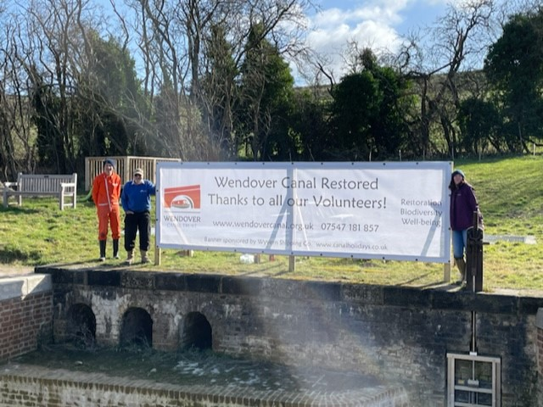
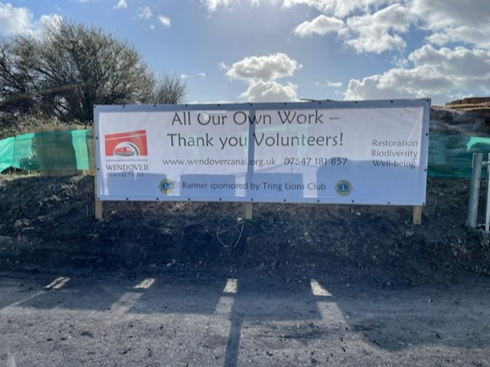
The March Tidy Friday worked in the Pocket Park between Bridge 4 and Whitehouses. Grassy areas were strimmed, and areas around the new trees were cleared to give them room to grow. Tree branches damaged in the storm were cut, gathered and burnt.
By Clive Johnson, Restoration volunteer and Chairman,
On behalf of all the Wendover Canal Trust team leaders and volunteers.

