Operations Report February 2022
As planned, we worked for one week and progressed a number of smaller tasks.
Narrows
Our main activity for the next few months, will be to construct a narrow section of canal (a “narrows”). This will be next to the Little Tring winding hole, which we built in Phase 1 opened 2005. This narrows is necessary to prevent wider boats trying to go any further, since they would not be able to pass any other boat as they go through our relined channel. We have been carefully excavating next to the winding hole, to expose the end of the Phase 1 concrete walls and lining. Pictures by Steve Bonser.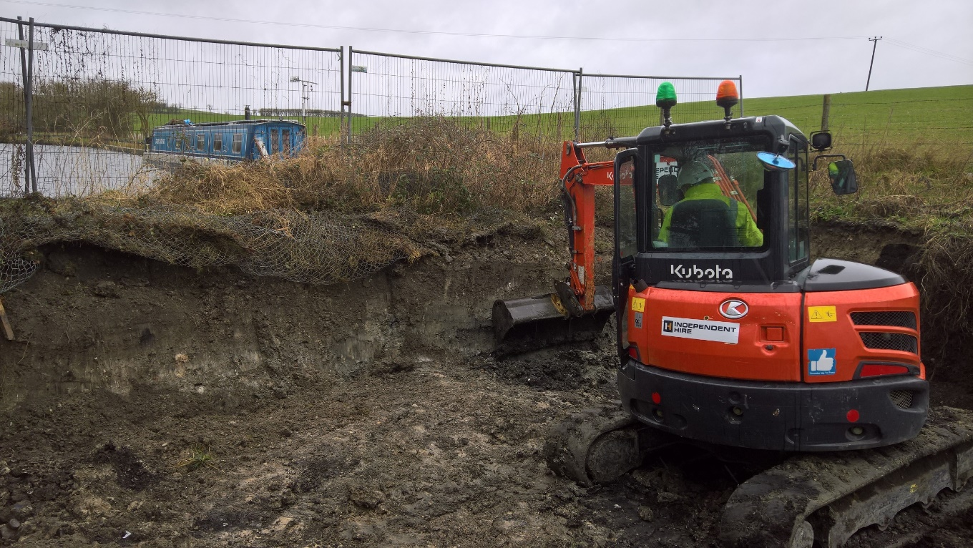
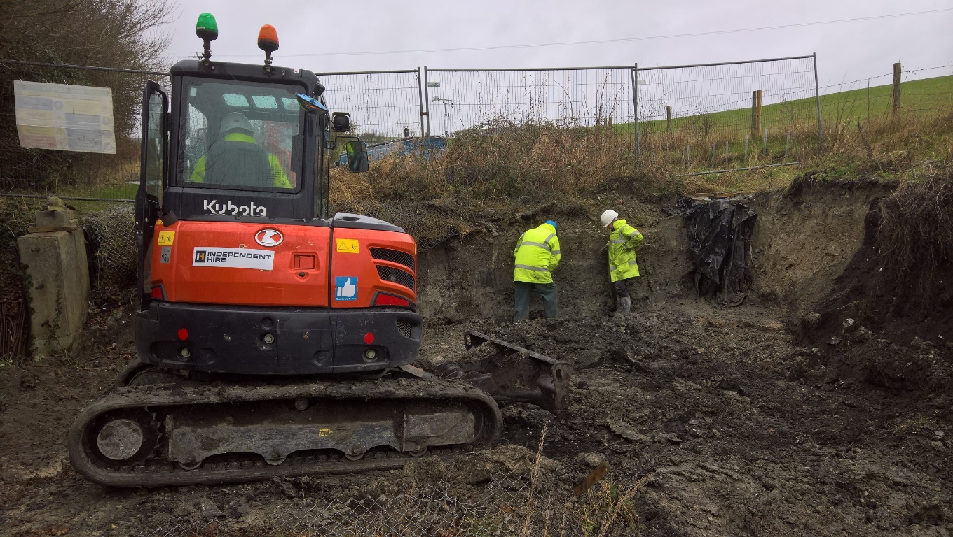
Ash Removal
Just next to the scene above, there was some ash to remove from the site of the planned narrows. Chemical Analysis last year had determined that most of the ash has been found to be non-hazardous (including all the ash removed last month). A small amount of ash in a specific location was found to include a higher lead content . All this material, 6 lorry-loads, was removed for processing at a site near Peterborough. We are not planning any further ash removal in the near future.
Margaret’s Bench
Overlooking this winding hole, there has for some time been an oak tree. This was planted by Margaret Leishman, the wife of our Vice President Roger, who for many years was our Restoration Director. In Margaret’s memory, Roger has now sponsored a bench alongside the oak tree. This is a lovely location to remember Margaret.
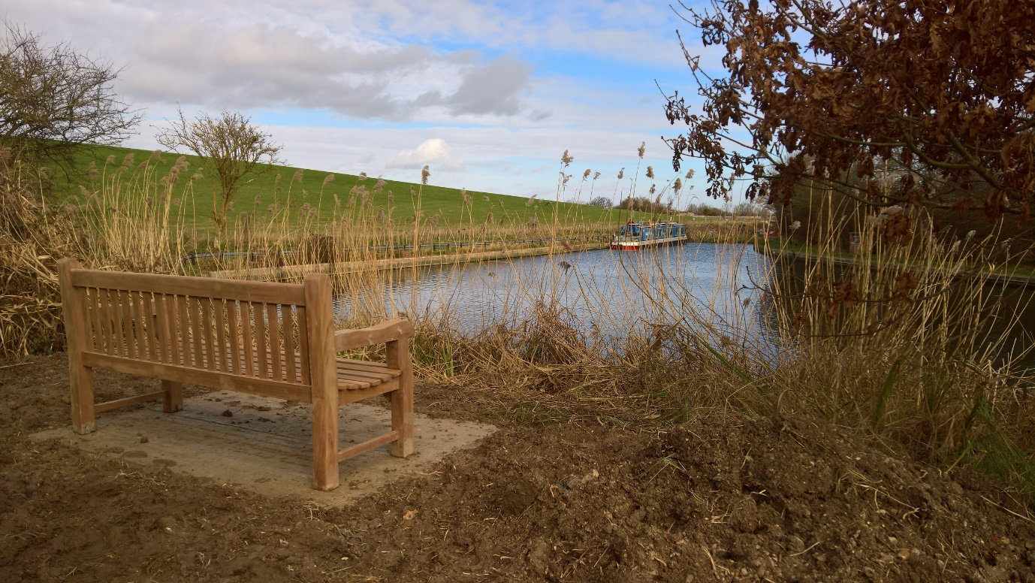

Re-watering from Bridge 4a to 4
Our ongoing work has not yet explained the water loss in this section. Our volunteers have been checking levels most days even when there isn’t a work party. There are some signs that the rate of water loss has reduced, though we don’t know why this should be. Relining remains temporarily paused.
Tringford Hut
Our old wooden hut next to Tringford pumping station has seen little use for many years because we were working elsewhere. It had become overgrown and we had lost track of what was in it. We have been tidying up and ensuring that anything we rediscover is put to good use.
Next Working Party
Our next working party will be a week starting on Friday March 4th, details to be sent to our volunteers.
Tidy Friday
Tidy Friday has been postponed to February 25th due to Storm Eunice, and will be reported next month.
By Clive Johnson, Restoration volunteer and Deputy Chairman,
On behalf of all the Wendover Canal Trust team leaders and volunteers.

