
THE WENDOVER ARM TRUST
ISSUE 82 WORKING PARTY NEWS December 2010

November Working Party

The November Working Party was memorable in that work on the Monday had to be cancelled soon after 9am because of driving rain in freezing conditions. Nevertheless, as you can see below, the blinding for the Stage 2 mooring wall was completed despite rain on the first day, Friday, making it almost impossible to read the level. Great care was taken to lay the blinding to line and level so as to act as a setting out line for the formwork in due course.
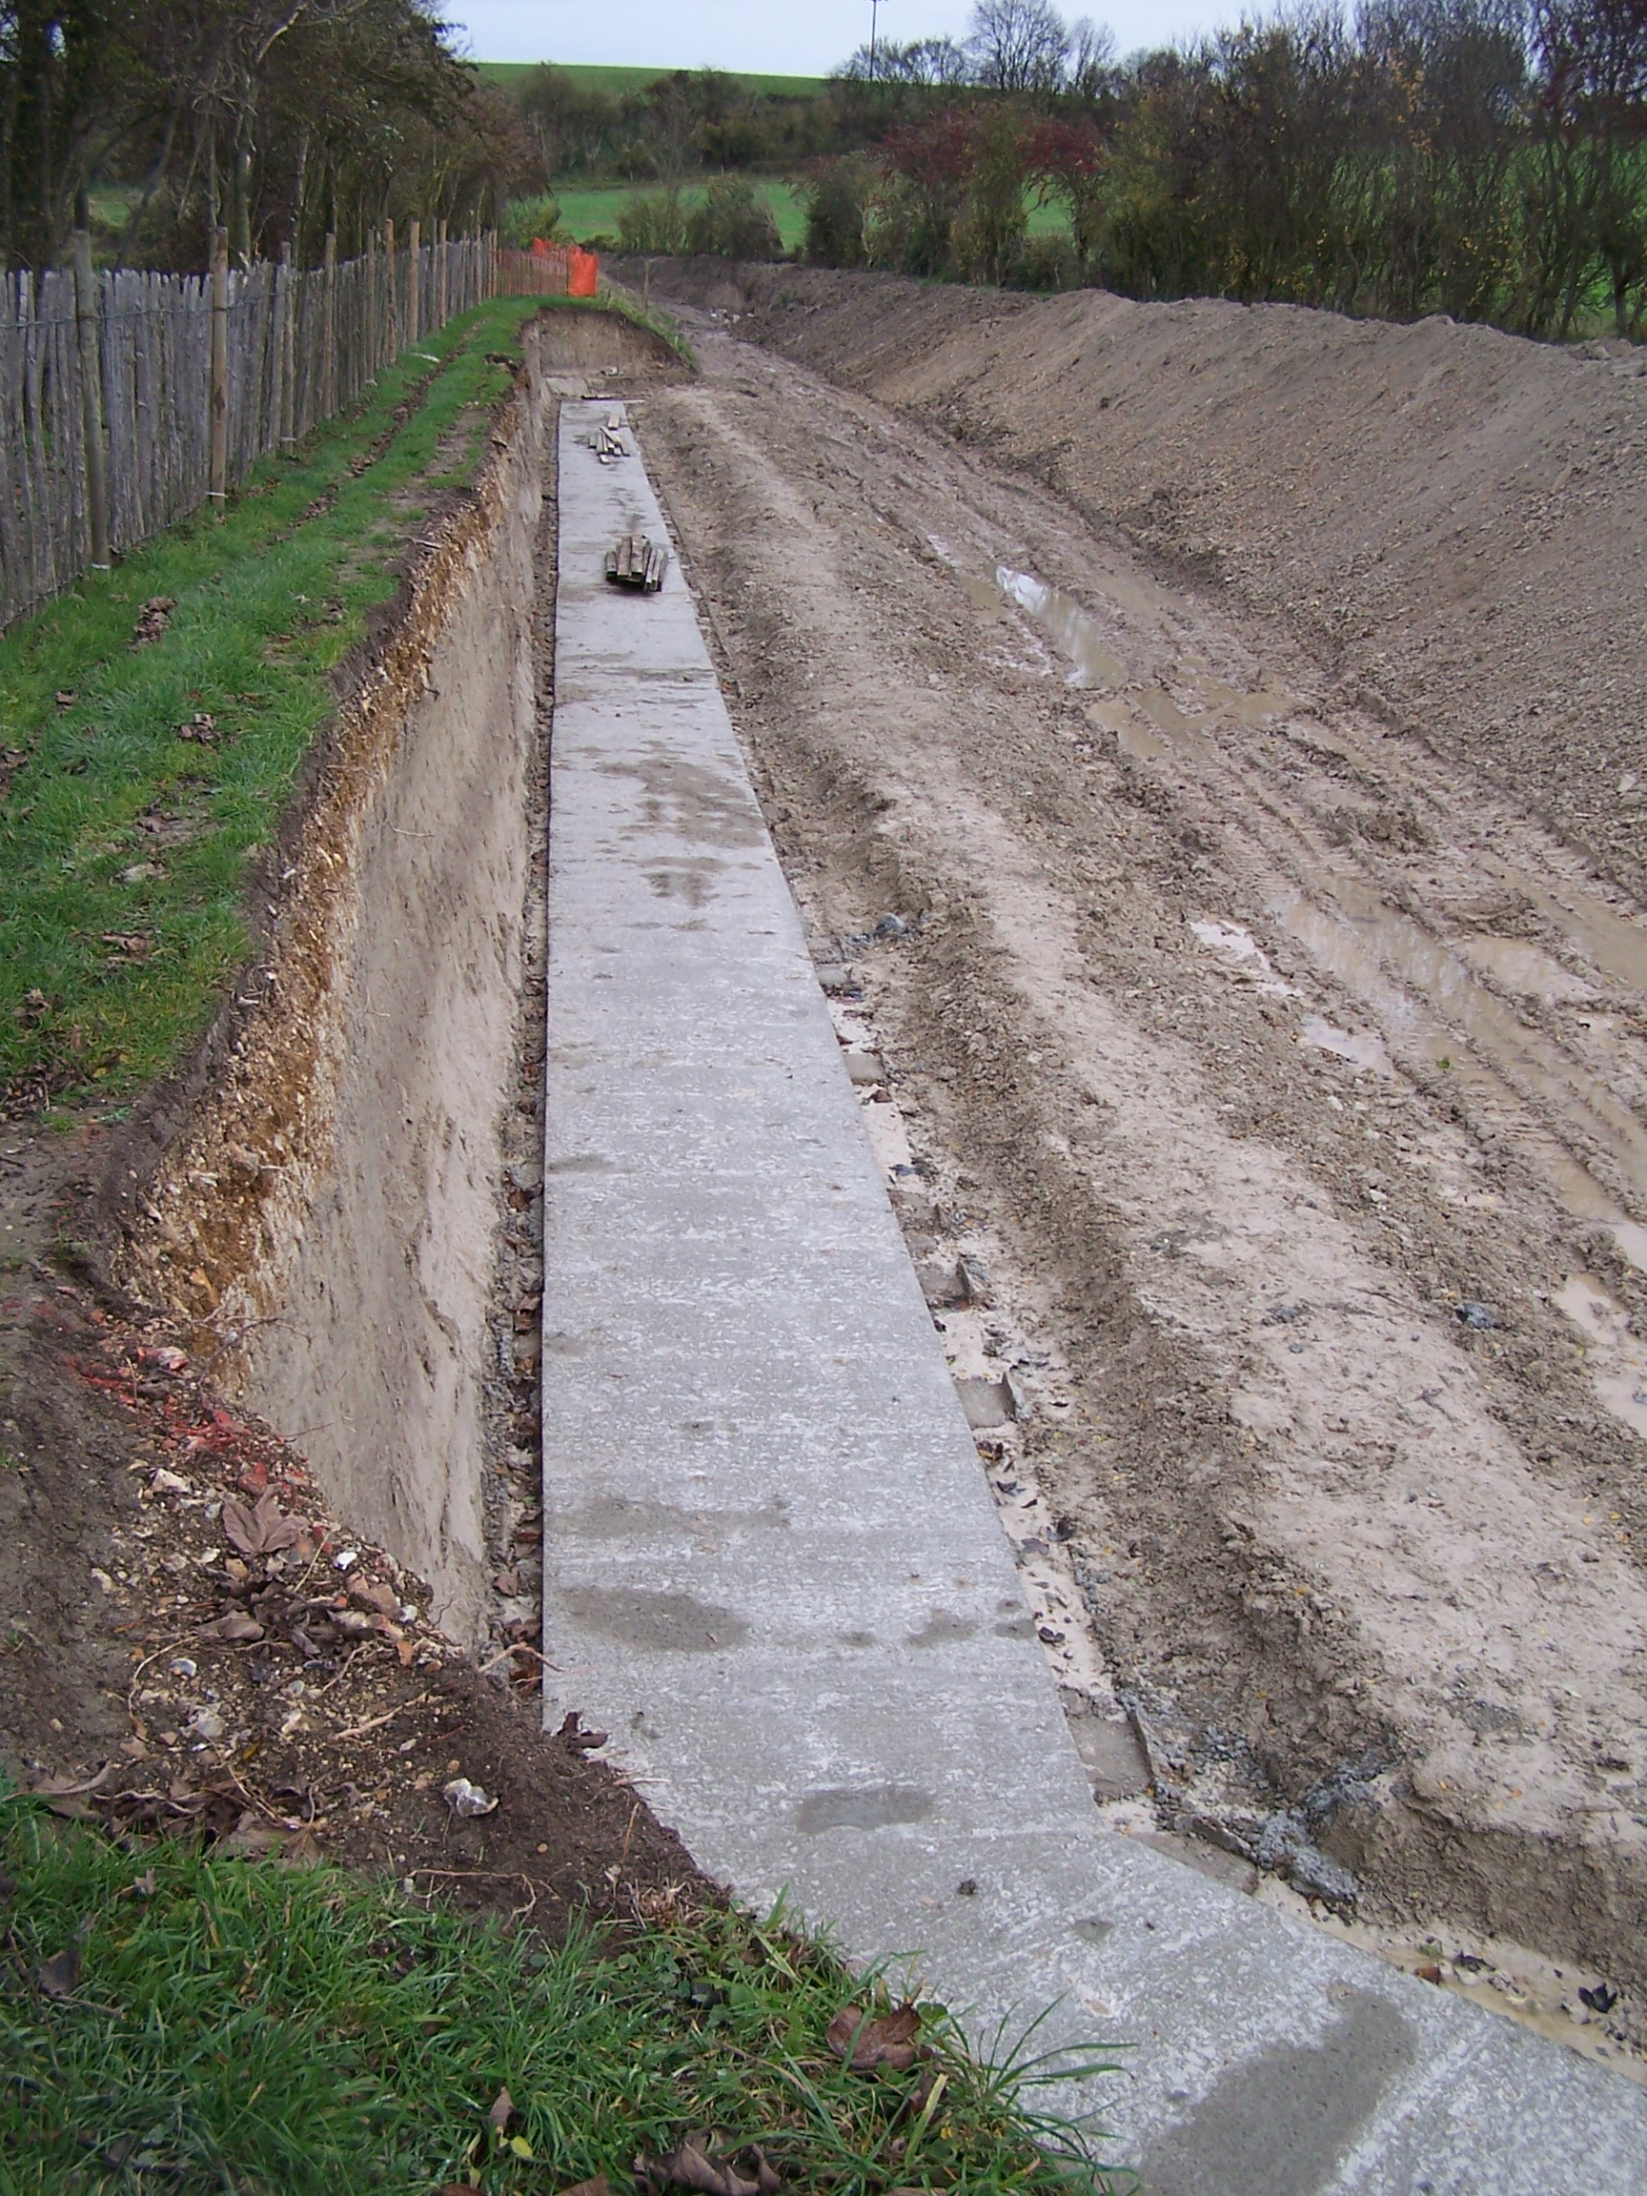
Roger Leishman
BLINDING CONCRETE FOR STAGE 2 MOORING BAY

A Merry Christmas and
A Happy New Year to all our readers

November Working Party (continued)

Work on bulk excavation and pipe capping continued during the working party and some 22 metres of pipe capping completed.

December Working Party

To avoid access problems to the Stage 2 mooring wall caused by the route of the pipe capping now moving over towards the centre of the canal bed it was decided to concentrate on completing the Stage 4 mooring wall at Footbridge 4. Here the blinding for the last 45 degree base was laid and the base formwork laid in position and completed bar one or two fittings on the angle. The formwork for the first (of six) wall pours was also completed, all by the Monday.

On Tuesday work concentrated on pipe capping and more than 30 metres was prepared for concreting on the Wednesday. Due to freezing conditions this was covered up overnight and on the Thursday the formwork removed and the concrete covered in a layer of spoil. The pipe capping is now only 15 metres from the end of Stage 2 but will continue for a further 100 metres into Stage 3 to allow for the next temporary bund to be in the Footbridge 4A narrows.

Completion of this pipe capping will block access to the Stage 2 mooring wall but should be completed by the time the Stage 4 mooring wall is completed and allow work to continue on the Stage 2 mooring wall.

January Working Party

The weather forecasts at present make us wonder if it will be a repeat of last January – heavy snow making work impossible.

Should the weather be reasonable and not freezing, the intention is to pour the first wall and last base sections of the Stage 4 mooring wall. The wall formwork will be moved up ready for another pour and the base formwork taken to the Stage 2 mooring wall if access is possible, otherwise it will be returned to Little Tring for storage.

If possible, work will continue on bulk excavation and pipe capping.

If the weather makes work on the Stage 4 mooring wall and/or pipe capping impossible but is reasonable enough, the intention will be to prepare a car parking area at Little Tring with hardcore and road stone.

February Working Party

Work will depend on what happens in January but will be a continuation of the Stage 4 mooring wall and bulk excavation/pipe capping/car parking.

Aquatic Planting

As you will have read in previous newsletters, it was the intention to plant reeds, rushes etc. above the coir rolls on both banks of all re-watered lengths. This was done for the 60 metres experimental length at Drayton Beauchamp and the plants have flourished.

Earlier this year I was walking along the new diverted length for the Aston Clinton by-pass and was horrified to see that the plants originally planted on both banks had spread across the bed of the canal from bank to bank. Since I observed this, BW have had to bring in a contractor to cut a two metre wide channel through this growth to allow the water from Wendover to flow freely.

This has worried me; the growth has taken seven or eight years to cover the canal bed but Phase II will not be complete for some seven years so could the same thing happen to our newly re-watered lengths? It has therefore been agreed to suspend planting the Phase II banks until we can see what happens in our experimental length.

Geoff Leonard

It was very sad to hear that Geoff Leonard died on December 8th. Geoff joined us after his retirement in April 2009 and was last at a working party in July 2009 since when his health prevented him from taking an active role. His wife, Carolyn, says that he died after a fortnight in hospital but the cause of his death is still unknown. We send her our sympathies at this sudden and unexpected loss. For working party members I have attached details of Geoff’s funeral on Thursday 23rd December but with postal delays this may not reach you in time if you do not have your newsletter by e-mail.

Web Site

The address of the Trust Restoration web site managed by Oliver Revel (that is linked to the main Trust site) is:

http://wendovercanal.org.uk/

The number of e-mail recipients of this newsletter is increasing; please let me know if you wish to join them as it saves me time and the Trust postage/printing costs.

Festival 2011 (late May Bank Holiday)

It is now certain that the Trust will be using land owned by the Box Moor Trust alongside the Grand Union Canal at Hemel Hempstead. Please keep these

dates open, especially the Thursday, Friday, Saturday morning and Tuesday to assist with the setting up/taking down of fencing etc.

General Notes.

All volunteers receive and sign for the Trust’s Restoration Handbook that includes full Health and Safety requirements for the restoration works. The handbook is the property of the Trust; if you leave the working parties for any reason, please return your Handbook to either Ray Orth or myself.

Hard hats for use at all times and high visibility jackets to be worn on sites with mobile plant in use are kept in the store at Tringford and must be drawn/returned there.

One first aid kit is kept in the store; another is kept in the VW Transporter for use on site.

Also available in the Transporter are ear defenders and goggles that must be worn when using strimmers, angle grinders, concrete breakers and the like. BW
will supply gloves and footwear with reinforced toecaps on request. We normally work from 9am to 5pm (or dark if earlier!) when we are hiring plant or taking delivery of ready-mix concrete early in the morning.

There are breaks for morning tea/coffee, packed lunch and afternoon tea/coffee. We take our own food and drink.

DATES FOR WORKING PARTIES

So you can plan your diary ahead, the following are the dates of the main working parties for 2011:

DATE | WORKING AT | WORK TO BE DONE
2011
Friday 7th January to  Thursday 13th January | Stages 2/3/4 | Stage 2/3 pipe capping and stage 4 mooring wall.
Friday 4th February to  Thursday 10th February | Stages 2/3/4 | Stage 2/3 pipe capping and Stage 4 mooring wall.
Friday 4th March to  Thursday 10th March | Stages 2/3/4 | See February 2011 newsletter in due course.
Friday 1st April to  Thursday 7th April | Stages 2/3/4 | See February 2011 newsletter in due course.
Friday 6th May to  Thursday 12th May | Stages 2/3/4 | KESCRG are scheduling to be with us on the Saturday and Sunday.
Thursday 26th May to  Tuesday 31st May | Box Moor,  Hemel Hempstead | Box Moor Canal Festival (Saturday pm/Sunday/Monday).  Working Parties Thursday/ Friday/Saturday am/Tuesday
Friday 3rd June to  Thursday 9th June | Stages 3/4 | As this is the weekend after the Festival it is not yet certain whether this work party will be held. To keep up progress it is hoped that a small number can be available each day, possibly over a reduced number of days, to keep some work in progress.
Friday 1st July to  Thursday 7th July | Stages 3/4
Saturday 6th August to  Sunday 14th August | Stages 3/4 | BITM have suggested coming for a visit in August but the dates are not yet fixed.
Friday 2nd September to  Thursday 8th September | Stages 3/4
Friday 30th September to  Thursday 6th October | Stages 3/4
Friday 4th November to  Thursday 10th November | Stages 3/4
Friday 2nd December to  Thursday 8th December | Stages 3/4

Please note that the January and February working parties may be shortened to five days (Friday to Tuesday) if weather prevents access to Stage 2.

Roger Leishman, Restoration Director. 7 Hall Park, Berkhamsted, Herts HP4 2NU.
(Tel:01442 874536, e-mail rleishman@ukgateway.net)

VOLUNTEER ROSTER FOR JANUARY 2011

Date (2010) | Location | Person/s in charge | Excavator  Driver | Dumper  Drivers | Pipe Capping |  | Mooring Bay
Thu 6th Jan | Plant Delivery | B Barry
Fri 7th Jan | Stage 2  Drayton - Bridge 4A | R Orth | R Orth | B Lansley  B Harris | J Henderson |  |  | B Barry  M Wright
Sat 8th Jan | Stage 2  Drayton - Bridge 4A | R Orth | R Orth | B Harris  J Brooman | B Fletcher  M Wright |  |  | J Reynolds  J Brice
Sun 9th Jan | Stage 2  Drayton - Bridge 4A | R Orth | R Orth | J Brooman  B Fletcher | M Wright
Mon 10th Jan | Stage 2  Drayton - Bridge 4A | R Leishman | P Bowers | B Harris | J Henderson R Leishman | D Cater
Tue 11th Jan | Stage 2  Drayton - Bridge 4A | P Bowers | P Bowers | B Lansley | P Bowers |  |  | J Reynolds
Wed 12th Jan | Stage 2  Drayton - Bridge 4A | R Orth | R Orth | B Lansley |  |  |  | J Reynolds  J Brice
Thur 13th Jan | Stage 2  Drayton - Bridge 4A | R Orth | R Orth | B Lansley | J Henderson  D Cater |  |  | J Reynolds
Fri 14th Jan | Plant Return | J Reynolds |  |  | P Bowers

VOLUNTEER ROSTER FOR FEBRUARY 2011

Date (2010) | Location | Person/s in charge | Excavator  Drivers | Dumper  Drivers |  | Pipe Capping |  | Mooring Bay
Thu 3rd Feb | Plant Delivery
Fri 4th Feb | Stage 2  Drayton - Bridge 4A | R Orth | R Orth | B Lansley  B Harris |  | J Henderson  D Cater |  | B Barry
Sat 5th Feb | Stage 2  Drayton - Bridge 4A | R Orth | R Orth | B Harris  J Brooman |  | B Fletcher |  | R Leishman  J Reynolds
Sun 6th Feb | Stage 2  Drayton - Bridge 4A | R Orth | R Orth | J Brooman  B Fletcher
Mon 7th Feb | Stage 2  Drayton - Bridge 4A | R Leishman |  | B Harris |  | J Henderson  D Cater |  | B Barry
Tue 8th Feb | Stage 2  Drayton - Bridge 4A | P Bowers | P Bowers | B Lansley |  | P Bowers  D Cater |  | J Reynolds  B Barry
Wed 9th Feb | Stage 2  Drayton - Bridge 4A | R Orth | R Orth | B Lansley |  |  | J Reynolds
Thur 10th Feb | Stage 2  Drayton - Bridge 4A | R Orth | R Orth | B Lansley |  | J Henderson  D Cater |  | J Reynolds
Fri 11th Feb | Plant Return | J Reynolds |  |  |  | P Bowers
The name of the person in charge on a particular day/site is printed in italics.
P Bowers 01255 504540 or 07880 744730 R Leishman 01442 874536 or 07850 170858
R Orth 01494 786868 or 07733 092034 R Fletcher 01494 812087
If you have booked in on either of these working parties, please contact Ray Orth or Roger Leishman at least the day before coming to find out the current situation regarding weather conditions on site.

IT IS WITH GREAT SADNESS
CAROLYN LEONARD
ANNOUNCES THE PASSING OF
HER HUSBAND GEOFF LEONARD

WEDNESDAY 8TH DECEMBER

Services are being held on Thursday 23rd December 2010
1PM: Committal
At the Milton Chapel, Chiltern Crematorium, Whielden Lane, Amersham, HP7 0ND

2PM: Service of Thanksgiving

At Christchurch, Chapel Road, Flackwell Heath, High Wycombe, HP10 9AA

Followed by a light buffet in the Church Centre

Dress Code: Smart Casual. Hints of blue would be appreciated, as this was Geoff’s favourite colour

Donations: Flackwell Heath Residents Association
c/o 8 Chapman Lane, Flackwell Heath, High Wycombe HP10 9AZ, marked on the back “In memory of Geoff Leonard”
These will be used to purchase more cherry trees etc to be placed
in the village.

