
THE WENDOVER ARM TRUST
WORKING PARTY NEWS

ISSUE 75 October 2009

September Working Party

Work was concentrated on bulk excavation at Drayton Beauchamp and successfully completed to the end of Stage 1 leaving only the banks to be profiled. The first two base sections of the mooring wall at Drayton Beauchamp were poured with ready-mix concrete and the surplus ready-mix used to lay about 8 metres of Stage 2 pipe capping. Two rolls of Bentomat were also cut to lengths ready for laying.

October Working Party

This was the first time we tried a monthly seven-day working party and was very successful. I am pleased to say that our volunteers responded well to taking days off and we still had an average of ten to eleven volunteers every day (10.3 to be exact but I did not see any incomplete bodies about!).

The extended working party, already scheduled for November and December, has enabled us to

keep on schedule for completing Stage 1 so far. In January we will revert to the normal Friday to Tuesday unless we are seriously behind and a spell of weather in the New Year enables us to complete any major unfinished work.

Ron Pittaway and Mike Wright fixed the two plaques on Little Tring Bridge, one commemorating the bridge opening, replacing the temporary board, the other commemorating the funding of the section between the lock and the bridge by IWA Grand Junction Region local branches.
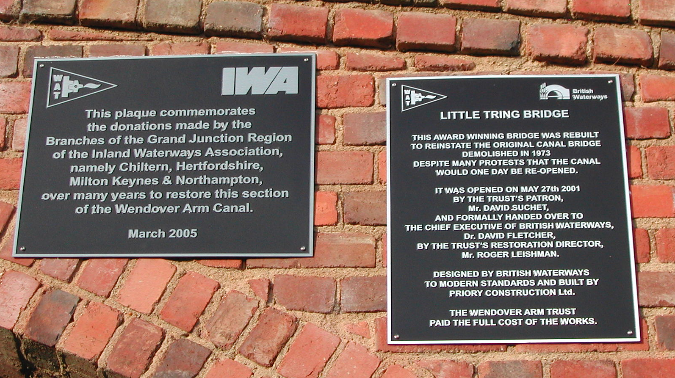
Mike Wright

November Working Party

The aim will be to complete Stage 1 profiling of both banks, extend the Bentomat lining and blocking as far as possible, place spoil on the banks above the coir rolls and extend the bed lining and spoil cover. Spoil from the profiling will be used to cover the lining to start with but when profiling is complete spoil will be taken from excavations to extend the Stage 2 pipe capping.

Deliveries of blocks are being made on the Monday, Tuesday and Wednesday at 9.30am (hopefully) and it is intended to fill the dumpers with solid blocks from these deliveries on each of these days for direct unloading at Drayton Beauchamp.

December Working Party

The aim will be to complete Bentomat lining and blocking of both banks to the end of Stage 1 and complete placing spoil on the banks and line and cover the bed with spoil as far as possible. Should progress be good we might even be able to construct the bund at the end of Stage 1 but this may well have to wait until the January Working Party.

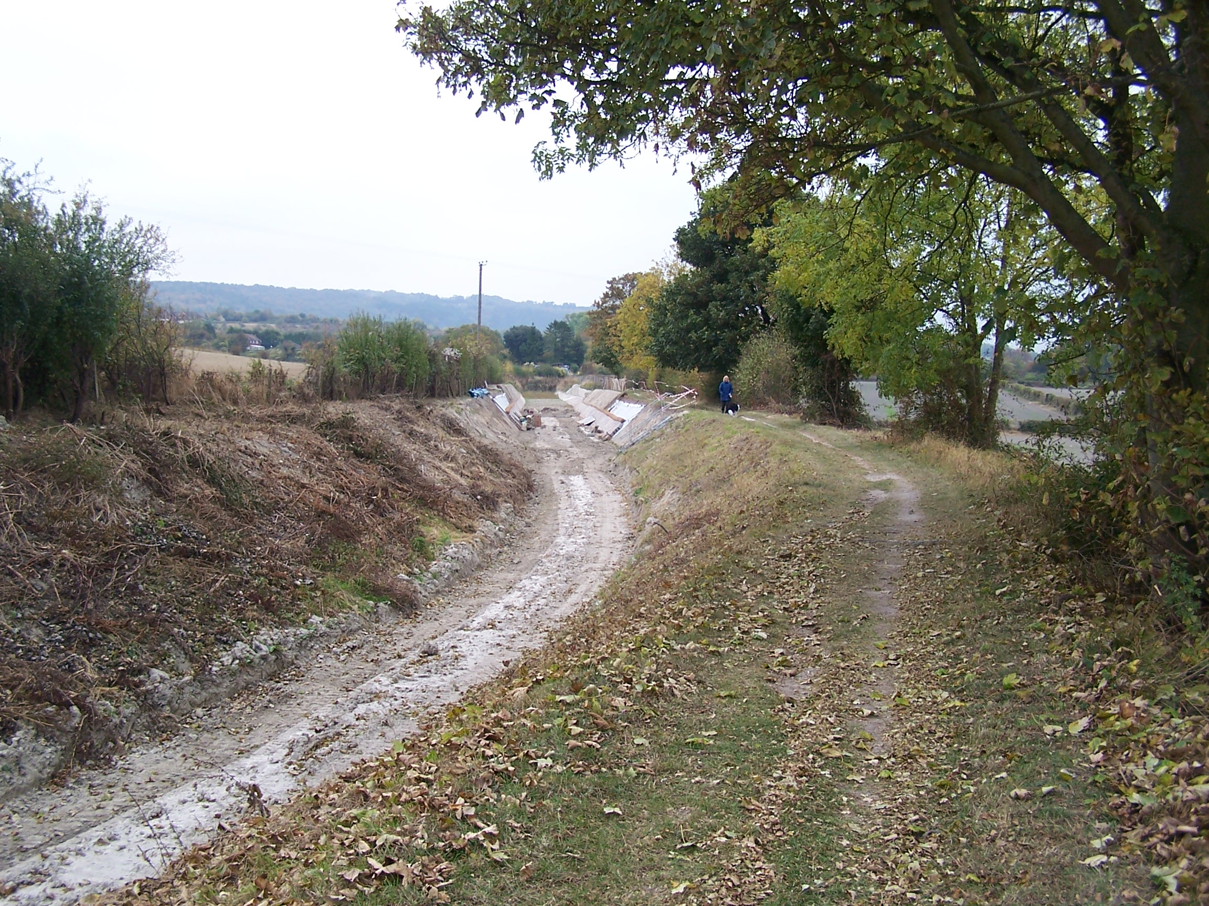
Roger Leishman
THIS PICTURE WAS TAKEN FROM THE SITE OF THE BUND TO BE BUILT AT THE END OF STAGE 1 AND SHOWS HOW CLOSE WE ARE TO COMPLETING THIS STAGE

Thieves about!

Yet another break-in – this time the BW store (where some of our equipment had been placed for more security!) was broken into despite two high security padlocks, a mortise lock and a special chain securing all our equipment together. Two pumps were stolen with a value less than our insurance excess of £250 as the thieves did not take the hoses that cost about as much as the pumps.

Insurance

It is incumbent on anyone, regardless of age, to inform the Trust in writing if they suffer from any medical condition that could in any way affect their ability to carry out their work as a Trust Work Party Volunteer.

Web Site

The address of the Trust Restoration web site managed by Oliver Revel (that is linked to the main Trust site) is:
http://wendovercanal.org.uk/

The number of e-mail recipients of this newsletter is increasing; please let me know if you wish to join them as it saves me time and the Trust postage/printing costs.

General Notes.

All volunteers receive and sign for the Trust’s Restoration Handbook that includes full Health and Safety requirements for the restoration works. The Handbook is the property of the Trust; if you leave the working parties for any reason, please return your Handbook to either Ray Orth or myself. It has now been updated for re-issue to all volunteers. Ray is still awaiting signed receipts for the newly revised handbook from some of us.

Hard hats for use at all times and high visibility jackets to be worn on sites with mobile plant in use are kept in the store at Tringford and must be drawn/returned there.

One first aid kit is kept in the store; another is kept in the VW Transporter for use on site.

Also available in the Transporter are ear defenders and goggles that must be worn when using strimmers, angle grinders, concrete breakers and the like.

Individual volunteers must provide their own gloves and footwear with reinforced toecaps.

We normally work from 9am to 5pm (or dark if earlier!) when we are hiring plant or taking delivery of ready-mix concrete early in the morning.

There are breaks for morning tea/coffee, packed lunch and afternoon tea/coffee. We take our own food and drink.

Six-monthly physical and financial update

You will find this report on the next page. The good news is that Stage 1 is going to be well within budget. This is due to the recent good weather and the fact that Herts County Council have let us tip on their land at the base of the old refuse tip adjacent to Bridge 4A saving a long spoil haul.

WENDOVER ARM CANAL RESTORATION PHASE II

PROGRESS REPORT AS AT 31st OCTOBER 2009

CANAL LINING
Item | Stage 1 | Stage 2 | Stage 3 | Stage 4 | Stage 5 | Stage 6 | Stage 7
Total length | 321m | 350m | 350m | 350m | 350m | 337m | -
Complete to date:
Bulk Excavation | 321m | 75m |  |  |  |  | ---------
Capping to pipe | 321m | 45m |  |  |  |  | ---------
Tipping to offside bank | 321m |  |  |  |  |  | ---------
Tipping to towpath bank | 321m
Profiling offside bank | 231m
Profiling towpath bank | 271m |  |  |  |  |  | ---------
Lining towpath bank | 225m |  |  |  |  |  | ---------
Lining offside bank | 165m |  |  |  |  |  | ---------
Level and line bed | 189m |  |  |  |  |  | ---------
Planting banks | 60m |  |  |  |  |  | ---------
Mooring wall length | 50m | 50m | -------- | 50m | 50m | -------- | 237m
Excavation | 50m |  | -------- | 50m |  | -------- | 10m
Blinding | 50m |  | -------- | 45m |  | --------
Wall base | 50m |  | -------- | 30m |  | --------
Wall upright | 50m |  | -------- | 4m |  | --------
Backfill | 50m |  | -------- |  |  | --------
Estimated Cost | £176,550 | £183,750 | £175,000 | £175,000 | £166,250 | £98,725 | £53,725
Cost to date/final | £110,608 | £5,840 | £361 | £4,315 | £345 | £179 | £390

FOOTBRIDGES & VARIOUS OTHER WORKS
Item | Stage 8 | Stage 9 | Stage 10 | Stage 11 | Stage 12 | Stage 13 | Stage 14
 | Bridge 4 | Bridge 4A | Whitehouses  Weir etc. | Cart track  Narrows  & Weir | Removal  of bunds | Winding  Hole nose | Nuttalls  Bund
Footbridge | 100% | 100% | ---------------- | ----------- | ---------- | ----------- | ----------
Excavation | 100% | 100% | ---------------- |  | ---------- |  | ----------
Blinding | 100% | 100% | ---------------- |  | ---------- |  | ----------
Wall base | 100% | 100% | ---------------- |  | ---------- |  | ----------
Wall upright | 100% | 100% | ---------------- |  | ---------- |  | ----------
Backfill | 100% | 100% | ---------------- |  | ---------- |  | ----------
Weir | --------- | --------- |  |  | ---------- | ----------- | ----------
Heritage work | --------- | --------- |  | ----------- | ---------- | ----------- | ----------
Other work | --------- | --------- | ---------------- | ----------- |  | ----------- | 100%
Estimated cost | £20,000 | £20,000 | £20,000 | £20,000 | £20,000 | £10,000 | £3,500
Cost to date/final | £20,122 | £20,031 | £722 |  |  |  | 3,501

SUMMARY INCLUDING INDIRECT COSTS
 | Lining | F/bridges  & other  works | Clear bed,  & Temp’y  Works | Environ’t  Reports | Materials  In stock | Admin | Tools &  Equip’t | Vehicle | Unallocated | TOTAL
Estimated cost | £1,029,000 | £113,500 | £15,000 | £3,500 | £0 | £25,000 | £5,000 | £10,000 | £49,000 | £1,250,000
Cost to date/final | £122,038 | £44,376 | £13,284 | £3,245 | £29,518 | £11,168 | £2,341 | £5,789 |  | £231,759

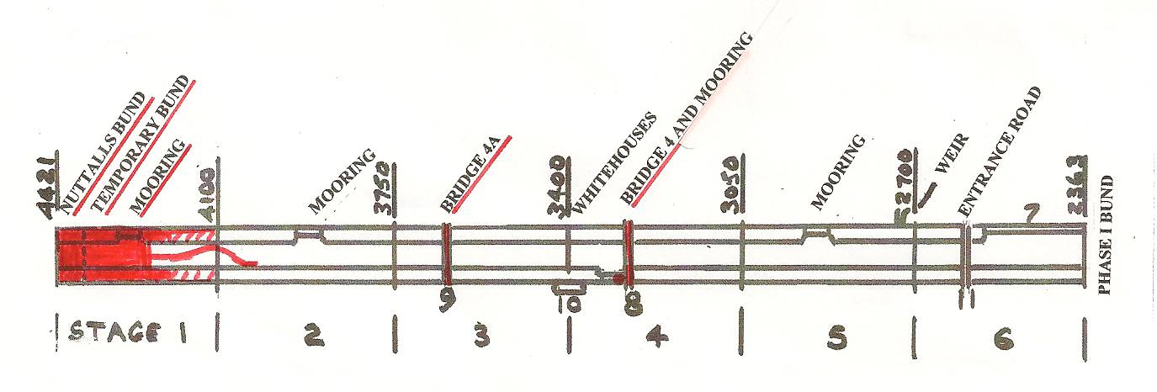

DATES FOR WORKING PARTIES

DATE | WORKING AT | WORK TO BE DONE
2009
Friday 23rd October | Bridge 4 | Stage 4 mooring bay.
Friday 6th November to  Thursday 12th November | Drayton Beauchamp | Profile and line banks of Stage 1.  Place spoil on banks and bed of Stage 1.  Cutting Bentomat.  Continue Stage 2 pipe capping.
Friday 20th November | Bridge 4 | Stage 4 mooring bay unless higher priority work, such as rolling 4 metres Bentomat onto cores, arises.
Friday 4th December to  Thursday 10th December | Drayton Beauchamp | Profile and line banks of Stage 1.  Place spoil on banks and bed of Stage 1.  Form temporary bund.  Continue Stage 2 pipe capping.
2010
Friday 8th January to  Tuesday 12th January | Drayton Beauchamp | Complete any outstanding Stage 1 works.  Continue Stage 2 pipe capping.  Stage 2 scrub clearance on banks.  Stage 4 mooring bay.
Thursday 14th January | Little Tring/Bridge 4 | Stage 4 mooring bay unless higher priority work arises.
Thursday 21st January | Drayton Beauchamp | Stage 2 scrub clearance on banks.
Thursday 28th January | Drayton Beauchamp | Stage 2 scrub clearance on banks.
Friday 5th February to  Tuesday 9th February | Drayton Beauchamp | Complete any outstanding Stage 1 works.  Continue Stage 2 pipe capping.  Stage 2 scrub clearance on banks.  Stage 4 mooring bay.
Thursday 11th February | Bridge 4 | Stage 4 mooring bay unless higher priority work arises.
Thursday 11th March | Drayton Beauchamp | Stage 2 scrub clearance on banks.

Roger Leishman, Restoration Director. 7 Hall Park, Berkhamsted, Herts HP4 2NU.
(Tel:01442 874536, e-mail rleishman@ukgateway.net)

WORK PARTY VOLUNTEER SCHEDULE TO JANUARY 2010

Date (2009) | Location |  | Excavator  Drivers | Dumper  Drivers | Other Volunteers
2009
Fri 23rd Oct | Bridge 4 | P Bowers | N/a | N/a | B Lansley
Thu 5th Nov | Plant Delivery | B Barry
Fri 6th Nov | Drayton Beauchamp | R Leishman/R Orth | R Orth  P Cardy | B Lansley  B Harris |  | J Henderson  R Evans | R Berry
Sat 7th Nov | Drayton Beauchamp | R Leishman/R Orth | R Orth  P Cardy | B Harris  B Fletcher
Sun 8th Nov | Drayton Beauchamp | R Orth | R Orth  P Cardy | B Lansley*  B Fletcher |  | D Ing  A Brown | R Berry
Mon9thNov | Drayton Beauchamp | R Leishman | B Matraves  P Cardy | B Harris  B Ing |  | J Henderson  J Reynolds | N Williams
Tue10thNov | Drayton Beauchamp | R Leishman | B Matraves | B Lansley  B Harris |  | P Bowers  J Henderson  R Berry | J Reynolds  R Evans
Wed11thNo | Drayton Beauchamp | R Orth | R Orth | B Lansley  B Ing |  | J Reynolds
Thu12thNov | Drayton Beauchamp | P Bowers | R Orth | B Lansley  B Harris |  | J Henderson  J Reynolds
Fri 13thNov | Plant Return | J Reynolds
Thu19thNov | Little Tring | P Bowers | N/a | N/a |  | B Lansley
Thu 3rd Dec | Plant Delivery | B Barry
Fri 4th Dec | Drayton Beauchamp | R Leishman/  R Orth | R Orth  P Cardy | B Lansley  B Harris
Sat 5th Dec | Drayton Beauchamp | R Leishman/  R Orth | R Orth  P Cardy | B Harris  B Fletcher
Sun 6th Dec | Drayton Beauchamp | R Orth | R Orth  P Cardy | B Lansley*  B Fletcher |  | B In g
Mon7th Dec | Drayton Beauchamp | R Leishman | B Matraves  P Cardy | B Harris  B Ing
Tue 8th Dec | Drayton Beauchamp | R Leishman | B Matraves | B Lansley  B Harris |  | P Bowers
Wed9th Dec | Drayton Beauchamp | R Orth | R Orth | B Lansley  B Ing
Thu10thDec | Drayton Beauchamp | P Bowers | R Orth | B Lansley  B Harris
Fri 11th Dec | Plant Return | J Reynolds
2010
Thu 7th Jan | Plant Delivery | B Barry
Fri 8th Jan | Drayton Beauchamp | R Leishman/  R Orth
Sat 9th Jan | Drayton Beauchamp | R Leishman/  R Orth
Sun 10th Jan | Drayton Beauchamp | R Orth
Mon11th Jan | Drayton Beauchamp | R Leishman
Tue 12th Jan | Drayton Beauchamp | R Leishman/  R Orth |  | P Bowers
Wed13th Jan | Plant Return | J Reynolds
Thu 14th Jan | Little Tring | P Bowers
Thu 21st Jan | Little Tring | P Bowers
Thu 28th Jan | Little Tring | P Bowers
* Brian Lansley is booked to come but, if we have a full complement of dumper drivers on the Sunday, will take the day off.
Note change of date
The name of the person in charge on a particular day/site is printed in italics.
P Bowers 01255 504540 or 07880 744730 R Leishman 01442 874536 or 07850 170858
R Orth 01494 786868 or 07733 092034 R Fletcher 01494 812087

