
THE WENDOVER ARM TRUST
WORKING PARTY NEWS

ISSUE 74 August 2009

July Working Party

This was very successful as Ray and those who were not away cruising (like me!) were able to profile the 1 in 3 slope at the bottom of the Stage 1 mooring wall and cover it in Bentomat and concrete blocks.

August Working Week (nine days)

Again this was very successful as we had a virtually dry nine days and have now completely finished the restored canal (water and plants excepted) to the east end of the mooring bay as well as being well advanced with the next 15 metres of bank lining and bulk excavation ahead of this.

My grateful thanks to all who toiled at both these working parties with such excellent results especially those who came from afar and stayed locally.
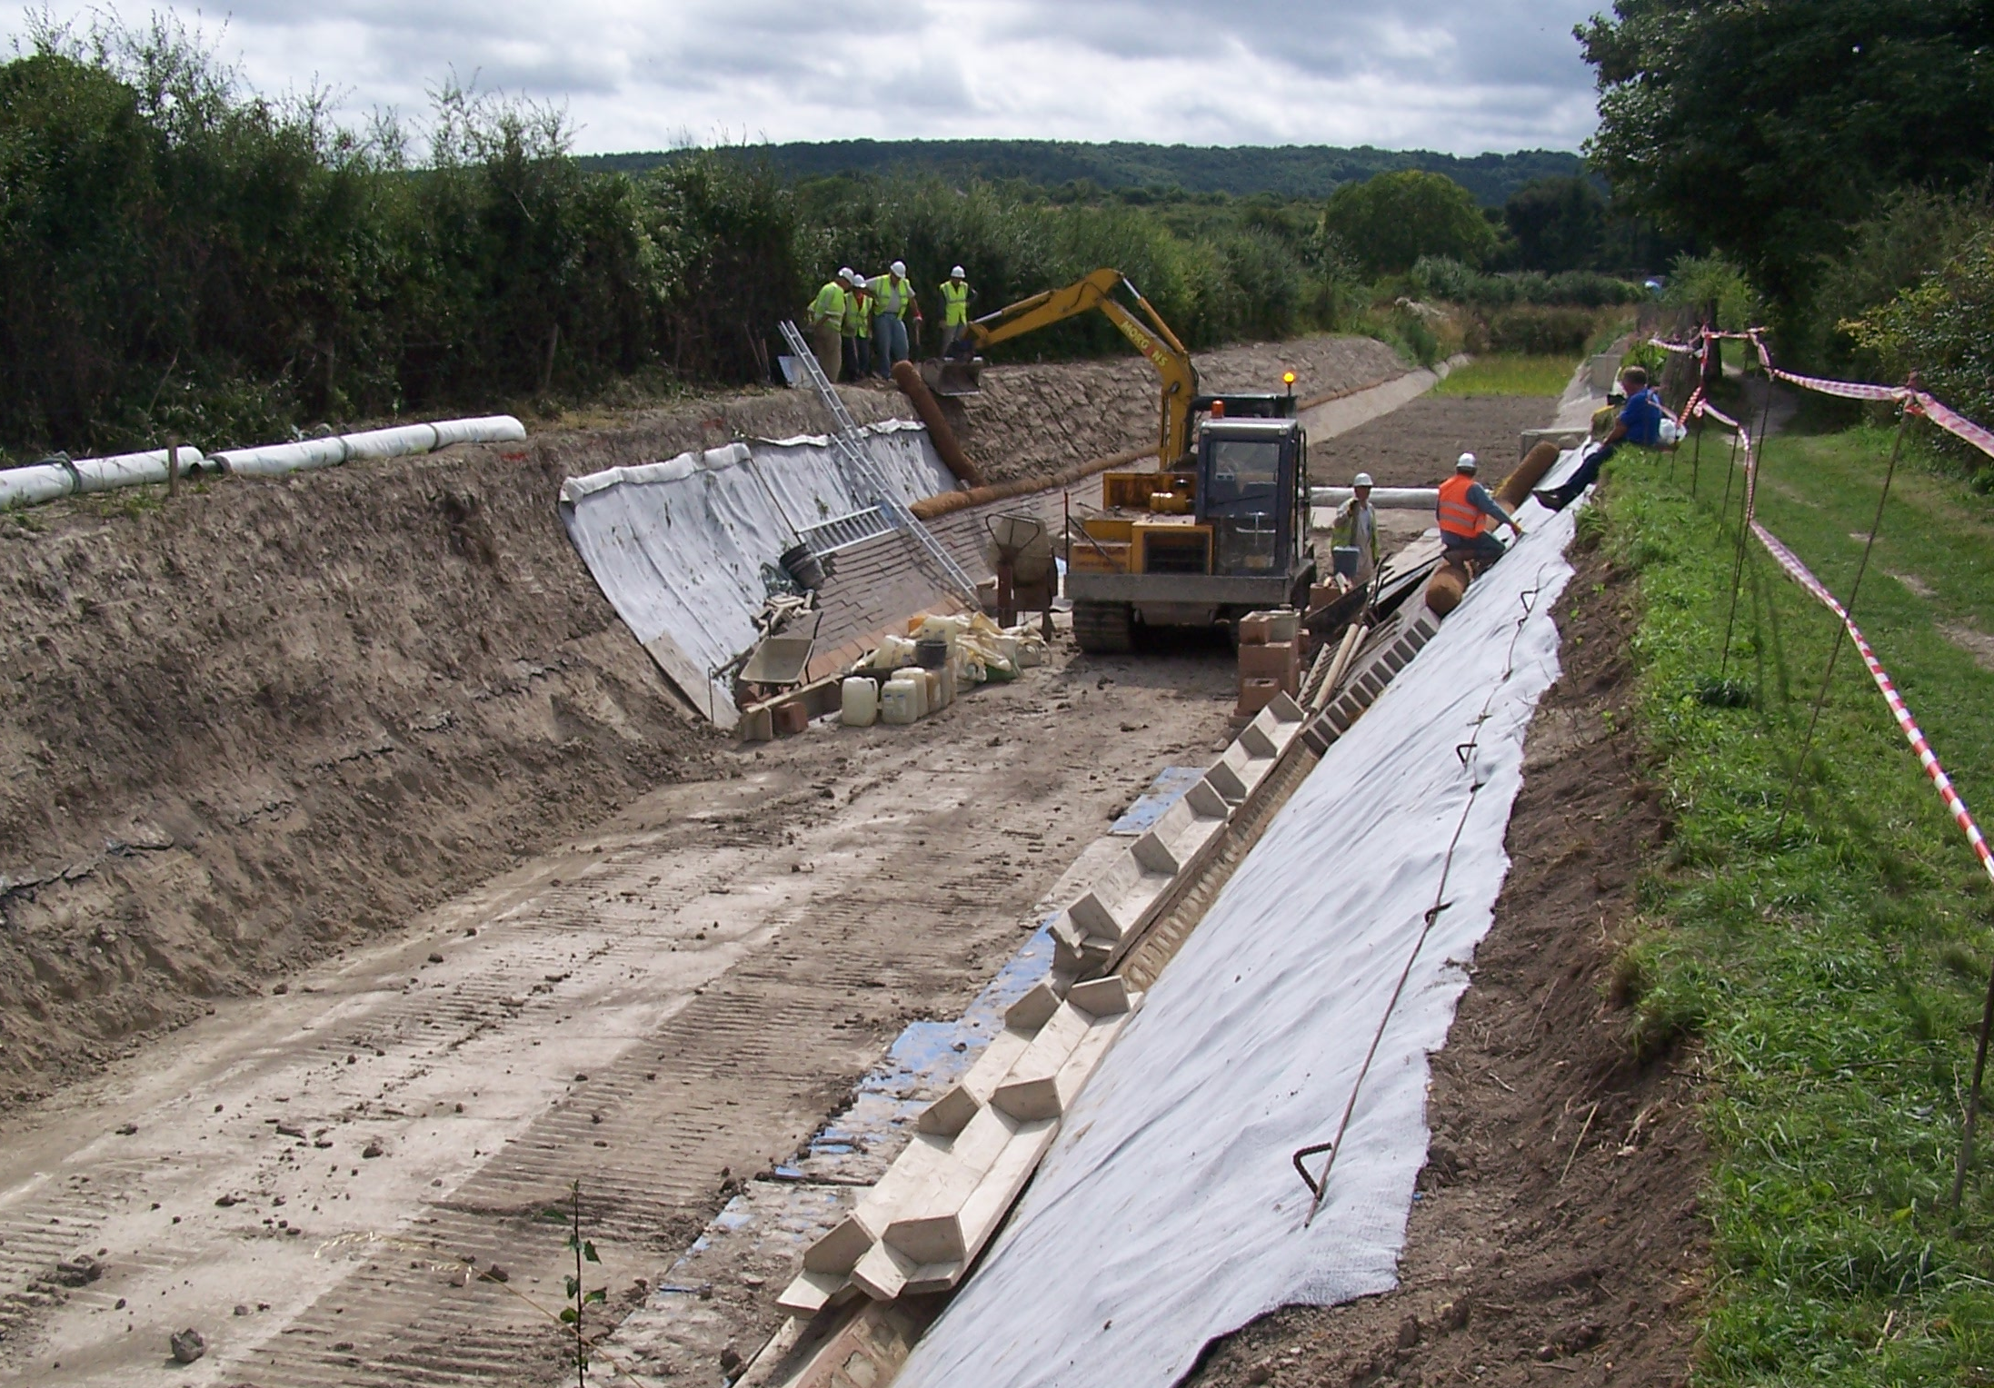
Margaret Leishman
WORK IN PROGRESS, AUGUST 2009

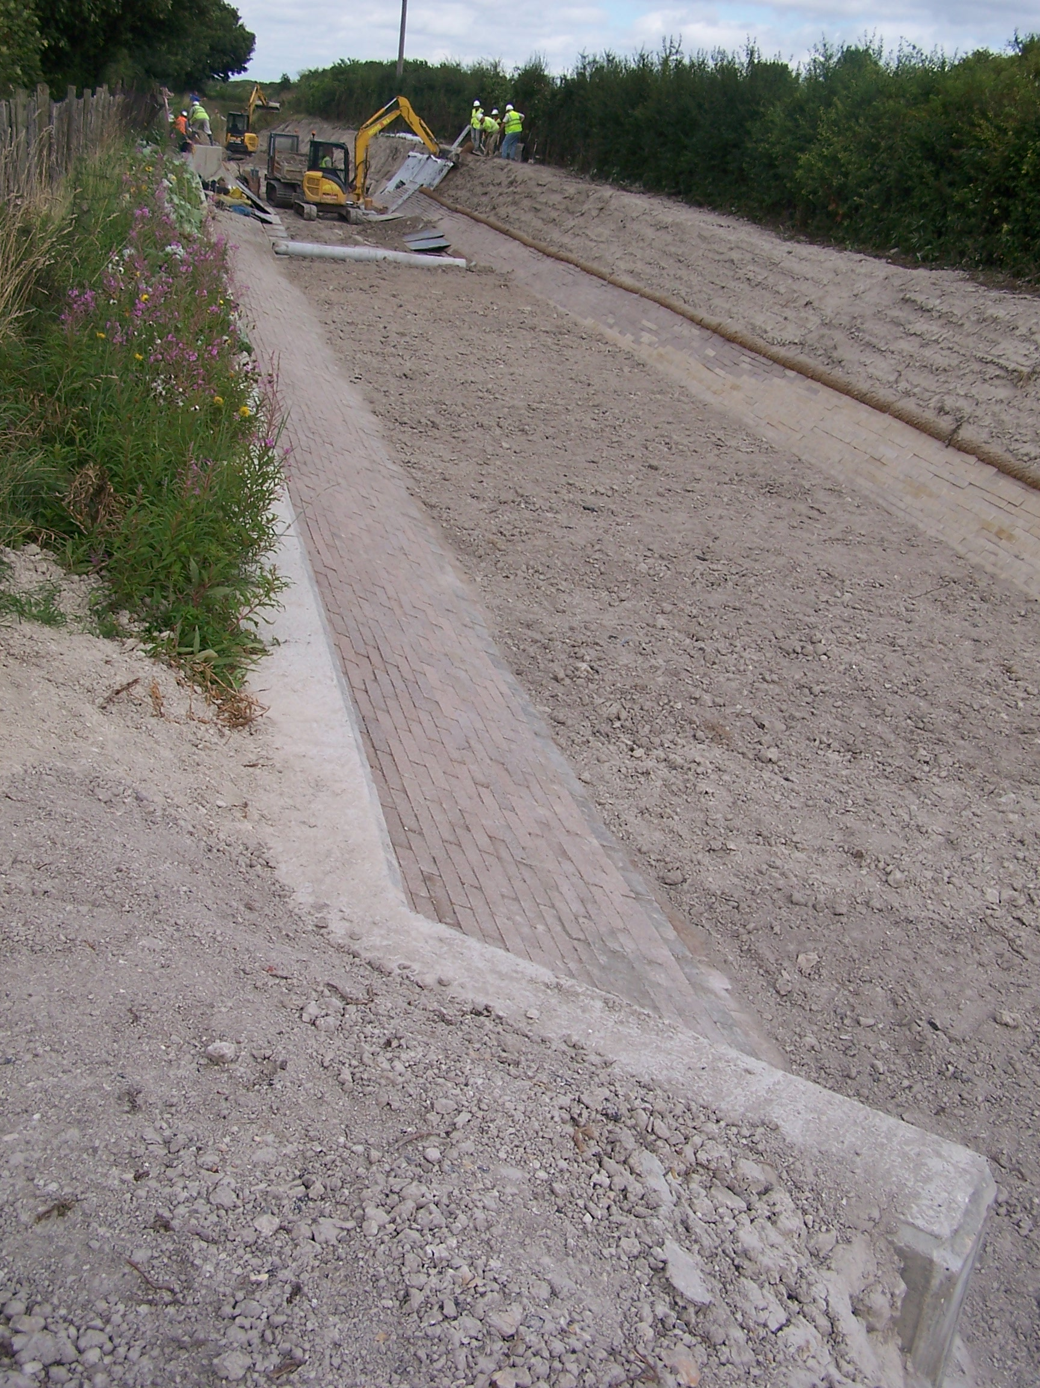
Margaret Leishman
THE COMPLETED MOORING BAY

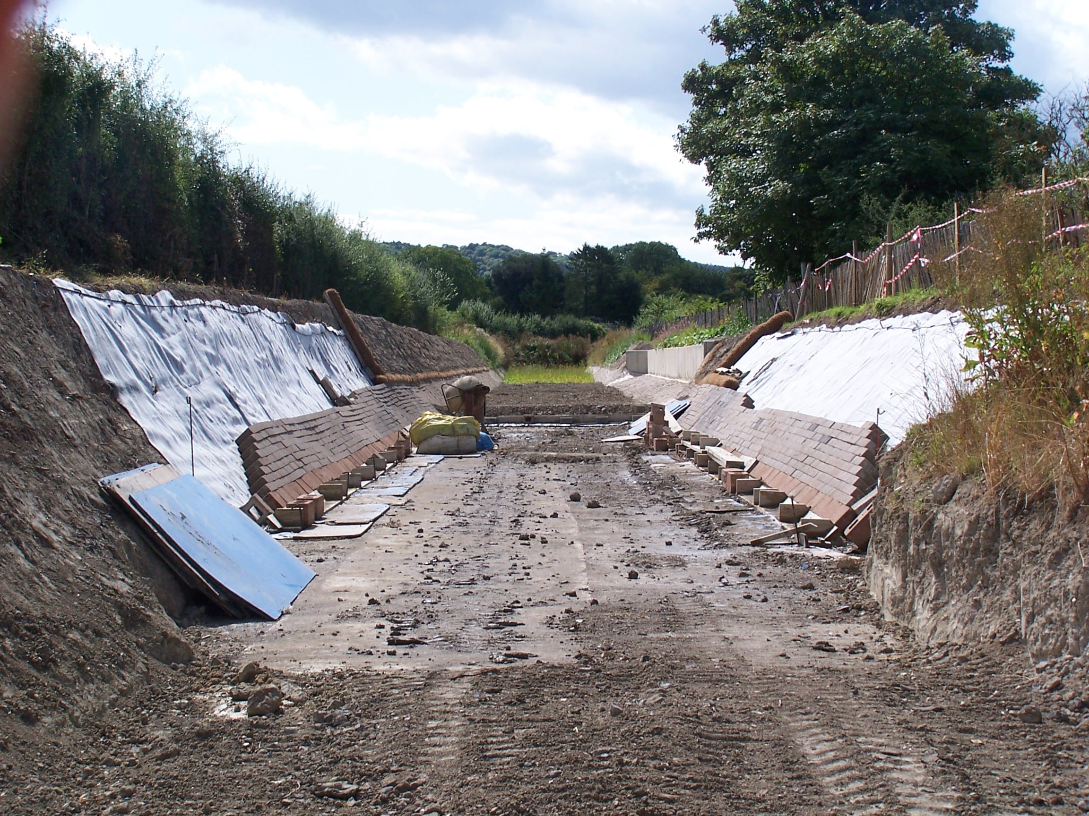
Roger Leishman
PROGRESS BY END OF AUGUST ‘WEEK’

Looking Ahead

There are now about 150 metres of Stage 1 left to profile and line in order to complete Stage 1 with a temporary bund at the end. Our aim is still to complete this in 2009, weather permitting.

The Trust has been very fortunate in welcoming several new working party volunteers recently and we have been considering how to utilise volunteers and plant to the best advantage. One idea that we are going to try out is to extend our five-day weekend by two days. Pete Bowers holds his weekday work party on a Thursday once a month and for the rest of this year his date follows on our five days with a gap of one day. We are going to work this day (Wednesday) in October, November and December but we do not want anyone to work too many consecutive days so, when you ring up or e-mail your availability could you please let us know alternative dates if possible so that we can schedule the required staffing each day, particularly with regard to plant drivers. You will note that Ray, Peter and myself are spreading our attendance.

September Working Party

As both Ray and Phill are away, we are particularly short of excavator drivers; also Brian Lansley is away so we are also short of tracked dumper drivers.

The aim is to complete bulk excavation down to top of pipeline capping for the rest of Stage 1 in order to leave the way clear for profiling and lining during the rest of the year.

Weather permitting we also need to cut a large supply of Bentomat lengths to complete Stage 1 so we are having an 8 ton excavator so that 40m rolls can be placed on the cutting platform first thing in the morning – providing we have enough volunteers for a cutting team.

On the Monday it is intended to pour the first base of the Stage 4 mooring bay at Bridge 4 so the formwork will have to be lined up and made ready. This will allow Pete and his gang on Thursday to strip and re-assemble the formwork for the second base.

Another job that must not be overlooked is continuing with the pipe capping in Stage 2 and it is intended to pour the next length at the same time as the base pour. This has been excavated and screed boards laid but will require cleaning out and laying the DPM and reinforcement.

October/November/December Working Parties

As we have 150 metres of Stage 1 to complete, the aim is to complete 50 metres of bed and bank lining at each of these seven-day work parties. This will be entirely dependant on the weather and availability of volunteers but it would be a great achievement to complete the stage before the weather turns against us in the winter.

Pete Bowers’ weekday Working Parties

Pete has given me some extra dates that you will see in the schedule of dates. Providing higher priority work does not arise, the aim is to continue with the Stage 4 mooring wall. There is also a need during the coming months to control some of the more vigorous saplings that are re-growing on the banks.

Thieves about!

Following the theft in May of equipment from our store at Tringford Pumping Station there was another break in during our working week in August. Ray Orth left the store locked first thing on Monday morning but received a phone call from BW at lunchtime saying the store had been broken into again. An attempt had also been made to break into the BW workshop. Fortunately all our valuable items are now stored elsewhere and only three full petrol cans had been stolen. One of these (empty) and another (not ours) were found on the towpath the next morning.

Have you lost a key ring?

No one has yet claimed the key ring that Ray Orth found on our site at Drayton Beauchamp. Unless it was dropped by an intruder on our working site, it seems likely that it was dropped by one of our volunteers. Please contact Ray if you think that it is yours.

Whitehouses Old Pumping Station

One of our members, Professor Timothy Peters is leading the investigations into the former pumping station at Whitehouses (decommissioned in 1836) and will in due course be reporting his findings and recommendations on preserving the site.

Earlier this year Timothy Peters and Barry Martin made an investigation of the site and Barry was able to take some photos of the underground chambers on the site. These are full of brick rubble, no doubt from the demolition of the two cottages some time after World War II.

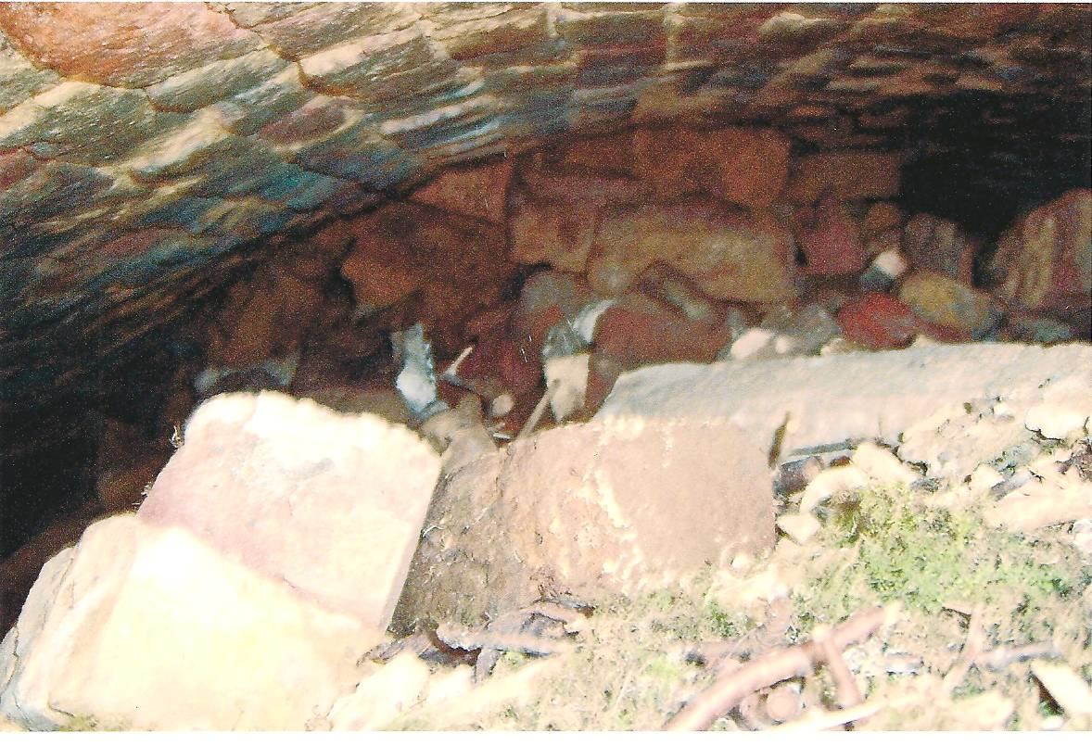
Barry Martin
UNDERGOUND CHAMBER AT WHITEHOUSES

Timothy Peters has been following up the history of the men who constructed the original pumping station and has had valuable information from local sources. We await with interest his findings in due course.

In June Timothy and I visited the site with Industrial Archaeologist Barrie Trinder who is an expert on old stationary steam engines. One conclusion we reached was that an initial excavation to a depth of, say two feet over the site is going to be the best way of determining the general layout of buildings and other structures. This will need to be under expert archaeological supervision and it is hoped that a group interested in this kind of work can be found as the Trust’s volunteers cannot be spared from restoration works for this task. There will be the problem of where to store excavated material that needs to be retained for further examination or re-use.

Another development that has taken place was a survey on the 19th August by the BW Underwater Team to determine where the shaft leading down to the heading to Wilstone Reservoir is located. They found the shaft just under 10m from the paddle gear at right angles to the canal near the cherry tree and covered with a concrete slab.
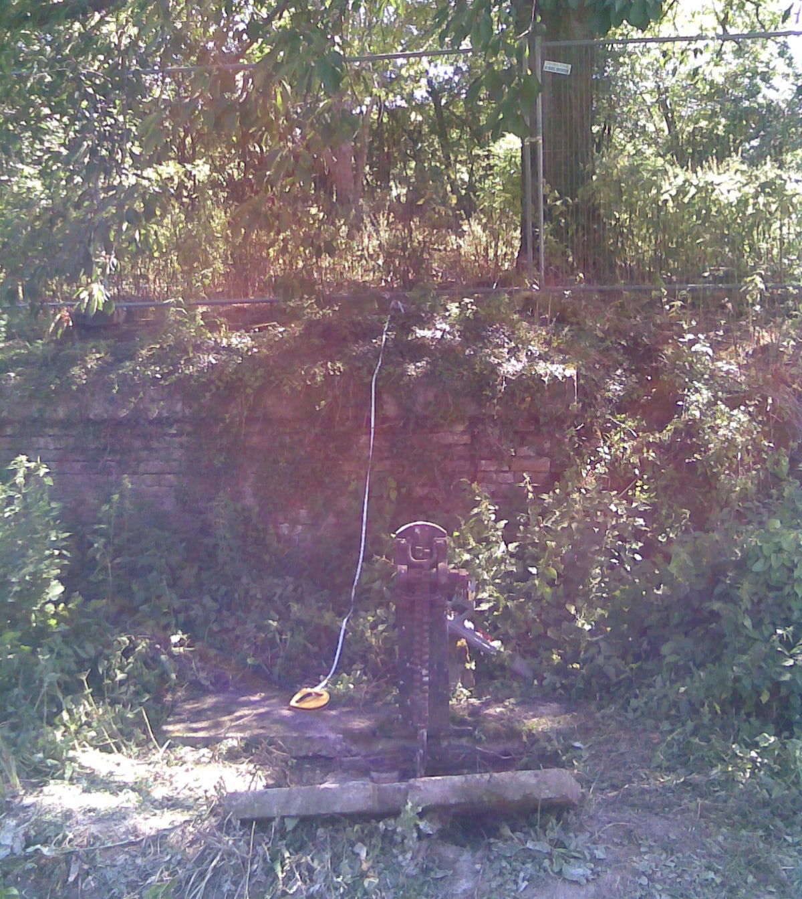
John Kearsey
PADDLE GEAR WITH SHAFT 10m BEHIND

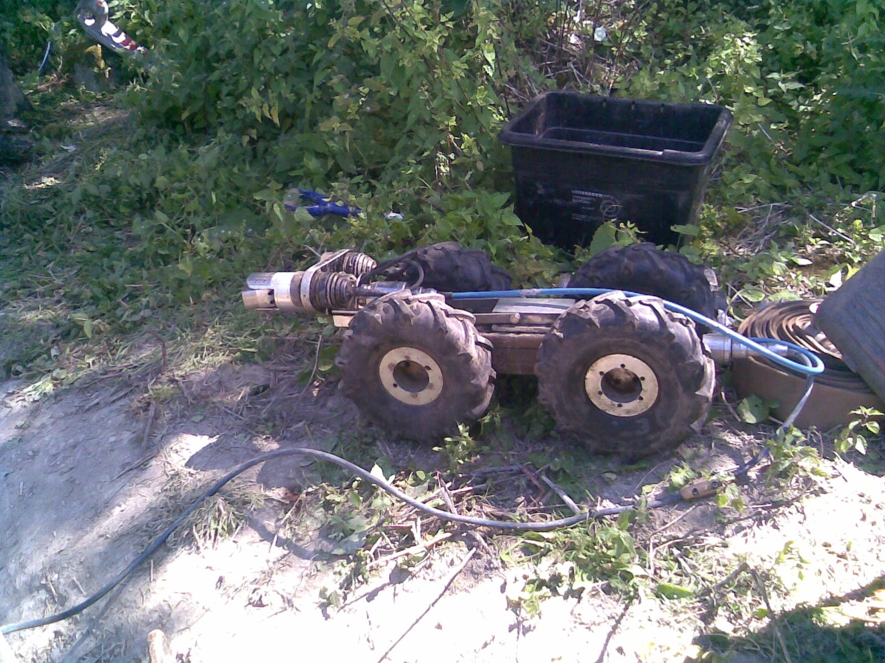
John Kearsey
THE UNDERGROUND (CAMERA) SPY

The good news is that the shaft, brick lined and approximately 1.5m in diameter, appears to be in good condition – after over 200 years!

The area has been fenced off to prevent the public straying onto a hazardous site

Insurance

It is incumbent on anyone, regardless of age, to inform the Trust in writing if they suffer from any medical condition that could in any way affect their ability to carry out their work as a Trust Work Party Volunteer.

Web Site

The address of the Trust Restoration web site managed by Oliver Revel (that is linked to the main Trust site) is:
http://wendovercanal.org.uk/

The number of e-mail recipients of this newsletter is increasing; please let me know if you wish to join them as it saves me time and the Trust postage/printing costs.

General Notes.

All volunteers receive and sign for the Trust’s Restoration Handbook that includes full Health and Safety requirements for the restoration works. The Handbook is the property of the Trust; if you leave the working parties for any reason, please return your Handbook to either Ray Orth or myself. It has now been updated for re-issue to all volunteers.

Hard hats for use at all times and high visibility jackets to be worn on sites with mobile plant in use are kept in the store at Tringford and must be drawn/returned there.

One first aid kit is kept in the store; another is kept in the VW Transporter for use on site.

Also available in the Transporter are ear defenders and goggles that must be worn when using strimmers, angle grinders, concrete breakers and the like.

Individual volunteers must provide their own gloves and footwear with reinforced toecaps.

We normally work from 9am to 5pm (or dark if earlier!) when we are hiring plant or taking delivery of ready-mix concrete early in the morning.

There are breaks for morning tea/coffee, packed lunch and afternoon tea/coffee. We take our own food and drink.

DATES FOR WORKING PARTIES

DATE (2009) | WORKING AT | WORK TO BE DONE
Friday 4th September to  Tuesday 8th September | Drayton Beauchamp | Complete Stage 1 bulk excavation.  Clearance of small trees etc. from Stages 1 & 2 banks.  Cutting/rolling Bentomat (8 x 20m and 62 x 4m rolls are required to complete Stage 1 including those already cut).  Pour Stage 2 pipe capping  Pour first base of Stage 4 mooring bay at Bridge 4
Thursday 10th September | Bridge 4 | Base formwork at mooring bay unless higher priority work arises
Friday 2nd October to  Thursday 8th October | Drayton Beauchamp | Profile and line banks of Stage 1.  Place spoil on banks and bed of Stage 1  (Target to complete 50 metres)
Friday 23rd October | Bridge 4 | Stage 4 mooring bay unless higher priority work arises
Friday 6th November to  Thursday 12th November | Drayton Beauchamp | Profile and line banks of Stage 1.  Place spoil on banks and bed of Stage 1  (Target to complete 50 metres)
Friday 20th November | Bridge 4 | Stage 4 mooring bay unless higher priority work arises
Friday 4th December to  Thursday 10th December | Drayton Beauchamp | Profile and line banks of Stage 1.  Place spoil on banks and bed of Stage 1  Form temporary bund.  (Target to complete 50 metres)

Roger Leishman, Restoration Director. 7 Hall Park, Berkhamsted, Herts HP4 2NU.
(Tel:01442 874536, e-mail rleishman@ukgateway.net)

WORK PARTY VOLUNTEER SCHEDULE TO DECEMBER 2009

Date (2009) |  | Location |  | Excavator  Drivers | Dumper  Drivers | Other Volunteers
Fri 4th Sep |  | Drayton Beauchamp | R Leishman | P Bowers | B Harris  Vacancy  Vacancy | R Berry
Sat 5th Sep |  | Drayton Beauchamp | R Leishman | B Fletcher | B Harris  J Brooman  Vacancy | J Stenhouse
Sun 6th Sep |  | Drayton Beauchamp | B Fletcher | B Fletcher | J Brooman  Vacancy  Vacancy | J Stenhouse  R Berry
Mon 7thSep |  | Drayton Beauchamp | R Leishman | D Wedd | B Harris  B Ing Vacancy | J Henderson  K Ward  J Reynolds |  | Bob Barry  P Lockett
Tue 8th Sep |  | Drayton Beauchamp | R Leishman | P Bowers | B Harris  Vacancy  Vacancy | J Henderson  [R Berry |  | J Reynolds  B Barry
Thu10thSep |  | Bridge 4 | P Bowers | N/a | N/a
Fri 2nd Oct | Drayton Beauchamp |  | R Leishman/R Orth | R Orth  P Cardy
Sat 3rd Oct |  | Drayton Beauchamp | R Leishman/R Orth | R Orth  P Cardy
Sun 4th Oct |  | Drayton Beauchamp | R Orth | R Orth  P Cardy
Mon 5th Oct |  | Drayton Beauchamp | R Leishman | Vacancy
Tue 6th Oct |  | Drayton Beauchamp | R Leishman | Vacancy
Wed 7th Oct |  | Drayton Beauchamp | R Orth | R Orth
Thu 8th Oct |  | Drayton Beauchamp | P Bowers | R Orth
Fri 23rd Oct |  | Bridge 4 | P Bowers | N/a | N/a
Fri 6th Nov |  | Drayton Beauchamp | R Leishman/R Orth | R Orth  P Cardy
Sat 7th Nov |  | Drayton Beauchamp | R Leishman/R Orth | R Orth  P Cardy
Sun 8th Nov |  | Drayton Beauchamp | R Orth | R Orth  P Cardy
Mon9thNov |  | Drayton Beauchamp | R Leishman | Vacancy
Tue10thNov |  | Drayton Beauchamp | R Leishman | Vacancy
Wed11thNo |  | Drayton Beauchamp | R Orth | R Orth
Thu12thNov |  | Drayton Beauchamp | P Bowers | R Orth
Fri 20thNov |  | Drayton Beauchamp | P Bowers | N/a | N/a
Fri 4th Dec |  | Drayton Beauchamp | R Leishman/R Orth | R Orth  P Cardy
Sat 5th Dec |  | Drayton Beauchamp | R Leishman/R Orth | R Orth  P Cardy
Sun 6th Dec |  | Drayton Beauchamp | R Orth | R Orth  P Cardy
Mon7th Dec |  | Drayton Beauchamp | R Leishman | Vacancy
Tue 8th Dec |  | Drayton Beauchamp | R Leishman | Vacancy
Wed9th Dec |  | Drayton Beauchamp | R Orth | R Orth
Thu10thDec |  | Drayton Beauchamp | P Bowers | R Orth
The name of the person in charge on a particular day/site is printed in italics.
P Bowers 01255 504540 or 07880 744730 R Leishman 01442 874536 or 07850 170858
R Orth 01494 786868 or 07733 092034 R Fletcher 01494 812087
WITH ONLY A WEEK TO GO BEFORE THE SEPTEMBER WORKING PARTY I HAVE ONLY HEARD FROM THOSE LISTED ABOVE. IF I CANNOT MAN THE WEEKEND AS PROGRAMMED I WILL HAVE TO CANCEL SOME OF THE HIRED PLANT – PLEASE LET ME KNOW AS SOON AS POSSIBLE IF YOU ARE COMING ON ANY OF THE DAYS. ROGER

