
THE WENDOVER ARM TRUST
WORKING PARTY NEWS

ISSUE 72 April 2009

April Working Party

On the Friday before this working party, Brian Harris and Brian Ing pumped out the worst water holes in the ‘dry’ bed and we were rewarded with a fine weekend that enabled us to work on dry land! Many thanks to the Brians.

Lining of the canal proceeded well and 20 metres of bed lining and 15metres of both banks were lined up to coir roll level and filling above the coir rolls commenced. This latter operation is the slowest and most laborious task we perform – the spoil has to be placed in position and compressed using an excavator bucket but includes a lot of manual effort from the top of the bank. If the spoil is too wet it is very difficult to place, if it is too dry is falls down to the bed of the canal. Any suggestions will be appreciated.
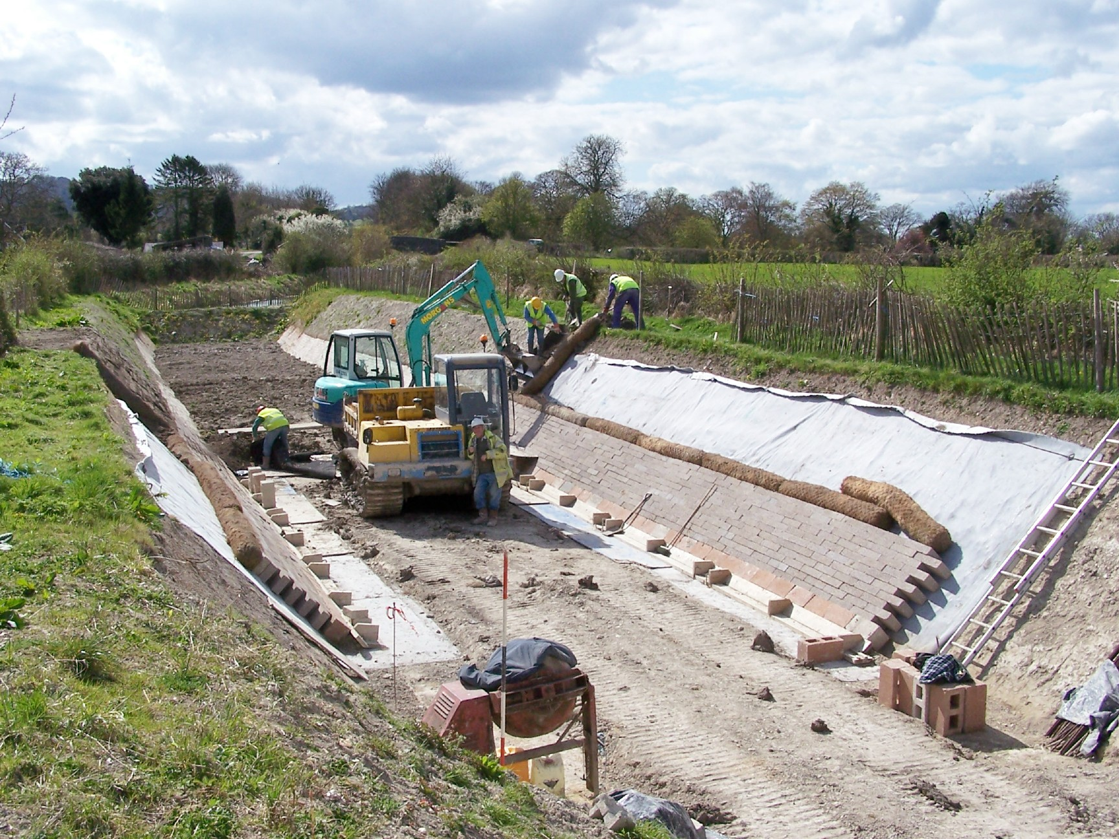
Bert Matraves
LINING AT DRAYTON BEAUCHAMP

The formwork for the last mooring wall pour was completed on Friday ready for a concrete pour on the Saturday and the formwork returned to store by the Tuesday. We did have a problem during the pour when one of the vibrating pokers got tangled in the reinforcement at the bottom of the wall – there were some unusual views of bodies suspended in the narrow formwork as well as worries about the concrete setting before the pour was completed. Eventually, the poker was freed.

On removing the formwork, all was well – there were no imperfections. At Pete Bowers’ Thursday work party, all the tie rod holes were sealed and final backfilling can take place at the May working party. Thus the mooring wall is now complete except for some backfilling and the work required to blend the end wing walls into the adjacent bank lining.
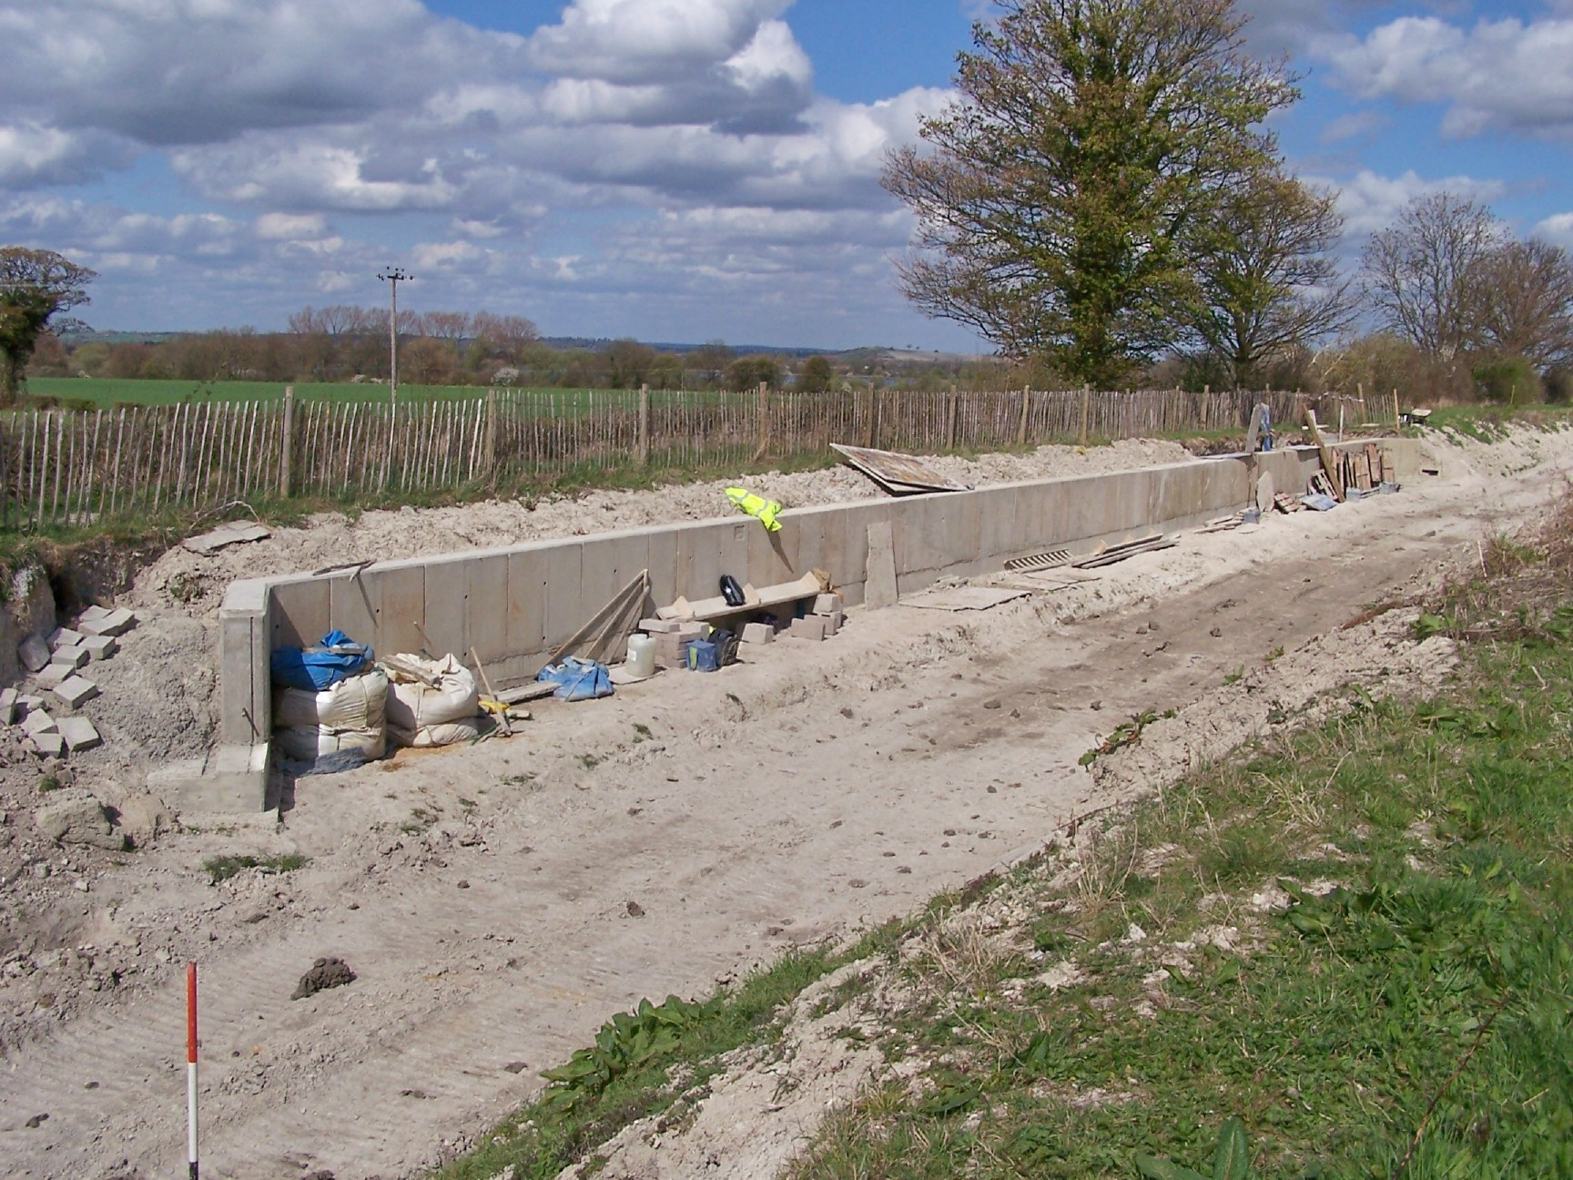
Bert Matraves
STAGE 1 COMPLETED 50m MOORING WALL

May Working Party

The final wall section of the Stage 1 mooring wall will be backfilled and the bank leading to the wing walls blended in at each end. The surplus concrete already used at the wing walls will be covered by hardcore or crushed concrete,

probably finished off with a weak concrete surface formed to support the Bentomat and block lining to avoid settlement.

The offside bank will be graded to final profile with the intention of lining this length for the public to see work in progress over the Festival weekend.

On Friday the line and level of the blinding for the mooring wall at Bridge 4 will be set out ready for Saturday and Sunday when we will be joined by KESCRG. They will be given the task of laying the 50 metres long blinding for the Stage 4 mooring bay that is an extension of the Bridge 4 offside wing wall.
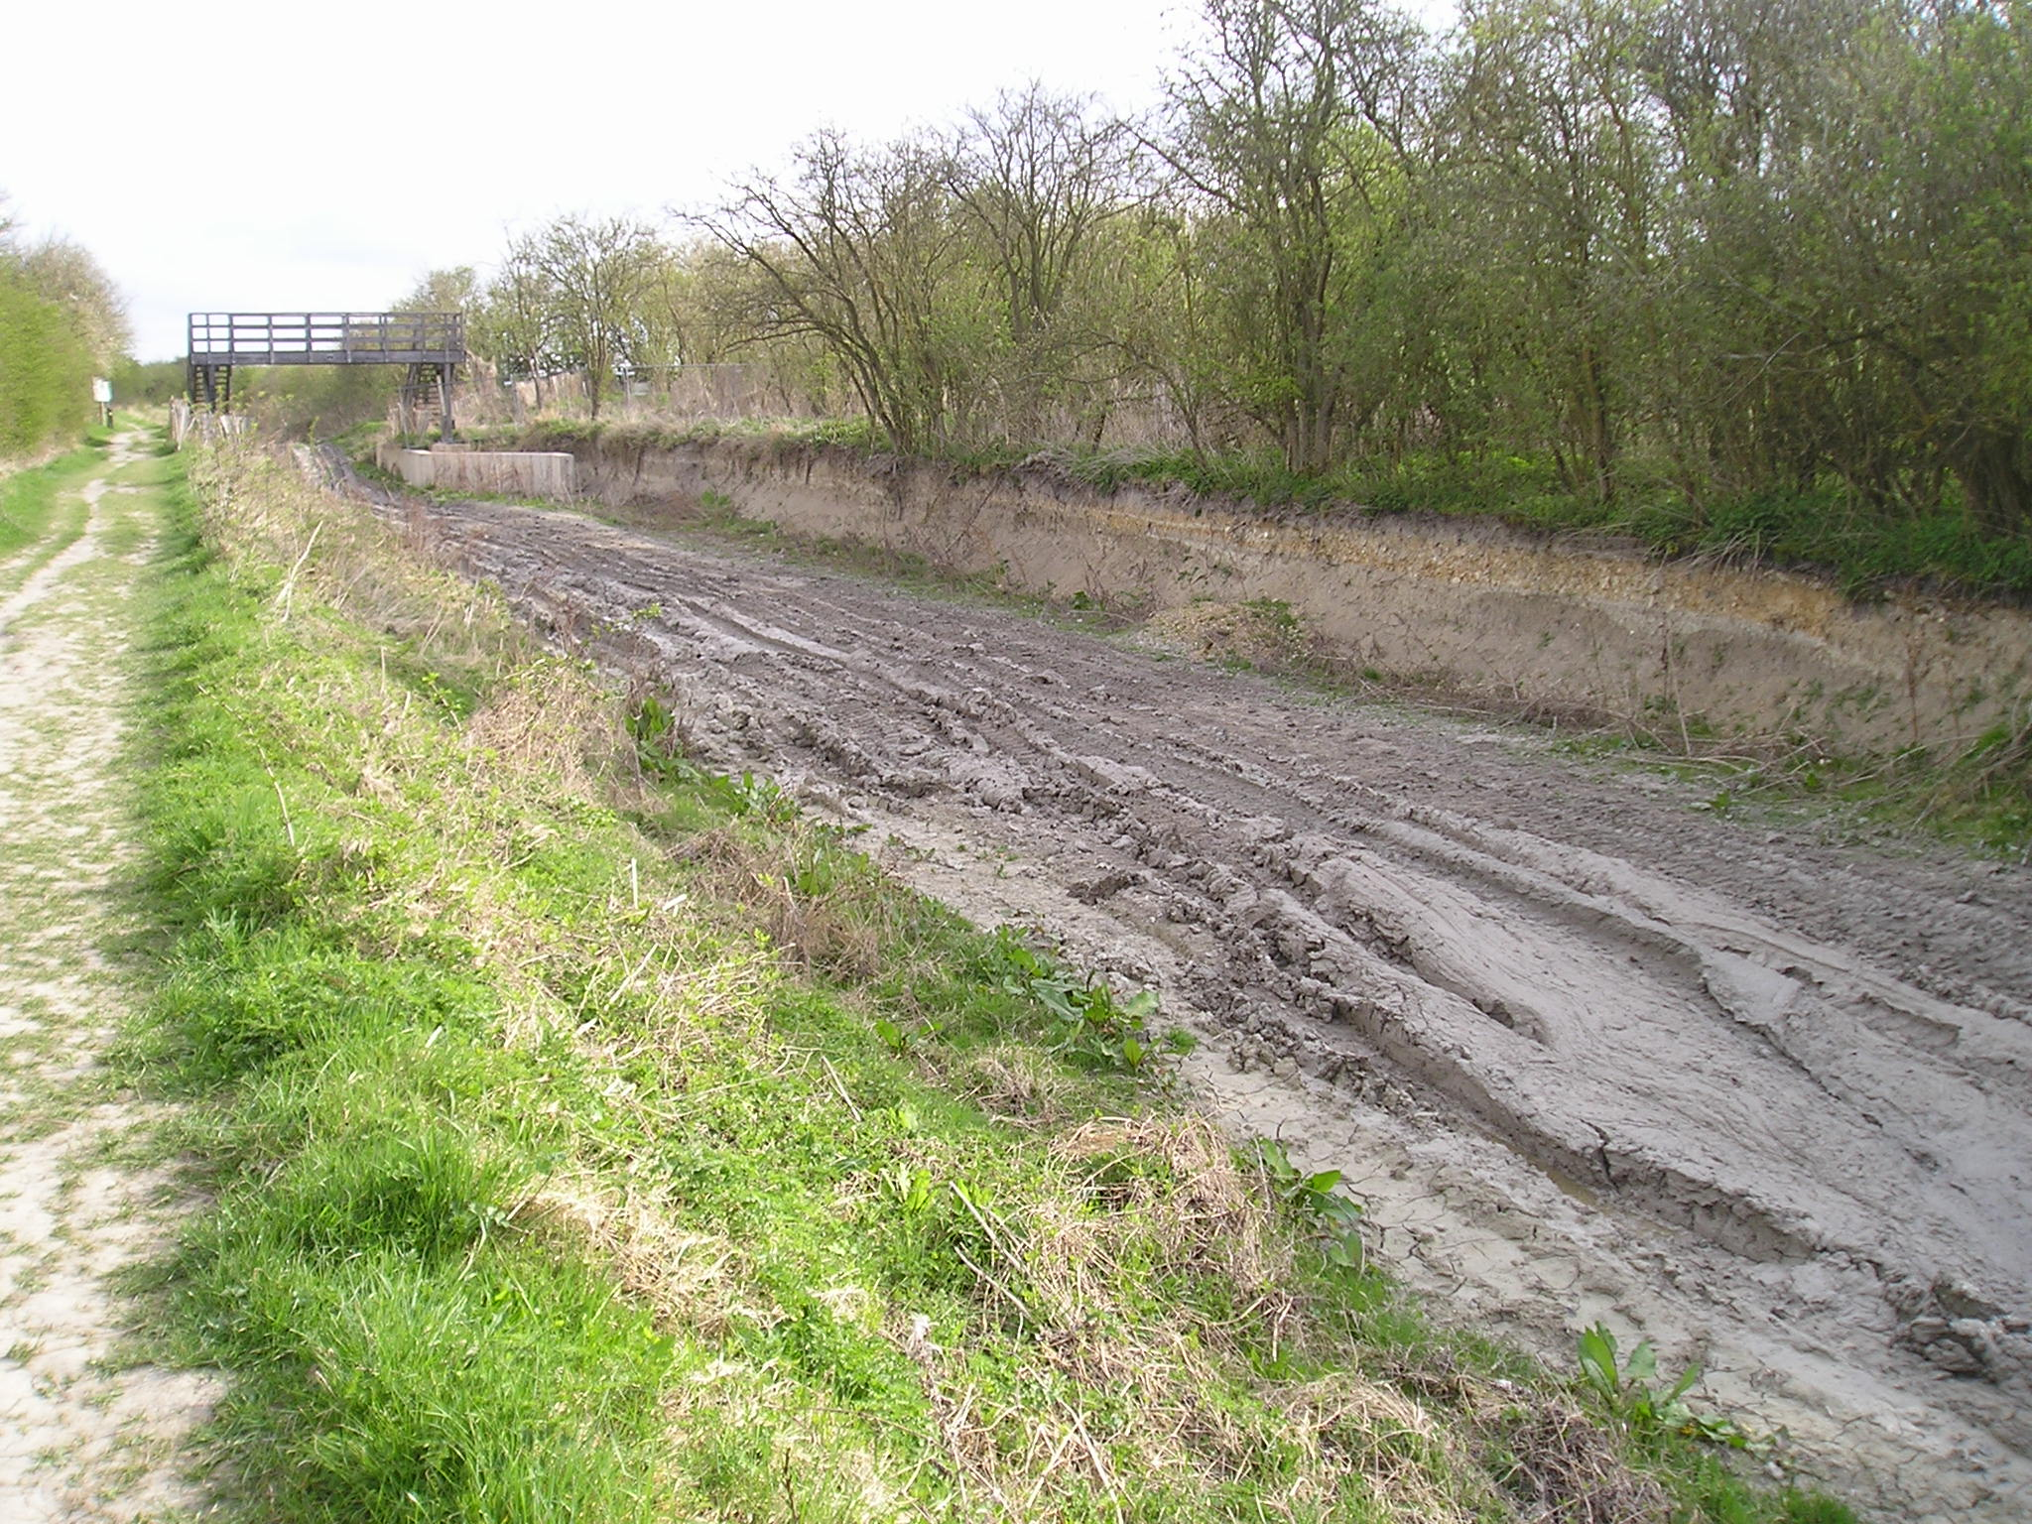
Phill Cardy
THE SITE OF THE BRIDGE 4 MOORING BAY

This will enable Pete Bowers, when his work parties are not on more urgent work, to set up and dismantle the formwork for casting the base and wall sections of this mooring bay.

If there are spare volunteers over the weekend we will continue cutting Bentomat at Little Tring – there are two 40 metre rolls on the cutting platform ready to cut.

As I mentioned in the February Working Party News, Kingdom Tours of Aylesbury has organised a canal restoration weekend over the early May Bank Holiday to visit the Buckingham Arm, Aylesbury Basin and the Wendover Arm. The visitors will be walking from Wendover to Buckland Wharf on Saturday and on Sunday going from Bulbourne to Little Tring by trip boat, a visit to Tringford Pumping Station and then walk from Little Tring to Buckland Wharf, seeing

KESCRG at work at Bridge 4 and our volunteers working at Drayton Beauchamp.

Tring Canal Festival 2009

We must have a change in the weather this year!

Firstly, fencing the Festival site. The Heras fencing panels will be delivered on Wednesday 20th May ready for us to put up on Thursday 21st May and dismantle on Tuesday 26th May.
BRING A 19mm SPANNER WITH YOU!

As restoration is so far behind due to weather conditions, it has been decided to carry on with work at Drayton Beauchamp although volunteers will be scheduled so that everyone has time off to visit the Festival. I am also arranging a roster for two of our volunteers to man the restoration display stand during festival opening hours.
Nigel Williams has organised a mini-bus on the Saturday and Sunday to take visitors from the Festival site to Drayton Beauchamp on a booked timetable. Nigel will drive and Ted Jones will act as guide on the mini-bus to escort the passengers and direct them round the work at Drayton Beauchamp - volunteers working there please be ready to answer questions. There is also a possibility that the mini-bus will be available on Monday and, if so, Pete Bowers will be driving it.

This year, as we are giving restoration work priority, we will not be having the display tent by the Bridge Café as we will not be able to man it as well as the main stand at the festival site.

Finally, if you are bringing your craft to the Festival and want to moor on the towpath west of Little Tring Bridge, please let me know, including boat name and length. To date I have the following boats attending – in order from Little Tring Bridge

MARY BETH 53ft
MADRIGAL 45ft
CHUMLEY B 46ft
KOFFEE & KREAM 40ft
SHALDON 40ft
KAY CEE TOO 58ft
SCYTHIA 58ft
MALAIKA 51ft

Wish List

Readers of the Trust’s Newsletter will have seen that we are promoting a wish list of items of equipment needed for the restoration works. You will be pleased to know that Trust Members Peter Lea and Richard Hope have each donated a new 2” water pump, replacing our life expired pumps that have given yeoman service but are now beyond repair.

Voluntary Labour

The table below shows the value of volunteer labour up to the end of 2009. Again, many thanks to Joyce Smith for all the time that she spends in collating our time sheets, a great asset when we require matching funding.

YEAR | HOURS | TOTAL  HOURS | VALUE  £ | TOTAL  VALUE  £
1996 | 1,016.50 | 1,016.50 | 8,132 | 8,132
1997 | 997.50 | 2,014.00 | 7,980 | 16,112
1998 | 2,696.00 | 4,710.00 | 43,174 | 59,286
1999 | 3,550.50 | 8,260.50 | 30,799 | 90,085
2000 | 4,239.90 | 8,479.90 | 36,865 | 126,950
2001 | 5,021.50 | 13,501.40 | 40,132 | 167,082
2002 | 5,560.00 | 19,061.40 | 44,480 | 211,562
2003 | 6,721.50 | 25,782.90 | 53,772 | 265,334
2004 | 6,647.75 | 32,430.65 | 55,366 | 320,700
2005 | 3,784.50 | 36,215.15 | 37,437 | 358,137
2006 | 4,179.50 | 40,394.65 | 35,326 | 393,463
2007 | 5,463.00 | 45,857.65 | 43,704 | 437,167
2008 | 4,342.00 | 50,199.65 | 34,736 | 471,903

Insurance

It is incumbent on anyone, regardless of age, to inform the Trust in writing if they suffer from any medical condition that could in any way affect their ability to carry out their work as a Trust Work Party Volunteer.

Web Site

The address of the Trust Restoration web site managed by Oliver Revel (that is linked to the main Trust site) is:
http://wendovercanal.org.uk/

The number of e-mail recipients of this newsletter is increasing; please let me know if you wish to join them as it saves me time and the Trust postage/printing costs.

General Notes.

All volunteers receive and sign for the Trust’s Restoration Handbook that includes full Health and Safety requirements for the restoration works. The Handbook is the property of the Trust; if you leave the working parties for any reason, please return your Handbook to either Ray Orth or myself. It has now been updated for re-issue to all volunteers.

Hard hats for use at all times and high visibility jackets to be worn on sites with mobile plant in use are kept in the store at Tringford and must be drawn/returned there.

One first aid kit is kept in the store; another is kept in the VW Transporter for use on site. Also available in the Transporter are ear defenders and goggles that must be worn when using strimmers,
angle grinders, concrete breakers and the like.

Individual volunteers must provide their own gloves and footwear with reinforced toecaps.

We normally work from 9am to 5pm (or dark if earlier!) when we are hiring plant or taking delivery of ready-mix concrete early in the morning.

There are breaks for morning tea/coffee, packed lunch and afternoon tea/coffee. We take our own food and drink.

WENDOVER ARM CANAL RESTORATION PHASE II

PRIGRESS REPORT AS AT 31st MARCH 2009
NB: Costs are to 31/3/2009 but physical progress is to 7/4/2009

CANAL LINING
Item | Stage 1 | Stage 2 | Stage 3 | Stage 4 | Stage 5 | Stage 6 | Stage 7
Total length | 321m | 350m | 350m | 350m | 350m | 337m | -
Complete to date:
Bulk Excavation | 321m | 75m |  |  |  |  | ---------
Capping to pipe | 321m | 40m |  |  |  |  | ---------
Tipping to offside bank | 321m |  |  |  |  |  | ---------
Tipping to towpath bank | 321m
Profiling offside bank | 115m
Profiling towpath bank | 115m |  |  |  |  |  | ---------
Lining towpath bank | 110m |  |  |  |  |  | ---------
Lining offside bank | 110m |  |  |  |  |  | ---------
Level and line bed | 96m |  |  |  |  |  | ---------
Planting banks | 60m |  |  |  |  |  | ---------
Mooring wall length | 50m | 50m | -------- | 50m | 50m | -------- | 237m
Excavation | 50m |  | -------- | 50m |  | -------- | 10m
Blinding | 50m |  | -------- | 4m |  | --------
Wall base | 50m |  | -------- | 4m |  | --------
Wall upright | 50m |  | -------- | 4m |  | --------
Backfill | 30m |  | -------- |  |  | --------
Estimated Cost | £176,550 | £183,750 | £175,000 | £175,000 | £166,250 | £98,725 | £53,725
Cost to date/final | £79,047 | £4,914 | £361 | £1,780 | £345 | £179 | £390

FOOTBRIDGES & VARIOUS OTHER WORKS
Item | Stage 8 | Stage 9 | Stage 10 | Stage 11 | Stage 12 | Stage 13 | Stage 14
 | Bridge 4 | Bridge 4A | Whitehouses  Weir etc. | Cart track  Narrows  & Weir | Removal  of bunds | Winding  Hole nose | Nuttalls  Bund
Footbridge | 100% | 100% | ---------------- | ----------- | ---------- | ----------- | ----------
Excavation | 100% | 100% | ---------------- |  | ---------- |  | ----------
Blinding | 100% | 100% | ---------------- |  | ---------- |  | ----------
Wall base | 100% | 100% | ---------------- |  | ---------- |  | ----------
Wall upright | 100% | 100% | ---------------- |  | ---------- |  | ----------
Backfill | 100% | 100% | ---------------- |  | ---------- |  | ----------
Weir | --------- | --------- |  |  | ---------- | ----------- | ----------
Heritage work | --------- | --------- |  | ----------- | ---------- | ----------- | ----------
Other work | --------- | --------- | ---------------- | ----------- |  | ----------- | 100%
Estimated cost | £20,000 | £20,000 | £20,000 | £20,000 | £20,000 | £10,000 | £3,500
Cost to date/final | £20,122 | £20,031 | £653 |  |  |  | 3,501

SUMMARY INCLUDING INDIRECT COSTS
 | Lining | F/bridges  & other  works | Clear bed,  & Temp’y  Works | Environ’t  Reports | Materials  In stock | Admin | Tools &  Equip’t | Vehicle | Unallocated | TOTALS
Estimated cost | £1,029,000 | £113,500 | £15,000 | £3,500 | £0 | £25,000 | £5,000 | £10,000 | £49,000 | £1,250,000
Cost to date/final | £87,016 | £44,307 | £13,092 | £3,245 | £36,497 | £10,330 | £1,156 | £4.610 |  | £200,253
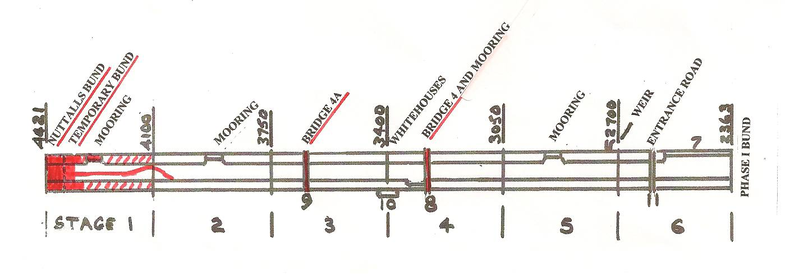

DATES FOR WORKING PARTIES

DATE (2009) | WORKING AT | WORK TO BE DONE
Friday 1st May to  Tuesday 5th May | Drayton Beauchamp | Bank profiling mooring bay length including blending towpath side into wing walls.  KESCRG laying blinding for Stage 4 mooring wall. (Sat/Sun)
Thursday 14th May | Drayton Beauchamp | Erect formwork for first base of Bridge 4 mooring wall.  Deal with undergrowth at Whitehouses old pumping station site.
Thursday 21st May | Festival Site | Erect Heras fencing
Friday 22nd May to  Monday 25th May | Drayton Beauchamp | Stage 1 offside lining through mooring wall length, about 60 metres..
Saturday 23rd May to  Monday 25th May | Festival Site/  Drayton Beauchamp | Manning Trust Stand and conducting tours with mini-bus to Drayton Beauchamp
Tuesday 26th May | Festival Site | Dismantle Heras fencing
Friday 3rd July to  Tuesday 7th July | Drayton Beauchamp | Continue Stage 1 lining.
Saturday 8th August to  Sunday 16th August | Drayton Beauchamp | Continue Stage 1 lining
Friday 4th September to  Tuesaday 8th September | Drayton Beauchamp | Continue Stage 1 lining

Roger Leishman, Restoration Director. 7 Hall Park, Berkhamsted, Herts HP4 2NU.
(Tel:01442 874536, e-mail rleishman@ukgateway.net)

WORK PARTY VOLUNTEER SCHEDULE TO MAY 2009

Date (2009) | Location |  | Excavator  Drivers | Dumper  Drivers | Other Volunteers
Fri 1st May | Drayton Beauchamp | R Leishman/  R Orth | R Orth  P Cardy | B Lansley  B Ing | K Graves  J Reynolds | B Matraves  M Wright
Sat 2nd May | Drayton Beauchamp | R Leishman/  R Orth | R Orth  P Cardy | B Harris  B Fletcher | K Graves  P Winter | J Brooman  J Reynolds
Sat 2nd May | Bridge 4 | R Leishman/  R Orth | KESCRG
Sun 3rd May | Drayton Beauchamp | R Leishman/  R Orth | B Fletcher Orth  P Cardy | B Lansley  B Ing | J Brooman  M Wright | B Matraves
Sun 3rd May | Bridge 4 | R Leishman/  R Orth | KESCRG
Mon 4th May | Drayton Beauchamp | R Orth | R Orth  P Cardy  B Matraves | B Lansley  B Harris | K Graves  C Johnson  N Williams | (J Brooman)  M Wright
Tue 5th May | Drayton Beauchamp | R Leishman/  R Orth | R Orth | B Lansley  B Harris | K Graves  B Ing  M Wright | P Winter  J Reynolds
Thu 14th May | Drayton Beauchamp | P Bowers | N/a
Thu 21st May | Festival Site | R Leishman/  R Orth | A roster will be issued at the start of the Festival.
Fri 22nd May | Drayton Beauchamp | R Leishman/  R Orth
Sat 23rd May | Drayton Beauchamp | R Leishman/  R Orth
Sun 24th May | Drayton Beauchamp | R Leishman/  R Orth
Mon 25th May | Drayton Beauchamp | R Leishman/  R Orth
Tue 26th May | Festival Site | R Leishman/  R Orth

The name of the person in charge on a particular day/site is printed in italics.
P Bowers 01255 504540 or 07880 744730 R Leishman 01442 874536 or 07850 170858
R Orth 01494 786868 or 07733 092034 R Fletcher 01494 812087

