
THE WENDOVER ARM TRUST
WORKING PARTY NEWS

ISSUE 68 August 2008

After the dreadful weather at the Festival we had hoped for some good weather for the August nine day working party. It was not to be and, apart from the strains of the work we did, most of us suffered from aching leg muscles just plodding our way through the mud.

At the July working party Bob Fletcher and his team pumped out the water below our new bund and removed the fence along the newly watered length including strimming the top of the bank.
As you can see below, it certainly looks good.
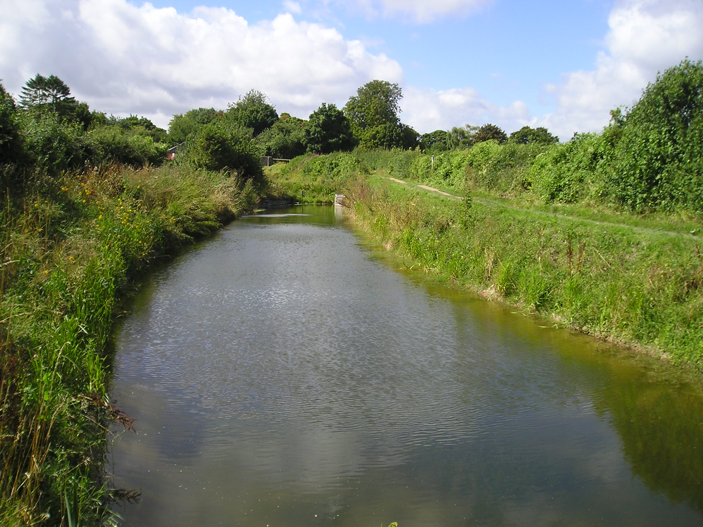
Phill Cardy

Alas, further rain resulted in Brian Harris and Brian Ing having to do another pumping session later in July.

Ray Orth and I were on site the Friday afternoon before the August working party, the whole area at Little Tring and Drayton Beauchamp was bone dry, even dusty, until late in the afternoon when the hired plant was being delivered and down came heavy rain again!
This put paid to cutting any more Bentomat and the ground never dried out for the rest of the week. By very good fortune we had cut ten pieces of Bentomat for lining banks on the dry Saturday of the Festival weekend and had a few cut last year. No need to tell you why we could not cut any more over that weekend.
Despite the weather we were able to profile 30 metres of both banks, lay the Bentomat and complete the block laying with coir rolls on top. However time and wet weather precluded finishing the spoil fill above the coir rolls and it is hoped to complete this at the September working party.
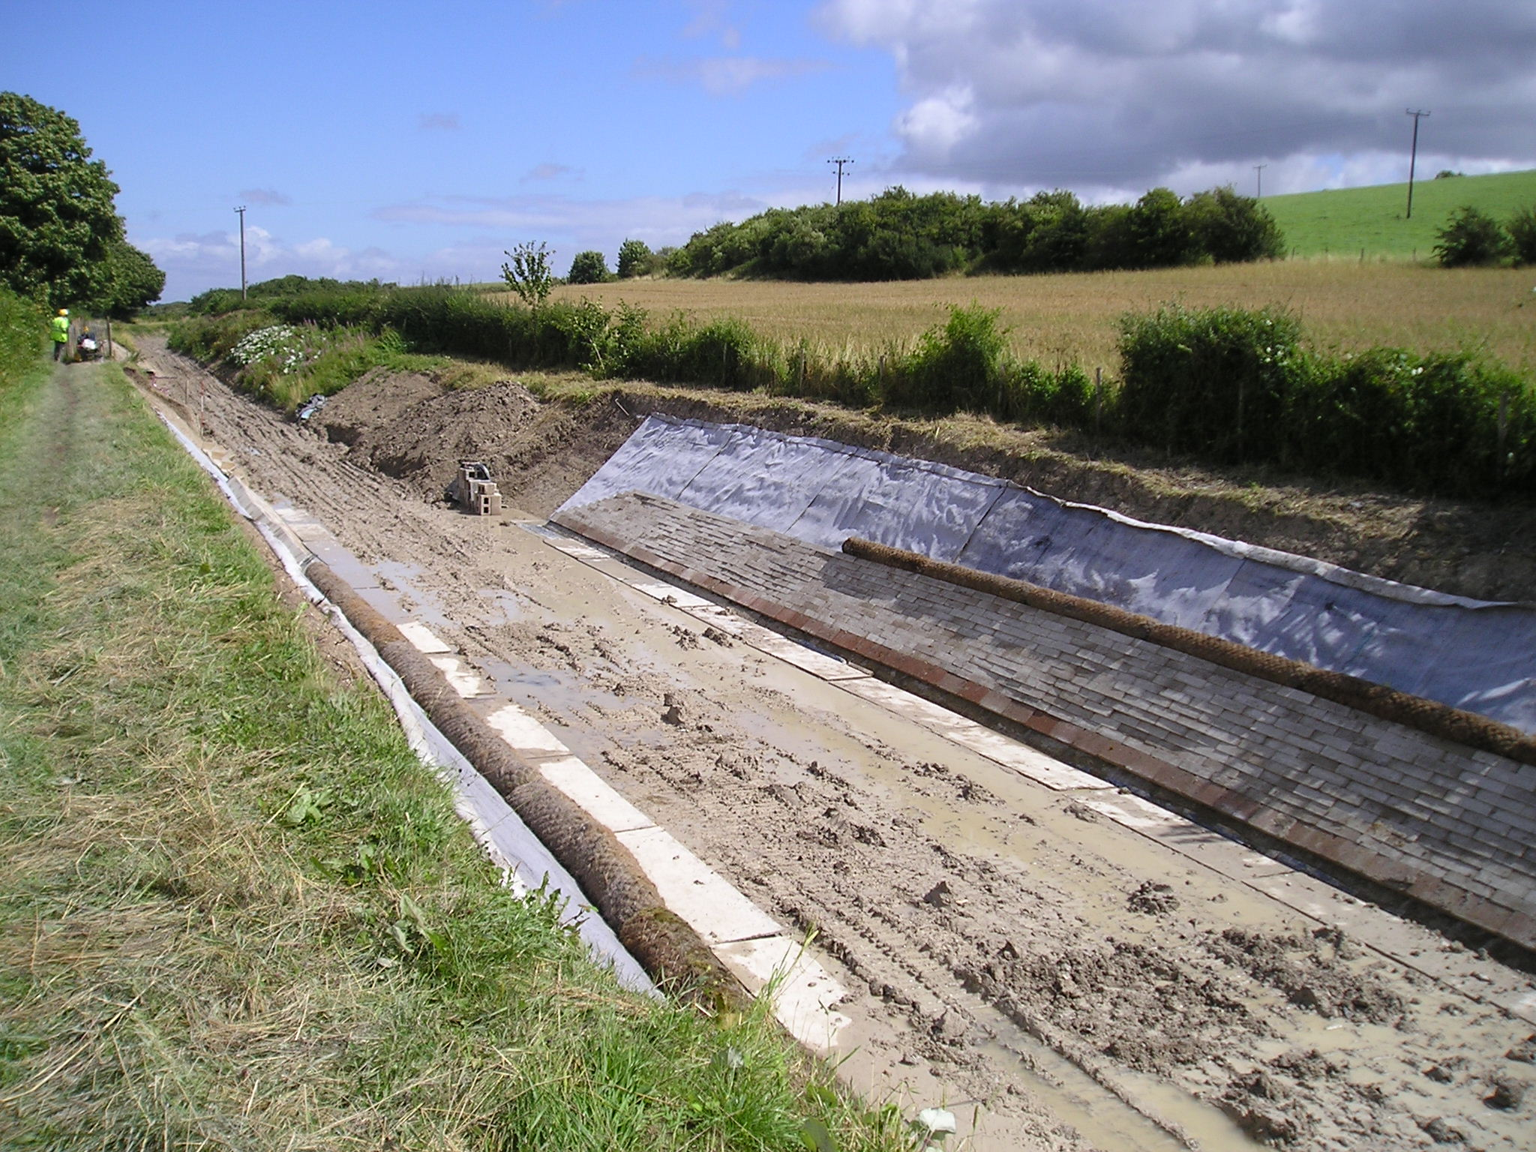
Phill Cardy
This was the result of our nine day working party when work was nearly finished.
It was also hoped to continue with work on the wall for the Stage 1 mooring bay but the weather again put paid to this as priority had to be given to the lining although bulk excavation for the second half of the wall was substantially completed.
However, all was not lost as Pete Bowers and his team on the weekday working party hand excavated and concreted enough blinding ready for the formwork for the third base of the wall to be set up at his next weekday working party in September.

September Working Party

The priority will be, weather permitting, to cut as many 4-metre lengths of Bentomat as possible for

bank lining. It is also hoped to place the spoil above the coir rolls already laid at Drayton Beauchamp, continue with profiling both banks up to the mooring bay and complete bulk excavation of the mooring bay.

The reinforcement for the third base of the mooring wall will be taken to Drayton Beauchamp ready for Pete Bowers and his team. Another job will be to fence off the old route of the footpath at Bridge 4 in readiness for removing the spoil between the abutments of the former Swing Bridge at this site.

October Working Party

There has been a mix-up over whether KESCRG will be coming for this weekend and I have not yet heard a definite yes or no – it seems that it depends on availability of accommodation at another site.

If Bentomat is cut and bank profiling has progressed in September, lining, block laying, coir rolls and spoil filling will continue up to the mooring bay.

On Friday the formwork for the first wall pour and the third base pour will be completed ready for pouring on the Saturday morning. It is also hoped to complete final excavation for and complete the blinding for at least another base with surplus ready-mix from these pours.

Depending on other priorities, weather and the number of volunteers on site, stripping and re-erection of formwork will continue on Sunday onwards, possibly another base pour on the Tuesday ready for Pete Bowers and his team to strip and re-erect on the Thursday.

Lining Specification

Prior to August the specification for the lining had been finalised except for the change to solid concrete blocks above the bottom row of hollow concrete blocks filled with concrete. This bottom row is required to give a firm base for the solid dry bedded concrete blocks.

The solid concrete blocks are easier and quicker to lay and eleven courses matched almost exactly the five courses of hollow concrete blocks already laid.

Although laying the solid blocks is not exactly a relaxing job the speed of laying is fast and there is no filling of the hollow blocks with concrete. From an engineering point of view they are an improvement, as they will individually settle back against the Bentonite should any voids occur in the bank, especially where the bank has had to be cut into for the pipe capping and reformed.

Progress was so quick that we used the complete stock of blocks at Little Tring to complete the 30 metres of lining; actually we were four blocks short! Ron Pittaway is now arranging for another two loads of blocks to be delivered in time for the October working party.

Berkhamsted Local History and Museum Society

The visit on Sunday 10th August had to be postponed because of the atrocious ground conditions and will be re-arranged for later this year – weather permitting!

Diane Edwards

We were very sorry to hear that Diane Edwards died in May this year. Diane and her partner Graham Waite were regular attendees at working parties and were very much involved in the scrub bashing for Phase II. Unfortunately Diane suffered ill health over recent years and had to give up coming to working parties. Our sympathies go to Graham at this time.

Operation “FLOODWATCH”

We are scheduling this operation for later in the year, probably October/November. BW is concerned over the raising of the water level and is consulting their hydrologist on the matter.

Memorial Seats

These seats, one in memory of our late Vice-President, Roger Lewis, will be on the towpath immediately west of Little Tring Bridge. The other seat, given by his family in memory of Trust Member Dick Cordell, will be sited alongside the towpath at peg 30, 200 metres east of footbridge 4.
Because of the delay to our restoration works due to bad weather, constructing the bases will have to wait until later in the year.

General Notes.

All volunteers receive and sign for the Trust’s Restoration Handbook that includes full Health and Safety requirements for the restoration works. The Handbook is the property of the Trust; if you leave the working parties for any reason, please return your Handbook to either Ray Orth or myself. It has now been updated to take into account procedures for the lining in Phase II and new BW requirements under their procedures for treating us as self-supervising. BW have made some comments and these will be actioned when I return from holiday at the end of September and then the revised Handbook will be issued to all volunteers.

Will all present holders of the Handbook who have not already done so please return them to Ray Orth or myself for updating and re-issue.

Hard hats for use at all times and high visibility jackets to be worn on sites with mobile plant in use are kept in the store at Tringford and must be drawn/returned there.
One first aid kit is kept in the store; another is kept in the VW Transporter for use on site. Also available in the Transporter are ear defenders and goggles that must be worn when using strimmers, angle grinders, concrete breakers and the like. Individual volunteers must provide their own gloves and footwear with reinforced toecaps.

We normally work from 9am to 5pm (or dark if earlier!) when we are hiring plant or taking delivery of ready-mix concrete early in the morning. There are breaks for morning coffee/tea, packed lunch and afternoon tea/coffee. We take our own food and drink.

DATES FOR WORKING PARTIES

DATE (2008) | WORKING AT | WORK TO BE DONE
Friday 5th September to  Tuesday 9th September | Little Tring  Bridge 4  Drayton Beauchamp | Cutting Bentomat. Deliver reinforcement for mooring bay.  Fencing off old footpath at Bridge 4.  Profiling banks, lining, and excavation to mooring bay.
Thursday 11th September | Drayton Beauchamp | Erect formwork for third wall base.
Friday 3rd October to  Tuesday 7th October | Drayton Beauchamp  Bridge 4 | Lining banks, blinding, pour first wall and third base to mooring bay. Possibly re-erect wall/base formwork and pour fourth base  Stage 2 bulk excavation & pipe capping  Excavate between walls of old swing bridge at Bridge 4.
Thursday 9th October | Drayton Beauchamp | Remove/re-erect mooring bay formwork.
Friday 31st October to  Tuesday 4th November | Drayton Beauchamp | Stage 1 mooring wall.  Stage 2 bulk excavation & pipe capping.
Thursday 13th November | Drayton Beauchamp | Remove formwork from capping.  Remove/re-erect mooring bay formwork.
Friday 5th December to  Tuesday 9th December | Drayton Beauchamp | Stage 1 mooring wall.  Stage 2 bulk excavation & pipe capping.
Thursday 11th December | Drayton Beauchamp | Remove formwork from capping.  Remove/re-erect mooring bay formwork.

Roger Leishman, Restoration Director. 7 Hall Park, Berkhamsted, Herts HP4 2NU.
(Tel:01442 874536, e-mail rleishman@ukgateway.net)

WORK PARTY VOLUNTEER SCHEDULE TO DECEMBER 2008

Date 2008 | Location |  | Excavator  Drivers | 6t Tracked  Dumper  Drivers | Other  Volunteers
Fri 5 Sep | Drayton Beauchamp | R Orth | P Cardy | B Lansley | K Graves | D Cater
Sat 6 Sep | Drayton Beauchamp | B Fletcher | P Cardy |  | K Graves
Sun 7 Sep | Drayton Beauchamp | R Orth | P Cardy | B Lansley | K Graves
Mon 8 Sep | Drayton Beauchamp | R Orth |  | B Lansley | K Graves | D Cater
Tue 9 Sep | Drayton Beauchamp | R Orth |  | B Lansley | K Graves
Thu 11 Sep | Drayton Beauchamp | P Bowers | N/a | N/a |  | D Cater
Fri 3 Oct | Drayton Beauchamp | R Leishman/ R Orth | P Cardy | B Lansley | K Graves
Sat 4 Oct | Drayton Beauchamp | R Leishman/ R Orth | P Cardy |  | K Graves  B Fletcher
Sun 5 Oct | Drayton Beauchamp | R Orth | P Cardy | B Lansley | K Graves  B Fletcher
Mon 6 Oct | Drayton Beauchamp | R Leishman/ R Orth | P Cardy | B Lansley | K Graves
Tue 7 Oct | Drayton Beauchamp | R Leishman/ R Orth |  | B Lansley | K Graves
Thur 9 Oct | Drayton Beauchamp | P Bowers | N/a | N/a
Fri 31 Oct | Drayton Beauchamp | R Leishman/ R Orth |  | B Lansley | K Graves
Sat 1Nov | Drayton Beauchamp | R Leishman/ R Orth |  |  | K Graves  B Fletcher
Sun 2 Nov | Drayton Beauchamp | R Orth |  | B Lansley | K Graves  B Fletcher
Mon 3 Nov | Drayton Beauchamp | R Leishman/ R Orth |  | B Lansley | K Graves
Tue 4 Nov | Drayton Beauchamp | R Leishman/ R Orth |  | B Lansley | K Graves
Thu 13 Nov | Drayton Beauchamp | P Bowers | N/a | N/a
Fri 5 Dec | Drayton Beauchamp | R Leishman/ R Orth | P Cardy | B Lansley | K Graves
Sat 6 Dec | Drayton Beauchamp | R Leishman/ R Orth | P Cardy |  | K Graves  B Fletcher
Sun 7 Dec | Drayton Beauchamp | R Orth | P Cardy | B Lansley | K Graves  B Fletcher
Mon 8 Dec | Drayton Beauchamp | R Leishman/ R Orth |  | B Lansley | K Graves
Tue 9 Dec | Drayton Beauchamp | R Leishman/ R Orth |  | B Lansley | K Graves
Thu 11 Dec | Drayton Beauchamp | P Bowers | N/a | N/a

The name of the person in charge on a particular day/site is printed in italics.

P Bowers 01255 504540 or 07880 744730 R Leishman 01442 874536 or 07850 170858
R Orth 01494 786868 or 07733 092034 R Fletcher 01494 812087

PLEASE NOTE THAT I AM AWAY DURING SEPTEMBER SO PLEASE CONTACT RAY ORTH ABOUT YOUR ATTENDANCE AT THE SEPTEMBER WORKING PARTY.

THANKS,

ROGER.

