
THE WENDOVER ARM TRUST
WORKING PARTY NEWS

ISSUE 63 October 2007

We have just completed a very successful ten day work party (Oct 5th to 14th) that has been a very satisfying turning point in the progress of Phase II. We were ably assisted by the Kent and East Sussex Canal Restoration Group (KESCRG) and by recruits from RAF Halton over the first weekend.
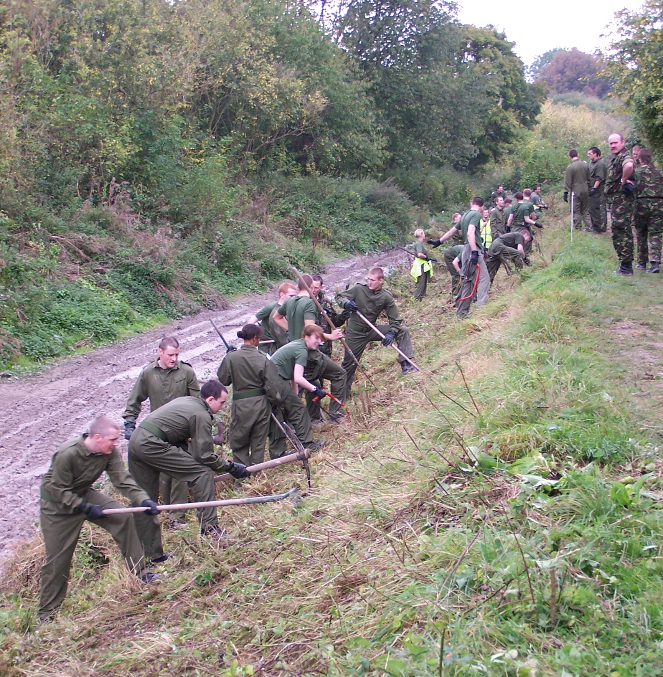
Margaret Leishman
RAF RECRUITS HARD AT WORK
APPROACHING WHITEHOUSES

For some time now we have been concerned about the re-growth of briars, potential saplings and the like on the banks of the Phase II dry bed. BW had offered to flail the banks for us but muddy conditions, then the loss of their tractor made this impossible. Fortunately for us, RAF Halton offered the services of about 50 of their recruits both on the Saturday and Sunday and they did a superb job, under the expert direction of ‘Sergeant’ Brian Ing (ex. RAF), clearing the towpath bank from Little Tring to the former pumping station at Whitehouses.
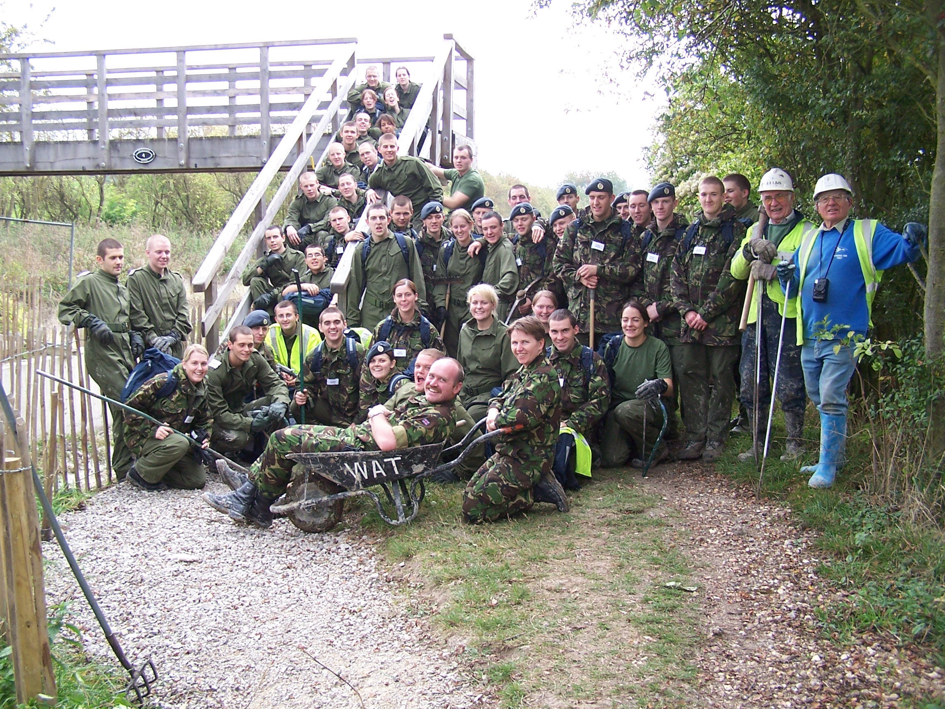
Margaret Leishman
SERGEANT LYNN PARSONS (ONETIME WRG) AND HER ‘TROOPS’ AT THE END OF THE SUNDAY

On the Saturday and Sunday, KESCRG cut 90 pieces of re-inforcement for the pipe capping slab, completed the formwork for block lining, fenced off part of the towpath for building the mooring bay in Stage 1 and worked very hard laying Bentomat sheeting on the banks, covering it with hollow concrete blocks, mixing concrete and filling the blocks.
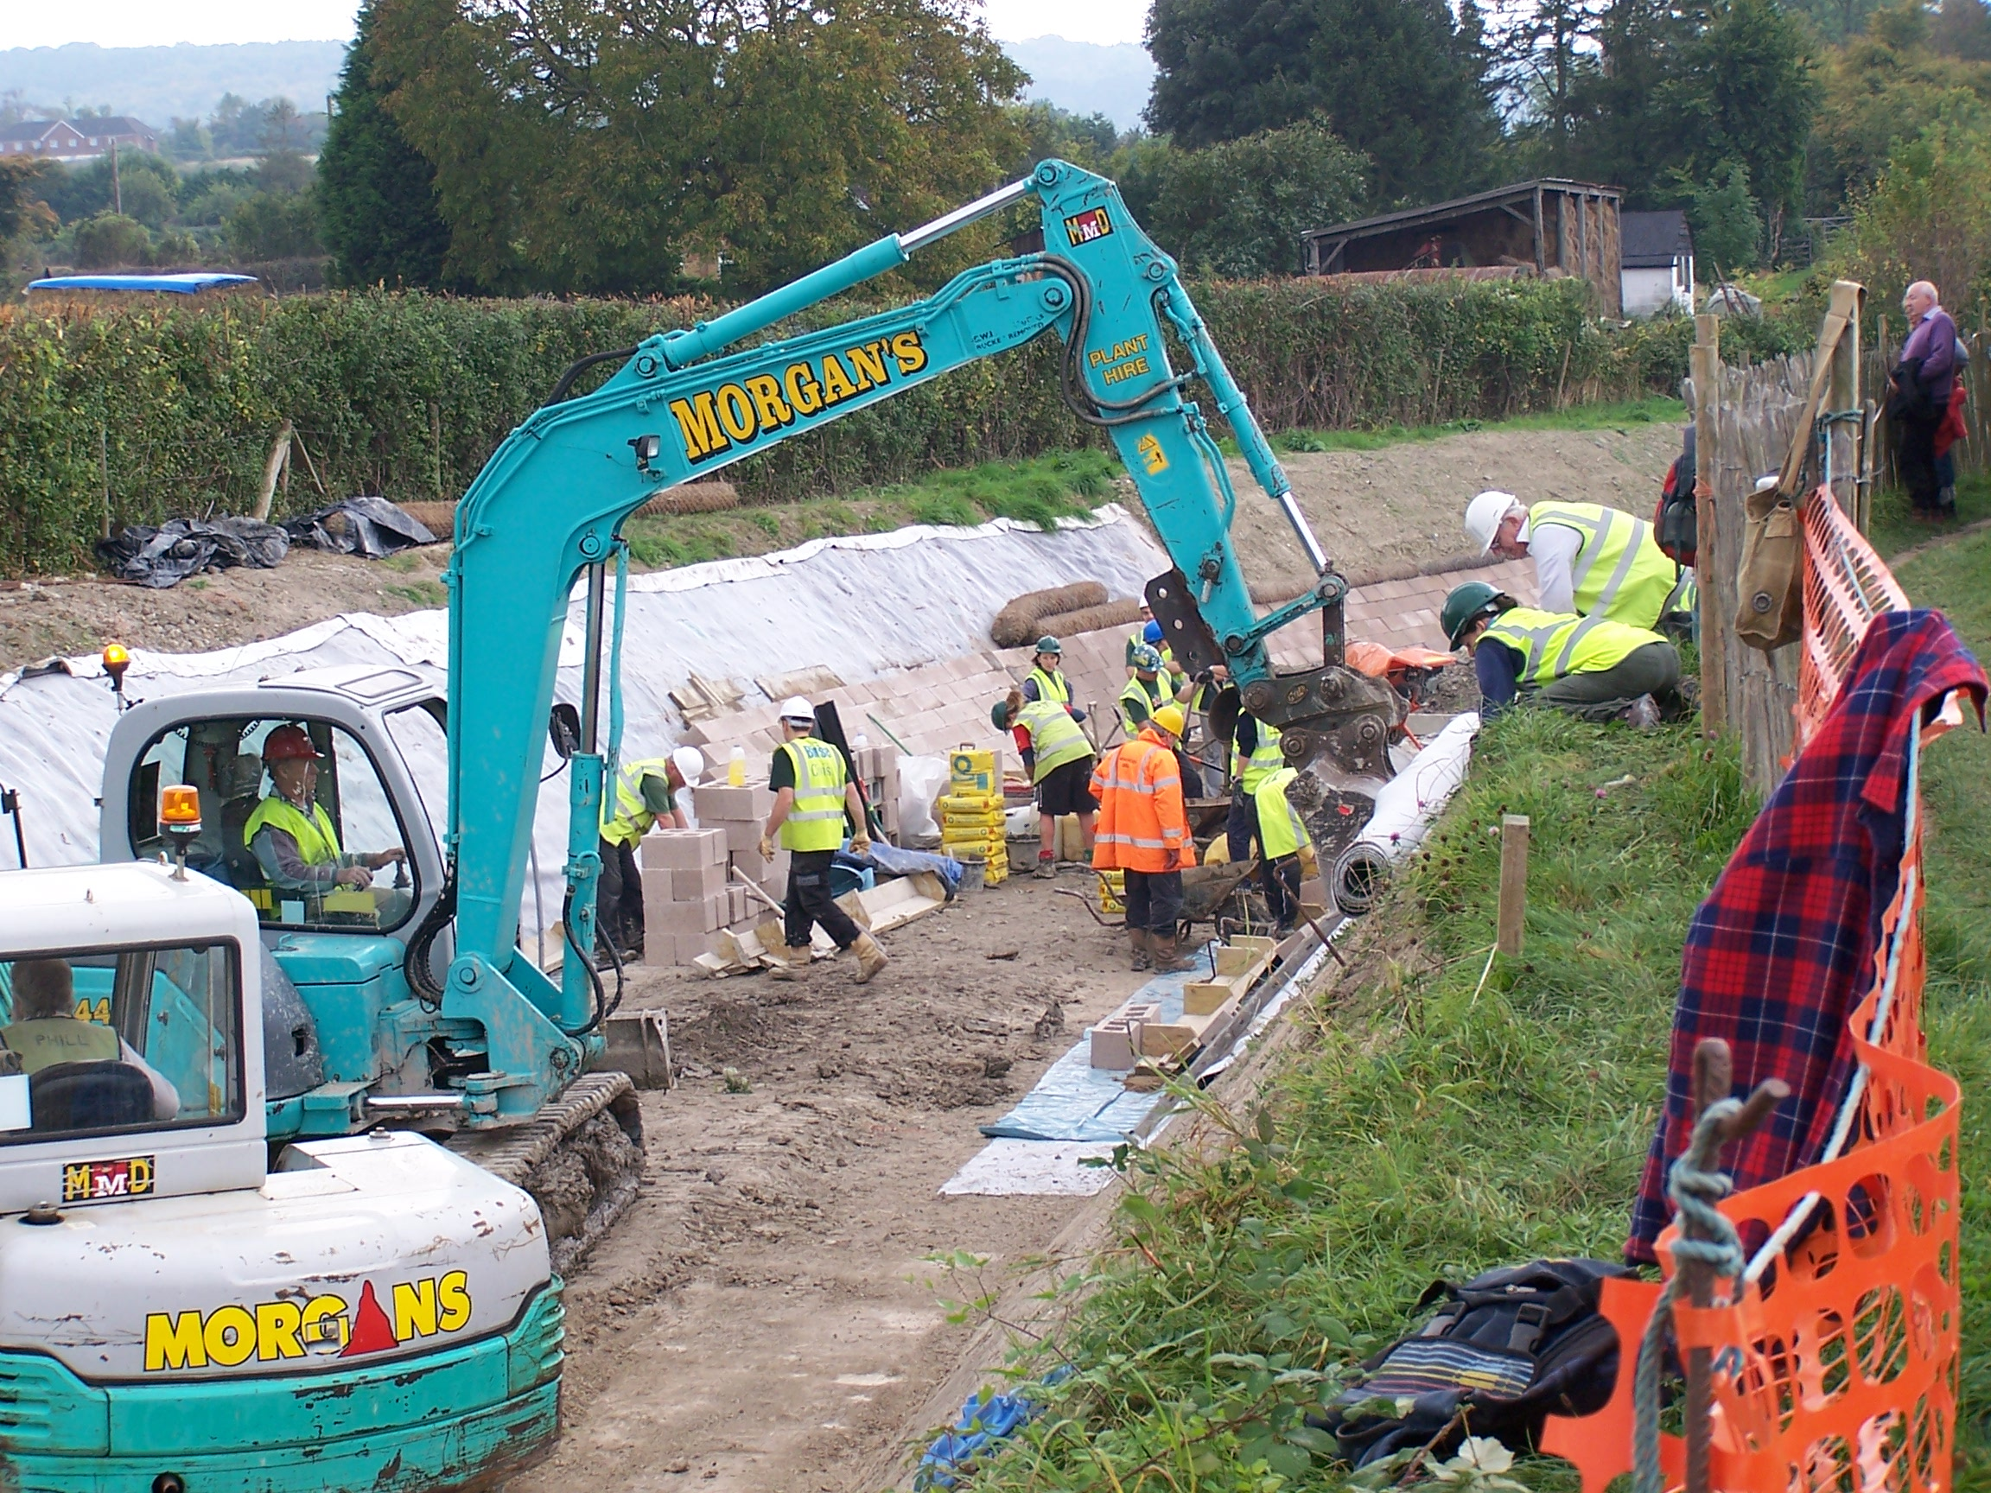
Margaret Leishman
LAYING BENTOMAT LINING ON THE TOWPATH SIDE
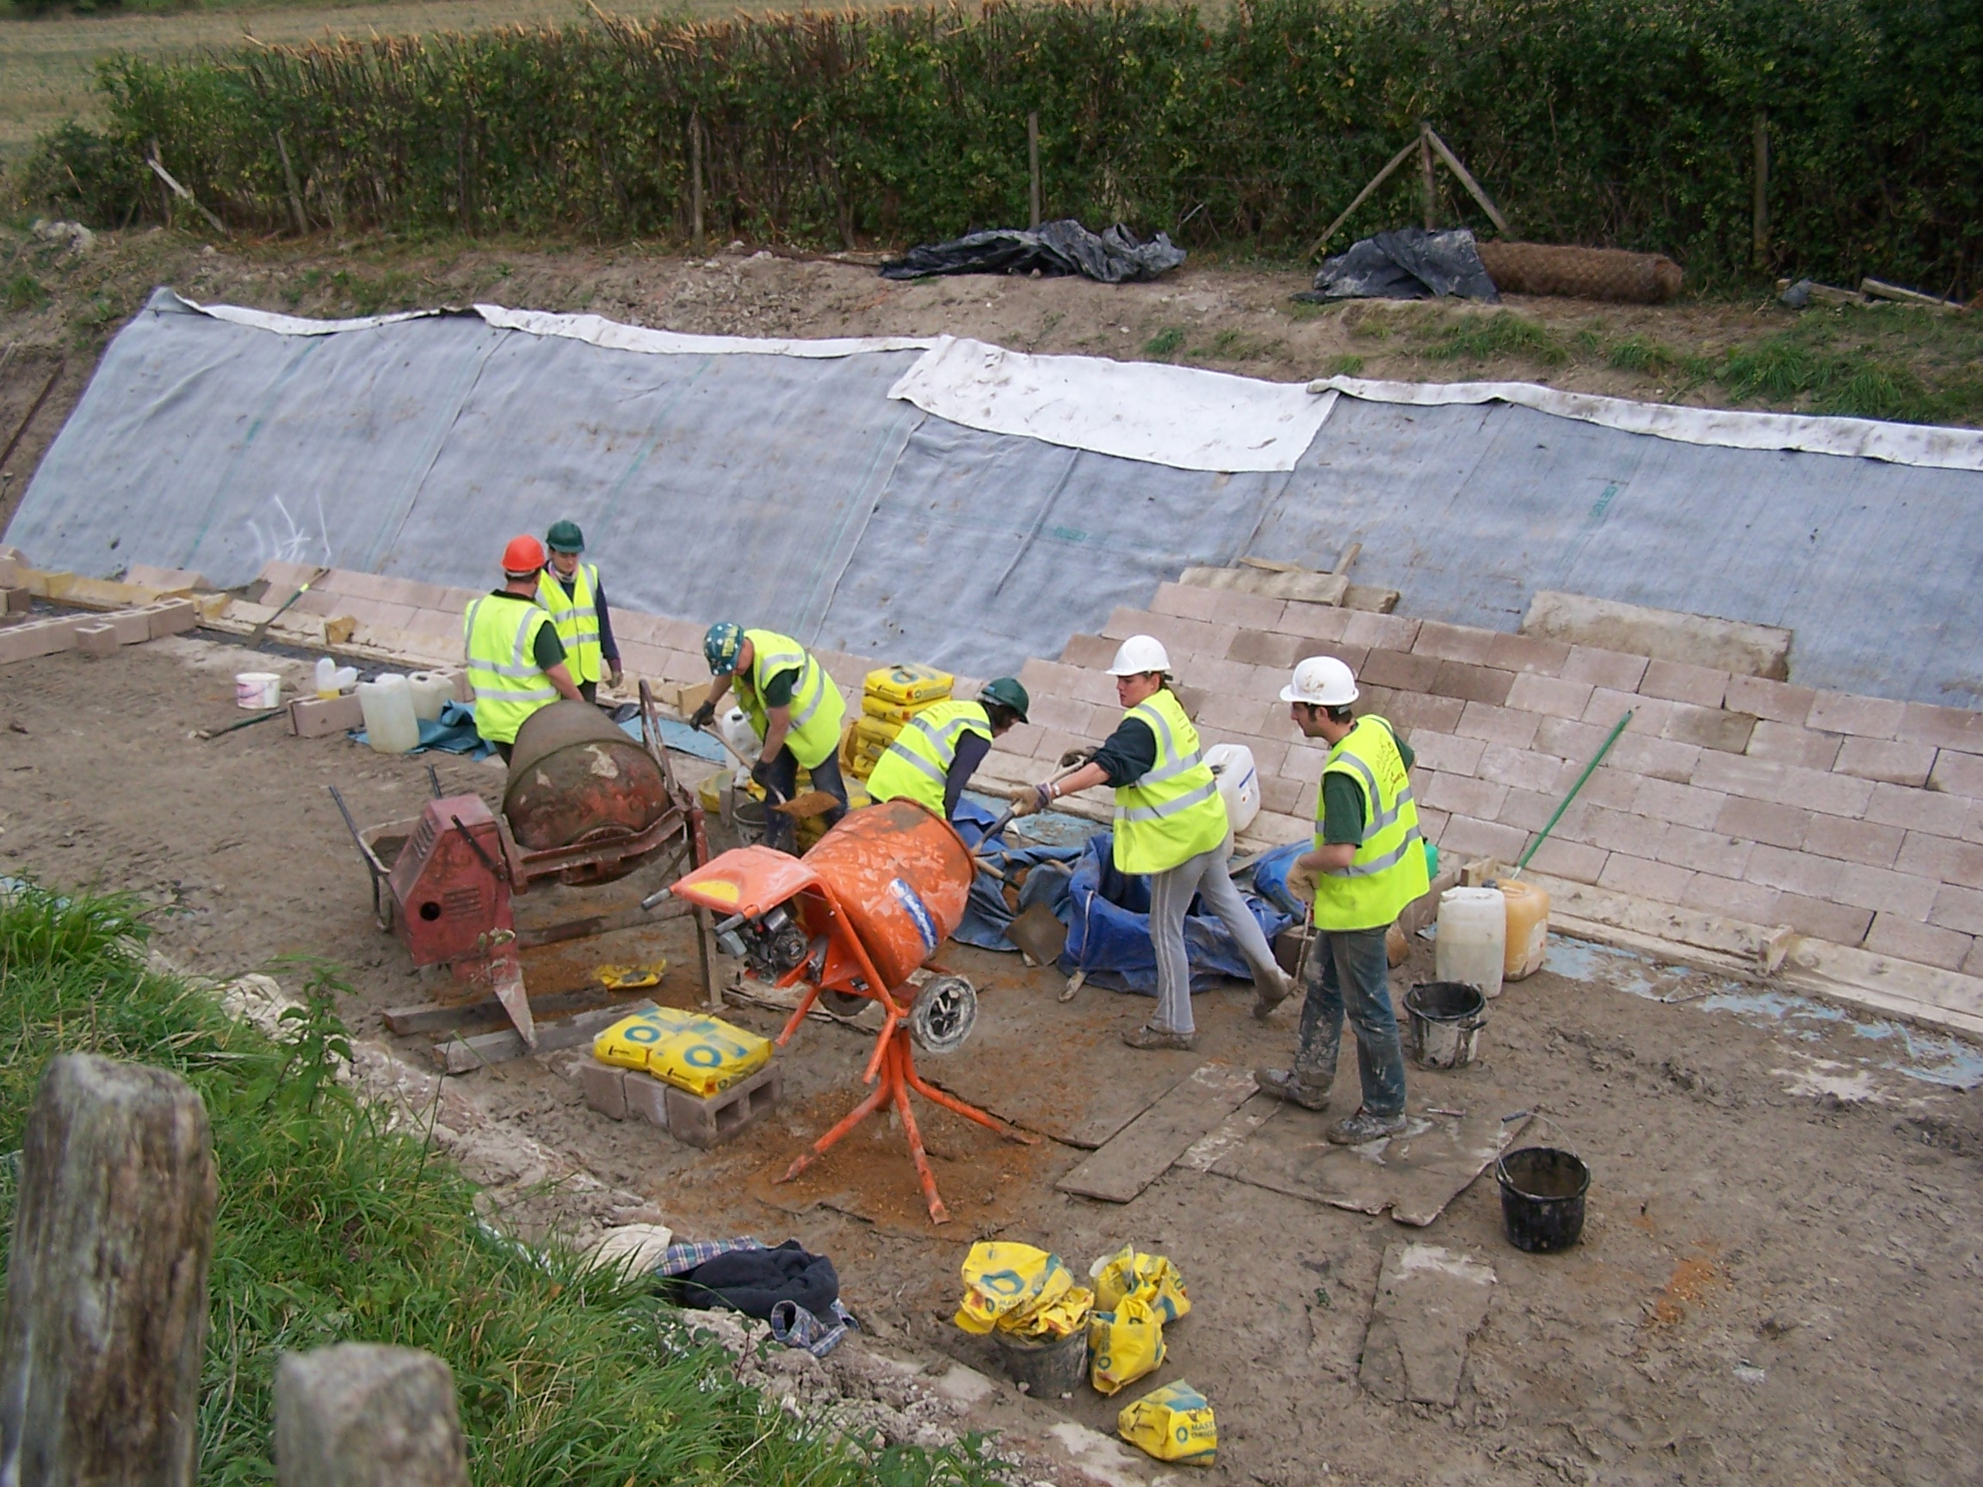
Margaret Leishman
KESCRG MIXING CONCRETE, LAYING AND FILLING THE HOLLOW BLOCKS

The Trust’s grateful thanks to KESCRG and the RAF and to Phil Cardy, Mark Gribble, Dave Wedd of WRG (BITM) and Anthoney Tidey of the Wilts & Berks Canal Trust, and my thanks in particular to our own volunteers, all of whom helped on various days, even though some used up holiday time from work.

At the end of the ten days 30 metres of lining from the Nuttalls bund had been completed, making it 70 metres in all, together with a waterproof bund allowing the re-watering of 60 metres of restored canal that will be planted with aquatic plants and the water let in to Wendover water level at the November work party.
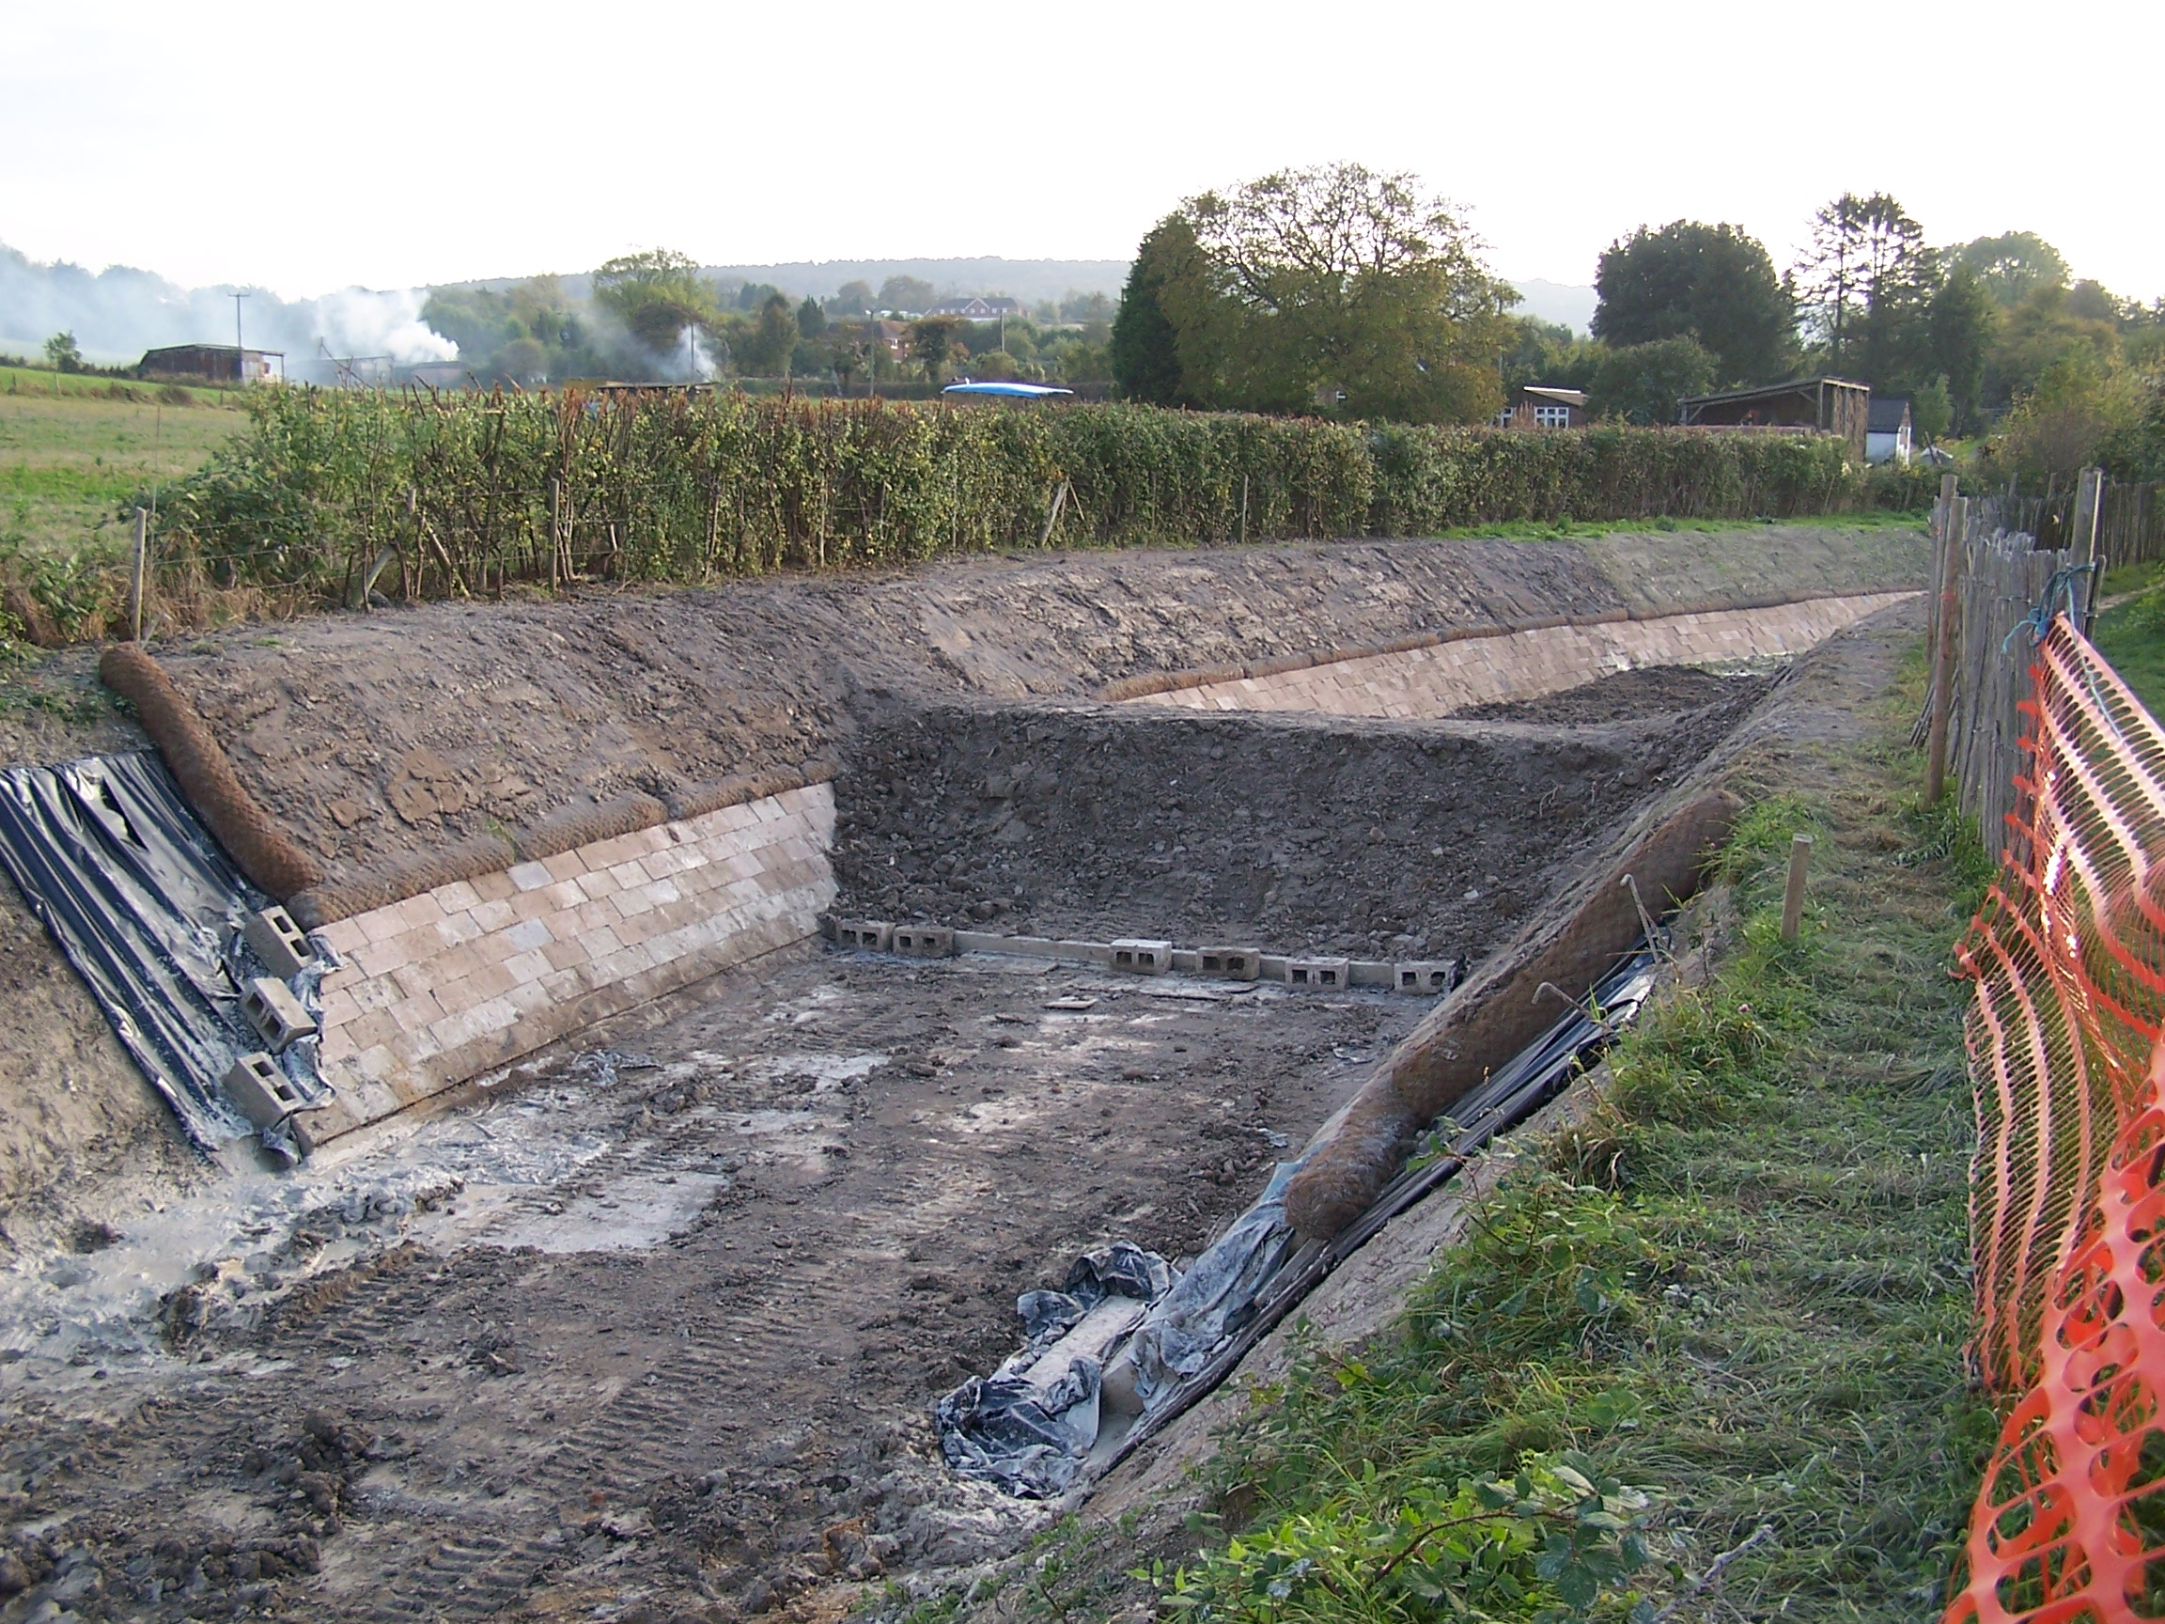
Roger Leishman
70 METRES OF FINISHED LINING WITH A TEMPORARY BUND READY FOR
RE-WATERING IN NOVEMBER

Since the method of working described in the last Working Party News we have had to think again. We had hoped to complete the spoil bed over Bentomat lining before placing the spoil above the coir rolls so that any spillage just fell onto the spoil bed. Our lining is so watertight that any rain is now caught in the ‘pond’ created by the bed making it too muddy for plant to operate on. We are therefore completing both banks and a mooring bay up to the site of the next temporary bund before laying the bed. This means that we are having to protect the Bentomat that comes down the bank where it is exposed at the bottom of the block lining with a layer of plastic so that it is clean for overlapping with the Bentomat on the bed when it is laid, maybe months later.

I am sure that we will have further changes but feel that we have surmounted the learning curve for the time being. Nevertheless it has come to my notice that further consultation with James Brindley in Coventry has taken place!

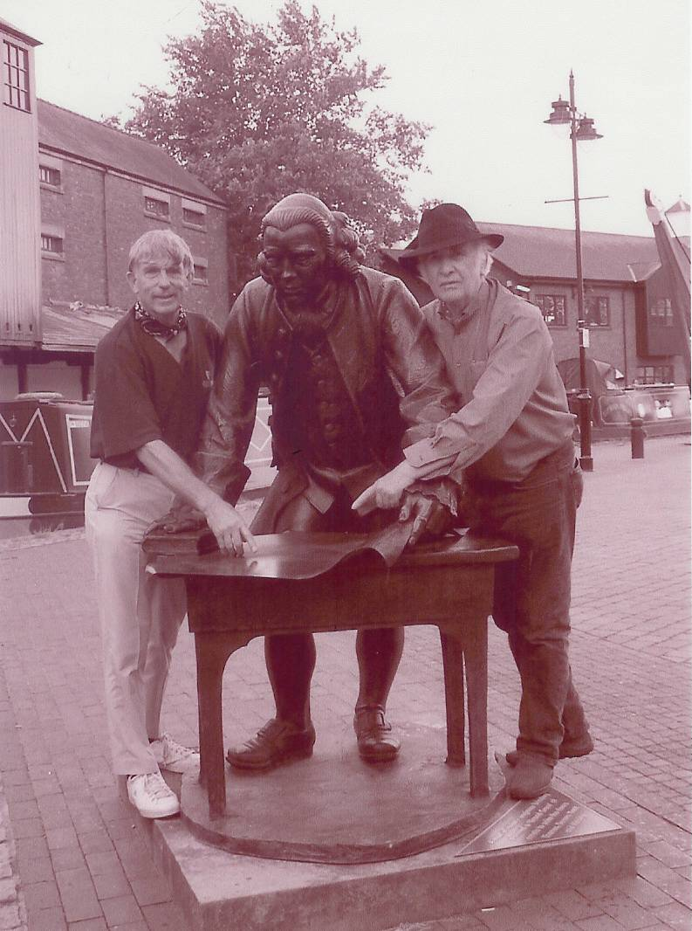
Val Matraves
BERT & BRIAN SEEK A SECOND OPINION

Our next task will be to complete the pipe capping for Stage 1 so that the offside bank (that has to be disturbed to lay the pipe capping in most lengths) can be restored over the capping and left as long as possible to consolidate before profiling. At the same time, weather permitting, we will be excavating for the 50 metre towpath mooring bay that starts some 50 metres beyond the completed lining.
Phase II Estimate and Timescale

I now turn to the big question, how much will Phase II now cost and how long will it take?

My last estimate for the cost of Phase II was £620,000 but this was based on spoil filled gabions and did not allow for the very wet weather we have encountered recently. It was also dependent on the results of the trial section at Drayton Beauchamp just completed.

The cost of hollow concrete blocks, associated concrete fill and coir rolls against wire gabion cages and spoil fill is significant. It also means that we have more spoil to send to tip. If we are to continue work in bad ground conditions, it will be necessary to hire tracked rather than wheeled dumpers. Not only do these cost over three times as much to hire as a wheeled dumper to hire, they move at a slower speed.

Ray Orth (plant hire), Ron Pittaway (materials) and I are meeting to finalise an estimate for Phase II but it will still have to be provisional in that we need to complete Stage 1 to confirm our estimates. My initial shot estimate is that the lining will cost on average around £500 per metre, 2,058 metres = £1,029,000! To this must be added the cost of ancillary works, footbridges, weirs, enlarging the 60ft winding hole at Saxonway Bridge and overheads so a target figure of £1.25m could well be realistic.

In round figures, to date we have spent £100,000, have £350,000 in the bank and have £110,000 yet to come from the BW contribution leaving a further £469,000k to be raised. For this we have mainly been dependent on the annual Festival but the weather let us down this year and the future of the Festival field is in doubt.

David Andrew, our Fund Raising Director, has proposed an appeal on the lines of ‘buy a concrete block’ or ‘sponsor one or more metres of canal lining’. This appeal is going to proceed and could well be the mainstay of our fund raising for completing Phase II.

Although this sum will complete work on Phase II, further funds will be needed to reinforce the canal banks between Buckland Wharf and Wendover so as to raise the water level to Tring summit level for navigation to open as far as the winding hole west of Saxonway Bridge under the new Aston Clinton by-pass. This work is currently under review by a fund raising committee of the Council.

Turning now to timescale. The original target was to complete the five stages in five years. We have already lost over a year building footbridges, repairing Nuttalls bund and carrying out trials for lining the canal and it is more realistic to think of one stage every two years – work will speed up the nearer we get to Little Tring. Currently we lose at least two hours a day just getting plant and equipment to and from Drayton Beauchamp! This gives a target completion date of 2016, six years more than we originally hoped. The bright side is that this does give more time to raise the funds needed to complete Phase II including raising the water level to navigational height.

On both cost and timescale it has become apparent that it will be much more economical to concentrate on one operation at a time, i.e. pipe capping or bank lining or completing the bed leaving the mooring walls as an ‘hospital’ job. We are working in a confined width and find that carrying out more than one operation at a time finds us ‘tripping over each other’!

Another option is to extend the length of our four- day work party to economise on plant hire and handling ready-mix concrete. One operation at a time does not require a large labour force on any one day, say 6 to 8 volunteers. If we could work to a pre-booked volunteer schedule using those still at work over the Saturday and Sunday and retired volunteers on weekdays, it would speed up progress and reduce plant hire costs.

Laying and filling the hollow concrete blocks is a time consuming task. I am wondering, when we have a good length profiled ready for lining and blocking, whether we would be able to engage the services of young offenders, either on community service or residing at HM Prison, the Mount for a concentrated effort at this work?

Any further ideas for fund raising or adding to the volunteer force will be welcome.

Progress Report, Physical and Financial
Readers of this newsletter during Phase I will recall that I gave regular progress reports. This has not been possible for Phase II until now because we have been on a learning curve with the experimental section at Drayton Beauchamp. I can now present a regular report based on the estimate on page 3.
Completion of Stage 1 will allow further refinement of this estimate in due course.

WENDOVER ARM CANAL RESTORATION PHASE IIAS AT 31st OCTOBER 2007

CANAL LINING
Item | Stage 1 | Stage 2 | Stage 3 | Stage 4 | Stage 5 | Stage 6 | Stage 7
Total length | 321m | 350m | 350m | 350m | 350m | 337m | -
Complete to date:
Bulk Excavation | 321m | 25m |  |  |  |  | ---------
Capping to pipe | 159m |  |  |  |  |  | ---------
Tipping to offside bank | 134m |  |  |  |  |  | ---------
Profiling towpath bank | 72m |  |  |  |  |  | ---------
Lining towpath bank | 68m |  |  |  |  |  | ---------
Profiling offside bank | 70m |  |  |  |  |  | ---------
Lining offside bank | 66m |  |  |  |  |  | ---------
Level and line bed | 60m |  |  |  |  |  | ---------
Planting banks |  |  |  |  |  |  | ---------
Mooring wall length | 50m | 50m | -------- | 50m | 50m | -------- | 237m
Excavation |  |  | -------- | 50m |  | -------- | 10m
Blinding |  |  | -------- | 4m |  | --------
Wall base |  |  | -------- | 4m |  | --------
Wall upright |  |  | -------- | 4m |  | --------
Backfill |  |  | -------- |  |  | --------
Estimated Cost | £176,550 | £183,750 | £175,000 | £175,000 | £166,250 | £98,725 | £53,725
Cost to date/final | £42,642 |  |  | £1,268

FOOTBRIDGES & VARIOUS OTHER WORKS
Item | Stage 8 | Stage 9 | Stage 10 | Stage 11 | Stage 12 | Stage 13 | Stage 14
 | Bridge 4 | Bridge 4A | Whitehouses  Weir etc. | Cart track  Narrows  & Weir | Removal  of bunds | Winding  Hole nose | Nuttalls  Bund
Footbridge | 100% | 100% | ---------------- | ----------- | ---------- | ----------- | ----------
Excavation | 100% | 100% | ---------------- |  | ---------- |  | ----------
Blinding | 100% | 100% | ---------------- |  | ---------- |  | ----------
Wall base | 100% | 100% | ---------------- |  | ---------- |  | ----------
Wall upright | 100% | 100% | ---------------- |  | ---------- |  | ----------
Backfill | 100% | 100% | ---------------- |  | ---------- |  | ----------
Weir | --------- | --------- |  |  | ---------- | ----------- | ----------
Heritage work | --------- | --------- |  | ----------- | ---------- | ----------- | ----------
Other work | --------- | --------- | ---------------- | ----------- |  | ----------- | 100%
Estimated cost | £20,000 | £20,000 | £20,000 | £20,000 | £20,000 | £10,000 | £3,500
Cost to date/final | £20,049 | £19,997 |  |  |  |  | 3,501

SUMMARY INCLUDING INDIRECT COSTS
 | Lining | F/bridges  & other  works | Clear bed,  & Temp’y  Works | Environ’t  Reports | Materials  In stock | Admin | Tools &  Equip’t | Vehicle | Unallocated | TOTALS
Estimated cost | £1,029,000 | £113,500 | £15,000 | £3,500 | £0 | 25,000 | 5,000 | 10,000 | £49,000 | £1,250,000
Cost to date/final | £43,910 | 43,547 | £8,216 | £3,245 | £19,297 | £5,998 | £869 | £3,262 |  | £ 128,344

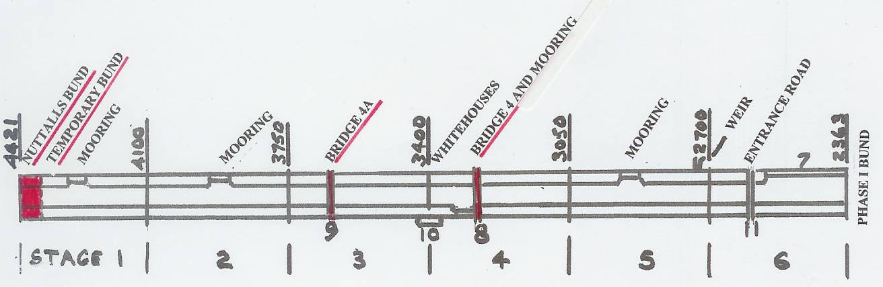

SCHEMATIC PLAN OF PHASE II
(2363 to 4421 are metres from Bulbourne Junc.)

Future Work Parties

Consideration will have to be given to our work party strategy if we are to speed up progress on the restoration and reduce the estimates on page 4.

Ray Orth and I have been considering the use of hired plant. At present our monthly work parties are for four days, Friday to Monday for which we have to pay a week’s hire for plant. Having said this, Morgans, the plant hire firm, are very good to us and reduce the cost if plant is idle on a particular day. Nevertheless, the cost would be the same if we worked for five days so consideration must be given to extending the long weekend by a day, say Friday to Tuesday. Tuesday would be preferable as it gives more flexibility to the delivery of ready-mix concrete and would also allow stripping of formwork on the Tuesday after a Monday pour.

To achieve this without everybody working five days, the suggestion is that a volunteer schedule is agreed in advance based mainly on retired persons manning the weekdays and those still at work the Saturday/Sunday. In particular we must ensure that the hired plant is manned throughout or we will lose out economically. Also, as the need for tracked vehicles is increasing, it will be necessary to train wheeled dumper drivers to handle tracked dumpers. A further consideration is when plant is in intensive use, if there are enough plant operators on site, should we stagger lunch hours so as to maximise utilisation of plant?

Even though a pre-booked volunteer schedule would be introduced, this must not preclude those who cannot commit themselves in advance from coming to work parties. There are always jobs to be done but volunteers should notify those in charge at least the evening before as it is difficult to employ anyone turning up unexpectedly if the necessary tools and/or equipment have not been provided at Drayton Beauchamp.

Ron Pittaway
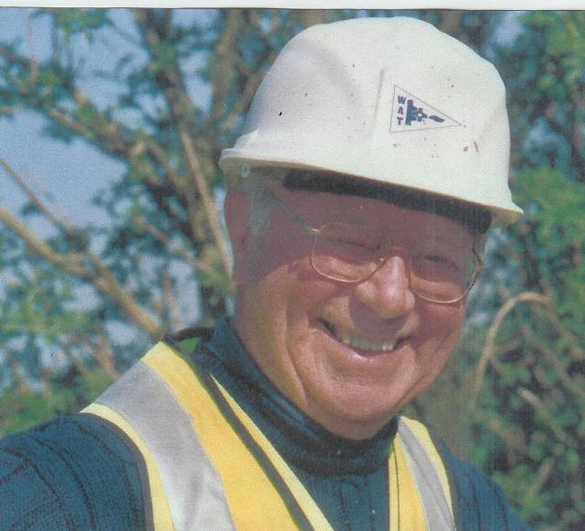
Margaret Leishman
Ron has decided that, as he will be 80 next birthday, he will have to relinquish coming to our work parties. He is also resigning as a WAT Council member. Fortunately he has agreed to continue as our procurement expert and remain a member of the Restoration Committee.

Ron was very much involved from the start of Phase I in 1997 and I am sure that you will all join me in thanking Ron for his sterling efforts in more than one way in supporting and progressing the restoration for so many years. Many thanks Ron from all of us.

Web Site

The address of the Trust Restoration web site managed by Oliver Revel (that is linked to the main Trust site) is:

http://wendovercanal.org.uk/

The number of e-mail recipients of this newsletter is growing. If you give me a request for e-mail transmission I will do so but please let me know if the attachment does not arrive. Please note that new volunteers are automatically sent the Working Party news by post unless they request that it is to be sent by e-mail.

First Aid

We still need volunteers who regularly come to work parties to take a First Aid Course so that we have a qualified first aider on site at work parties. Jon Kelly is our first volunteer to join Dave Barratt and will be taking his course soon. The Trust will pay any fees and expenses. Please let Ray Orth know if you are willing to help.

Insurance

It is incumbent on anyone, regardless of age, to inform the Trust in writing if they suffer from any medical condition that could in any way affect their ability to carry out their work as a Trust Work Party Volunteer.

General Notes.

All volunteers receive and sign for the Trust’s Restoration Manual that includes full Health and Safety requirements for the restoration works. The Manual is the property of the Trust; if you leave the working parties for any reason, please return the Manual to either Ray Orth or myself.

The Restoration Manual is currently being updated to take into account procedures for

the lining in Phase II and new BW requirements under their procedures for treating us as a self-supervising contractor. New volunteers will receive their copies as soon as the revisions are completed.

David Barratt is our qualified First-Aider and, even if he is not on site, lives in Pitstone and can be contacted on 07973 411176 if he is at home.

Hard hats for use at all times and high visibility jackets to be worn on sites with mobile plant in use are kept in the store at Tringford and must be drawn/returned there. One first aid kit is kept in the store; another is kept in the VW transporter for use on site. Also available in the transporter are ear defenders and goggles that must be worn when using strimmers, angle grinders, concrete breakers and the like. Individual volunteers must provide their own gloves and footwear with reinforced toecaps.

We normally work from 9am to 5pm (or dark if earlier!) when we are hiring plant or taking delivery of ready-mix concrete early in the morning. There are breaks for morning coffee/tea, packed lunch and afternoon tea/coffee. We take our own food and drinks.

DATES FOR WORKING PARTIES
DATE (2007) | WORKING AT | WORK TO BE DONE
Friday 2nd November to Monday 5th November | Drayton Beauchamp | Continue with pipe capping.  Planting verges of completed length of canal including sourcing aquatic plants and re-watering.
Thursday 8th November | Various | Scrub clearance and bonfiring. Strip pipe capping formwork.
Friday 30th November to Monday 3rd December | Drayton Beauchamp | Continue with pipe capping and possibly work on towpath mooring bay.
Thursday 13th December | Various | Scrub clearance and bonfiring. Strip pipe capping formwork.
DATE (2008)
Friday 4th January to  Tuesday 8th January | Drayton Beauchamp | Continue with pipe capping and possibly work on towpath mooring bay.
Thursday 10th January | Various | Scrub clearance and bonfiring. Strip pipe capping formwork.
Friday 1st February to  Tuesday 5th February | Drayton Beauchamp | Continue with pipe capping and possibly work on towpath mooring bay.
Thursday 14th February | Various | Scrub clearance and bonfiring. Strip pipe capping formwork.

Roger Leishman, Restoration Director. 7 Hall Park, Berkhamsted, Herts HP4 2NU.
(Tel:01442 874536, e-mail rleishman@ukgateway.net)

WORK PARTY VOLUNTEER SCHEDULE TO FEBRUARY 2008

We intend to experiment with the five-day work parties commencing in January 2008. With the December newsletter I will be sending all work party volunteers a form to complete for the January and February work parties and hope that this will be successful.

Date 2007 | Location
Fri 2 Nov | Drayton Beauchamp | R Orth/  R Leishman | K Graves
Sat 3 Nov  NWPG | Drayton Beauchamp | R Orth/  R Leishman | K Graves  R Berry | B Fletcher
Sun 4 Nov  NWPG | Drayton Beauchamp | R Orth/  R Leishman | K Graves | B Fletcher
Mon 5 Nov | Drayton Beauchamp | R Orth/  R Leishman | K Graves
Thur 8 Nov | Various | P Bowers
Fri 30 Nov | Drayton Beauchamp | R Orth/  R Leishman | K Graves  N Williams
Sat 1 Dec | Drayton Beauchamp | R Orth/  R Leishman | K Graves | B Fletcher
Sun 2 Dec | Drayton Beauchamp | R Orth | K Graves | B Fletcher
Mon 3 Dec | Drayton Beauchamp | R Orth/  R Leishman | K Graves
Thu 13 Dec | Various | P Bowers
Date 2008 | Drayton Beauchamp
Fri 4 Jan | Drayton Beauchamp | R Orth/  R Leishman
Sat 5 Jan | Drayton Beauchamp | R Orth/  R Leishman
Sun 6 Jan | Drayton Beauchamp | R Orth
Mon 7 Jan | Drayton Beauchamp | R Orth/  R Leishman
Tue 8 Jan | Drayton Beauchamp | R Orth/  R Leishman
Thu 10 Jan | Various | P Bowers
Fri 1 Feb | Drayton Beauchamp | R Leishman
Sat 2 Feb  LONDON WRG | Drayton Beauchamp | R Leishman
Sun 3 Feb  LONDON WRG | Drayton Beauchamp | R Leishman
Mon 4 Feb | Drayton Beauchamp | R Leishman
Tue 5 Feb | Drayton Beauchamp | R Leishman
Thu 14 Feb | Various | P Bowers

The name of the person in charge on a particular day/site is printed in italics.
P Bowers 01255 504540 or 07880 744730 R Leishman 01442 874536 or 07850 170858
R Orth 01494 786868 or 07733 092034

You will note from the above roster that we have two groups visiting us in the near future.
The Newbury Work Party Group will be coming to our November work party and WRG (London) will be coming to our February work party. Many thanks to both groups for coming to help us.

