
THE WENDOVER ARM TRUST
WORKING PARTY NEWS

ISSUE 56 August 2006

Festival 2006

Further to my report in the last newsletter, I am now told that the profit from the festival is more like £40,000 – amazing considering the weather.

Phase II, Stage 31 – Lining and mooring 4100 to 4221

At last we have plugged the leak in the Nuttall’s bund at Drayton Beauchamp although it took a solid block of concrete to seal the end of the stone filled gabions that were causing all the trouble because there was no watertight seal installed when the bund was constructed. What is aggravating about this problem is that has taken 18 days of work parties to resolve, time that could have been better spent on true restoration work. This new concrete plug will also make clear the 14ft narrows that will result from leaving the sump to the pipeline in place.

During the August working week (nine days!) work was able to proceed on the first length of lining as proposed in the June Newsletter. This was highly successful in that we at last can see a method of lining that is practical and associated with a straightforward method of working. The main constrictions on our working are

- After capping the pipe trench, tipping is required on the offside and must be left to settle for at least six months before lining and

- Wet weather precludes working on the bed of the canal, as it becomes a mud bath if churned up by mechanical plant.

Finally, a word of thanks to Anthony Tidey of the Wilts & Berks Canal Trust and Phil Cardy, Mark Gribble, Dave Wedd and Stella Wentworth of BITM who joined us for part or all of our nine day work party as well as to our own volunteers out in force as usual.

Phase II, Stage 34 – Lining and mooring 3050 to 3400

No further work has taken place since the bulk excavation for the 50 metres long mooring on the off side immediately west of bridge 4. If there are spare resources from other more urgent work the blinding for this wall will be laid thus enabling further work to be done if weather conditions prevent access to Drayton Beauchamp.

Phase II, Stage 38 – Footbridge 4

The last six steps have been fixed but the deck boards still have to be fixed in position. This is scheduled for the September work party.

The timber handrails of the footbridge have many splits and gaps with sharp edges that still require attention as well as trimming the end of all rails.

The steel stop plank grooves for the east end of the channel have been delivered and will be installed with the blinding for the walls and be fully cast in as the bases and walls are cast. This work has had to take second priority to the work at Drayton Beauchamp.

Phase II, Stage 39 – Footbridge 4A

The last six steps have been fixed but the deck boards still have to be fixed in position. This is scheduled for the September work party.

The timber handrails of the footbridge have many splits and gaps with sharp edges that, as in Bridge 4, still require attention as well as trimming the end of all rails.

The bases have been cast for the offside wing walls and most of the blinding completed for one of the towpath side wing walls. It is hoped to continue this work at the September work party but this will depend on the number of volunteers available.

Visit by the Lord Lieutenant of Hertfordshire

On Saturday 5th August 2006, the first day of our nine-day work party, our Vice President, Roger Lewis gave Sir Simon Bowes Lyon, the Lord Lieutenant of Hertfordshire, a conducted tour of our restoration work. He visited both the completed Phase I and work in progress on Phase II.

I have since received a letter from Sir Simon in which he says

“It was a great pleasure to meet with you on your working site at the canal and I found my visit most informative. I did not realise until my visit what an ambitious project this is and the completed work is certainly most impressive”

Phase II, Opening of footbridges

There will be a formal opening of both footbridges on Saturday 21st October 2006 and it is hoped that as many volunteers as possible will attend. I do not yet know whether it will be morning or afternoon.

A point that applies to both footbridges is that their completion has to be second priority to the lining work at Drayton Beauchamp. This means that it is unlikely that the access to the steps will be available in permanent form for the proposed opening in October.

Anglia Television ‘Country Days’

On Thursday 10th August we were interviewed at work by Pam Rhodes and filmed for a regular programme on Anglia TV called Country Days. I was told that it is likely to be broadcast on Anglia Television sometime in October.

To start with Pam Rhodes interviewed Barry Martin about the history of the Wendover Arm.
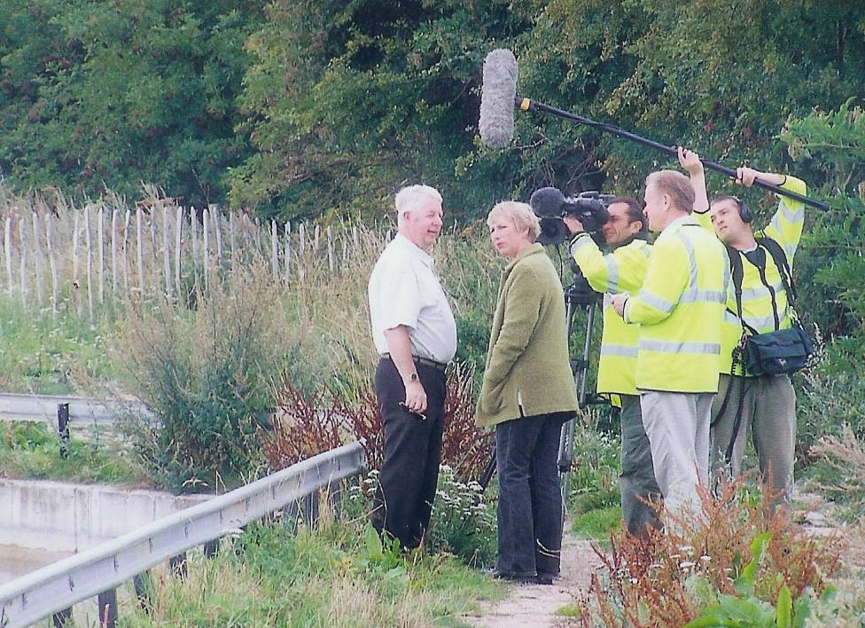

Next Pam interviewed me about the completed Phase I and was particularly impressed by the new Little Tring Bridge.
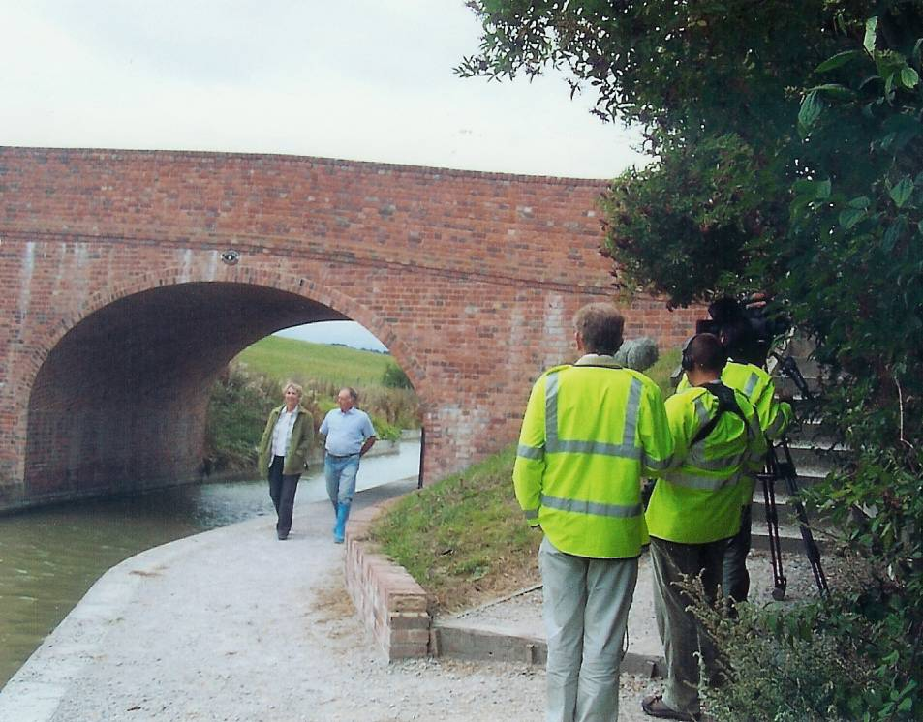

Then Pam interviewed Ron Pittaway about the footbridges.
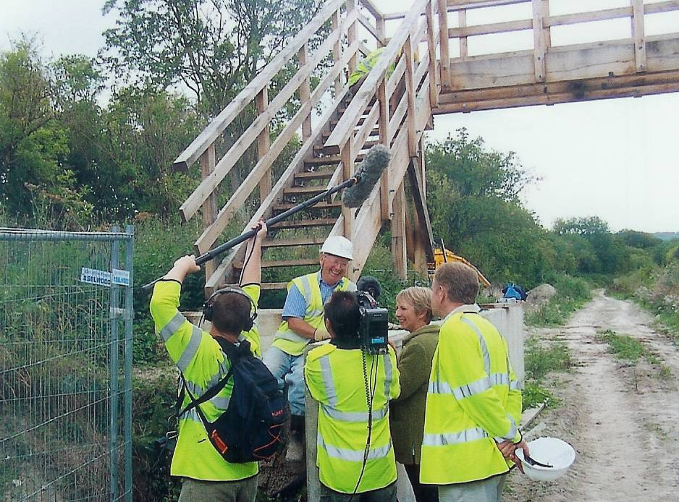

Finally Pam interviewed Ray Orth about the work in progress at Drayton Beauchamp and we were asked to demonstrate the laying of Bentomat lining that the film team had previously filmed being loaded at Little Tring.
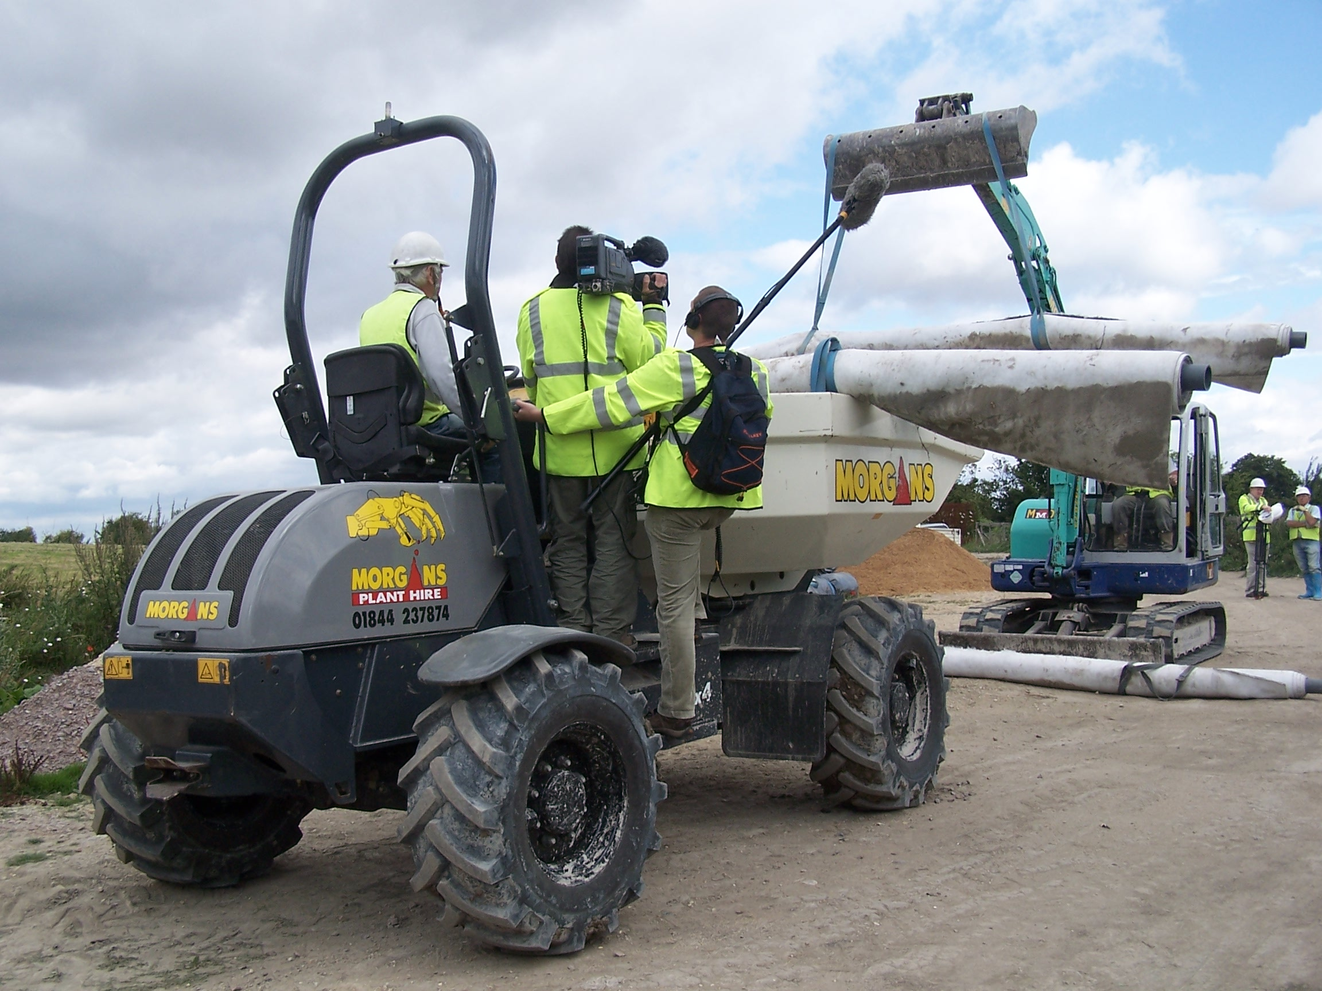

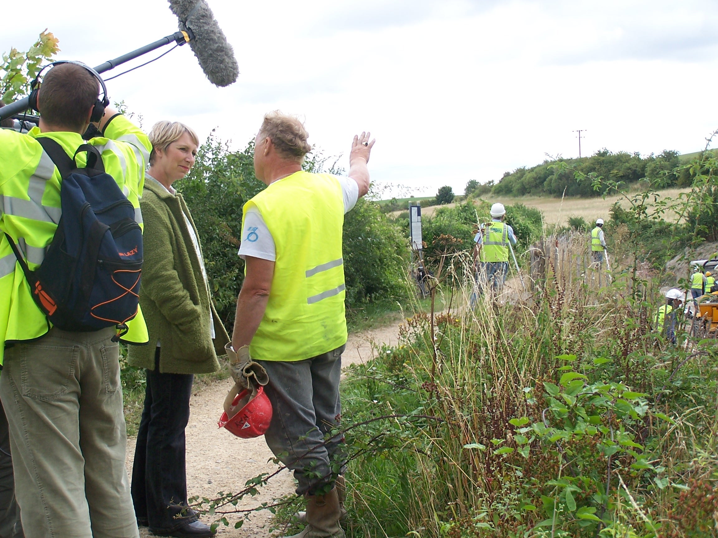

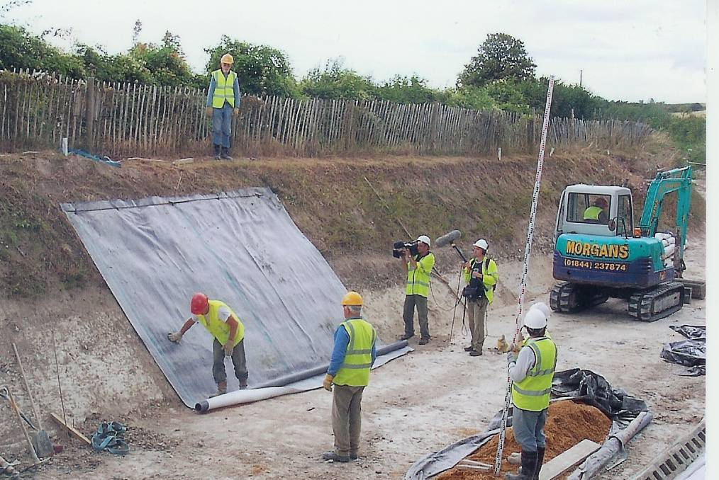
Close inspection at bottom right of this picture will reveal the hollow concrete blocks laid on the Bentomat lining.

Photographs by Margaret Leishman

Site Security

Despite my plea to leave padlocks and chains secure round a gate bar by whoever opens a gate
I am still finding unsecured padlocks and chains! Anyone could have walked off with the padlock and chain! Please ensure that the padlock and chain are left secure round gate bars if you open any of our gates.

Woodwork Vice

Ron Pittaway has been given a 9” Record Woodworkers Bench Vice.
This is in good condition and is ‘free’ to anyone in return for a donation to the Trust.

Web Site

The address of the Trust Restoration web site managed by Oliver Revel (that is linked to the main Trust site) is:
http://wendovercanal.org.uk/

E-mail

I am still receiving requests for this newsletter to be sent to readers by e-mail; this does save the Trust postage costs. If you give me a request for e-mail transmission I will do so but please let me know if the attachment arrives or not.

Wendover Trust Mugs

Please see Ray Orth or myself if you want Trust mugs. They are bone china, £6 each, two for £11.50 or four for £22. If you have not seen them, they commemorate the opening of Phase I with a view through Little Tring Bridge on both sides with ‘Wendover Arm Trust 2005’ underneath.

Insurance

It is incumbent on anyone, regardless of age, to inform the Trust in writing if they suffer from any medical condition that could in any way affect their ability to carry out their work as a Trust Work Party Volunteer.
User Manuals will be updated to include this requirement so that, when you sign that you have read your manual, or amendments to it, you will acknowledge your responsibility in this matter. Any incident arising from an undeclared medical condition is not covered by the Trust’s insurance.

General Notes.

All volunteers receive and sign for the Trust’s Restoration Manual that includes full Health and Safety requirements for the restoration works. The Manual is the property of the Trust; if you leave the working parties for any reason, please return the Manual to either Ray Orth or myself.

David Barratt is our qualified First-Aider and, even if he is not on site, lives in Pitstone and can be contacted on 07973 411176 if he is at home.

Hard hats for use at all times and high visibility jackets to be worn on sites with mobile plant in use are kept in the store at Tringford and must be drawn/returned there. One first aid kit is kept in the store; another is kept in the VW transporter for use on site. Also available in the transporter are ear defenders and goggles that must be worn when using strimmers, angle grinders, concrete breakers and the like. Individual volunteers must provide their own footwear with reinforced toecaps.

We normally work from 9am to 5pm (or dark if earlier!) when we are hiring plant or taking delivery of ready-mix concrete early in the morning. There are breaks for morning coffee/tea, packed lunch and afternoon tea/coffee. We take our own food and drinks. However, do not feel bound by these times, as half a day is better than no help at all.

DATES FOR WORKING PARTIES

DATE (2006) | WORKING AT | WORK TO BE DONE
Friday 1st September | Drayton Beauchamp and footbridges. | Lining work at Drayton Beauchamp including completion of block wall opposite sump, bulk excavation and preparation for pipe capping. Laying boards to footbridges and fettling timber.  Wing walls and bases at footbridges
Saturday 2nd September | Drayton Beauchamp and footbridges. | -do-
Sunday 3rd September | Drayton Beauchamp and footbridges. | -do-
Monday 4th September | Drayton Beauchamp and footbridges. | Ready-mix concrete for blinding/bases, pipe capping and bund.
Friday 6th October | Drayton Beauchamp and footbridges. | Lining work at Drayton Beauchamp including bulk excavation and preparation for pipe capping. Laying boards to footbridges and fettling timber if not completed in September.  Wing walls and bases at footbridges
Saturday 7th October | Drayton Beauchamp and footbridges. | -do-
Sunday 8th October | Drayton Beauchamp and footbridges. | -do-
Monday 9th October | Drayton Beauchamp and footbridges. | Ready-mix concrete for blinding/bases and pipe capping.
Saturday 21st October | Footbridges | Formal opening of footbridges.
Friday 3rd November | Drayton Beauchamp and footbridges. | Lining work at Drayton Beauchamp including bulk excavation and preparation for pipe capping. .  Wing walls and bases at footbridges
Saturday 4th November | Drayton Beauchamp and footbridges. | -do-
Sunday 5th November | Drayton Beauchamp and footbridges. | -do-
Monday 6th November | Drayton Beauchamp and footbridges. | Ready-mix concrete for blinding/bases and pipe capping.
Friday 1st December | Drayton Beauchamp and footbridges. | Lining work at Drayton Beauchamp including bulk excavation and preparation for pipe capping. .  Wing walls and bases at footbridges
Saturday 2nd December | Drayton Beauchamp and footbridges. | -do-
Sunday 3rd December | Drayton Beauchamp and footbridges. | -do-
Monday 4th December | Drayton Beauchamp and footbridges. | Ready-mix concrete for blinding/bases and pipe capping.

Roger Leishman, Restoration Director. 7 Hall Park, Berkhamsted, Herts HP4 2NU.
(Tel:01442 874536, e-mail rleishman@ukgateway.net)

WORK PARTY VOLUNTEER SCHEDULE TO DECEMBER 2006
Date | Location
Fri 1 Sep | Little Tring to Drayton B’Champ | R Leishman and/or  R Orth | N Williams  (C Reed)
Sat 2 Sep | Little Tring to Drayton B’Champ | R Leishman and/or  R Orth | B Ing
Sun 3 Sep | Little Tring to Drayton B’Champ | R Leishman and/or  R Orth | B Ing
Mon 4 Sep | Little Tring to Drayton B’Champ | R Leishman and/or  R Orth | D Cater
Fri 6 Oct | Little Tring to Drayton B’Champ | R Leishman and/or  R Orth | B Ing  D Cater
Sat 7 Oct | Little Tring to Drayton B’Champ | R Leishman and/or  R Orth | B Ing  D Cater
Sun 8 Oct | Little Tring to Drayton B’Champ | R Leishman and/or  R Orth | R Waters
Mon 9 Oct | Little Tring to Drayton B’Champ | R Leishman and/or  R Orth | (D Cater)
Fri 3 Nov | Little Tring to Drayton B’Champ | R Leishman and/or  R Orth | N Williams  (C Reed) | B Ing
Sat 4 Nov | Little Tring to Drayton B’Champ | R Leishman and/or  R Orth | D Cater | B Ing
Sun 5 Nov | Little Tring to Drayton B’Champ | R Leishman and/or  R Orth |  | B Ing
Mon 6 Nov | Little Tring to Drayton B’Champ | R Leishman and/or  R Orth | (D Cater)
Fri 1 Dec | Little Tring to Drayton B’Champ | R Leishman and/or  R Orth | B Ing
Sat 2 Dec | Little Tring to Drayton B’Champ | R Leishman and/or  R Orth | P Cardy | B Ing
Sun 3 Dec | Little Tring to Drayton B’Champ | R Leishman and/or  R Orth | P Cardy | B Ing
Mon 4 Dec | Little Tring to Drayton B’Champ | R Leishman and/or  R Orth

(……….) Indicates provisional

The name of the person in charge on a particular day/site is printed in italics.
P Bowers 01255 504540 or 07880 744730 E Evans 01628 526236 or 01628 526898
R Leishman 01442 874536 or 07850 170858 R Orth 01494 786868 or 07733 092034
R Pittaway 01296 630968 or 07946 484156 K Graves 01494 563813

