THE WENDOVER ARM TRUST
WORKING PARTY NEWS
ISSUE 54 April 2006

I have deliberately held back publication of this newsletter until May so that I can, firstly, report progress on the footbridges and, secondly, give our work party schedule for the 2006 Festival.

It was originally intended to erect the footbridges over the early May Bank Holiday weekend but it was agreed between Ray Orth, Ron Pittaway and myself that there was a risk of slowing down the work because of large members of the public on the towpath over that weekend. We therefore advanced the work to commence on Tuesday 25th April and asked the necessary number of weekday volunteers to help us over the three days, Tuesday to Thursday. Our decision was justified in that there were no walkers on the Tuesday when we moved the first bridge but there were continuous walkers over the following weekend. By the end of the first day, Tuesday, the span of 4A was ready for lifting in position on the trestles as seen in this picture below.
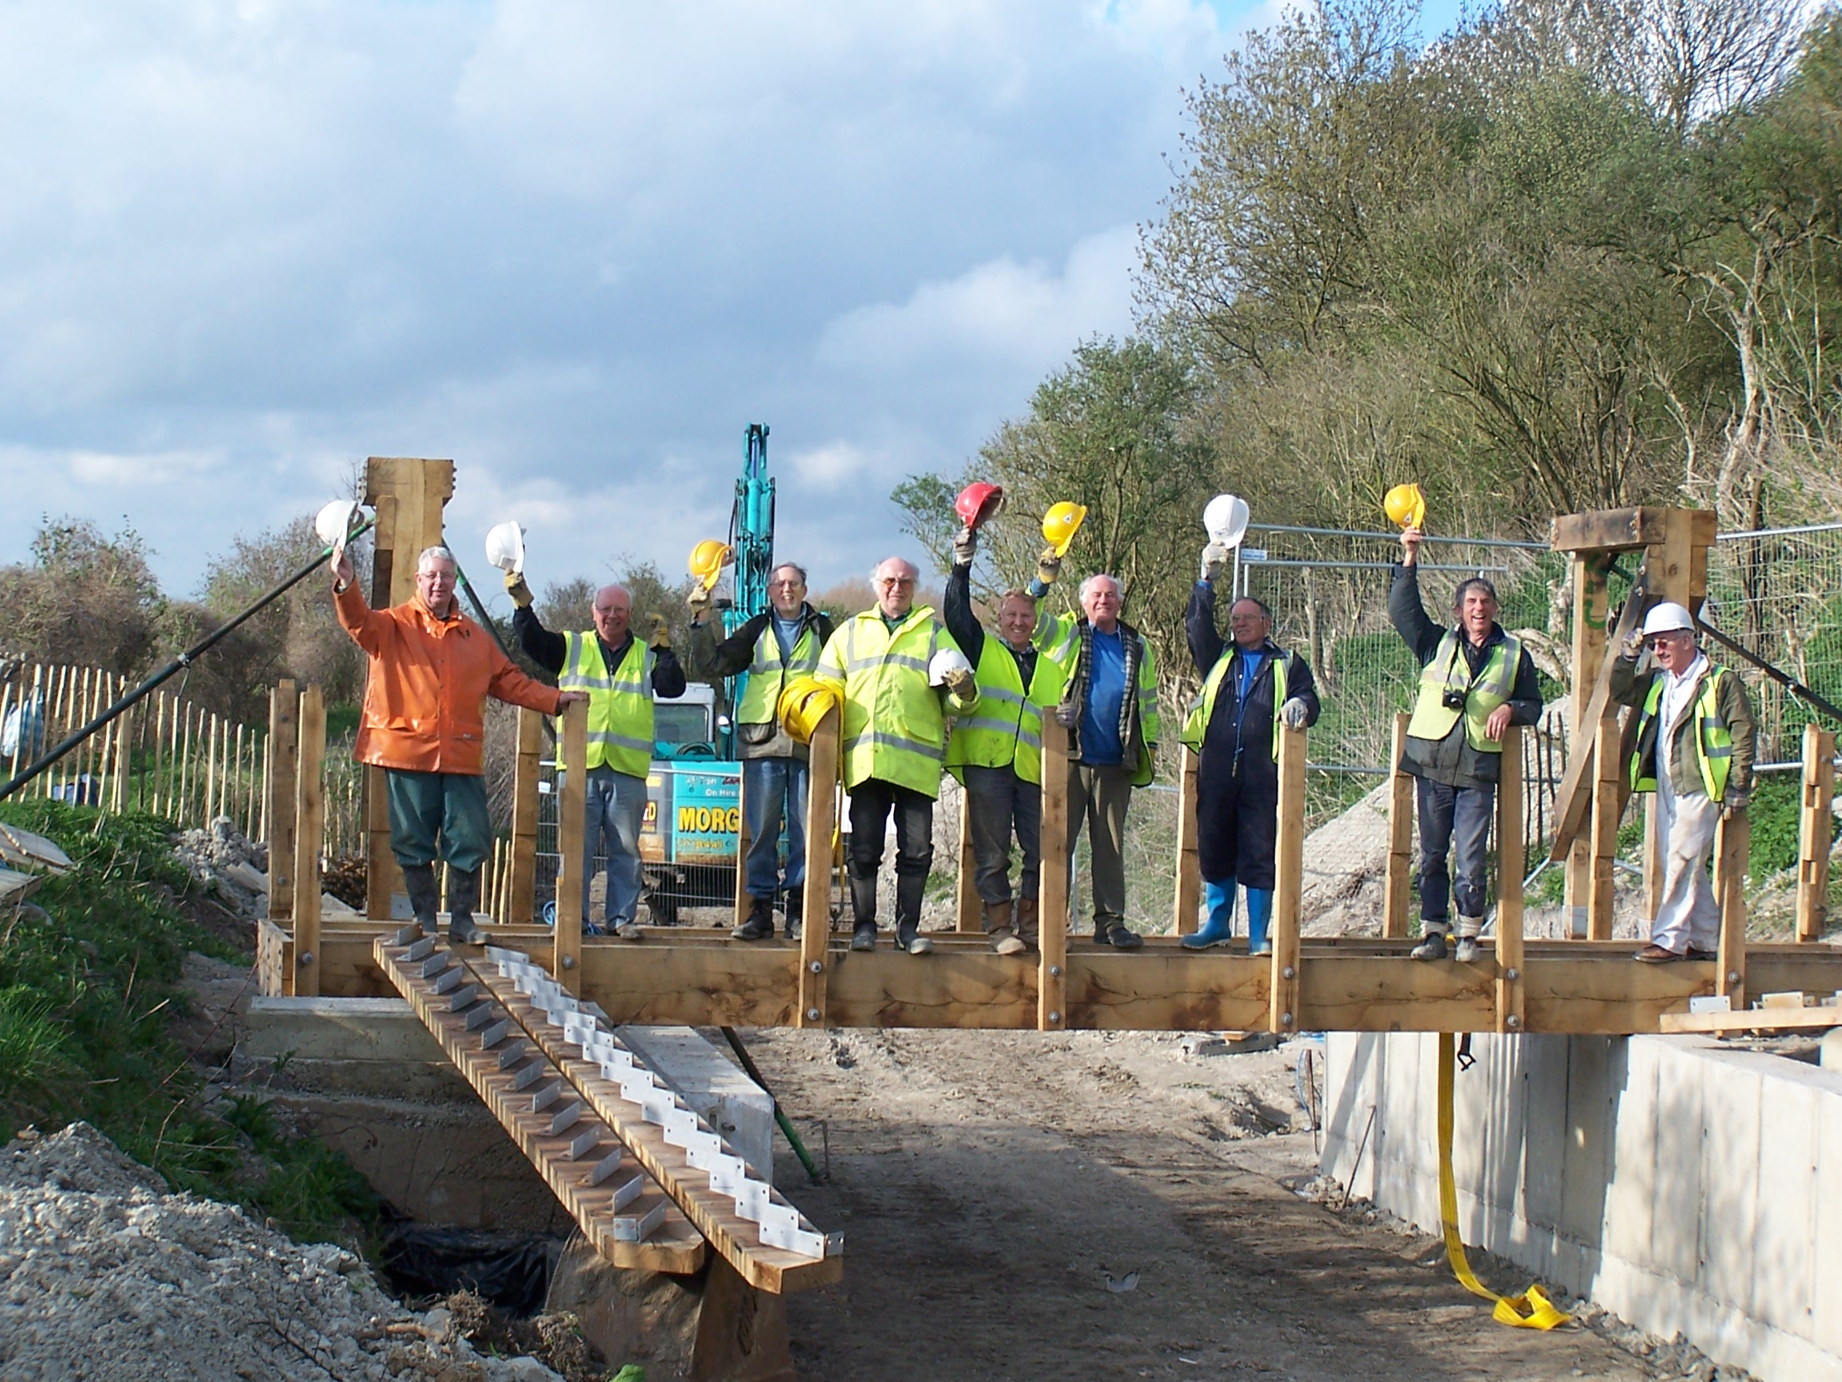

By the end of the second day the main structure of footbridge 4A was completed. This was our learning curve! On the third day, the main structure of footbridge 4 was completed in half the time!

On the following days we completed the handrails and various fixings but have had to wait to complete the steps and decking of both footbridges until they have been routed to take plaques recording donations. Many thanks to Ron Pittaway for organising the routing.

On the Saturday to Monday we were ably assisted by KESCRG who cut and bent steel reinforcement mesh to cover most, if not all, of our requirements for this year and also cleared and levelled the remainder of the area up to our inner entrance gate for parking and storage of materials. Many thanks KESCRG for your assistance.

I must also thank Ken Graves who has produced all the drawings for the reinforced concrete wing walls and mooring lengths as well as fabricating the timber formwork for the 45-degree angle sections. Ken has spent around 70 hours at home on this task!

Phase II, Stage 31 – Lining and mooring 4100 to 4221

Still no progress with the lining at Drayton Beauchamp, due to adverse weather conditions. It is intended to re-start work at the 2006 Festival in May.

There has been much debate on the construction method to be used for the lining. The current proposal is to lay Bentonite down the banks only extending far enough into the level bed for an overlap with Bentonite laid along the level bed when the banks are completed. The Bentonite on the banks will be anchored using horizontal rods secured by pins at regular intervals. Two or three horizontal rows of hollow concrete blocks will then be bedded on concrete haunching at the bottom of the bank including concrete filling of the hollows. Then horizontal rows of solid concrete blocks will be laid up to ‘Wendover’ water level. Finally the Bentonite will be covered in spoil to above water level with a mesh covering to prevent erosion. When both banks are completed, Bentonite will be laid along the bed overlapping the Bentonite on the banks and finally covered with 12” (300mm) of spoil.

The intention is to construct bunds at regular intervals as work progresses and as each new bund is constructed the previous bund will be breached to allow water into the canal to keep the Bentonite moist. Aquatic plants can then be planted on both sides at (Wendover) water level. When work on Phase II is finally complete, the temporary bunds will be removed by dredging.

Phase II, Stage 34 – Lining and mooring 3050 to 3400

During recent work on the footbridges there has been spare excavator and dumper time that has been employed to complete the bulk excavation for the 50 metre visitor mooring on the off side immediately west of bridge 4. Any further spare resources will be used to excavate the final few inches for the blinding, place formwork and pour the blinding with surplus ready-mix concrete from other works. This mooring is on the offside because the position of footbridge 4 centrally over the pipeline does not allow room for a mooring lay-by on the towpath side and there is easy access from the towpath via the footbridge.

Phase II, Stage 38 – Footbridge 4

The straight reinforced concrete walls on each side of the narrows, backfill behind the walls, with areas of weak mix concrete and concrete pads on top for the main supports and bottom of the steps of the footbridge were completed at the March work party.

BW has supplied us with details of the stop plank grooves etc. required at the east end of the narrows after which the 45-degree end walls will be cast.

There will also be 45 degree ends to the west end of the walls but the offside wall will be inset a narrow boat’s width and extended 50 metres for the short term visitor mooring.

The opportunity has also been taken to cut down the scrub, mainly old elder trees, before the nesting season commences in order to clear the future route of the diverted footpath from the gate on the BW boundary to the bottom of the offside steps.

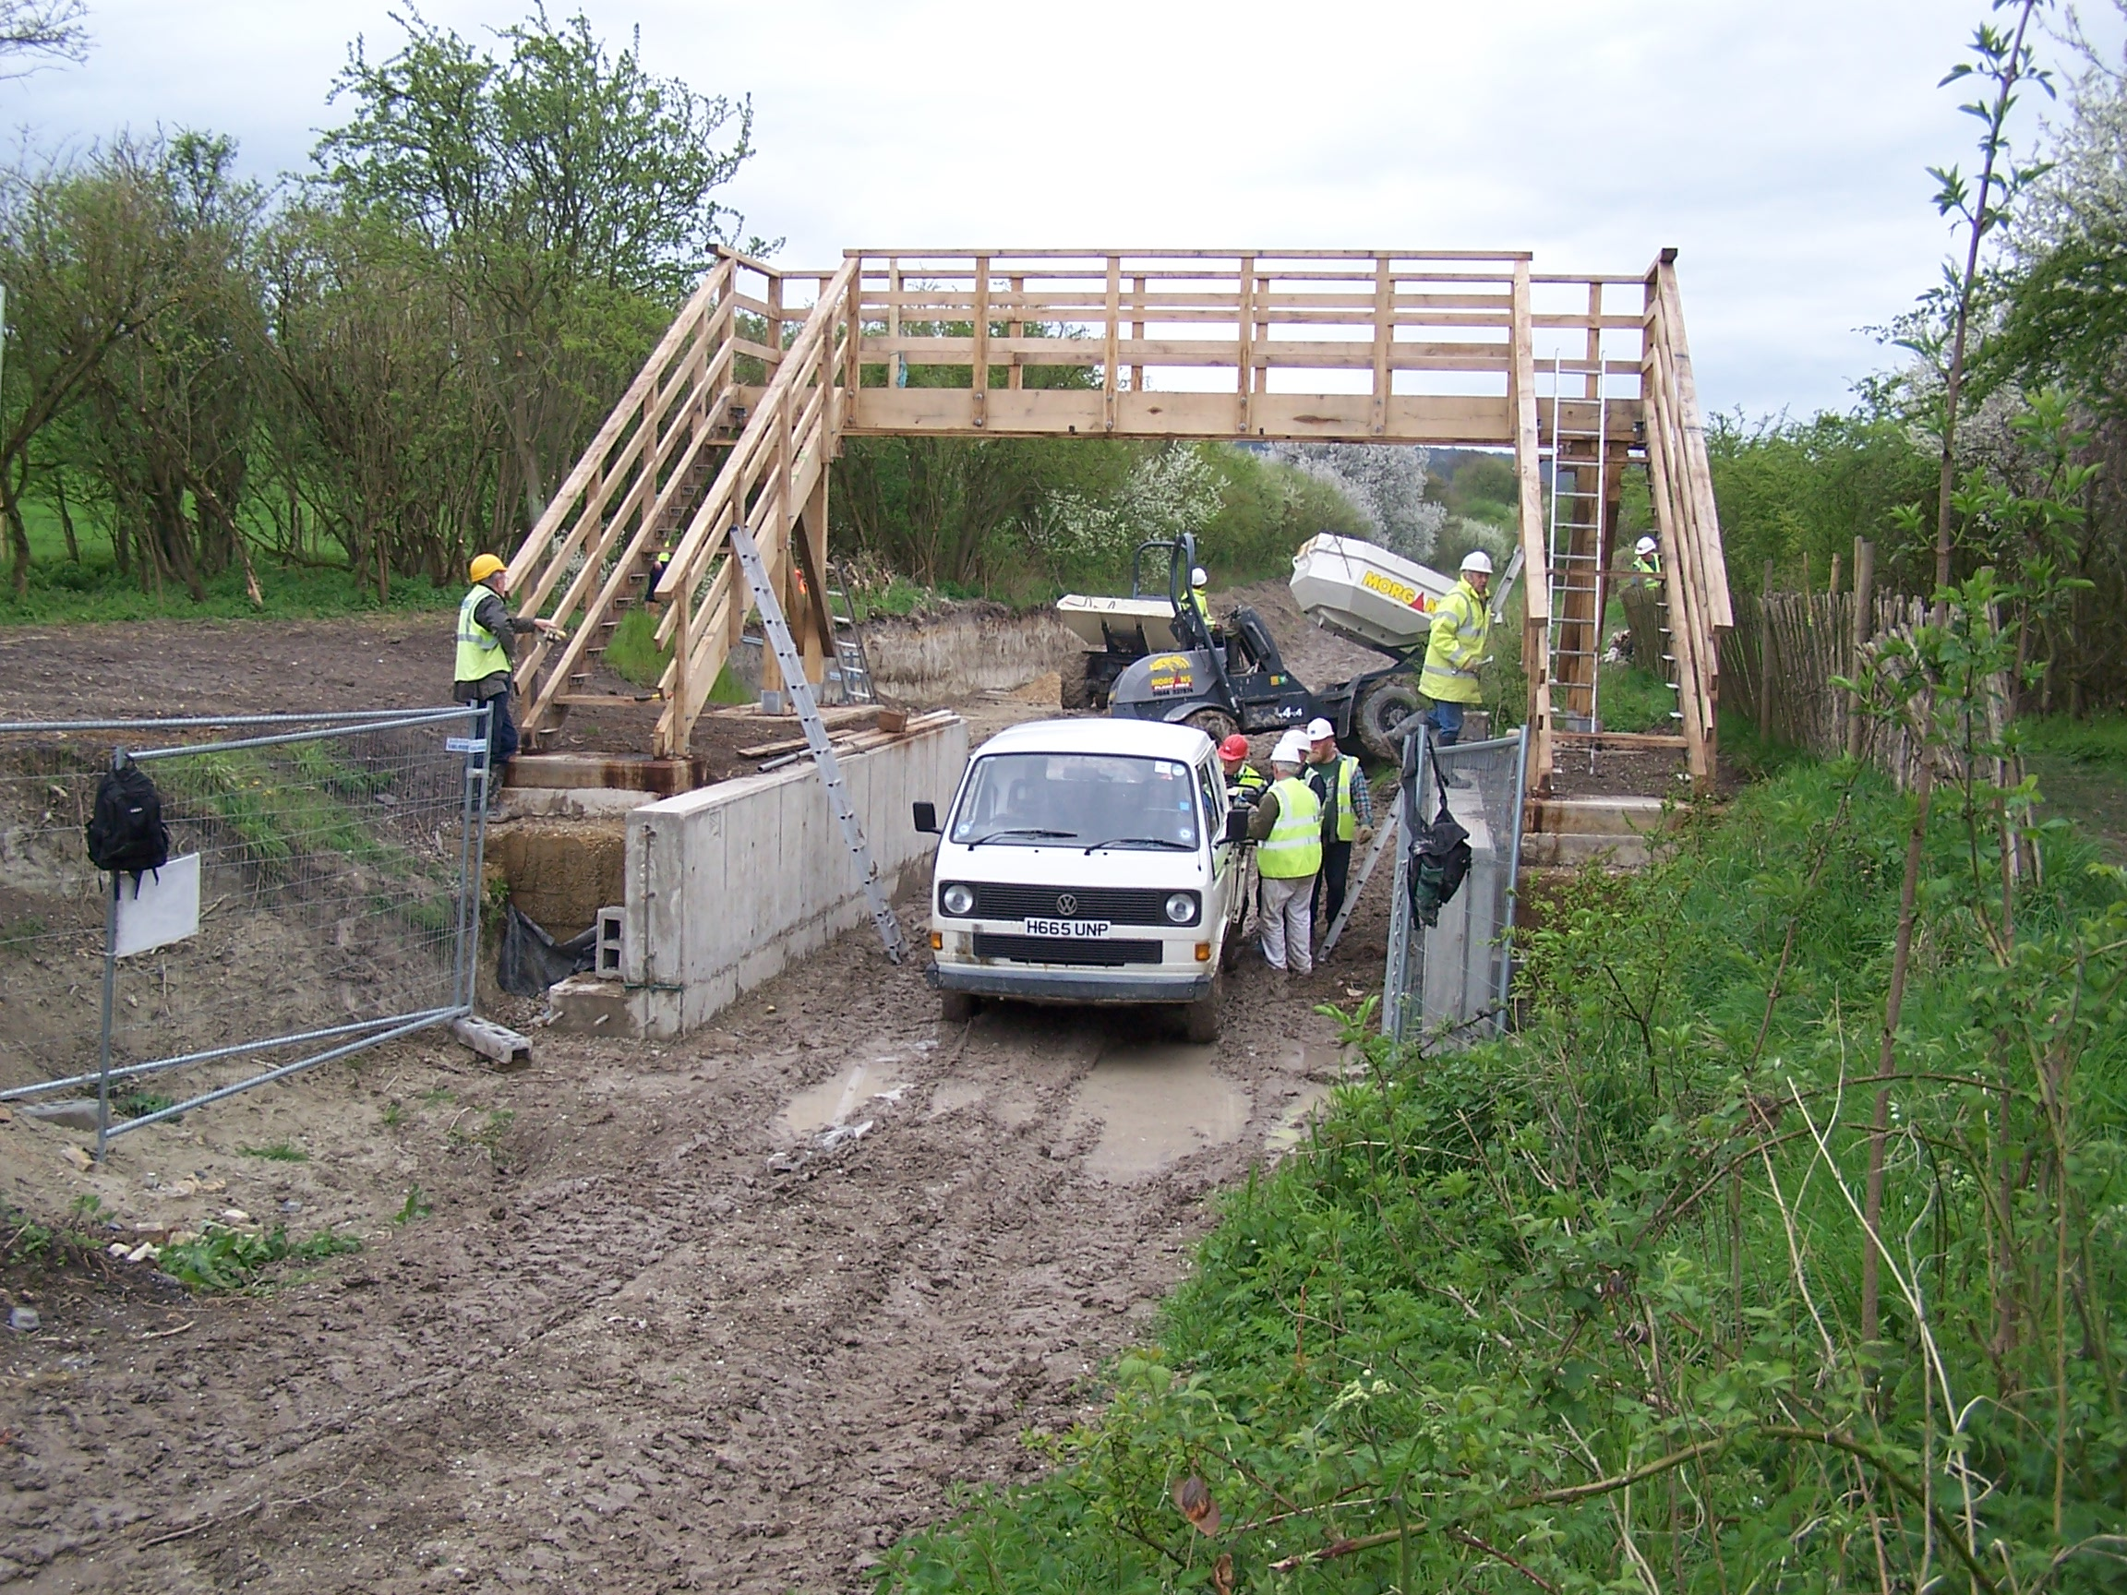

As you can see this footbridge is now in position other than for stair treads and deck boards that are being routed ready for the plaques that are being sponsored by donation.

You can also see in the background the offside excavation for the future short-term mooring

Phase II, Stage 39 – Footbridge 4A

The straight reinforced concrete walls on each side of the narrows, backfill behind the walls, with areas of weak mix concrete and concrete pads on top for the main supports and bottom of the steps of the footbridge were completed at the April work party. Blinding has also been laid ready for the wing walls on the offside.

As you can see, this footbridge is also complete other than for stair treads and deck boards. Some of the hard working construction gang are assembled on the span.

In the foreground the excavation for wing walls on the towpath side is underway and was completed at the May work party ready for blinding in due course.
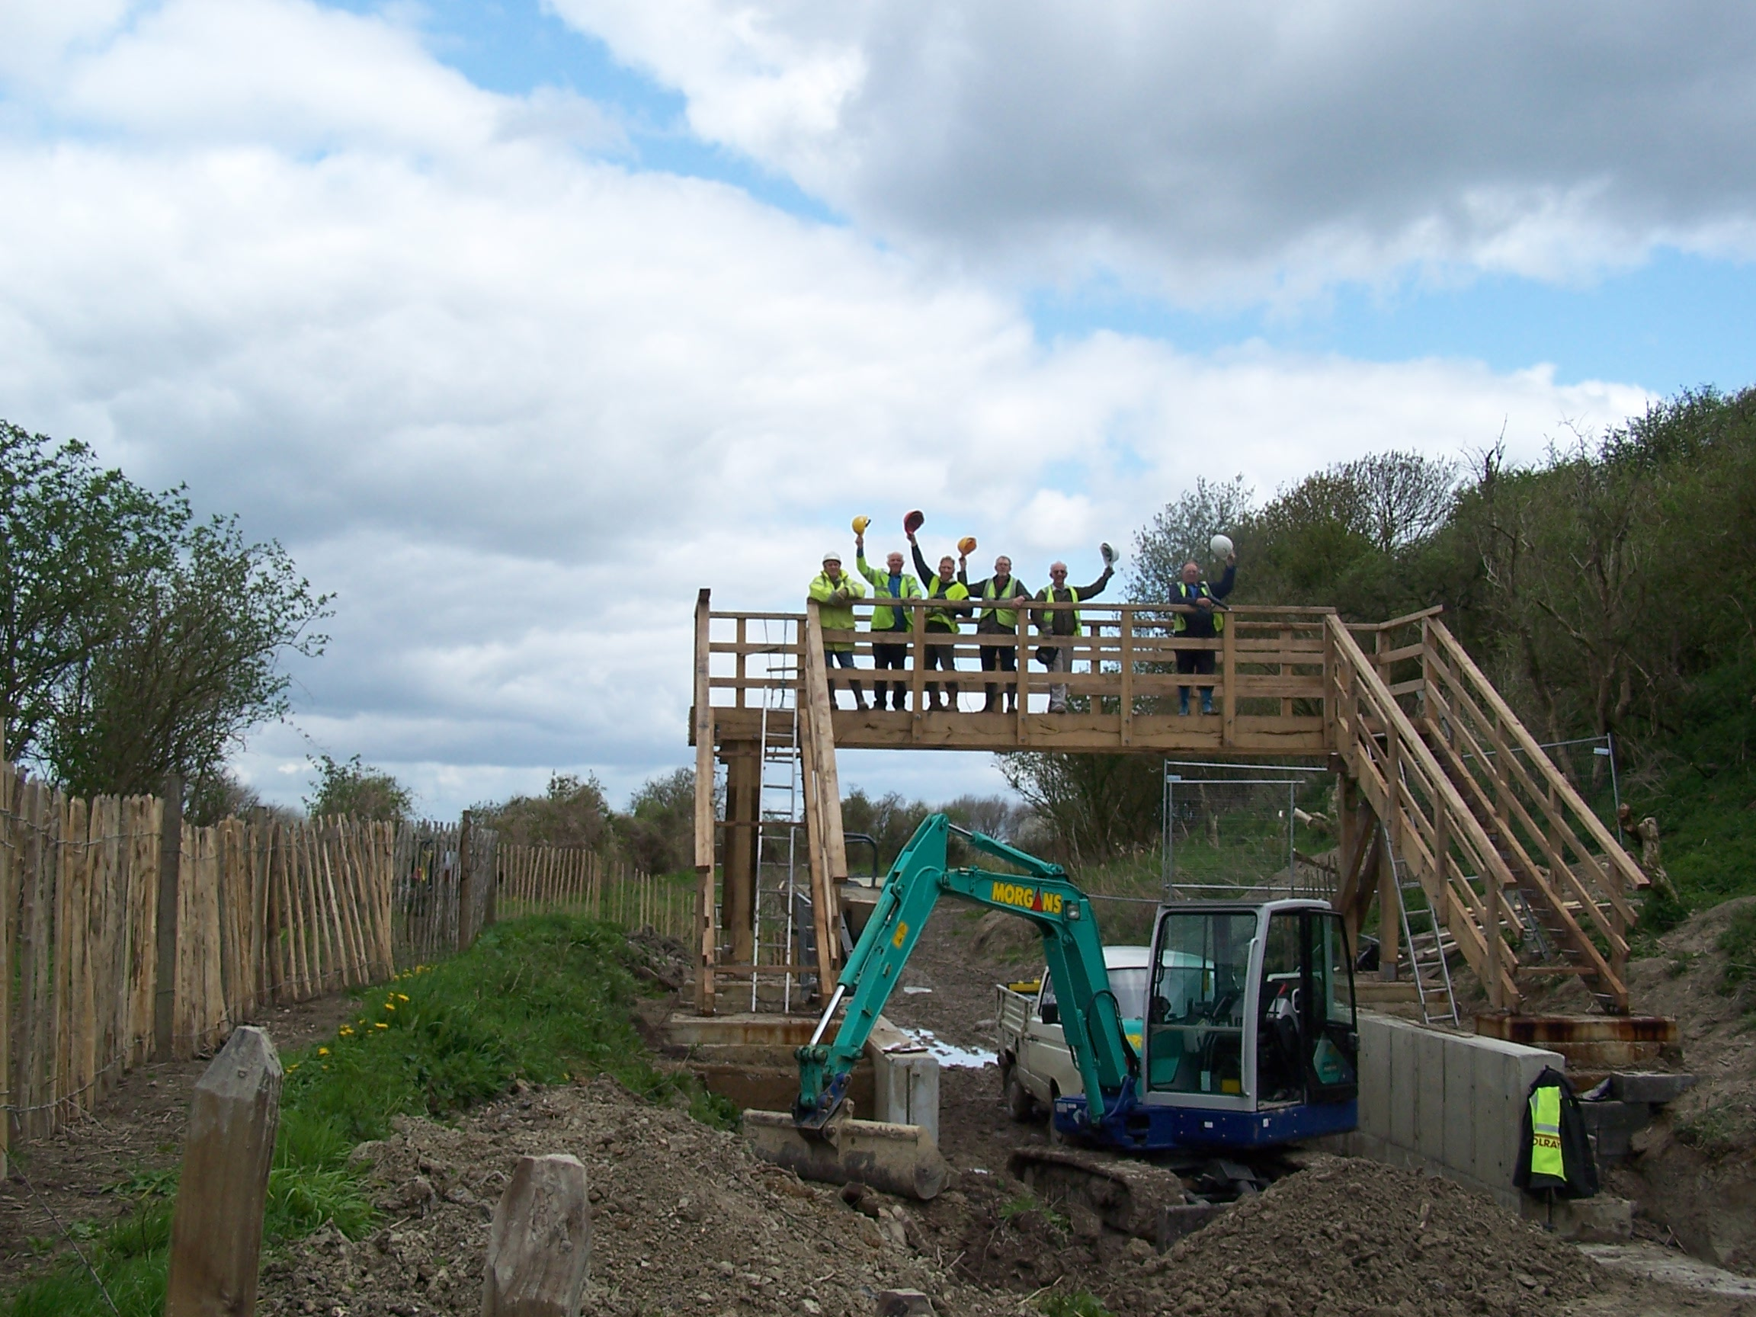

Site Security

Twice recently I have had to lock up site gates and found that the padlock and chain had not been left secure round a gate bar by whoever opened the gate. Anyone could have walked off with the padlock and chain! Please ensure that the padlock and chain are left secure round gate bars if you open any of our gates. Also please ensure that the two padlocks on the outer gate are kept separate so that either padlock can be used to open the gate.

Woodwork Vice

Ron Pittaway has been given a 9” Record Woodworkers Bench Vice.
This is in good condition and is ‘free’ to anyone in return for a donation to the Trust.

Web Site

The address of the Trust Restoration web site managed by Oliver Revel (that is linked to the main Trust site) is:
http://wendovercanal.org.uk/

2006 Tring/Wendover Festival 28th/29th May

The boat bookings for the Festival include the following work party volunteer’s boats who will have a reserved mooring on the towpath between Little Tring Bridge and the winding hole:

Roger Leishman 53ft MARY BETH
Rodney Evans 58ft SCYTHIA
Ray Orth 45ft MADRIGAL
Bert Matraves 45ft CHUMLEY B
Brian Ing 58ft KAY CEE TOO
Denis Cater 40ft SHALDON
Pete Bowers 40ft KOFFEE & CREAM
Brian Lansley 51ft MALAIKA
Bob Everett 42 ft FOOTLOOSE II

E-mail

I have now received several requests for this newsletter to be sent to readers by e-mail; this does save the Trust postage costs. If you give me a request for e-mail transmission I will do so but please let me know if the attachment arrives or not. There could be problems with this issue as Margaret and I have just replaced our PCs and LAN as well as switching to Broadband with the usual teething problems

Wendover Trust Mugs

If you did not have the chance to buy Trust mugs at the last Festival, they will be on sale again at the Trust stands, both at the main site and by the Bridge Café. They are bone china, £6 each, two for £11.50 or four for £22. If you did not see them, they commemorate the opening of Phase I with a view through Little Tring Bridge on both sides with ‘Wendover Arm Trust 2005’ underneath.

Insurance

It is incumbent on anyone, regardless of age, to inform the Trust in writing if they suffer from any medical condition that could in any way affect their ability to carry out their work as a Trust Work Party Volunteer.
User Manuals will be updated to include this requirement so that, when you sign that you have read your manual, or amendments to it, you will acknowledge your responsibility in this matter. Any incident arising from an undeclared medical condition is not covered by the Trust’s insurance.

General Notes.

All volunteers receive and sign for the Trust’s Restoration Manual that includes full Health and Safety requirements for the restoration works. The Manual is the property of the Trust; if you leave the working parties for any reason, please return the Manual to either Ray Orth or myself.

David Barratt is our qualified First-Aider and, even if he is not on site, lives nearby and can be contacted on 07973 411176 if he is at home.

Hard hats for use at all times and high visibility jackets to be worn on sites with mobile plant in use are kept in the store at Tringford and must be drawn/returned there. One first aid kit is kept in the store; another is kept in the VW transporter for use on site. Also available in the transporter are ear defenders and goggles that must be worn when using strimmers, angle grinders, concrete breakers and the like.

We normally work from 9am to 5pm (or dark if earlier!) when we are hiring plant or taking delivery of ready-mix concrete early in the morning. There are breaks for morning coffee/tea, packed lunch and afternoon tea/coffee. We take our own food and drinks. However, do not feel bound by these times, as half a day is better than no help at all.

DATES FOR WORKING PARTIES
DATE | WORKING AT | WORK TO BE DONE
Thursday 25th May 2006 | Festival site | Fencing off festival site etc.
 | Bridge 4A | Base formwork for two wing wall bases
Friday 26th May 2006 | Festival site | If not already complete, finish fencing and then to Little Tring.
 | Little Tring &  Bridges 4/4a | Lay water main through bridge; erect tent/safety fence and notices for Bridge Café. Fitting stair treads to footbridges.  Fabricate gabions for Drayton Beauchamp.  Load gabions and stone for bund at Drayton Beauchamp
 | Drayton Beauchamp | Lay Bentonite to offside bank after trimming to smooth surface.  Lay gabions and fill with stone, rough excavation for new bed.
 | Bridge 4A | Base formwork for two wing wall bases, prepare for blinding other two wing walls.
Saturday 27th May 2006 | Bridge 4A | Pour ready-mix concrete to two wing wall bases, blinding for other two bases and any surplus to Drayton Beauchamp.
 | Little Tring | Load materials for Drayton Beauchamp.
 | Drayton Beauchamp | Pour any surplus ready-mix concrete to pipe trench capping  Lay gabions and fill with stone, rough excavation for new bed and backfill to gabion wall
Sunday 28th May 2006 | Bridge 4A | Strip formwork from wing wall bases and re-erect on other side
 | Drayton Beauchamp | Lay gabions and fill with stone, rough excavation for new bed and backfill to gabion wall
 | Trust stands | Man Trust stands at Little Tring Bridge and Festival Site
Monday 29th May 2006 | Bridge 4A | Strip formwork from wing wall bases and re-erect on other side
 | Drayton Beauchamp | Lay gabions and fill with stone, rough excavation for new bed and backfill to gabion wall
 | Trust standa | Man Trust stands at Little Tring Bridge and Festival Site
Tuesday 30th May 2006 | Festival site | Strip fencing from festival site and store at Tringford.
 |  | Note that, as usual, there is no June work party as it is too near the Festival.
Saturday 1st July to  Sunday 2nd July 2006 | Little Tring, Wendover & Drayton Beauchamp | Erect notice boards at Wendover and Little Tring.  Erect seat at Drayton Beauchamp By-pass Bridge.
Saturday 5th August to  Sunday 13th August 2006 | Drayton Beauchamp | PLEASE BOOK THIS IN YOUR DIARY FOR ANY DAYS YOU CAN MANAGE SO THAT WE CAN HAVE A CONCERTED EFFORT AT LINING AT DRAYTON BEAUCHAMP.

Roger Leishman, Restoration Director. 7 Hall Park, Berkhamsted, Herts HP4 2NU.
(Tel:01442 874536, e-mail rleishman@ukgateway.net)

WORK PARTY VOLUNTEER SCHEDULE TO JULY 2006

Date | Location
Thu 25 May | Festival site | R Orth | B Ing  R Evans  R Pittaway | B Lansley  D Cater | B Matraves  P Bowers
 | Bridge 4A | R Leishman | K Graves | B Everitt
Fri 26 May | Festival site then  Little Tring | R Orth | B Ing  R Evans  R Pittaway | B Lansley  D Cater | B Matraves
 | Bridge 4A | R Leishman | K Graves | B Everitt | P Bowers
Sat 27 May | Little Tring &  Drayton B’champ | R Orth | B Ing (pm)  R Evans  R Pittaway | B Lansley (pm)  D Cater | B Matraves
 | Bridge 4A  Dumper drivers | R Leishman | K Graves  B Ing (am) | B Everitt  B Lansley (am) | P Bowers
Sun 28 May Tue 25 | Little Tring &  Drayton B’champ | R Orth | B Ing  R Pittaway | B Lansley  D Cater | B Matraves  P Bowers
 | Bridge 4A | R Leishman | K Graves | B Everitt | P Bowers
 | Trust standa | C Johnson  R Evans
Mon 29 May | Little Tring &  Drayton B’champ |  | B Ing  R Pittaway | B Lansley  D Cater | B Matraves
 | Bridge 4A | R Leishman | K Graves | B Everitt | P Bowers
 | Trust stands | C Johnson  R Evans
Tue 30 May | Festival site | R Leishman | R Orth  B Ing  R Evans | B Lansley  D Cater  B Everitt | B Matraves  P Bowers  R Pittaway
Sat 1 Jly | Little Tring,  Drayton B’Champ  And Wendover | B Fletcher | K Graves
Sun 2 Jly | Little Tring,  Drayton B’Champ  And Wendover | B Fletcher | K Graves
I have assumed that all work party boaters are available but please let Ray or myself know if you are not able to come on any one or more days. Also please book mornings or afternoons when you want to visit the Festival or have family to entertain. Also will those without boats at the Festival let us know if you are coming on any of the days? Please let us know by the 21st May in case we have to alter plant hire arrangements.

If you are available on July 1st and/or 2nd will you please let Bob Fletcher know? We are erecting notice boards provided under grants and a bench seat donated by Drayton Beauchamp Parish Meeting.
(……….) Indicates provisional

The name of the person in charge on a particular day/site is printed in italics.

P Bowers 01255 504540 or 07880 744730 E Evans 01628 526237 or 01628 526898
R Leishman 01442 874536 or 07850 170858 R Orth 01494 786868 or 07733 092034
R Pittaway 01296 630968 or 07946 484156 K Graves 01494 563813
B Fletcher 01494 812087

