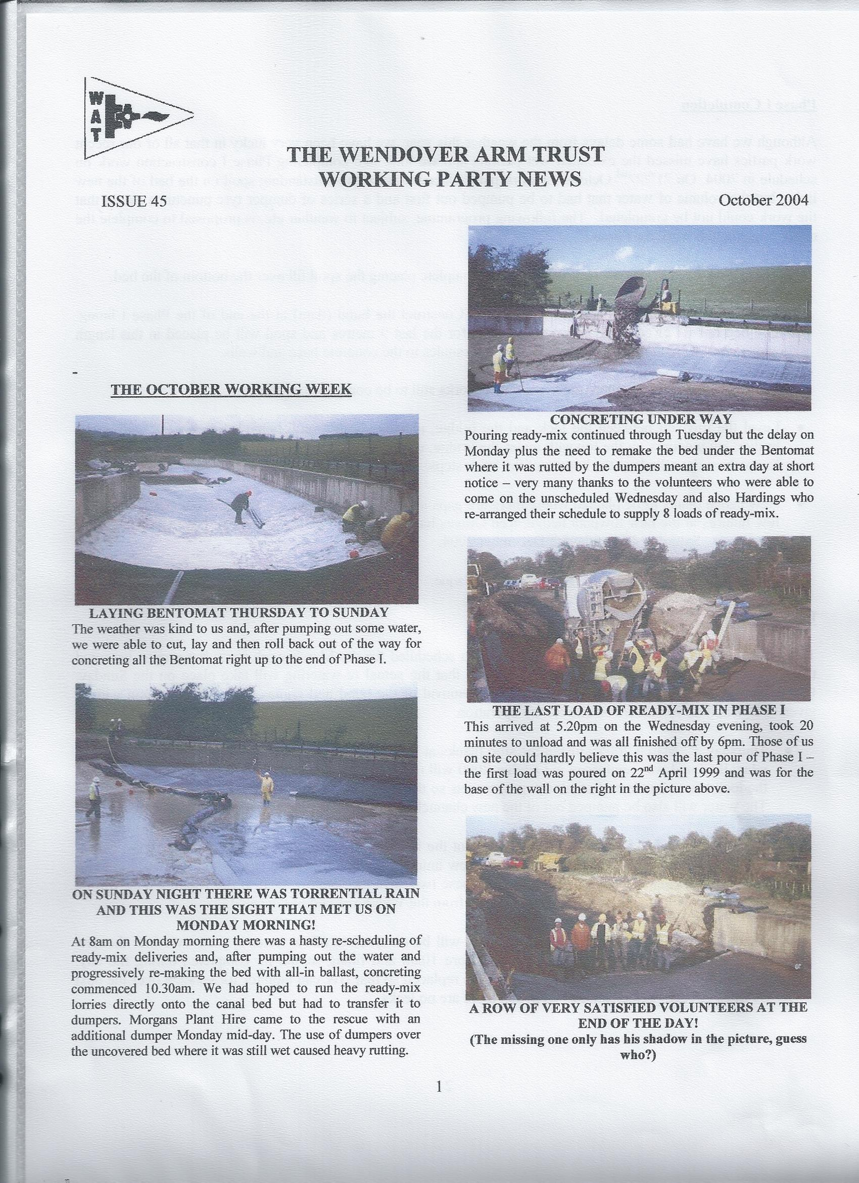

Phase I Completion

Although we have had some delays from the weather this year, we have been very lucky in that all of our recent work parties have missed the extended wet periods and we look like completing Phase I construction work on schedule in 2004. On 21st/22nd October, a work party placed most of the outstanding spoil on the bed of the new lining but the volume of water that had to be pumped out first and a series of dumper tyre punctures meant that the work could not be completed. The following programme, subject to weather etc, is proposed to complete the major construction work for Phase I.

- Thursday 4th and Friday 5th November 2004. Complete placing the spoil fill over the bottom of the bed.

- Saturday 6th and Sunday 7th November 2004. Construct the bund (dam) at the end of the Phase I lining. The bed has 6” of concrete cover right across for the last 9 metres and spoil will be placed in this length with a core of Bentonite sealed with Bentonite granules to the concrete base and walls.

As well as the major works, there are some minor works still to be completed:

- Level the towpath between the lock and the bridge, placing surplus spoil behind the new toe wall at the bridge; lay paviours on the towpath under the bridge; clear the towpath steps at the bridge and improve the footpath on the offside at the bottom of the brick steps.

- New hedge plants to be planted where there are gaps in the old towpath hedge and where there have been a few failures in the new towpath hedge. Ken Graves has ordered 150 plants for planting over the December work party, Saturday 4th/Sunday5th December 2004.

- Brickwork and capping for the Tim Wilkinson plaque.

Phase I in water

This brings us to the actual re-watering that has been scheduled for the March work party but it must be noted that it is provisional in that it cannot be guaranteed that the actual re-watering will take place on the Sunday: Ray Orth has drafted a Method Statement for the removal of the bund and copies of the final version will be given to BW and all volunteers on site for the operation.

- Thursday 3rd March 2005. Install the stop planks at Tringford stop lock. Those of you who were present when the bund was reinforced in October 2000 will remember that this is a difficult task, as the bottom of the lock has to be cleared of silt using water jets so that the bottom plank sits firmly on the concrete base. The water will also be pumped out of the new channel to facilitate the placing of spoil from the bund.

- Friday 4th/Saturday 5th March 2005. Pump out the lock, remove the bund and steel piling at the end of the stop lock placing spoil in the bed of the new lining towards Little Tring Bridge and hardcore in skips in Tringford Pumping Station Yard. During these two days the shallow shelf in the winding hole will be planted with aquatic plants previously sourced from the Wendover end of the canal.

- Sunday 6th March 2005. The top stop plank will be removed to allow water to weir over into the new length of canal. This will not commence before 10am and filling should be completed during the day. When filling is complete, the top plank will be replaced so that BW can monitor for leakage over the next 30 days or such period satisfies them that there are no leaks.

The new stretch will be open for navigation when BW give their clearance and it has been arranged that the Vice-President, Roger Lewis and myself will take our boats through first followed by a working boat and a butty. These will carry all work party volunteers (including WRG BITM, WRG Essex, KESCRG and Newbury Work Party), WAT Council members, Festival and all other WAT helpers who are attending and not bringing their own boats for the event. This is not an official opening but is bound to be a red letter day as far as WAT and its supporters are concerned.

Phase II

The level survey for Phase II was finally completed at the September six day party. A level peg has been concreted in every 100 metres from Little Tring to Drayton Beauchamp. After careful checking and rechecking the closing error between the Ordnance Survey benchmarks at Little Tring Cottages and St Mary’s Church at Drayton Beauchamp was 18mm (3/4”).

Discussions are currently in progress and it is hoped to agree a specification with BW for the first 50 metres at Drayton Beauchamp that has been authorised by the WAT Council. The agreed cross-section will be published in this Newsletter. Typical cross-sections have been surveyed and it is hoped that the amount of surplus spoil will not be as great as was once feared.

As previously reported in Issue 43, June 2004, it is proposed to install timber footbridges at the two footpath crossings over the present dry bed. These will be an early priority in Phase II and are scheduled for completion in 2005 as soon as agreement has been reached with BW and the Footpath Authority (Herts County Council represented by the Dacorum Borough Council Footpaths Officer).

BW is also going to flail the dry bed during the winter so avoiding a long and arduous manual strimming of a mile of dry bed. There is still a loose stump to be moved up to Little Tring and it is intended to do this on 4th/5th November next as well as some general levelling of the canal bed.

Web Site

The address of the Trust web site managed by Oliver Revel is: http://wendovercanal.org.uk/

General Notes.

All volunteers receive and sign for the Trust’s Restoration Manual that includes full Health and Safety requirements for the restoration works. The Manual is the property of the Trust; if you leave the working parties for any reason, please return the Manual to either Ray Orth or myself.

David Barratt is our qualified First-Aider and, even if he is not on site, lives nearby and can be contacted on 01442 822523 if he is at home.

Hard hats for use at all times and high visibility jackets to be worn on sites with mobile plant in use are kept in the store at Tringford and must be drawn/returned there. One first aid kit is kept in the store; another is kept in the VW transporter for use on site. Also available in the transporter are ear defenders and goggles that must be worn when using strimmers, angle grinders, concrete breakers and the like.

My mobile phone number at working parties is 07850-170858. It is not always left on continuously but has a message facility that I check from time to time. We normally work from 9am to 5pm (or dark if earlier!) when we are hiring plant or taking delivery of ready-mix concrete early in the morning. There are breaks for morning coffee/tea, packed lunch and afternoon tea/coffee. We take our own food and drinks. However, do not feel bound by these times, as half a day is better than no help at all.

Financial Position and progress as at 10th October 2004

The costs to date include all orders issued to date including those not yet invoiced/paid

Stage | Description | Budget  1997  £ | Current  Budget  £ | Costs to  date  £ | Progress  to date
 | Restoration Phase I
1 | Towpath wall, bridge to end at old tip | 22,990 | 18,769 | 18,769 | 100%
2 | Offside walls, bridge to end at old tip | 25,630 | 30,153 | 30,153 | 100%
3 | Bund in lock and removal | 500 | 1,310 | 162 | 30%
4 | Towpath wall up to/through bridge | 4,928 | 6,599 | 6,599 | 99%
5 | Towpath wall, lock to bridge | 7,843 | 7,844 | 7,844 | 99%
6 | Offside wall, lock to bridge | 7,843 | 9,319 | 9,319 | 100%
7 | Leak proof lining with concrete/spoil cover | 64,000 | 58,809 | 58,809 | 99%
8 | Bund at west end of Phase I | 500 | 1,035 | 0 | 10%
 | Temporary roadways | 5,000 | 5,931 | 5,931 | 100%
 | Rebuilding Little Tring Bridge | 222,000 | 223,055 | 223,055 | 100%
 | Bottle clearance at Little Tring | -1,492 | -1,492 | -1,492 | 100%
 | Boundary fences etc. at Little Tring | 236 | 236 | 236 | 100%
 | Administration, insurance etc | 8,000 | 12,500 | 12,226 | ongoing
 | VW Transporter | 0 | 4,012 | 4,012 | ongoing
 | Plant and equipment | 5,000 | 5,540 | 5,540 | 100%
 |  | --------- | --------- | -------
 | Phase I totals | 372,978 | 383,590 | 381,163
 |  | ====== | ====== | ======
 | Restoration Phase II
 | Clearance and temporary roadway |  | 8,000 | 6,319 | 95%
 | Section 1 excavation (50m only) |  | 4,000
 | Section 1 protect pipe below (50m only) |  | 2,000
 | Section 1 lining and cover (50m only) |  | 10,000 | 1,920
 | Environmental Impact Report |  | 3,466 | 3,466 | 100%
 | Administration, insurance etc |  | 2,000 | 100 | ongoing
 | VW Transporter |  | 1,500 | 144 | ongoing
 |  |  | --------- | ---------
 | Phase II totals |  | 30,996 | 11,949
 |  |  | ====== | =====
 | Grand totals for work to which the Trust is committed to date |  | £414,106 | £393,152

DATES FOR WORKING PARTIES

DATE | WORKING AT | WORK TO BE DONE
Thursday 4th November 2004 | Little Tring | Complete placing spoil on new lining.
Friday 5th November 2004 | Drayton Beauchamp | Tidying up work at Drayton Beauchamp.
Saturday 6th November 2004 | Little Tring | Construction of bund at end of Phase I
Sunday 7th November 2004 | Little Tring | Construction of bund at end of Phase I
Thursday 2nd December 2004 | Little Tring  Drayton Beauchamp | Tidy up at Little Tring  Preparatory work for Phase II
Friday 3rd December 2004 | Little Tring  Drayton Beauchamp | Tidy up at Little Tring  Preparatory work for Phase II
Saturday 4th December 2004 | Little Tring  Drayton Beauchamp | Hedge planting.  Preparatory work for Phase II.
Sunday 5th December 2004 | Little Tring  Drayton Beauchamp | Hedge planting.  Preparatory work for Phase II .
Saturday 8th January 2005  NEWBURY WORK PARTY | Little Tring  Drayton Beauchamp | Levelling towpath lock to bridge  Management of towpath hedge
Sunday 9th January 2005  NEWBURY WORK PARTY | Little Tring  Drayton Beauchamp | Levelling towpath lock to bridge  Management of towpath hedge
Saturday 5th February 2005 | Drayton Beauchamp | Retrieve aquatic plants for Little Tring
Sunday 6th February 2005 | Drayton Beauchamp | Retrieve aquatic plants for Little Tring
Saturday 26th February 2005 | Little Tring | Preparatory work for removal of bund (small work party)
Sunday 27th February 2005 | Little Tring | Preparatory work for removal of bund (small work party)
Thursday 3rd March 2005 | Little Tring | Install stop planks at Tringford Stop Lock
Friday 4th March 2005 | Little Tring | Pump out lock and remove bund from Tringford Stop Lock
Saturday 5th March 2005 | Little Tring | Remove bund from Tringford Stop Lock
Sunday 6th March 2005 | Little Tring | Re-water Phase I

The preparation work for Phase II is taking up a great deal of my time and I have been falling behind with survey work, specifications and drawings. Whilst still accepting full responsibility for the engineering and control aspects of the Restoration I have asked Ray Orth to take charge of working parties for Phase II and he has agreed to do this. This will not, of course, preclude others, e.g. Pete Bowers, Eddy Evans and Ron Pittaway from taking charge of work parties as they have done in the past. Many thanks Ray.

Roger Leishman, Restoration Director. 7 Hall Park, Berkhamsted, Herts HP4 2NU.
(Tel:01442 874536, e-mail rleishman@ukgateway.net)

WORK PARTY VOLUNTEER SCHEDULE TO SEPTEMBER 2004

Date | Location

2004
Thu 4 Nov | Little Tring | P Bowers | R Orth
Fri 5 Nov | Little Tring | P Bowers | R Orth
Sat 6 Nov | Little Tring | R Leishman | R Orth
Sun 7 Nov | Little Tring | R Leishman | R Orth
Thu 2 Dec | Little Tring/DB | P Bowers
Fri 3 Dec | Little Tring/DB | P Bowers
Sat 4 Dec | Little Tring/DB | R Leishman | R Orth
Sun 5 Dec | Little Tring/DB | R Leishman | R Orth

2005
Sat 8 Jan | Little Tring | R Orth | R Leishman |  |  | NWG
Sun 9 Jan | Little Tring | R Orth | R Leishman |  |  | NWG
Sat 5 Feb | Little Tring | R Leishman
Sun 6 Feb | Little Tring | R Leishman
Sat 26 Feb | Little Tring | R Orth
Sun 27 Feb | Little Tring | R Orth
Thu 3 Mar | Little Tring | R Leishman | R Orth
Fri 4 Mar | Little Tring | R Leishman | R Orth
Sat 5 Mar | Little Tring | R Leishman | R Orth
Sun 6 Mar | Little Tring | R Leishman | R Orth
 | Little Tring | R Leishman
 | Little Tring | R Leishman

(……….) Indicates provisional

Please ring the person in charge and let them know that you are coming as soon as possible.

The name of the person in charge on a particular day/site is printed in italics.

P Bowers 01255 504540 or 07880 744730 E Evans 01628 526237 or 01628 526898
R Leishman 01442 874536 or 07850 170858 R Orth 01494 786868 or 07733 092034
R Pittaway 01296 630968 or 07946 484156

