THE WENDOVER ARM TRUST
WORKING PARTY NEWS
ISSUE 132 April 2019

VALETE

Farewell. After 24 years looking after restoration and having passed my 87th birthday the time has come at last for me to hang up my hard hat.

I have therefore resigned as Restoration Director and as a Director of the Trust as from the end of April this year so this is my last issue of the Working Party News, the first issue of which was in June 1997.

My concern as a Civil Engineer is that the Trust has continuity in this vital area and has particularly welcomed recently retired CRT Civil Engineer Mikk Bradley as mentioned in the last issue and who has greatly helped with development of our Whitehouses plans. Mikk also works as a volunteer for IWA.

All that remains is for me to express my grateful thanks to all those volunteers, both restoration and others, who have worked so tirelessly to further restoration, especially those who were with us during Phase I and not forgetting those no longer with us.

March and April working parties

Work continued on re-lining Stage 4 between Whitehouses and Bridge 4 as shown below.
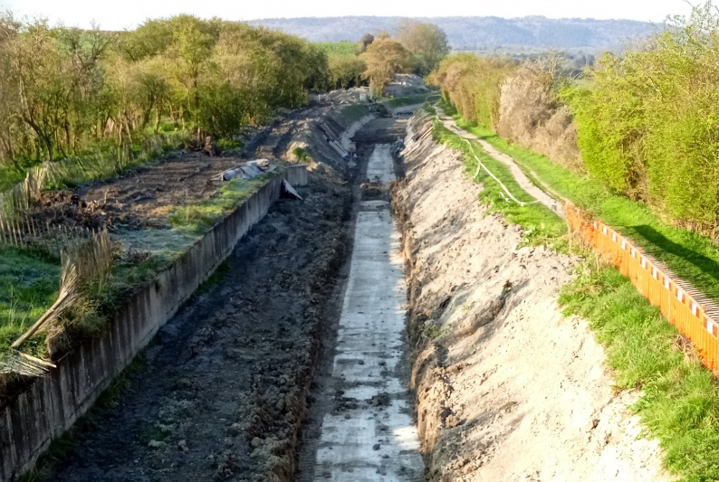
Tony Bardwell
THE VIEW FROM BRIDGE 4

Tidy Friday

The work of John Reynolds and his team in keeping our restoration tidy is continuing very successfully, thank you all. See schedule on page 4 for dates.

Whitehouses

The bid for funds from the LEADER programme has been turned down. Reasons given for the rejection are factually incorrect! The Trust still awaits CRT’s proposals to carry out the work at the Trust’s expense.

Events

Please give Jenny Brice a ring on 01494 873298 if you can spare a day, or even a half day, to help at one of the Trust’s events that give us good publicity and also raise some funds.

General Notes

Further to my note in the last issue about insurance for over 75’s, IWA have asked me to point out that this refers to personal accidents, not personal liability. Personal Accident cover is where a volunteer causes injury to themselves through no fault of anyone else but themselves.

There are in fact no age limits on the liability insurances, which is where anyone working under the Trust’s direction and control causes injury or harm to person or property belonging to anyone else, including colleagues, other volunteers, the general public etc.

All volunteers receive and sign for the Trust’s Restoration Handbook that includes full Health and Safety requirements for the restoration works. The handbook is the property of the Trust; if you leave the working parties for any reason, please return your Handbook to the Trust.

Hard hats for use at all times and high visibility jackets to be worn on sites with mobile plant in use are kept in the store at Tringford and must be drawn/returned there.

One first aid kit is kept in the store and one in the Whitehouse container and each qualified first-aider will have their own kit with them when on site.

Also available in the store at Tringford are ear defenders and goggles that must be worn when using strimmers, angle grinders, concrete breakers and the like. CRT will supply hard hats, gloves and footwear with reinforced toecaps on request.

We normally work from 9am to 5pm (or dark if earlier!). There are breaks for morning tea/coffee, packed lunch and afternoon tea/coffee. We take our own food and drink.

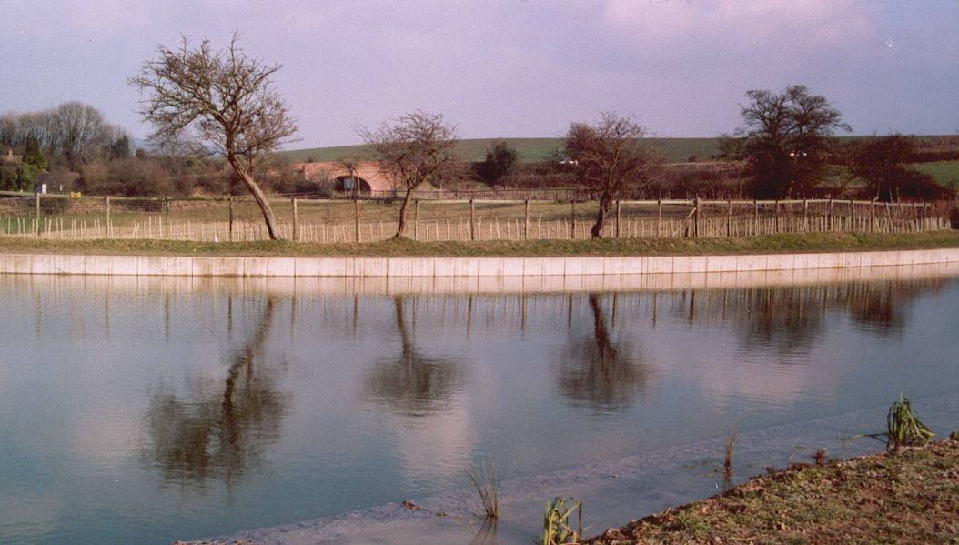
Margaret Leishman
IT COULDN’T BE DONE

Somebody said that it couldn’t be done,
But they, with chuckles replied,
That maybe it couldn’t, but they would be the ones
Who wouldn’t say so till they’d tried.
So they buckled right in with the trace of a grin
On their faces; if they worried they hid it.
They started to sing as they tackled the thing
That couldn’t be done, and they did it.

Somebody scoffed: “Oh you’ll never do that,
At least no one ever has done it”.
And they took off their coats and donned their hard hats,
And the first thing we knew they’d begun it.
With a lift of the chin and a bit of a grin,
Without any doubting or quiddit,
They started to sing as they tackled the thing
That couldn’t be done, and they did it.

There are thousands to tell you it cannot be done,
There are thousands to prophesy failure,
There are thousands to point out to you, one by one,
The dangers that are sure to assail you.
But just buckle in with a bit of a grin,
Then take off your coat and go to it.
Just start in to sing as you tackle the thing
That “cannot be done”, and you’ll do it.

With apologies to the anonymous author
for minor alterations!

I could not let the last issue of this newsletter go out without repeating the front page of the April 2005 issue showing the re-watering of Phase I at Easter 2005, 14 years ago, a very emotional event!

WENDOVER ARM CANAL RESTORATION PHASE II

PROGRESS REPORT AS AT 5th APRIL 2019

CANAL LINING
Item | Stage 1 | Stage 2 | Stage 3 | Stage 4 | Stage 5 | Stage 6 | Stage 7 | Total
Total length | 321m | 350m | 350m | 350m | 350m | 337m | -
Complete to date:
Bulk Excavation | 321m | 350m | 350m | 120m |  |  | ---------
Capping to pipe | 321m | 350m | 340m | 126m |  |  | ---------
Tipping to offside bank | 321m | 350m | 330m | 60m |  |  | ---------
Tipping to towpath bank | 321m | 350m | 350m | 60m
Profiling offside bank | 321m | 350m | 330m | 60m |  |  | ---------
Profiling towpath bank | 321m | 350m | 350m | 60m |  |  | ---------
Lining towpath bank | 321m | 350m | 350m | 60m |  |  | ---------
Lining offside bank | 321m | 350m | 330m | 60m |  |  | ---------
Level and line bed | 321m | 350m | 330m | 20m |  |  | ---------
Planting banks | 60m | -------- | -------- | -------- |  |  | ---------
Mooring wall length | 50m | 50m | -------- | 50m | --------- | -------- | 237m
Excavation | 50m | 50m | -------- | 50m | -------- | -------- | 10m
Blinding | 50m | 50m | -------- | 50m | -------- | --------
Wall base | 50m | 50m | -------- | 50m | -------- | --------
Wall upright | 50m | 50m | -------- | 50m | -------- | --------
Backfill | 50m | 50m | -------- | 50m | -------- | --------
Estimated Cost | £128,272 | £154,579 | £200,000 | £200,000 | £200,000 | £98,725 | £53,725 | £1,035,301
Cost to date/final | £128,272 | £154,579 | £192,977 | £57,617 | £2,886 | £304 | £633 | £537,268

FOOTBRIDGES & VARIOUS OTHER WORKS
Item | Stage 8 | Stage 9 | Stage 10 | Stage 11 | Stage 12 | Stage 13 | Stage 14 | Total
 | Bridge 4 | Bridge 4A | Whitehouses | Cart track  Narrows | Removal  of bunds | Winding  Hole nose | Nuttalls  Bund
Footbridge | 100% | 100% | ---------------- | ----------- | ---------- | ----------- | ----------
Excavation | 100% | 100% | ---------------- |  | ---------- |  | ----------
Blinding | 100% | 100% | ---------------- |  | ---------- |  | ----------
Wall base | 100% | 100% | ---------------- |  | ---------- |  | ----------
Wall upright | 100% | 100% | ---------------- |  | ---------- |  | ----------
Backfill | 100% | 100% | ---------------- |  | ---------- |  | ----------
WAT Heritage work | --------- | --------- | 100% | ----------- | ---------- | ----------- | ----------
CRT contract work | --------- | --------- | ? | ----------- |  | ----------- | ----------
Estimated cost | £20,122 | £20,031 | £95,000 | £20,000 | £20,000 | £10,000 | 3,501 | £188,654
Cost to date/final | £20,122 | £20,031 | £18,934 |  |  |  | 3,501 | £62,588

SUMMARY INCLUDING OVERHEAD COSTS AND PHASE I
 | Lining | F/bridges  & other  works | Clear bed,  & Temp’y  Works | Environ’t  Reports | Materials  In stock | Admin | Tools &  Equip’t | Vehicle | Unallocated  contingency | TTOTAL
Estimated cost | £1,035,301 | £188,654 | £28,000 | £3,245 | £0 | £43,000 | £15,000 | £22,500 | £36,536 | £1,372,236
Cost to date/final | £537,268 | £62,588 | £24,620 | £3,245 | £0 | £39,075 | £13,541 | £22,374 | £0.00 | £702,711
Final cost of Phase I completed in 2004 and opened to navigation in 2005 |  |  |  |  |  |  |  |  |  | £400,349
Total spend on restoration by Wendover Arm Trust to date |  |  |  |  |  |  |  |  |  | £1,103,060
Tidy Friday maintenance in 2018/2019 |  |  |  |  |  |  |  |  |  | £22
A red figure indicates a final cost/physical progress. A green figure indicates a revised budget figure, either to match a finished cost or to give a re-appraisal in the light of experience to date.

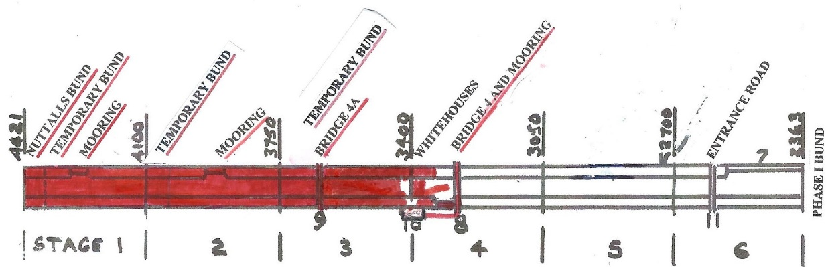

Physical and Financial Progress

As this is my final report I would like to point out the following:

The cost of Stage 3 has gone down since my last report as there were surplus lining materials that have been transferred to Stage 4.

The only outstanding work to Stage 3 is connecting the offside banks to CRT’s new Whitehouse works.

No information is yet forthcoming from CRT as to the timescale and cost of their Whitehouses works but there is an outstanding budget figure of just over £76,000 to cover CRT’s work and any outstanding work by WAT at Whitehouses.

I have reduced the value of materials in stock at present to nil reducing the unallocated contingency accordingly. Most of the written off value refers to the cost of mattress gabions that were at one time going to be tested for bank lining. The Trust unfortunately had to take delivery of a minimum order amount but those of you present when the proposed system was trialled will remember what a failure it was. The gabions were later sold as scrap metal.

The budget for Stage 4 has been left as the same as Stage 3 as, although unit costs will go up, it will not be burdened with the massive earthworks in Stage 3 where the pipeline ran well under the high offside bank that had to be removed and reinstated.

The budget for Stage 5 is also left at the same figure on the basis that it is much nearer Little Tring and has no mooring wall.

Stage 7 is now probably obsolete. It was the towpath wall through the tip at Little Tring and was kept as a separate stage as it could have been worked on while previous stages were still in progress.

This leaves Stage 6 awaiting future plans for a by-pass and will need a revised budget in due course.

As Tidy Friday is not part of restoration but ongoing maintenance I have charged costs to a “Phase IV”.

WORKING PARTIES
So you can plan your diary ahead, the following are the dates of future working parties. The work to be done is very much subject to the weather especially during the winter months.

DATE | WORKING AT | WORK TO BE DONE
2019
Friday 3rd May to  Thursday 9th May | Stage 4 to Bridge 4 | Stage 4 lining.
Friday 10th May | Meet at Little Tring | ‘Tidy Friday’ vegetation control party
Friday 31st May to  Thursday 6th June | Stage 4 to Bridge 4 | Stage 4 lining.
Friday 7th June | Meet at Little Tring | ‘Tidy Friday’ vegetation control party
Friday 5th July to  Thursday 11th July | Stage 4 to Bridge 4 | Stage 4 lining.
Friday 12th July | Meet at Little Tring | ‘Tidy Friday’ vegetation control party
Friday 2nd August to  Thursday 8th August | Stage 4 to Bridge 4 | Stage 4 lining.
Friday 9th August | Meet at Little Tring | ‘Tidy Friday’ vegetation control party
Friday 6th September to  Thursday 12th September | Stage 4 to Bridge 4 | Stage 4 lining.
Friday 13th September | Meet at Little Tring | ‘Tidy Friday’ vegetation control party
Friday 4th October to  Thursday 10th October | Stage 4 to Bridge 4
Friday 11th October | Meet at Little Tring | ‘Tidy Friday’ vegetation control party
Friday 1th November to  Thursday 7th November | Stage 4 to Bridge 4
Friday 8th November | Meet at Little Tring | ‘Tidy Friday’ vegetation control party
Friday 6th December to  Thursday 12th November | Stage 4 to Bridge 4
Friday 13th December | Meet at Little Tring | ‘Tidy Friday’ vegetation control party

Roger Leishman, Restoration Director. 7 Hall Park, Berkhamsted, Herts HP4 2NU. Tel: 01442 874536,

