THE WENDOVER ARM TRUST
WORKING PARTY NEWS
ISSUE 131 February 2019

January and February working parties

Work progressed in January with 10m of towpath bank and 15m offside bank fully lined.
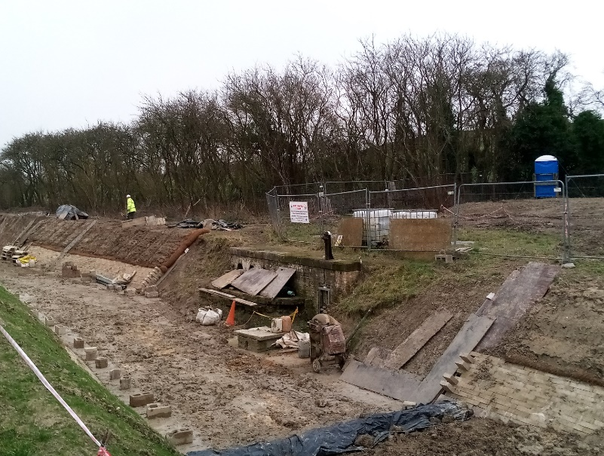
Tony Bardwell
JANUARY PROGRESS
The abutment walls of the former swing bridge 4 were exposed to examine their condition, because CRT Heritage are keen to preserve them as the former swing bridge was part of an olden road of historical interest. What is clear is that in no way could the existing abutments be stable or watertight so complete rebuilding will be necessary. Hopefully an outside volunteer group will be able to take this on.
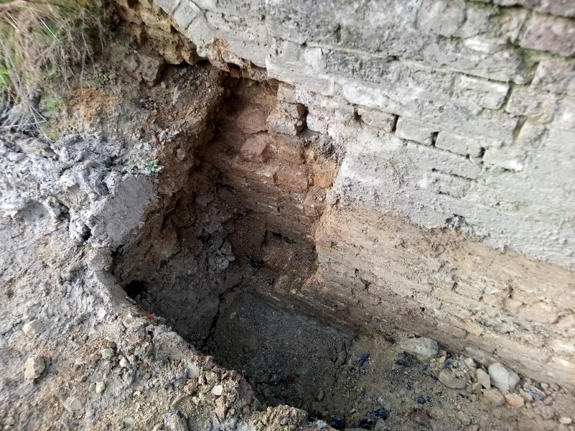
Tony Bardwell
THE OLD ABUTMENT ON ONE SIDE
During the January working party driver training on wheeled dumpers was undertaken. These cannot be used in the extreme muddy conditions, but a good spell of dry weather would enable them to be used at a great cost saving.

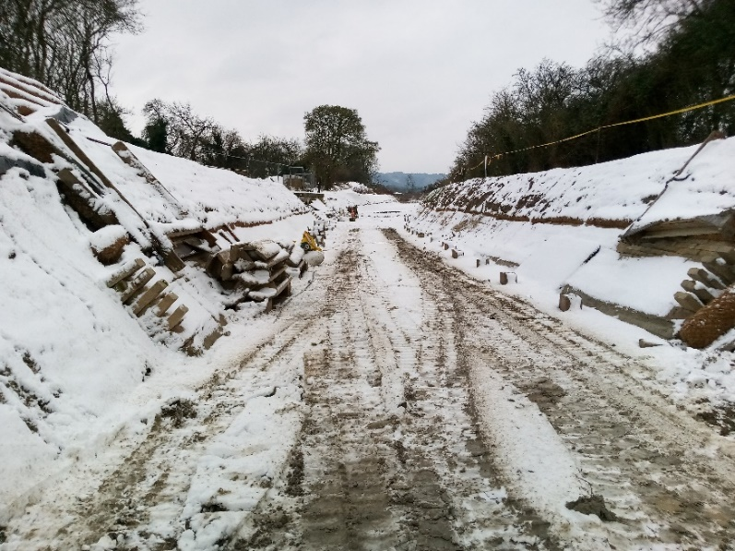
Tony Bardwell
THE SITE AT THE START OF THE FEBRUARY WORKING PARTY!

In February a further 15m of both banks were completed so bank lining is now about 80m from the mooring wall at Bridge 4.

Cut lengths of Bentomat were running low so a further supply was cut.

Tidy Friday

The work of John Reynolds and his team in keeping our restoration tidy is continuing very successfully, thank you all. See schedule on page 3 for dates.

Whitehouses

The outcome for the bid for funds for the work at Whitehouses from the Leader Fund is still not forthcoming.

We are very grateful to Mikk Bradley, an ex. CRT civil engineer now working voluntarily with the IWA, for his help in progressing the design of the work at Whitehouses and hope that it will soon be completed.

We must also thank Mikk for his assistance in finalising the design of the bed concrete at Bridge 4 for the stop planks and also help with the reconstruction of the old Bridge 4 swing bridge abutments.

General Notes

Many moons ago I drew attention in this newsletter to the fact that our insurance policy does not cover personal liability if you are over 70. During recent enquiries it has come to light that this age limit has been lifted to 75.

Again, in this newsletter, I have also stated that it is incumbent on anyone, regardless of age, to inform the Trust in writing if they suffer from any medical condition that could in any way affect their ability to carry out their work as a Trust Working Party volunteer.

I understand that it is the practice in some groups to request over 74’s to sign an indemnity re personal liability. I think that the Trust should take this action bearing in mind that it does include non-restoration volunteers.

All volunteers receive and sign for the Trust’s Restoration Handbook that includes full Health and Safety requirements for the restoration works.
The handbook is the property of the Trust; if you leave the working parties for any reason, please return your Handbook to either Tony Bardwell or myself.

Hard hats for use at all times, and high visibility jackets to be worn on sites with mobile plant in

use, are kept in the store at Tringford and must be drawn/returned there.

One first aid kit is kept in the store and one in the Whitehouse container and each qualified first-aider will have their own kit with him/her when on site.

Also available in the store at Tringford are ear defenders and goggles that must be worn when using strimmers, angle grinders, concrete breakers and the like. CRT will supply hard hats, gloves and footwear with reinforced toecaps on request.

We normally work from 9am to 5pm (or dark if earlier!). There are breaks for morning tea/coffee, packed lunch and afternoon tea/coffee. We take our own food and drink.

WORKING PARTIES

So that you can plan your diary ahead, the following are the dates of future working parties. The work to be done is very much subject to the weather especially during the winter months.

DATE | WORKING AT | WORK TO BE DONE
2019
Friday 1st March to  Thursday 7th March | Stage 4 to Bridge 4 | Stage 4 lining.
Friday 8th March | Meet at Little Tring | ‘Tidy Friday’ vegetation control party
Friday 5th April to  Thursday 11th April | Stage 4 to Bridge 4 | Stage 4 lining.
Friday 12th April | Meet at Little Tring | ‘Tidy Friday’ vegetation control party
Friday 3rd May to  Thursday 9th May | Stage 4 to Bridge 4 | Stage 4 lining.
Friday 10th May | Meet at Little Tring | ‘Tidy Friday’ vegetation control party
Friday 31st May to  Thursday 6th June | Stage 4 to Bridge 4 | Stage 4 lining.
Friday 7th June | Meet at Little Tring | ‘Tidy Friday’ vegetation control party
Friday 5th July to  Thursday 11th July | Stage 4 to Bridge 4 | Stage 4 lining.
Friday 12th July | Meet at Little Tring | ‘Tidy Friday’ vegetation control party
Friday 2nd August to  Thursday 8th August | Stage 4 to Bridge 4 | Stage 4 lining.
Friday 9th August | Meet at Little Tring | ‘Tidy Friday’ vegetation control party
Friday 6th September to  Thursday 12th September | Stage 4 to Bridge 4 | Stage 4 lining.
Friday 13th September | Meet at Little Tring | ‘Tidy Friday’ vegetation control party
Friday 4th October to  Thursday 10th October | Stage 4 to Bridge 4
Friday 11th October | Meet at Little Tring | ‘Tidy Friday’ vegetation control party
Friday 1th November to  Thursday 7th November | Stage 4 to Bridge 4
Friday 8th November | Meet at Little Tring | ‘Tidy Friday’ vegetation control party
Friday 6th December to  Thursday 12th November | Stage 4 to Bridge 4
Friday 13th December | Meet at Little Tring | ‘Tidy Friday’ vegetation control party

Roger Leishman, Restoration Director.
7 Hall Park, Berkhamsted, Herts HP4 2NU.
Tel: 01442 874536,
e-mail rwleishman@gmail.com

