THE WENDOVER ARM TRUST
WORKING PARTY NEWS
ISSUE 130 December 2018

Compliments of the Season and a Happy New Year to all our readers

My own grateful thanks to all our volunteers who have worked so hard on site and in some very bad weather conditions.

Thanks also to all those other volunteers who have worked so hard to keep the Trust running and raise the finances to enable restoration to carry on.

November and December Working Parties

Apart from a reinforced concrete apron and new wing walls at the old wharf wall at Whitehouses Stage 3 lining was completed.

Lining of Stage 4 has commenced and, as you can see from the next photograph, a start has been made on both banks.

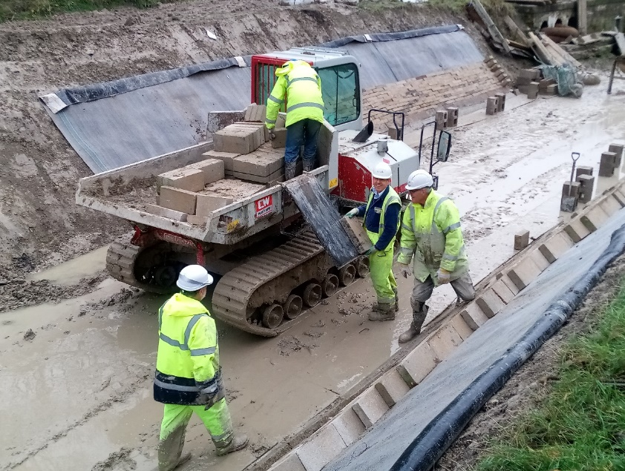
Tony Bardwell
STAGE 4 LINING IN PROGRESS

After making an early start to the December working party Bob Barry project managed a remodelling of the car park area at Little Tring.
As can be seen below the general area at Little Tring had become somewhat muddy

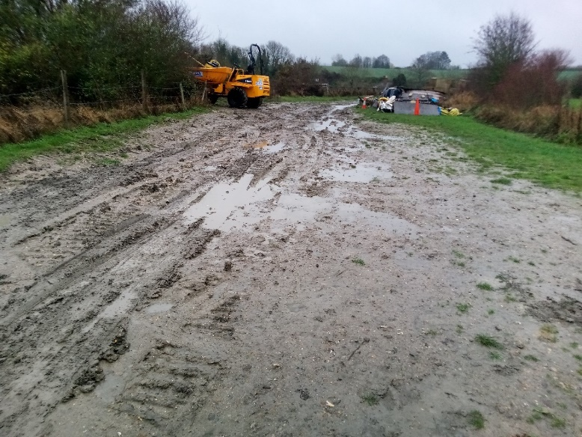
Tony Bardwell
To avoid heavy plant using the same roadway as volunteers’ cars, the car park has been moved to the Little Tring Road side. This allows heavy plant to move to and from the working site through a new gate on the opposite side.

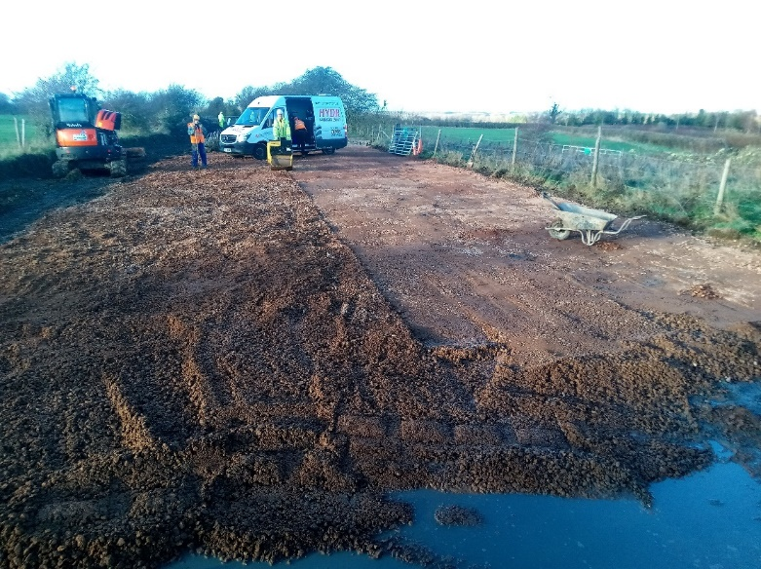
Tony Bardwell

As you can see from the above photograph there is now a clean area dressed with MOT quality road stone for car parking, accessible from Little Tring Road, clear of the route now to be used by heavy plant. Heavy plant operators must keep clear of this area and the approach road at all times. Also please use care not to deposit mud from dirty boots wherever possible.

Diesel store

At the same time as re-siting the car park the diesel store was moved nearer the entrance, as the delivery lorry was having difficulty reaching the old store and also suffering from muddy wheels resulting from our very bad ground conditions. The store is now a four barrel bund container to cope with any leakage without affecting ground conditions.

Tidy Friday

The work of John Reynolds and his team in keeping our restoration tidy is working very successfully, thank you all. See schedule on page 3 for dates.

Defibrillator

We now have a defibrillator on site in case of an emergency.

Whitehouses

It would seem likely that the bid for funds from the Leader Fund will not be forthcoming so a decision may soon have to be made as to whether our volunteers carry out the work at Whitehouses at a cost in the order of £25,000 or fund a CRT contractor to carry out the work at nearer three times this cost.

We are very fortunate in having the services of a volunteer, Mikk Bradley, who is a civil engineer who has formerly worked for CRT. He is currently revising the plans for the concrete apron and wing walls and seeking the approval of CRT for these plans. Once this is done we can consider whether or not to do the work with the Trust’s volunteers if Leader funds are not forthcoming.

General Notes

All volunteers receive and sign for the Trust’s Restoration Handbook that includes full Health and Safety requirements for the restoration works.

The handbook is the property of the Trust; if you leave the working parties for any reason, please return your Handbook to either Tony Bardwell or myself.

Hard hats for use at all times and high visibility jackets to be worn on sites with mobile plant in use are kept in the store at Tringford and must be drawn/ returned there.

One first aid kit is kept in the store and one in the Nissan Cabstar and each qualified first-aider will have their own kit with him/her when on site.

Also available in the store at Tringford are ear defenders and goggles that must be worn when using strimmers, angle grinders, concrete breakers and the like. CRT will supply hard hats, gloves and footwear with reinforced toecaps on request.

We normally work from 9am to 5pm (or dark if earlier!). There are breaks for morning tea/coffee, packed lunch and afternoon tea/coffee. We take our own food and drink.

WORKING PARTIES

So you can plan your diary ahead, the following are the dates of future working parties. The work to be done is very much subject to the weather especially during the winter months.

DATE | WORKING AT | WORK TO BE DONE
2019
Friday 4th January to  Thursday 10^{tth} January | Stage 4 to Bridge 4 | Stage 4 bank lining
Friday 11th January | Meet at Little Tring | ‘Tidy Friday’ vegetation control party
Friday 1st February to  Thursday 7th February | Stage 4 to Bridge 4 | Stage 4 bank lining.
Friday 8th February | Meet at Little Tring | ‘Tidy Friday’ vegetation control party
Friday 1st March to  Thursday 7th March | Stage 4 to Bridge 4 | Stage 4 bank lining.
Friday 8th March | Meet at Little Tring | ‘Tidy Friday’ vegetation control party
Friday 5th April to
Thursday 11th April
Friday 12th April | Meet at Little Tring | ‘Tidy Friday’ vegetation control party
Friday 3rd May to
Thursday 9th May
Friday 10th May | Meet at Little Tring | ‘Tidy Friday’ vegetation control party
Friday 31st May to
Thursday 6th June
Friday 7th June | Meet at Little Tring | ‘Tidy Friday’ vegetation control party
Friday 5th July to
Thursday 11th July
Friday 12th July | Meet at Little Tring | ‘Tidy Friday’ vegetation control party
Friday 2nd August to
Thursday 8th August
Friday 9th August | Meet at Little Tring | ‘Tidy Friday’ vegetation control party
Friday 6th September to
Thursday 12th September
Friday 13th September | Meet at Little Tring | ‘Tidy Friday’ vegetation control party
Friday 4th October to
Thursday 10th October
Friday 11th October | Meet at Little Tring | ‘Tidy Friday’ vegetation control party
Friday 1th November to
Thursday 7th November
Friday 8th November | Meet at Little Tring | ‘Tidy Friday’ vegetation control party
Friday 6th December to
Thursday 12th November
Friday 13th December | Meet at Little Tring | ‘Tidy Friday’ vegetation control party

You will note that work from April onwards is left blank awaiting the outcome of who does the work at Whitehouses.

Roger Leishman, Restoration Director.
7 Hall Park, Berkhamsted, Herts HP4 2NU.
Tel: 01442 874536,
e-mail rwleishman@gmail.com

