THE WENDOVER AR M TRUST
WORKING PARTY NEWS
ISSUE 129 October 2018

Congratulations

I was very pleased to read that Pete Bowers has been awarded an IWA Richard Bird medal for his work as a restoration volunteer. Pete is one of our longest serving volunteers and the award is well earned as not only does he work on our restoration but has worked on many others over the years.

Congratulations Pete, from all of us, you deserve it.

Newsletter distribution

Recently I was a little concerned to find that some people thought that this publication went to all the Trust membership.

The working party news was first issued in June 1997 and every other month thereafter to all working party members to keep them up to date with recent progress and future working parties. Copies also go to WAT Council members, BW/CRT, and all others e.g. WRG, KESCRG, RAF Halton, etc. who have assisted us over the years.

I often receive requests from individuals who are not necessarily volunteers or WAT members to have a copy. In more recent years it has been available to anyone with access to the WAT website. Those with longer memories will recall that the original website founded by Torkel Larsen was for restoration only.

August and September Working Parties

Great progress was made during these months bringing us within spitting distance of the end of Stage 3.

At the August and September WAT working parties a great effort was made to prepare as much bank lining complete with hollow concrete blocks as possible in preparation for a WRG BITM working party in mid-September. By the end of the September working party 64 metres of both banks had been lined of which 14 metres were completed with solid blocks and coir rolls leaving 50 metres of both banks for WRG BITM to complete with solid concrete blocks and coir rolls.

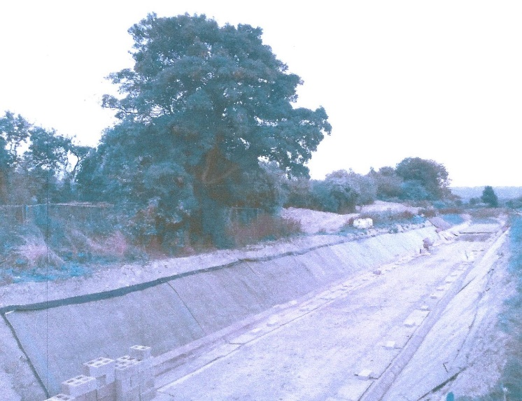
Tony Bardwell
THE SITE READY FOR WRG BITM

WRG BITM all but completed the solid blocking on the Saturday finishing off complete with coir rolls on the Sunday morning.

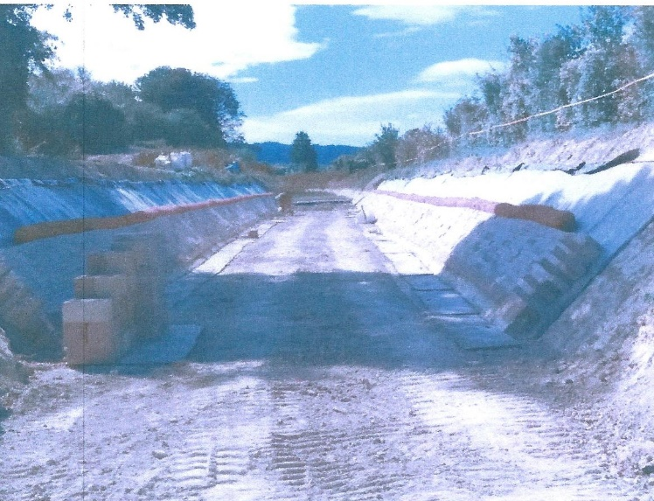
Tony Bardwell
COMPLETED WORK BY WRG BITM

This is not the end of the WRG BITM work over the weekend. It had been agreed with CRT that the old coal bunkers at Whitehouses that once had a brick arch over them needed to be made safe. The brick arch had been broken in the past, probably when the former cottages were demolished and was recently removed as it was liable to collapse. The bunkers were to be filled with brick rubble and pea shingle to fill in all of the voids. This work was done by WRG BITM on the Saturday

Many thanks to WRG BITM who have helped us so well over the years.

To finish the great effort of these work parties, in October the newly blocked length was completed with spoil on both banks and the bed lining completed with the last 20 metre roll getting very close to the end.

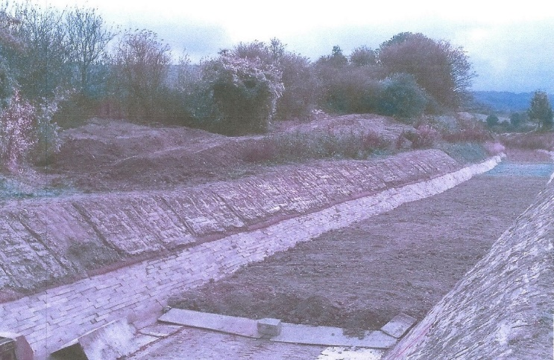
Tony Bardwell
THE FINISHED WORK – NEARLY THE END OF STAGE 3

A day was spent at each of the working parties, when there were good numbers of volunteers present, cutting rolls of Bentomat both for bank and bed lining. This took advantage of the good weather and ensures that we have a good supply of Bentomat ready for future lining of Stage 4.

The area on the offside just past Whitehouses belonging to Herts County Council who allowed us to tip spoil against the high bank was trimmed off with berms (shelves) to ensure good stability.

Well done by all concerned.

Tidy Friday

The work of John Reynolds and his team in keeping our restoration tidy is working very successfully, thank you all. See schedule on page 5 for dates.

Reed clearance

CRT clearance of the aquatic vegetation in the canal between the sump at Drayton Beauchamp and the old A41 Bridge is now under way and it is being done very thoroughly.

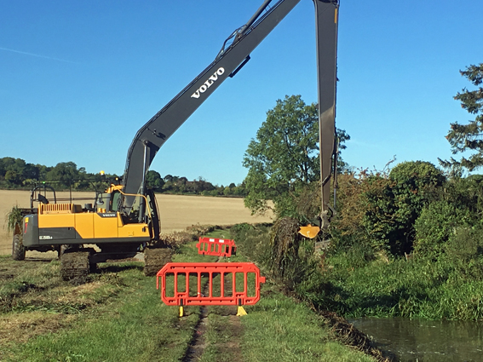
Chris Sargeant
THIS SHOWS THE CHANNEL BEING CLEARED BEHIND WENWELL CLOSE, HOPEFULLY ALL ROOTS GONE UNTIL NEXT YEAR

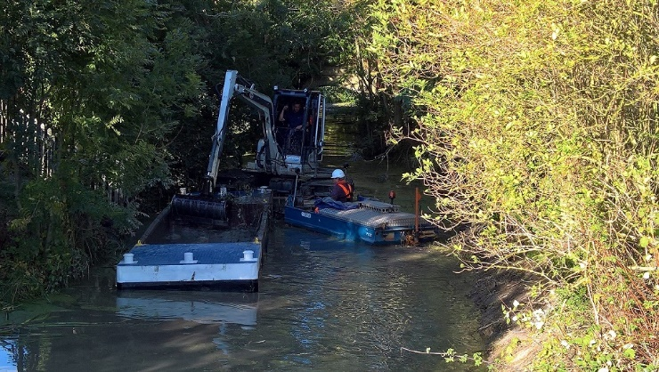
Stephen Bonsor
A NOT SO ACCESSIBLE LENGTH BEING CLEARED

Photographs

I must thank all who send me photos of the restoration. Although I cannot use them all in this newsletter they are added to my WAT PHOTO GALLERY that covers all aspects of restoration so please keep sending them.

6-Monthly Physical and Financial Report

You will find this on the next page. In some ways it needs updating as the CRT contract work at Whitehouses is not included and account will have to be taken of the possibility of a by-pass channel alongside the 200 metre long old council tip at Little Tring. There is also the question of the suspended bid to the Heritage Lottery Fund. I will update as and when these plans are finalised. Hopefully the contract work at Whitehouses will be funded by a successful bid to the Leader Fund.

New jobs

With the departure of Ray Orth, tasks he previously undertook have been taken over as follows:

Clive Johnson has taken over Ray’s task of giving talks about the restoration to interested bodies. I understand that his diary is already filling up!

Peter Lockett, who already helps me with ordering materials, has additionally taken over from Ray the ordering of hire plant and the associated supply of diesel fuel.

John Reynolds has taken over from Ray the training and certification of excavator and dumper drivers.

Also Mike Wright (not the Grand Draw Michael Wright) has taken on the Health & Safety role formerly held by Charles Carrington.

In addition Boyd Williams has taken over from Brian Ing looking after the Trust’s plant and equipment, in particular regular safety testing. Brian is having health problems and we wish him a rapid recovery.
Please note that it would help Boyd a great deal if everyone cleaned the hand tools they were using at the end of every day’s working party.

My grateful thanks to all concerned; without this kind of support restoration would stall.

General Notes

We operate as a self-supervising group under CRT and all volunteers receive and sign for the Trust’s Restoration Handbook that includes full Health and Safety requirements for the restoration works.

The handbook is the property of the Trust; if you leave the working parties for any reason, please return your Handbook to either Tony Bardwell or myself.

Hard hats for use at all times and high visibility jackets to be worn on sites with mobile plant in use are kept in the store at Tringford and must be drawn/returned there.

One first aid kit is kept in the store and one in the Nissan Cabstar and each qualified first-aider will have their own kit with him/her when on site.

Also available in the store at Tringford are ear defenders and goggles that must be worn when using strimmers, angle grinders, concrete breakers and the like. CRT will supply hard hats, gloves and footwear with reinforced toecaps on request.

We normally work from 9am to 5pm (or dark if earlier!). There are breaks for morning tea/coffee, packed lunch and afternoon tea/coffee. We take our own food and drink.

WENDOVER ARM CANAL RESTORATION PHASE II

PROGRESS REPORT AS AT 12th OCTOBER 2018

CANAL LINING
Item | Stage 1 | Stage 2 | Stage 3 | Stage 4 | Stage 5 | Stage 6 | Stage 7 | Total
Total length | 321m | 350m | 350m | 350m | 350m | 337m | -
Complete to date:
Bulk Excavation | 321m | 350m | 340m |  |  |  | ---------
Capping to pipe | 321m | 350m | 340m | 126m |  |  | ---------
Tipping to offside bank | 321m | 350m | 330m |  |  |  | ---------
Tipping to towpath bank | 321m | 350m | 350m
Profiling offside bank | 321m | 350m | 330m |  |  |  | ---------
Profiling towpath bank | 321m | 350m | 340m |  |  |  | ---------
Lining towpath bank | 321m | 350m | 330m |  |  |  | ---------
Lining offside bank | 321m | 350m | 330m |  |  |  | ---------
Level and line bed | 321m | 350m | 320m |  |  |  | ---------
Planting banks | 60m | -------- | -------- |  |  |  | ---------
Mooring wall length | 50m | 50m | -------- | 50m | --------- | -------- | 237m
Excavation | 50m | 50m | -------- | 50m | -------- | -------- | 10m
Blinding | 50m | 50m | -------- | 50m | -------- | --------
Wall base | 50m | 50m | -------- | 50m | -------- | --------
Wall upright | 50m | 50m | -------- | 50m | -------- | --------
Backfill | 50m | 50m | -------- | 50m | -------- | --------
Estimated Cost | £128,272 | £154,579 | £225,000 | £200,000 | £166,250 | £98,725 | £53,725 | £1,026,551
Cost to date/final | £128,272 | £154,579 | £199,412 | £32,884 | £2,821 | £304 | £633 | £518,905

FOOTBRIDGES & VARIOUS OTHER WORKS
Item | Stage 8 | Stage 9 | Stage 10 | Stage 11 | Stage 12 | Stage 13 | Stage 14 | Total
 | Bridge 4 | Bridge 4A | Whitehouses | Cart track  Narrows | Removal  of bunds | Winding  Hole nose | Nuttalls  Bund
Footbridge | 100% | 100% | ---------------- | ----------- | ---------- | ----------- | ----------
Excavation | 100% | 100% | ---------------- |  | ---------- |  | ----------
Blinding | 100% | 100% | ---------------- |  | ---------- |  | ----------
Wall base | 100% | 100% | ---------------- |  | ---------- |  | ----------
Wall upright | 100% | 100% | ---------------- |  | ---------- |  | ----------
Backfill | 100% | 100% | ---------------- |  | ---------- |  | ----------
Heritage work | --------- | --------- | 100% | ----------- | ---------- | ----------- | ----------
Other work | --------- | --------- | 100% | ----------- |  | ----------- | 100%
CRT contract | --------- | --------- |  | --------- | --------- | --------- | ---------
Estimated cost | £20,122 | £20,031 | £67,552 | £20,000 | £20,000 | £10,000 | 3,501 | £161,206
Cost to date/final | £20,122 | £20,031 | £18,450 |  |  |  | 3,501 | £62,104

SUMMARY INCLUDING OVERHEAD COSTS AND PHASE I
 | Lining | F/bridges  & other  works | Clear bed,  & Temp’y  Works | Environ’t  Reports | Materials  In stock | Admin | Tools &  Equip’t | Vehicle | Unallocated  contingency | TTOTAL
Estimated cost | £1,026,551 | £161,206 | £22,000 | £3,245 | £0 | £43,000 | £12,000 | £25,000 | £40,000 | £1,333,002
Cost to date/final | £518,905 | £62,104 | £21,417 | £3,245 | £4,561 | £37,301 | £11,302 | £22,374 | £0.00 | £680,939
Final cost of Phase I completed in 2004 and opened to navigation in 2005 |  |  |  |  |  |  |  |  |  | £400,349
Total spend on restoration by Wendover Arm Trust to date |  |  |  |  |  |  |  |  |  | £1,081,288
A red figure indicates a final cost/physical progress. A green figure indicates a revised budget figure, either to match a finished cost or to give a re-appraisal in the light of experience to date.

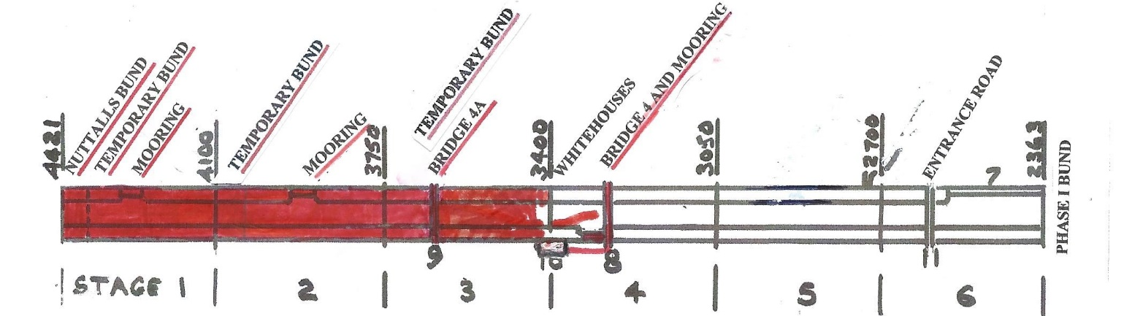

WORKING PARTIES

So you can plan your diary ahead, the following are the dates of future working parties. The work to be done is very much subject to the weather especially during the winter months.

DATE | WORKING AT | WORK TO BE DONE
2018
Friday 2nd November to  Thursday 8th November | Stage 3 to Bridge 4 | Stage 3 lining
Friday 9th November | Meet at Little Tring | ‘Tidy Friday’ vegetation control party
Friday 30th November to  Thursday 6th December | Stage 4 to Bridge 4 | Stage 4 excavation/filling to rough profile
Friday 7th December | Meet at Little Tring | ‘Tidy Friday’ vegetation control party
2019
Friday 4th January to  Thursday 10^{tth} January | Stage 4 to Bridge 4 | Stage 4 excavation/filling to rough profile
Friday 11th January | Meet at Little Tring | ‘Tidy Friday’ vegetation control party
Friday 1st February to  Thursday 7th February | Stage 4 to Bridge 4 | Stage 4 excavation/filling to rough profile
Friday 8th February | Meet at Little Tring | ‘Tidy Friday’ vegetation control party
Friday 1st March to  Thursday 7th March | Stage 4 to Bridge 4 | Stage 4 excavation/filling to rough profile
Friday 8th March | Meet at Little Tring | ‘Tidy Friday’ vegetation control party
Friday 5th April to
Thursday 11th April
Friday 12th April | Meet at Little Tring | ‘Tidy Friday’ vegetation control party
Friday 3rd May to
Thursday 9th May
Friday 10th May | Meet at Little Tring | ‘Tidy Friday’ vegetation control party
Friday 31st May to
Thursday 6th June
Friday 7th June | Meet at Little Tring | ‘Tidy Friday’ vegetation control party
Friday 5th July to
Thursday 11th July
Friday 12th July | Meet at Little Tring | ‘Tidy Friday’ vegetation control party
Friday 2nd August to
Thursday 8th August
Friday 9th August | Meet at Little Tring | ‘Tidy Friday’ vegetation control party
Friday 6th September to
Thursday 12th September
Friday 13th September | Meet at Little Tring | ‘Tidy Friday’ vegetation control party
Friday 4th October to
Thursday 10th October
Friday 11th October | Meet at Little Tring | ‘Tidy Friday’ vegetation control party
Friday 1th November to
Thursday 7th November
Friday 8th November | Meet at Little Tring | ‘Tidy Friday’ vegetation control party
Friday 6th December to
Thursday 12th November
Friday 13th December | Meet at Little Tring | ‘Tidy Friday’ vegetation control party

You will note that work from April onwards is left blank as we are still awaiting CRT plans for their work at Whitehouses without which we cannot plan our work in detail.

Roger Leishman, Restoration Director.
7 Hall Park, Berkhamsted, Herts HP4 2NU.
Tel: 01442 874536,
e-mail rwleishman@gmail.com

