THE WENDOVER ARM TRUST
WORKING PARTY NEWS
ISSUE 127 June 2018

Margaret Leishman

Many of you already know that Margaret died on Friday 15th June and I was very touched that so many involved with the Trust attended her funeral on Thursday 28th June. Margaret and I started our support of the Trust in the 1980s scrub bashing the canal bed.

I well remember Eddy Evans suggesting one evening at a Chiltern IWA meeting that we should sell teas and cakes at the restoration site during our annual festivals. Margaret landed the job of organising this on our boat, Mary Beth, and the first “Lock Café” was in 1997. It subsequently became the “Bridge Café” when Phase I was completed and finally a tea stall at the two annual open days held at St.Mary’s Church, Drayton Beauchamp. She handed over to Jo Orth after twenty years.

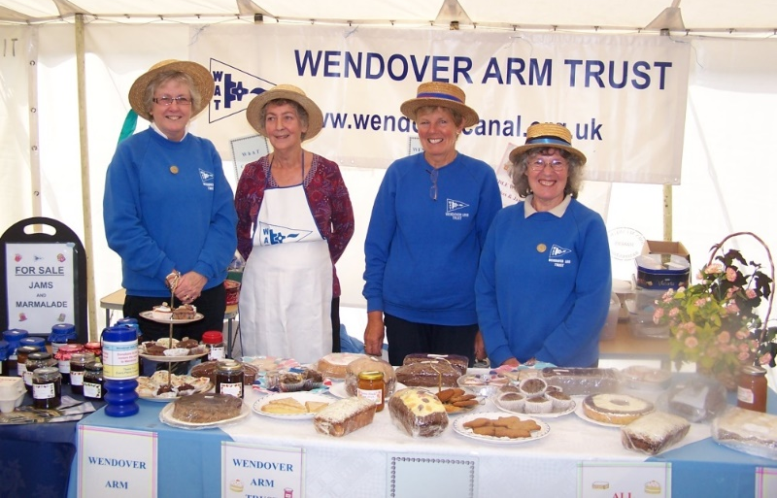

JO ORTH, MARGARET LEISHMAN,

JENNY BRICE AND VAL MATRAVES

WITH THEIR SELECTION OF GOODIES IN 2011

As a former BBC secretary she was able to take notes in shorthand and the then WAT Chairman Bob Wheal persuaded her to act as Minutes Secretary to the WAT Council, a job she did for eight years.

Ray Orth

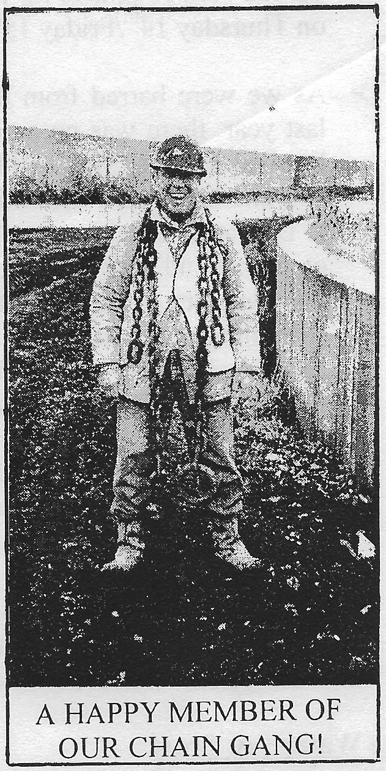
(from the February 2002 issue!)

I was very sorry to hear from Ray Orth that he and Jo are going to move from Chesham to Dorset in the near future. Ray has been a restoration volunteer as long as I have and I remember well my relief when he took early retirement and became my right hand man on the restoration. The amount of time he has devoted to the restoration beggars belief and he is certainly due a well-earned rest.

May and June Working Parties

Both working parties started with the Friday spent pumping out water! During May work had to be restricted to bulk excavation but things improved in June; 27 metres of both banks were profiled ready for lining.

July and August Working Parties

Work can now progress on lining both banks and follow with bed lining.

Whitehouses

The work now forging ahead means that work will reach Whitehouses probably before CRT even begin work on the pseudo weir at Whitehouses; we still await their estimate for the work.

Times have changed since I was a project engineer in charge of major civil engineering works. In 1960 I was faced with a very similar problem involving construction of a permanent access to an egg shaped public sewer that ran under a main line and a new reinforced concrete retaining wall. As trains had to be kept running we could not wait several years, as we have with Whitehouses, so the Local Authority Engineer, my best and very experienced bricklayer and myself agreed the design on the spot and the work was completed without any delay.

Tidy Friday

John Reynolds and his team continue with their good work of vegetation control. See schedule on page 3 for dates.

This is valuable work and I am sure John would like to hear from anyone able to spare a Friday once a month.

General Notes

We operate as a self-supervising group under CRT and all volunteers receive and sign for the Trust’s
Restoration Handbook that includes full Health and Safety requirements for the restoration works.

The handbook is the property of the Trust; if you leave the working parties for any reason, please return your Handbook to either Ray Orth or myself.

Hard hats for use at all times and high visibility jackets to be worn on sites with mobile plant in use are kept in the store at Tringford and must be drawn/returned there.

One first aid kit is kept in the store and one in the Nissan Cabstar and each qualified first-aider will have their own kit with him/her when on site.

Also available in the store at Tringford are ear defenders and goggles that must be worn when using strimmers, angle grinders, concrete breakers and the
like. CRT will supply hard hats, gloves and footwear with reinforced toecaps on request.

We normally work from 9am to 5pm (or dark if earlier!). There are breaks for morning tea/coffee, packed lunch and afternoon tea/coffee. We take our own food and drink.

WORKING PARTIES

So you can plan your diary ahead, the following are the dates of future working parties. The work to be done is very much subject to the weather especially during the winter months.

DATE | WORKING AT | WORK TO BE DONE
2018
Friday 6th July to  Thursday 12th July | Stage 3 to Bridge 4 | Stage 3 profiling and lining.
Friday 13th July | Meet at Little Tring | ‘Tidy Friday’ vegetation control party.
Friday 3rd August to  Thursday 9th August | Stage 3 to Bridge 4 | Stage 3 profiling and lining.
Friday 10th August | Meet at Little Tring | ‘Tidy Friday’ vegetation control party.
Friday 31st August to  Thursday 6th September | Stage 3 to Bridge 4 | Stage 3 profiling and lining.
Saturday 15th & Sunday 16th September  WRG BITM * | Whitehouses and Bridge 4 | Filling in old coal cellars at Whitehouses and removing the old abutments of the Bridge 4 swing bridge.
Friday 5th October to  Thursday 11th October | Stage 4 to Bridge 4 | Stage 4 profiling and lining subject to CRT work at Whitehouses being completed.
Friday 2nd November to  Thursday 8th November | Stage 4 to Bridge 4 | Stage 4 profiling and lining subject to CRT work at Whitehouses being completed.
Friday 30th November to  Thursday 6th December | Stage 4 to Bridge 4 | Stage 4 profiling and lining subject to CRT work at Whitehouses being completed.

*This is a provisional date as the village hall at Ivinghoe Aston, where we have had accommodation for visitors in recent years, has closed and we need new accommodation.

Roger Leishman, Restoration Director.
7 Hall Park, Berkhamsted, Herts HP4 2NU.
Tel: 01442 874536,
e-mail rwleishman@gmail.com

