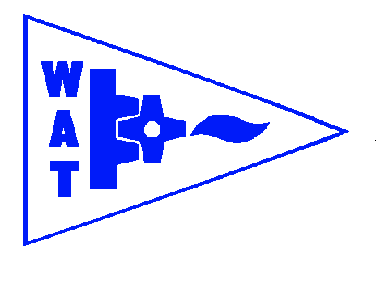
THE WENDOVER ARM TRUST
WORKING PARTY NEWS
ISSUE 125 February 2018

January and February Working Parties

No progress on the relining front during these two working parties due to bad weather conditions. Even a short step back when melting snow coming down the offside bank washed out spoil from above the coir rolls as the spoil had not had time to settle and dry out.

Both work parties concentrated on scrub bashing the offside bank between the cart track entrance and Bridge 4 (Stages 4/5) as shown below.

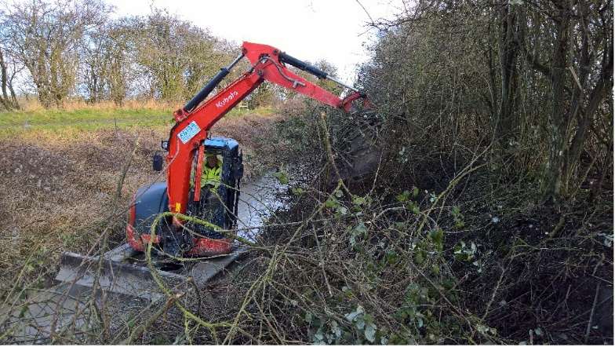
Stephen Bonsor
THIS ILLUSTRATES THE NEED TO CLEAR THIS OFFSIDE BANK

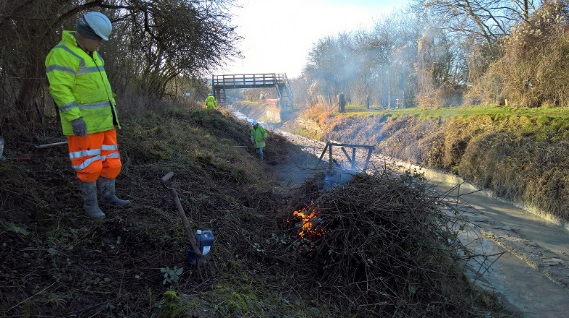
Stephen Bonsor
AT LEAST IT WAS POSSIBLE TO KEEP A BIT WARM!

At the February working party the opportunity was taken to dig trial holes to determine the exact line of the former canal bed through the old tip at Little Tring. When the boundaries were pegged out in 1997 the existing offside fence was assumed by BW to be correct but when WAT subsequently installed the towpath side fence we nearly lost a crowbar into loose ash of the canal bed leading us to realise that the line of the canal strayed a bit off course.
In the event the BW land fenced off was the same area as before even if not 100% on the line of the canal.

March and April Working Parties

Weather permitting work will re-commence on Stage 3 lining. It is to be hoped that the snow forecast for the end of February will not affect the work. If it does work will have to fall back on scrub bashing Stages 4/5.

Welcome to another team leader

I was very pleased to hear that Michael Wright (not to be confused with Mike Wright, our volunteer of many years) has agreed to be a Team Leader at working parties. Many thanks Michael.

Whitehouses

The latest news on the design and progress of the pseudo weir and wing walls to the wharf wall at Whitehouses is that the design has been received by WAT but is still being costed by CRT. WAT have agreed to pay the cost. It is something that could be done by volunteers but would probably extend our programme by up to a year.

Tidy Friday

John Reynolds and his team continue with their good work of vegetation control. See schedule on page 3 for dates.

This is valuable work and I am sure John would like to hear from anyone able to spare a Friday once a month.

Water from Wendover

CRT has at long last restored the flow of water from Wendover by reed cutting the growth that was blocking the channel. Our newly restored Phase II is again in water and hopefully the wildlife will come back again

I don’t think that I was the only person deeply upset at the loss of wildlife, particularly fish that were so plentiful in our new waters. We only hope that CRT keep their eye on the ball in future so that we do not have another ecological disaster.

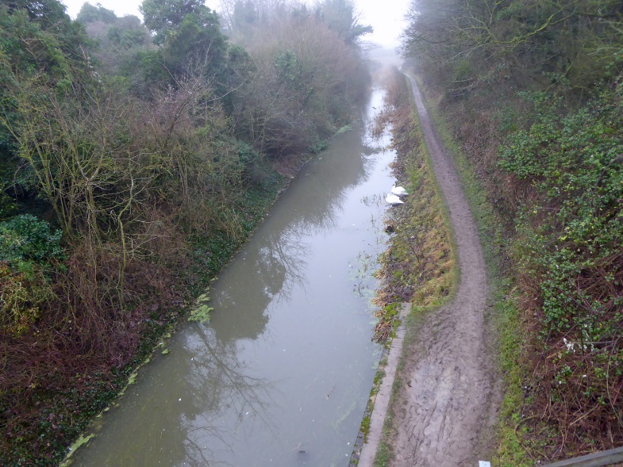
Chris Sargeant
WATER FLOWING AGAIN TOWARDS DRAYTON BEAUCHAMP BRIDGE

Chiltern IWA Branch outing

See page 4 for details of this year’s Chiltern Branch outing. Do join in if you can. Apart from being a very interesting weekend it is an enjoyable social gathering.

General Notes

We operate as a self-supervising group under CRT and all volunteers receive and sign for the Trust’s
Restoration Handbook that includes full Health and Safety requirements for the restoration works.

The handbook is the property of the Trust; if you leave the working parties for any reason, please return your Handbook to either Ray Orth or myself.

Hard hats for use at all times and high visibility jackets to be worn on sites with mobile plant in use are kept in the store at Tringford and must be drawn/returned there.

One first aid kit is kept in the store and one in the Nissan Cabstar and each qualified first-aider will have their own kit with him/her when on site.

Also available in the store at Tringford are ear defenders and goggles that must be worn when using strimmers, angle grinders, concrete breakers and the
like. CRT will supply hard hats, gloves and footwear with reinforced toecaps on request.

We normally work from 9am to 5pm (or dark if earlier!). There are breaks for morning tea/coffee, packed lunch and afternoon tea/coffee. We take our own food and drink.

WORKING PARTIES

So you can plan your diary ahead, the following are the dates of future working parties. The work to be done is very much subject to the weather especially during the winter months.

DATE | WORKING AT | WORK TO BE DONE
2018
Friday 2nd March to  Thursday 8th March | Stage 3 | Stage 3 profiling and lining, weather permitting!
Friday 9th March | Meet at Little Tring | ‘Tidy Friday’ vegetation control working party
Friday 6th April to  Thursday 12th April | Stage 3 | Stage 3 profiling and lining.
Friday 13th April | Meet at Little Tring | ‘Tidy Friday’ vegetation control working party
Friday 4th May to  Thursday 10th May | Stage 3 | Stage 3 profiling and lining.
Friday 11th May | Meet at Little Tring | ‘Tidy Friday’ vegetation control working party
Friday 1st June to  Thursday 7th June | Stage 3 | Stage 3 profiling and lining.
Friday 8th June | Meet at Little Tring | ‘Tidy Friday’ vegetation control working party
Friday 6th July to  Thursday 12th July | Stage 4 to Bridge 4 | Stage 4 profiling and lining.
Friday 3rd August to  Thursday 9th August | Stage 4 to Bridge 4 | Stage 4 profiling and lining.
Friday 31st August to  Thursday 6th September | Stage 4 to Bridge 4 | Stage 4 profiling and lining.
Friday 5th October to  Thursday 11th October | Stage 4 to Bridge 4 | Stage 4 profiling and lining.
Friday 2nd November to  Thursday 8th November | Stage 4 to Bridge 4 | Stage 4 profiling and lining.
Friday 30th November to  Thursday 6th December | Stage 4 to Bridge 4 | Stage 4 profiling and lining.

Roger Leishman, Restoration Director.
7 Hall Park, Berkhamsted, Herts HP4 2NU.
Tel: 01442 874536,
e-mail rwleishman@gmail.com

Date for the diary; 3 days to explore
London’s lost route to Littlehampton and Portsmouth plus the Bluebell railway.

For the past 20+ years, Chiltern Branch of the Inland Waterways Association have enjoyed weekend trips away to explore areas of interest; as in other years, our trip in 2018 will include a visit to a waterway restoration, a boat trip and a day exploring a heritage railway.
In 1785, during the Napoleonic wars (1799 to 1815) the Wey and Arun Canal Act was passed; it was planned to enable safe inland movement of troops and supplies to Littlehampton on the south coast. It was finished in 1816, it was made redundant by the railways and an Act of Abandonment passed in 1871; 99 years later the Wey and Arun Canal Trust was formed.
The Bluebell was the first preserved standard gauge steam-operated passenger railway in the world to operate a public service, the society ran its first train on 7 August 1960, less than three years after the line from East Grinstead to Lewes had been closed by British Railways. Today the railway is managed and run largely by volunteers; it has over 30 steam locomotives - the largest collection in the UK after the National Railway Museum at York. The Bluebell also has almost 150 carriages and wagons, most of them pre-1939.

This information for planning your diary only;
Dates will be Friday 21st to Sunday 23rd September 2018; the cost will be circa £250 per person, this to include travel by coach, hotel – bed breakfast and evening meal. Convenient pick-up points for the coach will allow for access by car and or public transport.
Full details and final costs will be published in February 2018.
To register interest please email colin.bird@waterways.org.uk or contact Dave Chapman on 07808 720555.

