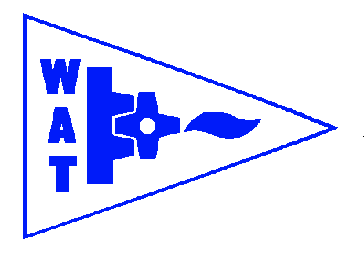
THE WENDOVER ARM TRUST
WORKING PARTY NEWS
ISSUE 124 December 2017

Wishing all our readers a Happy New Year and a special thankyou to all who have worked so hard both on site and those who have worked on all other aspects of the Trust’s work.

An apology

I regret that this issue is rather late as I usually publish before Christmas and it is also rather brief.

On December 1st I had a new left hip and, although I have been totally pain free from when I woke up after the operation, I have to do exercises and take plenty of rest for six weeks. Believe it or not, after a 9am OP I was walking around on crutches the same afternoon.

November and December Working Parties

Bank and bed lining again proceeded during these working parties and, subject to weather, will continue in January and February.

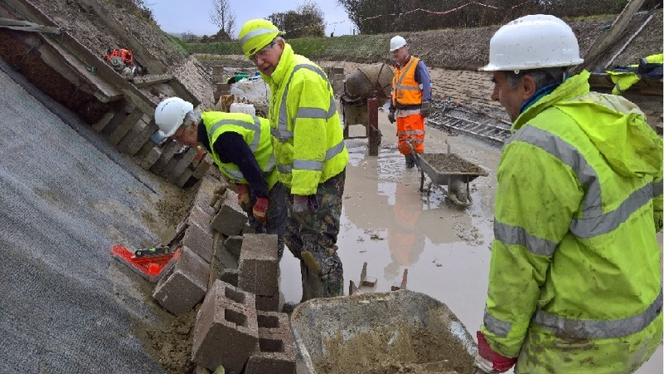
Stephen Bonser
WORK IN PROGRESS LAYING HOLLOW CONCRETE BLOCKS IN DECEMBER

Whitehouses

The latest news on the design and progress of the pseudo weir and wing walls to the wharf wall at Whitehouses is that the design has been received by WAT and is at present being costed by CRT. No firm date for this work has been agreed although a date of April/May next year has been suggested but attempts are being made to bring this forward to avoid clashing with WAT’s work that should have reached Whitehouses about that time.

Tidy Friday

John Reynolds and his team continue with their good work of vegetation control. See schedule on page 2 for dates.

HLF Bid

As I expect many of you already know the HLF bid is currently ‘on hold’ pending a review of the project due to an estimated cost overrun and other delays.

General Notes

We operate as a self-supervising group under CRT and all volunteers receive and sign for the Trust’s Restoration Handbook that includes full Health and Safety requirements for the restoration works.

The handbook is the property of the Trust; if you leave the working parties for any reason, please return your Handbook to either Ray Orth or myself.

Hard hats for use at all times and high visibility jackets to be worn on sites with mobile plant in use are kept in the store at Tringford and must be drawn/returned there.

One first aid kit is kept in the store and one in the Nissan Cabstar and each qualified first-aider will have their own kit with him/her when on site.

Also available in the store at Tringford are ear defenders and goggles that must be worn when using strimmers, angle grinders, concrete breakers and the
like. CRT will supply hard hats, gloves and footwear with reinforced toecaps on request.

We normally work from 9am to 5pm (or dark if earlier!). There are breaks for morning tea/coffee, packed lunch and afternoon tea/coffee. We take our own food and drink.

WORKING PARTIES

So you can plan your diary ahead, the following are the dates of future working parties. The work to be done is very much subject to the weather especially during the winter months.

DATE | WORKING AT | WORK TO BE DONE
2018 | Meet at Little Tring
Friday 5th January to  Thursday 11th January | Stage 3 | Stage 3 profiling and lining.
Friday 12th January | Meet at Little Tring | ‘Tidy Friday’ vegetation control working party
Friday 2nd February to  Thursday 8th February | Stage 3 | Stage 3 profiling and lining.
Friday 9th February | Meet at Little Tring | ‘Tidy Friday’ vegetation control working party
Friday 2nd March to  Thursday 8th March | Stage 3 | Stage 3 profiling and lining.
Friday 9th March | Meet at Little Tring | ‘Tidy Friday’ vegetation control working party
Friday 6th April to  Thursday 12th April | Stage 3 | Stage 3 profiling and lining.
Friday 13th April | Meet at Little Tring | ‘Tidy Friday’ vegetation control working party
Friday 4th May to  Thursday 10th May | Stage 3 | Stage 3 profiling and lining.
Friday 11th May | Meet at Little Tring | ‘Tidy Friday’ vegetation control working party
Friday 1st June to  Thursday 7th June | Stage 3 | Stage 3 profiling and lining.
Friday 8th June | Meet at Little Tring | ‘Tidy Friday’ vegetation control working party
Friday 6th July to  Thursday 12th July | Stage 4 to Bridge 4 | Stage 4 profiling and lining.
Friday 3rd August to  Thursday 9th August | Stage 4 to Bridge 4 | Stage 4 profiling and lining.
Friday 31st August to  Thursday 6th September | Stage 4 to Bridge 4 | Stage 4 profiling and lining.
Friday 5th October to  Thursday 11th October | Stage 4 to Bridge 4 | Stage 4 profiling and lining.
Friday 2nd November to  Thursday 8th November | Stage 4 to Bridge 4 | Stage 4 profiling and lining.
Friday 30th November to  Thursday 6th December | Stage 4 to Bridge 4 | Stage 4 profiling and lining.

Roger Leishman, Restoration Director.
7 Hall Park, Berkhamsted, Herts HP4 2NU.
Tel: 01442 874536,
e-mail rwleishman@gmail.com

